Direct Connection (Configuration Options)

During the construction phase of the Collocation, the CLEC has the opportunity to pre-provision an infrastructure for ordering services. This consists of cabling and blocks from a demarcation point to an appropriate existing frame.

To provide CenturyLink with the quantity and the technical specifications for this infrastructure, the CLEC should indicate on the Collocation Application the number of terminations it anticipates it will need. Further information for completing these sections may be found in the Collocation Application and associated job aid.

Demarcation Options:

1) Demarcation at the ICDF
When this option is selected, the tie cabling will be pre-designed and pre-constructed from existing frames throughout the building to the ICDF. The CLEC typically uses CLEC-provided cabling to connect at the ICDF to its Collocation space.

- Shared Access

2) Demarcation within the Collocation Space
The CLEC has two further options for the infrastructure configuration with this choice:
- Shared Access
- Direct Connection (ordered via the Collocation Order Form- Direct Connections)
3) Demarcation outside the Collocation Space
- Direct Connection (ordered via the Collocation Order Form- Direct Connections)
Configuration Options

A demarcation point is needed to clearly mark the juncture of facilities owned by the collocator and facilities owned by CenturyLink. CenturyLink will provide a connection between Unbundled Network Elements and ancillary services and the demarcation point. This is an Interconnection Tie Pair (ITP). The demarcation point may be:
- Shared Access: at a CenturyLink-provided shared or dedicated InterConnection Distribution Frame (ICDF);
- Direct Connection: at a collocator-provided termination point located in the collocator’s Collocation Space; or
- At another demarcation point mutually agreed to by the parties.

Shared Access

In a Shared Access configuration, there are multiple frames that could be designated as an ICDF or appropriate demarcation point, including, but not limited to, the following:

- Existing InterConnection Distribution Frame (ICDF)
- Existing DSX Panels for DS-1 and DS-3 services
- New InterConnection Distribution Frame
- Existing Toll Frame
- Fiber Distribution Panel
- Existing Intermediate frame

The ICDF is the test access point. It would not be uncommon to find multiple service providers, including CenturyLink, on the ICDF at any one time. Charges include CenturyLink provided termination blocks, installation labor between CLEC collocated equipment and the appropriate cross connect device.
Cabling is also required and may be provided by the CLEC or at its request, CenturyLink will provide cabling at an additional charge. CLEC also has the option of installing the cable between the ICDF and the collocation space and procuring the block and providing it to CenturyLink for mounting. If the CLEC selects this option, CenturyLink will apply engineering, block placement and racking charges instead of the standard termination rates applied when CenturyLink provides the material and performs the entire installation. CenturyLink will provide CLEC with the type of block to be provided and also the route to follow for installing the cable between the ICDF and the collocation space. CenturyLink will lease the block back from the CLEC and inventory it as it’s asset for proper database inventory capabilities. Once the block is placed and stenciled, CenturyLink will provide the CLEC with a assignments through standard APOT processes. In the case of a decommissioned site involving a CLEC provided block, CenturyLink will not return the block and in exchange will not charge the CLEC for it’s removal at the time of decommissioning.

Direct Connection

Direct Connection provides an uninterrupted path from the Collocation space to an existing frame. This option will guarantee that there will not be an ICDF. The connection will be designed from the Collocation space to the same frame that CenturyLink uses to connect to that specific service. For example, if the CLEC wants to connect directly from its Collocation space to a Enhanced 911 (E911) router, the infrastructure for the E911 trunks will terminate in a DS-1 bay location with the E911 router circuits. CenturyLink will provide the CLEC the same connection to the network as CenturyLink uses for provision of services to CenturyLink end-users. The direct connection to CenturyLink’s network is provided to the CLEC through direct use of CenturyLink’s existing cross connection network. The CLEC and CenturyLink will share the same distributing frames for similar types and speeds of equipment, where technically feasible and space permitting.

There are several options for the location of the demarcation point. The CLEC will select its desired option via the Direct Connection (DC-POT) Collocation Form DC050900. If the CLEC chooses a demarcation inside the Collocation space, the CLEC should order and install the termination equipment itself. Demarcation equipment must be noted on the order form so that a CLLI code and unique tie cable assignments can be generated for service order systems flow through. If the CLEC chooses a demarcation outside its Collocation space, CenturyLink will maintain and inventory this device. Direct terminations may be ordered where frame space is available. If frame space is exhausted, the terminations may need to be made at another frame.

Upon completion of the pre-provisioning of the Direct Connection, the CLEC will receive an Alternate Point Of Termination (APOT) form so that it may order finished services and Unbundled Network Elements (UNEs). The CLEC will be responsible for augmenting terminations as required. The Direct Connection APOT information must be provided on the ASR or the LSR to ensure that the services are designed to the dedicated path.

The collocator’s termination point will require a CLLI code and Frame or Relay Rack Number, and the dedicated tie pairs will require a unique name to enable automatic assignment through TIRKS™ and SWITCH™ via the Carrier Facilities Address (CFA) methods.

The CLEC terminations will be placed on the appropriate CenturyLink cross connection frames using standard engineering principles. The CLEC terminations will share frame space with CenturyLink terminations on CenturyLink frames without a requirement for an intermediate device.

If the CLEC wishes to arrange terminations on a 2-wire POTS level cross-connect device of the modular type (i.e., COSMIC™ Hardware), standard-engineering principles will apply. Provisioning intervals and costs will be customized and determined on an individual case basis (ICB). A five-year forecast of terminations will be required. MELD™ runs will be required for the initial COSMIC plan and each subsequent block addition. Minimum installation is 1 block for every 2 outside plant module, with a ½ shelf of block capacity reserved for future block space, where space is permitting. Where ½ shelf space is not available, re-termination (grooming) of circuits and frame growth may be required. Costs for such activities will be assessed to the CLEC and listed on the quote.

Requests for terminations at a DS-O, DS-1, DS-3 and optical level (non-POTS) may also be made directly to the respective frame or panel (i.e., toll frame, DSX, FDP, etc.). Direct Connections to these frames do not require MELD™ runs and short jumper engineering principals, as with the COSMIC™ frame. However, these connections will require coordination between CenturyLink and the CLEC to ensure that the cable is terminated in an existing frame with the service that the CLEC is wishing to connect with.

Terminations on these frames are ordered in the following increments:

- DS-0--100 terminations
- DS-1--1 termination
- DS-3--1 termination
- Fiber--12 fiber strands

Direct Connection is ordered via the Collocation Order Form-Direct Connection (DC-POT) Collocation. Intervals and pricing are on an Individual Case Basis (ICB), and all costs will be delivered to the CLEC in the form of a quote. A non-refundable Quote Preparation Fee is to be paid with the first 50 percent down payment of quoted charges or is due upon refusal of the quote.

Direct Connections: “CenturyLink/CLEC Guide to Provisioning Direct Connections”

This describes the process by which CenturyLink establishes for a CLEC a dedicated tie cable from its Collocation space to a termination on the same frame that CenturyLink uses to terminate established trunking or signaling for the same types of services (e.g., E911, Common Channel Signaling). This description complements other CenturyLink documents by clarifying the provisioning of a somewhat unique interconnection request. This is for use by both CLECs and CenturyLink employees with provisioning responsibilities.

Process Outline
Typically, there are four major steps in the provisioning process:
- Establish Collocation;
- Establish Direct Connection tie cabling;
- Establish Transport on the Direct Connection tie cabling; and
- Route desired service type onto transport facility.

Where Direct Connection is requested in a Wire Center where the CLEC already has established Collocation and upon receipt of the applicable portions of a complete Collocation Application, CenturyLink will perform a feasibility study to determine if adequate cable racking can be found for the placement of copper, coax, or fiber optic cable, or any other technically feasible method, used for Direct Connection. The feasibility study will be provided within ten (10) calendar days from date of receipt of a complete Application.
If CenturyLink determines that the Application is not complete, CenturyLink shall notify the CLEC of any deficiencies within ten (10) calendar days of the Application. CenturyLink shall provide sufficient detail so that CLEC has a reasonable opportunity to cure each deficiency. To retain its place in the Collocation queue for the requested Premises, CLEC must cure any deficiencies in its Application and resubmit the Application within ten (10) calendar days after being advised of the deficiencies.
Quotation – If existing cable racking is available, CenturyLink will provide the CLEC with a Quote and the specific cable rack route with the feasibility study. If additional cable racking is required to accommodate the CLEC’s request, CenturyLink shall provide a Quote to the CLEC no later than ten (10) calendar days after receipt of a complete Collocation Application. Direct Connection quotes will be honored for thirty (30) calendar days from the date the quote is provided. During this period, the space is reserved pending the CLEC’s Acceptance of the quoted charges.
Acceptance – There are two forms of Acceptance for Direct Connection:
Direct Connection with existing cable rack. – The CLEC must submit payment of one hundred percent (100%) of the quoted non-recurring charges with its Acceptance notification.
Direct Connection using new cable rack. – Upon receipt of a complete Acceptance from the CLEC, CenturyLink will begin construction of the new cable rack.
Interval – The construction interval for Direct Connections shall be dependent upon whether the Direct Connection is to the COSMIC™ frame requiring a MELD™ and or if new cable racking is required.
If the CLEC provides a complete Acceptance within thirty (30) calendar days of receipt of the CenturyLink Collocation quotation, CenturyLink shall complete its installation of the Direct Connection above the DS-0 level where no new cable racking is required within thirty (30) calendar days of the receipt of the complete Collocation Acceptance. If Direct Connection is required at the DS-0 level, to the COSMIC™, or if new cable racking needs to be installed, CenturyLink will provision the direct trunking within sixty (60) calendar days of the receipt of the complete Collocation Acceptance.

Following are illustrations of the main steps involved in provisioning Direct Connections for E911 and Common Channel Signaling:

DIRECT CONNECTIONS FOR E911

The four steps illustrated below are for arranging E911 trunking via collocated facilities:

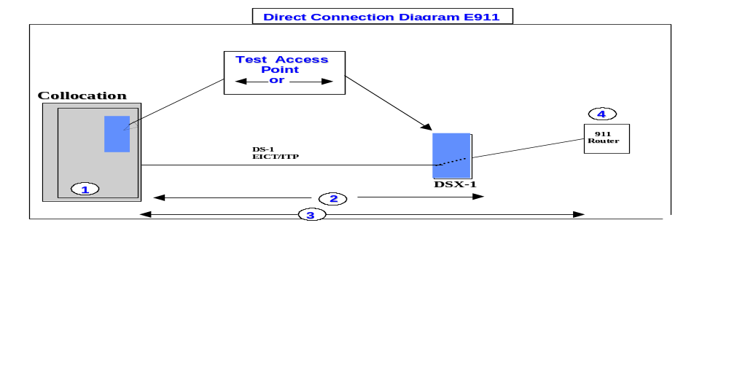
*See Attachment A of this section, for example of CLEC Collocation Multi-Floor Configuration

*See Attachment B of this section, for descriptions and diagram of Demarcation Options

Process Details for E911 Direct Connections
- Collocation
1a. The CLEC fills out the Collocation Application and CLEC Information Form. Copies of the forms and instructions can be found at URL: http://www.centurylink.com/wholesale/forms/collocationapp.html

CLEC can find documentation for Collocation by accessing URL: http://www.centurylink.com/wholesale/pcat/interconnection.html
1b. Assuming the CLEC accepts CenturyLink's Collocation quote, CenturyLink provisions the Collocation order, e.g., facilities, power, lighting, ventilation, synchronization.

1c. Terminations are constructed inside the Collocation space. Spare terminations must be equal in quantity and service level to the Direct Connections requested. This termination may or may not become the demarcation between networks.

- Establish Direct Connection Tie Cabling:
2a. CLEC fills out Direct Connection (DC-POT) Collocation Form . Copies of the form and instructions can be found at URL: http://www.centurylink.com/wholesale/forms/collocationapp.html

- CLEC documentation for Direct Connection options can be found in the Product Catalog (PCAT) at URL: http://www.centurylink.com/wholesale/forms/collocationapp.html

- Additional CLEC documentation for Direct Connection options is available in Qwest Technical Publication 77386, Chapter 3 (Interconnection Arrangements) and Chapter 16 (Interconnection with Finished Services). Technical Publications may be accessed on-line at www.centurylink.com/wholesale/notices/techPub.html

- It is recommended that a joint planning session be held between the CLEC and CenturyLink to determine the most efficient routing and ensure mutual understanding of technical requirements.

2b. Assuming the CLEC accepts CenturyLink's Collocation quote, CenturyLink plans, designs and installs Direct Connection facilities from CLEC demarcation to the same frame that CenturyLink uses to terminate established E911 end office trunking to the E911 Selective Router.
2c. CLEC receives updated Alternate Point of Termination (APOT)
from CenturyLink. A copy of the APOT Form is provided as Attachment C. The CLEC cable-naming key (Cable Naming Convention) is provided as Attachment D of this section.

3. Establish Transport on the Direct Connection Tie Cabling:
3a. CLEC fills out Access Service Request (ASR) and Transport Request forms. These forms are attached to this document as Attachments E and F, of this section, respectively.

- The ASR form is also found at the end of the Ordering and Billing Forum’s Access Service Request (ASR), Access Service Ordering Guidelines Industry Support Interface, ATIS/OBF-ASR-001. TheWeb site is located at http://www.centurylink.com/wholesale/forms/asr.html

- The Transport Request form is also found at the end of the Ordering and Billing Forum’s Transport Form Preparation Guide, Access Service Ordering Guidelines Industry Support Interface, ATIS/OBF-ASR-005.

3b. The CLEC enters tie cable termination addressing from the APOT document into the Cross Connect Equipment Assignment (CCEA) field (#45) of the Transport Request form.

3c. The CLEC gets a Firm Order Confirmation (FOC) of the Transport Order from CenturyLink. The FOC includes the facility name (ECCKT) and the Design Layout Record Date (DLRD). A copy of the FOC is provided as Attachment G of this section.

4. Route E911 Messages onto Transport Facility
4a. The CenturyLink Account Team member completes the RG 29-0029 (911/E911 Project Workbook) in consultation with the CLEC. The due date should be scheduled after the DLRD for the facility.

- The RG 29 Form establishes the E911 service (switches route E911 messages to the specific circuits going to the E911 selective router/PSAP). The CenturyLink Account Team member will provide the CLEC a copy of the Master Street Address Guide (MSAG) and Public Safety Answering Point (PSAP) contact information. This information is initially provided by either CenturyLink or a third party (e.g., Intrado) and is updated on a quarterly basis (or more often if necessary).

- CLEC documentation for E911 service can be found at URL:
http://www.centurylink.com/wholesale/pcat/interconnection.html

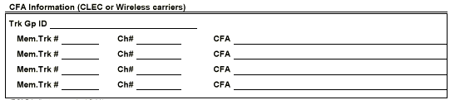4b. CenturyLink enters Connecting Facility Assignment (CFA) data from the Transport Request FOC onto the CFA Information block on page 8 of the RG29-0029 Form, which is shown below:

- As explained in the RG29-0029 Instructions, the Trunk Group Identification (Trk Gp ID) is the Number Plan Area/Public Safety Answering Point (NPA/PSAP). The CFA field may contain the Circuit Identification Number or the DS-1 service order number. Trunk group member and transport system channel number are also entered here.

4c. CenturyLink and CLEC coordinate order completion and test calling.
DIRECT CONNECTIONS FOR SIGNALING

The four steps illustrated below are for arranging Common Channel Signaling via collocated facilities:

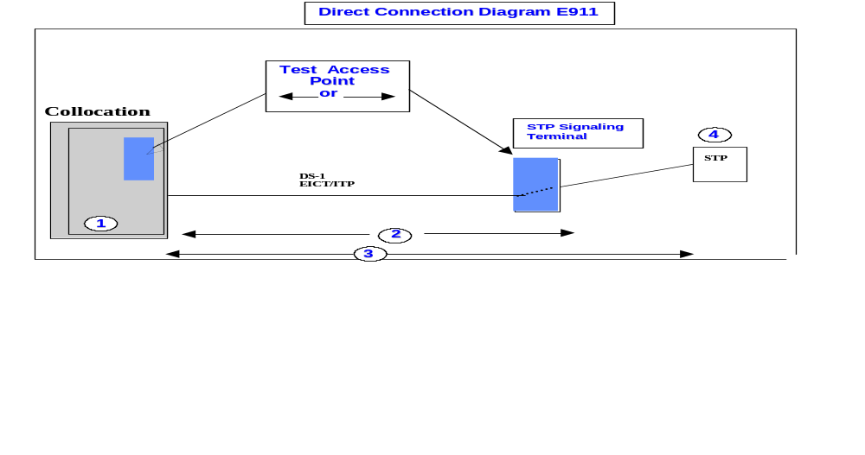
*See Attachment A of this section, for example of CLEC Collocation Multi-Floor Configuration

*See Attachment B of this section, for descriptions and diagram of Demarcation Options

Process Details for Common Channel Signaling Direct Connections
1. Collocation
1a. CLEC fills out the Collocation Application and CLEC Information Form. Copies of the forms and instructions can be found at URL: http://www.centurylink.com/wholesale/forms/collocationapp.html

- CLEC can find documentation for Collocation by accessing URL: http://www.centurylink.com/wholesale/forms/collocationapp.html

1b. Assuming CLEC accepts CenturyLink's Collocation quote, CenturyLink provisions the Collocation order, e.g., facilities, power, lighting, ventilation, synchronization.

1c. Terminations are constructed inside the Collocation space. Spare terminations must be equal in quantity and service level to the Direct Connections requested. This termination may or may not become the demarcation between networks.

2. Establish Direct Connection Tie Cabling:
2a. CLEC fills out Direct Connection (DC-POT) Collocation Form. Copies of the form and instructions can be found at URL: http://www.centurylink.com/wholesale/forms/collocationapp.html

- CLEC documentation for Direct Connection options can be found at URL: http://www.centurylink.com/wholesale/forms/collocationapp.html

- Additional CLEC documentation for Direct Connection options is available in Qwest Technical Publication 77386, Chapter 3 (Interconnection Arrangements) and Chapter 16 (Interconnection with Finished Services). Technical Publications may be accessed on-line at www.centurylink.com/wholesale/notices/techPub.html
- It is recommended that a joint planning session be held between the CLEC and CenturyLink to determine the most efficient routing and ensure mutual understanding of technical requirements.

2b. Assuming the CLEC accepts CenturyLink's Collocation quote, CenturyLink plans, designs, and installs Direct Connection facilities from the CLEC demarcation to the same frame that CenturyLink uses to terminate established Common Channel Signaling.

2c. The CLEC receives an updated Alternate Point of Termination (APOT) from CenturyLink. A copy of the APOT Form is provided as Attachment C. The CLEC cable naming key (Cable Naming Convention) is provided as Attachment D of this section.

3. Establish Transport/Signaling on the Direct Connection Tie Cabling:
3a. A Common Channel Signaling Access Capability (CSAC/SS7) initial planning session is required between CenturyLink and the CLEC prior to order submission. In the initial planning session, the parties will complete a pre-order form, link data sheet and special requirements for certain sections of the Access Service Request (ASR). Requirements for Direct Connection will also be determined during this meeting.

3b. CenturyLink and CLEC switches must be tested to prove compliance and compatibility with industry network standards. Worksheets specifying SS7 tests are available on URL: http://www.centurylink.com/wholesale/pcat/interconnection.html

3c. The CLEC submits appropriate CCSAC service requests (ASR Form, BCD Form). The ASR form is provided with this document as Attachment E of this section.

The ASR form is found at the end of the Ordering and Billing Forum’s Access Service Request (ASR), Access Service Ordering Guidelines Industry Support Interface, ATIS/OBF-ASR-001. The ATIS Web site is located at http://www.centurylink.com/wholesale/forms/asr.html

- The CCSAC ordering forms are provided at the pre-order meeting. CCSAC ordering forms are also available on URL: http://www.centurylink.com/wholesale/pcat/interconnection.html.

3d. The ACTL code for Collocation suffix is HG(x) or HJ(x), indicating CCSAC is connected to the CLEC's Collocation site.

3e. The APOT field of the ASR is populated with the bay panel and jack information when the customer is ordering to a Collocation site and is connecting with a D-S1 EICT. If the bay panel and jack information is longer than the allotted space, the information is shown in the remarks section.

4. Route Signaling onto Link Facility
4a. CenturyLink, in consultation with the CLEC, completes the appropriate forms and agrees upon the CCS Link Due Date intervals. The Due Date should be scheduled after the DLRD for the facility.

- CCSAC Baseline Service provides the means for transporting signaling information by way of Switched Access Links. This signaling information includes but is not limited to specific information regarding calls being made on associated Feature Group D trunks, Local Interconnection Service (LIS) trunks, Line Information DataBase (LIDB) data, 800 Set Up information, Call Set Up information and Transient messages. Information regarding signaling products is available on URL:

- www.centurylink.com/wholesale/notices/techPub.html

4b. CenturyLink and the CLEC will coordinate order completion and test calling.

ATTACHMENT A - Example of Interconnection in Multi-Story Building
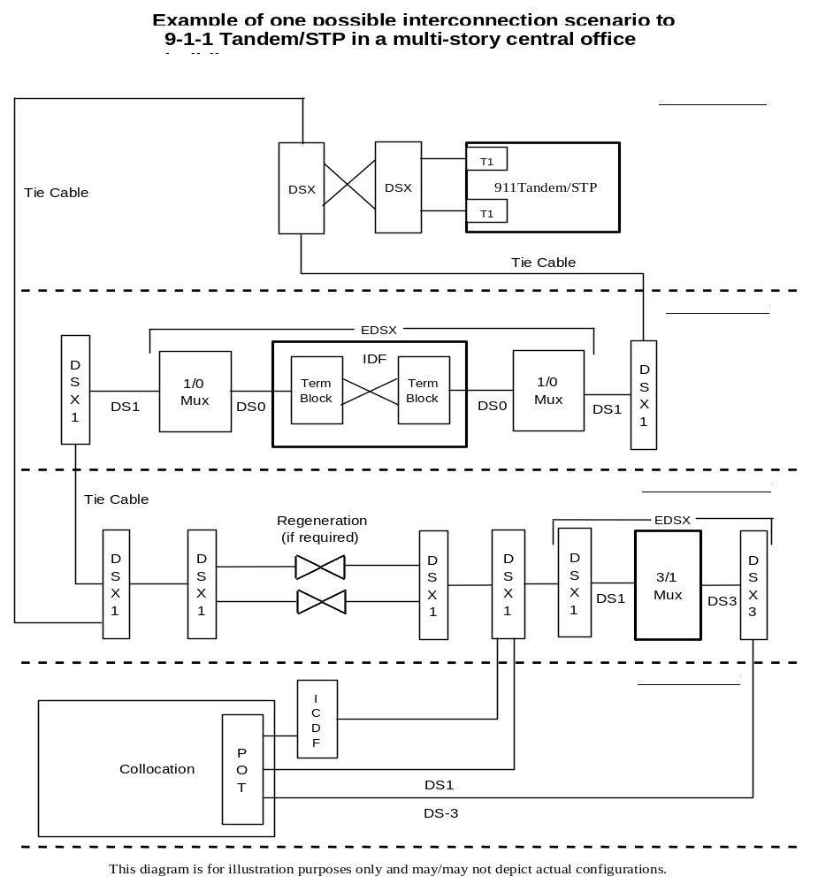

ATTACHMENT B - DEMARCATION OPTIONS

Demarcation Options

The attached diagrams consider three possible network demarcations. The FCC’s rule 47 C.F.R. §51.323 requires that intermediate frames not be necessarily interposed between the collocated equipment of a CLEC and the interconnected equipment of an ILEC in the same building. The following discussion attempts to evaluate the strengths and weakness of each option.

CenturyLink is willing to operate under any of the three options described. The collocator may choose the option best suited to its needs.

ATTACHMENT B - DEMARCATION OPTIONS

Option 1 – Direct Connection – Dedicated Point of Termination (DC-POT)

The first option is CenturyLink’s existing Direct Connection-Point of Termination (DC-POT) offering. This option establishes the demarcation in the Collocation space on a passive cross-connect device of some kind. Examples of passive cross-connect devices include terminal blocks, terminal strips, jack panels and DSX frames. As shown with arrows at the bottom of the diagram, a CLEC is responsible for repair and maintenance of the portion of the circuit to the left of the DC-POT. CenturyLink is responsible for repair and maintenance of the portion of the circuit to the right of the DC-POT. Each party’s technicians have access to the DC-POT 24x7.

Weaknesses
--Cost of the passive device
--No sharing of tie cabling between collocators in the same building
--No provisioning until collocator places an order

Strengths
--Proven and available offering
--Familiar demarcation for technicians
--Secure termination

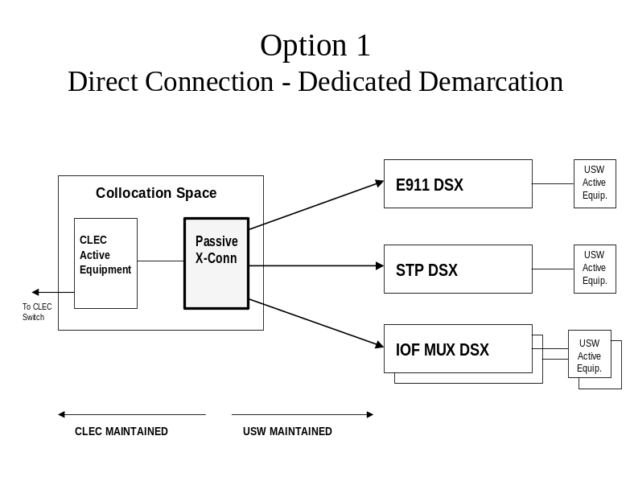
ATTACHMENT B - DEMARCATION OPTIONS

Option 2 – Direct Connection – Existing CenturyLink DSX

The second option is similar to CenturyLink’s existing ICDF offering. Since mid-1999, CenturyLink has been using its existing frames as ICDFs. In a building where this is the configuration, no “new” cross-connect serves collocators. In a building where a “new” ICDF configuration has been constructed near the collocated equipment, this option, like the first option, would need to deliberately bypass the “new ICDF.” Like the first option, this tie cabling would parallel the existing tie cabling now serving the ICDF. This option establishes the demarcation outside the Collocation space on a passive cross-connect device that would need to be accessible to all collocators’ technicians and CenturyLink technicians.

In offices where the ICDF is an existing CenturyLink DSX, the CLEC technician access to this DSX is the current practice. If a collocator wishes to arrange terminations on a 2-wire POTS level cross-connect device of the modular type, i.e., COSMIC Hardware, standard-engineering principles will apply. Provisioning intervals and costs will be customized and determined on an individual case basis (ICB). As shown with arrows at the bottom of the diagram below, a CLEC is responsible for repair and maintenance of the portion of the circuit to the left of the DSX. CenturyLink is responsible for repair and maintenance of the portion of the circuit to the right of the DSX. This option potentially establishes the demarcation a long distance away from the collocated equipment. In buildings (multi-story), the demarcation could be on a different floor from the collocated equipment. The cable between the demarcation and the collocator’s equipment would either be sold (not leased) by CenturyLink to the collocator, or provided by the collocator, owned by the collocator and only racked and terminated at the existing CenturyLink DSX by CenturyLink. The collocator would rack, terminate and repeater the same cable within the Collocation space. CenturyLink would provide the measurement of distance to the collocator early in Collocation construction processing.

Weaknesses
--Less secure termination
--No sharing of tie cabling between collocators in the same building
--Not provisioned before collocator places an order

Strengths
--Saves cost of one passive device

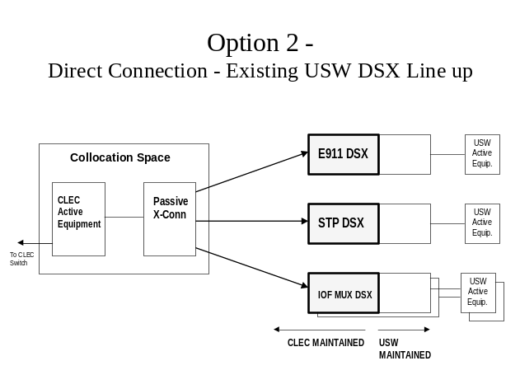

Option 3 – ICDF (Shared Access Configuration if Direct Connection is not requested)

The third option is CenturyLink’s existing InterConnection Distribution Frame (ICDF)/Interconnection Tie Pair (ITP) offering. This option establishes the demarcation outside the Collocation space on a passive cross-connect device that is accessible to all collocators’ technicians and CenturyLink technicians. As shown with arrows at the bottom of the diagram, a CLEC is responsible for repair and maintenance of the portion of the circuit to the left of the ICDF. CenturyLink is responsible for repair and maintenance of the portion of the circuit to the right of the ICDF. The cable between the ICDF and the collocator’s equipment is either sold (not leased) by CenturyLink to the collocator, or, as is more frequently the case, provided by the collocator, owned by the collocator and only racked and terminated at the ICDF by CenturyLink. The collocator racks and terminates the same cable within the Collocation space. CenturyLink provides the measurement of distance to the collocator early in Collocation construction processing.

Weaknesses
--Cost of the passive device
--Less secure termination

Strengths
--Proven and available offering
--Familiar demarcation for technicians
--Sharing of tie cabling between collocators in the same building
--Usually provisioned before collocator places an order
--Possible future interconnection between collaborating collocators

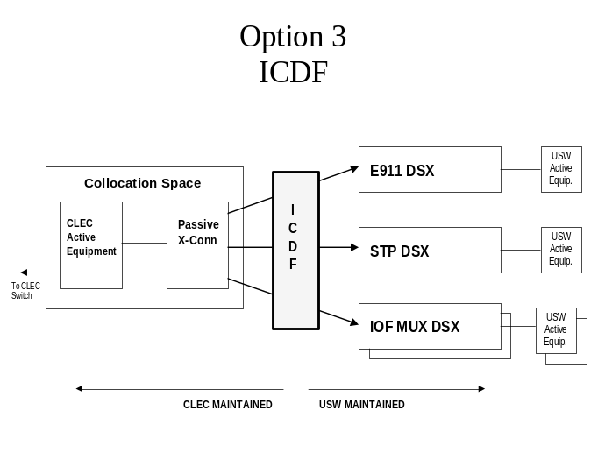

ATTACHMENT C - APOT FORM

APOT-ICDF
APOT-Virtual/Physical
APOT-Splitter in DLEC Site
APOT-Splitter Outside DLEC Site

ATTACHMENT D - CABLE NAMING CONVENTION
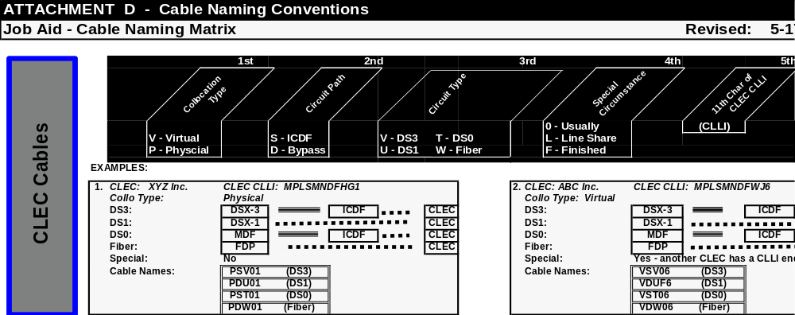
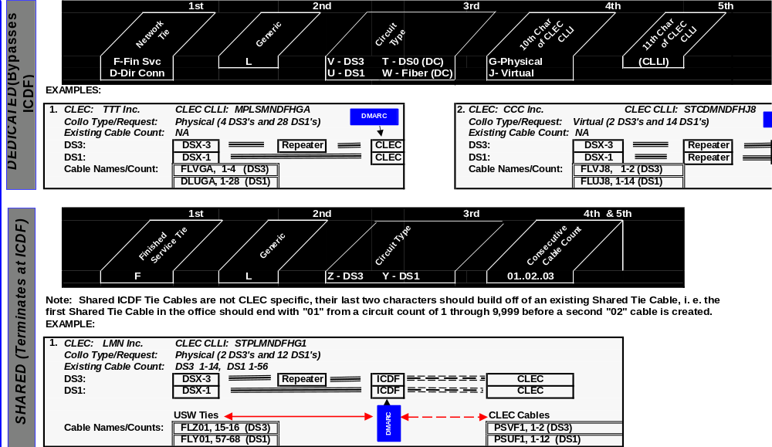
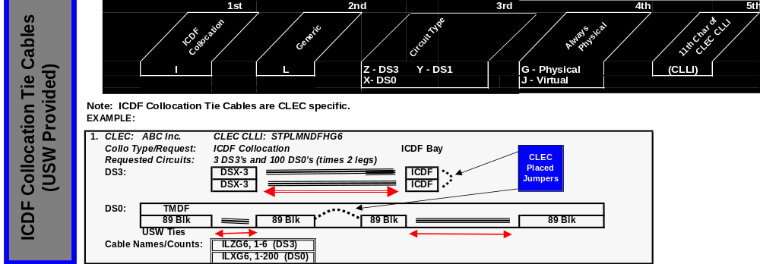

ATTACHMENT E - ACCESS SERVICE REQUEST (ASR)

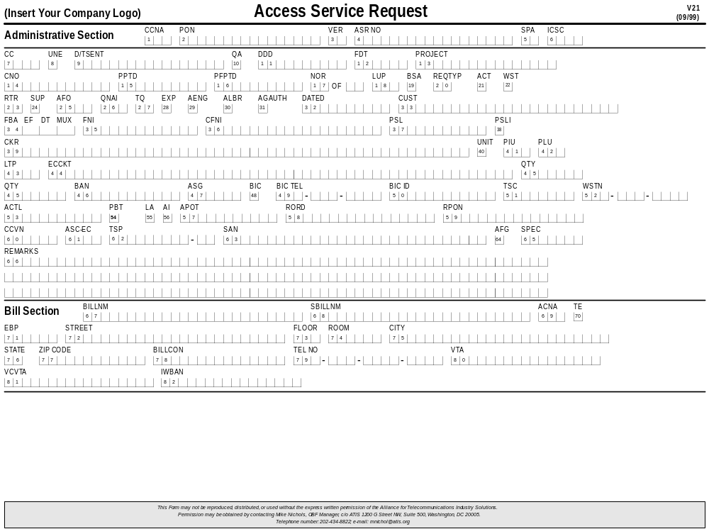
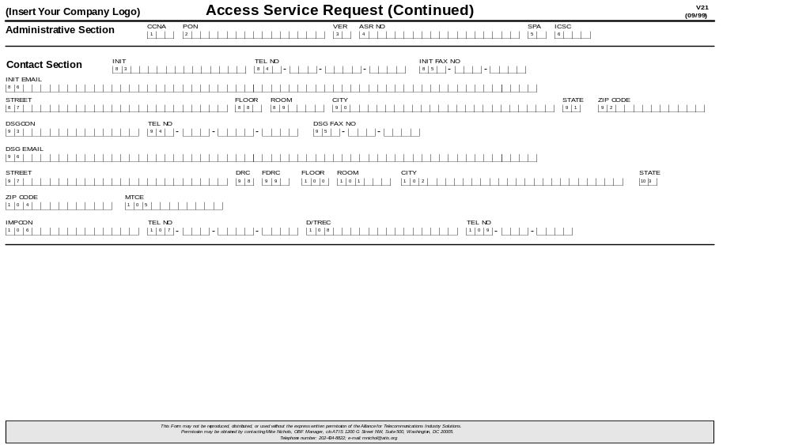
ATTACHMENT F -TRANSPORT FORM

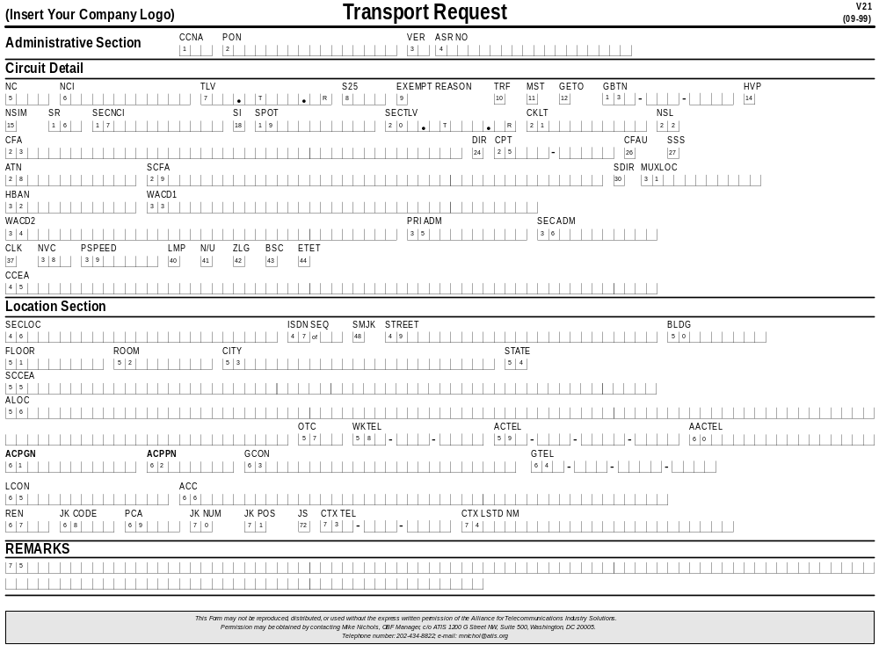
ATTACHMENT G - FIRM ORDER CONFIRMATION



