CLEC Performance Results Report
AND PAP PAYMENT CALCULATIONS

Requirements to access the report
To use the QPID system you need access to a browser and an Internet connection. Most of the commonly used browsers (Internet Explorer, Netscape, Mozilla, or Firefox) will work. There are no version level constraints on the QPID interface today, although it’s best to stay reasonably current with your browser version.
- Access Authorization
- Microsoft Excel (97 – 2003 Workbook or higher)

Certification to Access the Report
Users will need to gain Access Authorization with access to CenturyLink Protected Internet Delivery (QPID) by contacting their Service Manager.
If you currently have QPID access, you will need to verify that access includes the report posting site. The Access Authorization form is located at: http://www.centurylink.com/wholesale/clecs/electronicaccess.html Click on the MS Excel Downloads: “ECR Access Requests” and complete the form.
If you do not have CenturyLink access, please visit the following URL for Access Authorization Requirements and ordering instructions: http://www.centurylink.com/wholesale/systems/generalinfo.html. Click on “View information about Access to CenturyLink QC’s Systems.” and follow the instructions listed.

Additional Help with QPID application
All questions regarding content on the QPID site should be directed to the CLEC’s service manager. Users who have questions regarding the “availability” of the site or who wish to report trouble with the site can contact the Wholesale Systems Help Desk at 888-796-9102.

Supporting Documentation
The Qwest Government and Enterprise Metrics (QGEM) results reports and the 271 Performance Indicator Definitions (PID) can be found using an Internet browser at the following URL which will take you to the CenturyLink Protected Internet Delivery web site.
- http://qpid01.qwest.com/
At the top of the selection list, choose “Access the Secure Site at https://qpid01.qwest.com” to open the login page. Enter your ‘User ID’ and ‘Password’ to open the listing of all reports authorized under your specific login.
To access the Performance Results Reports click on the name of the report for an Excel version of the state or regional aggregate results. You will need Microsoft Office Excel to view these reports.
The Excel reports contain results for all states for the last 13 months. The naming convention for the aggregate CLEC report is 271_Exhibit(14_State_PID_Excel_ALL_MmmYY where Mmm equals 3 character month and YY equals 2 character year abbreviation. The naming convention for the CLEC-specific reports is 271_Exhibit(14_State_PID_Excel_XXX_RG where XXX equals a 3 character RSID Mmm equals a 3 character month and YY equals a 2 character year abbreviation.

Accessing the Report
Users can access individual CLEC reports by going to the following url and logging into the QPID system:
- https://qpid01.qwest.com/cgi-bin/index.exe
CLECs have the option to request adhoc reports of record level detail which are also posted to this website.

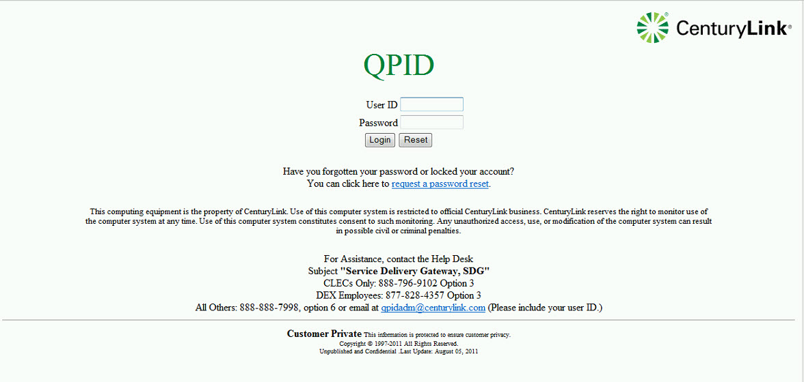

CLEC Name
Each individual login in is associated to the reports to which access is authorized for that login. Reports will be in alphabetical order.
You must be authorized to view these pages. If you see a page that says "not found", or have other problems accessing the reports, please contact your service manager.

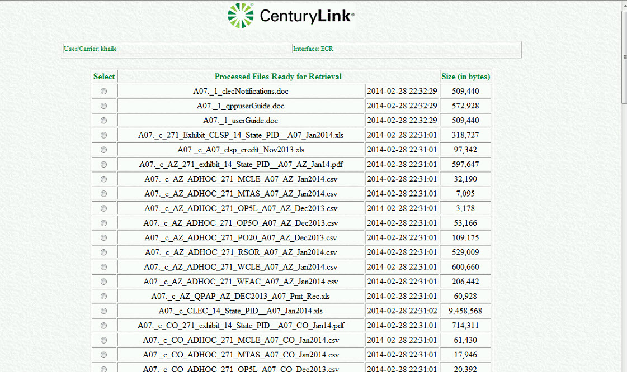

Understanding the Report
Reported measures are listed in the columns titled PID and PID Title (Column D and E) of the report. Measures that do not have data will not be reported. Contact your service manager regarding discrepancies in expected data vs. reported data.

Explanations For Reading Column Headings on Spreadsheets
The following are explanations of key components of the spreadsheets reported for either CenturyLink QC’s aggregate or CLEC-specific performance results.

NOTE: Due to the width of the actual spreadsheet, it has been split into three separate examples. Each spreadsheet example is followed by a description of each of the column headings for that section.

Spreadsheet, Example Part 1
Month | State | PID Category | PID | PID Title
November 2013 | CO | Billing | BI-2 | Invoices Delivered within 10 Days
November 2013 | CO | Billing | BI-3A | Billing Accuracy - Adjustments for Errors
November 2013 | CO | Billing | BI-3B | Billing Accuracy - Adjustments for Errors
November 2013 | CO | Billing | BI-4A | UNEs and Resale Aggregate
November 2013 | CO | Billing | BI-4B | Reciprocal Compensation (MOU):
November 2013 | CO | Database Updates | DB-1B | All
November 2013 | CO | Database Updates | DB-1C-1 | All
November 2013 | CO | Electronic Gateway Availability | GA-1 | Gateway Availability - LSR

Column heading definitions for Example Part 1
Month | Reporting month of data
State | State designation is in an abbreviated format (i.e. CO = Colorado) All state designations are postal abbreviations. States that are not under contract, or where there is no data, will not be listed on the reports
PID Category | PID Group of the Measurement reported
PID | 3 – 4 character Peformance Indicator Definition Abbreviation (PID)
PID Title | Performance Indicator Definition expanded title in Exhibit B

Spreadsheet, Example Part 2
Product Category | Standard | Benchmark | CLEC Numerator | CLEC Denominator | CLEC Result
All | Parity by Design | N/A |  |  | 100.00%
UNEs and Resale Aggregate | Diagnostic | N/A | 1,638,846 | 1,639,803 | 99.94%
Reciprocal Compensation | Diagnostic | N/A | 37,919 | 37,919 | 100.00%
UNEs and Resale Aggregate | Parity | N/A | 3,590 | 3,594 | 99.89%
Reciprocal Compensation | Diagnostic | N/A | 37,847 | 37,847 | 100.00%
LIDB | Parity by Design | N/A |  |  | 1.05
Directory Listing | Parity by Design | N/A |  |  | 0.16
IMAGUI | Diagnostic | N/A | 29,340 | 29,340 | 100.00%

Column heading definitions for Example Part 2
Product Category | Product where applicable or additional defining detail from Performance Indicator Definition in Exhibit B; e.g. In the PO-1 measurement, where pre-order query/response transaction time intervals are measuered, the Product Category column specifies which time interval is being reported.
Standard | PID standard from Exhibit B – Either parity, parity by design, benchmark or diagnostic .
Benchmark | Applicable fixed benchmark standard for the PID from Exhibit B if applicable
CLEC Num. or Numerator | The quantity meeting the criteria described in the performance indicator definition for the numerator of the formula for the measurement, dealing with services CenturyLink QC provides to CLEC(s). NOTE: for parity by design metrics there is no ability to identify CLEC specific numerator so this column is blank.
CLEC Denom. or Denominator | The sample size or number of events contributing to the measurement, as defined in the PID for the denominator in the formula, dealing with services CenutryLink provides to CLEC(s). NOTE: for parity by design metrics there is no ability to identify CLEC specific denominator so this column is blank.
CLEC Result or Result | The outcome of executing the formula calculation defined in the PID to represent the specified dimension of service performance provided to CLEC(s). NOTE: for parity by design metrics the result3 displayed in this column is the result of combined retail and wholesale activity for this measurement.

Spreadsheet, Example Part 3
CLEC Standard Deviation | CTL-Q Numerator | CTL-Q Denominator | CTL-Q Result | CTL-Q Standard Deviation | Modified Z Score | Parity Score
3.33% | 112,172 | 113,413 | 98.91% | 10.40% | -5.576654 | -4.390365

Column heading definitions For Example Part 3
CLEC Std. Dev | The CLEC standard statistical parameter representing the degree of variability of performance in the PID-specified dimension of the service (e.g., installation or repair) for the events measured in accordance with the PID. Standard deviations are generally reported where statistical methods will be used to evaluate the comparisons between performance for CLECs and for retail.
CTL-Q Num | The quantity meeting the criteria described in the performance indicator definition (PID) for the numerator of the formula for the measurement, dealing with services CenturyLink QC provides to retail customers or, as specified, to "itself" (e.g., for network components used in providing retail service, as stated in the PID). NOTE: for parity by design metrics there is no ability to identify CTL-Q specific numerator so this column is blank. When there is no retail comparative for a metric this column is blank..
CTL-QDenom | The sample size or number of events contributing to the measurement, as defined in the PID for the denominator in the formula, dealing with services CenturyLink QC provides to retail customers or, as specified, to "itself" (e.g., for network components used in providing retail service, as stated in the PID). NOTE: for parity by design metrics there is no ability to identify CTL-Q specific denominator so this column is blank. When there is no retail comparative for a metric this column is blank.
CTL-Q Result | The outcome of executing the formula calculation defined in the PID to represent the specified dimension of service performance provided to retail customers. NOTE: for parity by design metrics there is no ability to identify CTL-Q specific result so this column is blank. When there is no retail comparative for a metric this column is blank.
CTL-Q Std. Dev | The CTL-Q standard statistical parameter representing the degree of variability of performance in the PID-specified dimension of the service (e.g., installation or repair) for the events measured in accordance with the PID. Standard deviations are generally reported where statistical methods will be used to evaluate the comparisons between performance for CLECs and for retail. NOTE: When there is no retail comparative for a metric this column is blank.
Modified Z-Score | This is either a modified z-score, based on the ILEC variance, for the difference between CLEC and retail results reported in the table, calculated using standard statistical methods, or, if a permutation or exact proportions test is run on the data, it is the z-score equivalent of the calculated p-value for the statistical test.
Parity Score | A numeric indication of whether the reported difference in results is statistically significant based on the z-score and a critical value. Often, the critical value is 1.645, but in certain instances a different critical value is used, as specified in the PAP . A positive Parity Score means the result is statistically significant and, if the critical value is 1.645, statistically significant at the 95 percent confidence level. A negative Parity Score means the result is not statistically significant at the 95 percent confidence level, if the appropriate critical value is 1.645
Where there is no retail comparison reported, the spreadsheet only reports the result representing the service performance as provided to CLEC(s).
If a month or measurement is not shown on the spreadsheet, it means that there was no activity to be reported under the specified measurement in the reporting month.

Printing/Saving the Report
Print as a normal Excel file by clicking on the printer icon or selecting 'Print' from the 'File' drop down menu. NOTE: the spreadsheet columns exceed the standard page width so each row will print across multiple pages.
You may also choose to save the report to a different drive. Select 'Save As' from the 'File' drop down menu. Select the drive you wish to save the report to, name it, and select 'OK'.
Each report will be available until the next cycle replaces it; for example, Feb 01 replaces Jan 01.
These reports will be used to determine the PAP payment calculations. Payment calculations will also be available to view at this website.

PAP Payment Calculations

The PAP payment calculations are in Excel workbooks beginning with “P271_PAP_SUMCLEC”. There is one report for each CLEC for each month, covering all states in which there was PAP activity for the month. Each workbook contains two worksheets. The worksbooks can be printed and saved to local disk drives.

Explanations For Reading Column Headings on Spreadsheets
The following are explanations of key components of the spreadsheet reporting PAP payment calculations.
The worksheet marked “SUMMARY” is a summary of payments to the CLEC by state, PID and product. Spreadsheet Example 1 – Summary Tab
State | CLEC | Date | PID | Product | Current Month  Payment | Incremental Rerun  Payment | Interest
ND | XXX | 03/01/2014 | OP-4 | UBL_DS1 | 259 | 0 | 0

Column heading definitions for Example 1 – Summary Tab
State | State designation is in an abbreviated format (i.e. CO = Colorado) All state designations are postal abbreviations. States that are not under contract, or where there is no data, will not be listed on the reports
CLEC | 3 character RSID
Date | Performance month for which the payment is being made
PID | 3 – 5 character Peformance Indicator Definition Abbreviation (PID)
Product | The service type disaggregation. All service disaggregations are listed in the Exhibit B or Exhibit K of the SGAT.
Current Month Payment | Total payment to the CLEC for each state/PID/product combination for the data month in the “Date” column
Incremental Rerun Payment | Total payment for each state/PID/product combination for data months prior to the “Date” column date
Interest | Interest payments on the incremental rerun payments

The worksheet marked “PAP_DTL” lists the detailed performance and payment calculation fields for each measurement that generated a payment. The following fields are in the PAP_DTL worksheet:

NOTE: Due to the width of the actual spreadsheet, it has been split into three separate examples. Each spreadsheet example is followed by a description of each of the column headings for that section.
Spreadsheet Example 1 – PAP_DTL Tab
State | CLEC | Date | PID | Product | Parity or  Benchmark  Measure | CLEC  Numerator | CLEC  Volume | CLEC  Result
ND | XXX | 03/01/2014 | OP-4E | UBL_DS1 | B | 26 | 3 | 8.67

Column heading definitions for Example 1 – PAP_DTL Tab
State | State designation is in an abbreviated format (i.e. CO = Colorado) All state designations are postal abbreviations. States that are not under contract, or where there is no data, will not be listed on the reports
CLEC | 3 character RSID
Date | Performance month for which the payment is being made
PID | 3 – 5 character Peformance Indicator Definition Abbreviation (PID)
Product | The service type disaggregation. All service disaggregations are listed in the Exhibit B or Exhibit K of the NTA.
Parity or Benchmark Measure | P means the sub-measurement’s performance standard is parity; B means the sub-measurement’s performance standard is a benchmark.
CLEC Numerator | The numerator of the formula specified by the PID for the purpose of calculating the performance level provided to the CLEC by CenturyLink QC.
CLEC Volume | The denominator of the formula specified by the PID for the purpose of calculating the performance level provided to the CLEC by CenturyLink QC. The denominator is generally the relevant CLEC business volume for the activity measured by the PID.
CLEC Result | The performance level provided to the CLEC by CenturyLink QC, calculated pursuant to the formula specified in the PID.

Spreadsheet Example 2 – PAP_DTL Tab
CTL-Q  Numerator | CTL-Q  Volume | CTL-Q  Result | Statistical  Critical  Value | Z-Score | Standard  Result | Misses | Non-Conformance  Payment Level | Payment  Level
 |  |  | . | . | 5.5 | 1.727273 | L1 | 1

Column heading definitions for Example 2 – PAP_DTL Tab
CTL-Q Numerator | The numerator of the formula specified by the PID for the purpose of calculating the performance level provided by CenturyLink QC to its retail operations. NOTE: When there is no retail comparative for a metric this column is blank.
CTL-Q Volume | The denominator of the formula specified by the PID for the purpose of calculating the performance level provided by CenturyLink QC to its retail operations. The denominator is generally the relevant CenturyLink QC retail business volume for the activity measured by the PID. NOTE: When there is no retail comparative for a metric this column is blank.
CTL-Q Result | The performance level provided by CenturyLink QC to its retail operations, calculated pursuant to the formula specified in the PID. NOTE: When there is no retail comparative for a metric this column is blank.
Statistical Critical Value | The critical value if appropriate (i.e., a parity measure)
Z-Score | The statistical z-score parity test, calculated as specified in Exhibit K from either a modified z-test or permutation test. If the Z-Score is greater than the Statistical Critical Value, the measurement is missed. NOTE: When there is no retail comparative for a metric this column is blank.
Standard Result | The result that is required to meet the benchmark or parity standard for the measurement
Misses | This is the number of occurrences calculated according to Exhibit K, used in calculating the payment
Non-Conformance Payment Level | CenturyLink QC’s performance levels delivered to CLEC as defined in Section 6.0 (Exhibit K) for a payment-eligible submeasurement
Payment Level | This is the payment escalation level, and determines whether the per miss payment amount will be escalated from the base payment determined by the non-conformance payment level and/or the payment amount

Spreadsheet Example 3 – PAP_DTL Tab
Per Miss  Payment Amt | Payment  Amount | Incremental  Amount | Interest  Amount | Total  Payment
150 | 259 | 0 | 0 | 259

Column heading definitions for Example 3 – PAP_DTL Tab
Per Miss Payment Amount | Based on non-conformance payment level and payment level, the per miss payment amount is multiplied by misses to get the payment amount
Payment Amount | Generally this is equal to misses multiplied by Per Miss Payment Amount
Incremental Amount | If the measurement is a recalculation of a prior month’s payment, this column represents the additional payment due (or, if negative, a payment amount to be recovered.)
Interest Amount | This is the interest payment on any positive incremental payment
Total Payment | Total of Payment Amount, Incremental Amount and Interest Amount

PAP Payment Reconciliation Report
The PAP payment reconciliation reports are in Excel workbooks with the file pattern “QPAP_state_date_CLEC_Pmt_Rec.” There is one report for each CLEC for each state in which a payment was due.

CenturyLink - QC PERFORMANCE ASSURANCE PLAN (PAP)
Monthly Payment Reconciliation Report
CLEC ID | XXX
CLEC Name | XXXXXXXXXXX
State | SS
Date | Month Year
Serial No. | PAPSSMMYY_XXX
Payment Amount |  |  | $ XXX.00
Prior Month Adjustment Amount |  |  | $ -
Interest Associated with Prior Month Adjustment |  |  | $ -
Sub Total Payment |  |  | $ XXX.00
Carry forward of negative Total Payment amount from prior month. |  |  | $ -
Total Payment |  |  | $ XXX.00
Note, negative Total Payment amounts will be used to offset future Total Payment amounts.
See table below for payments by bill credit and/or check or EFT.

BAN/BTN | Invoice | Method of Credit | Amount | Adjustment Number
XXX XXX-XXXX XXX | 14019 | adj in iabs | $ XXX.00 | XXXXXXXXXX
1. Total Credits Posted to BAN/BTN |  |  | $ XXX.00
2. Payment Amounts via Check/EFT |  |  | $ -
3. Grand Total Credits and Check/EFT Pmts (L1 + L2) |  |  | $ XXX.00

These worksheets can be printed and the workbooks can be saved to local disk drives. If a payment due was reduced due to an overpayment in a prior month, this report will display this information. Also, if payments were made by bill credits, the BAN/BTN information will be displayed.

