CONTENTS
Chapter and Section Page
5. Technical Specifications Unbundled Digital Loops 5-1
5.1 General 5-1
5.2 Unbundled Digital Data Services (DDS) Capable Loop 5-1
5.3 Unbundled Integrated Services Digital Network (ISDN) Basic Rate Interface (BRI) Capable Loop 5-2
5.4 Unbundled xDSL-I Capable Loop 5-4
5.5 Testing Unbundled ISDN BRI Capable Loop) and Unbundled xDSL-I Capable Loop
5-6
5.7 Unbundled DS3 Capable Loop 5-7
Figures
5-1 Typical Unbundled DDS Capable Loop 5-1
5-2 Typical Unbundled DSL Capable Loop 5-3
5-3 Typical Unbundled xDSL-I Capable Loop 5-5
5-4 Typical Unbundled DS1 Capable Loop. 5-7
5-5 Typical Unbundled DS3 Capable Loop. 5-8

5. Technical Specifications Unbundled Digital Capable Loops

5.1 General
An Unbundled Digital Capable Loop is a digital transmission path that runs from a CenturyLink central office (CO) building (from a main distribution frame, DSX or other suitable frame called the Central Office Network Interface [CO-NI]) to an End-User Network Interface (EU-NI). The EU-NI is located at the EU’s designated premises within the serving area of the CenturyLink CO. The EU-NI is typically a Network Interface Device or NID. The NID divides the CenturyLink facility and the EU’s customer installation, i.e., inside wiring and customer premises equipment.
Integrated Services Digital Network Basic Rate Interface Capable Unbundled Loop (ISDN BRI Capable Loop) and Unbundled Local Loop Digital Subscriber Line - Integrated Services Digital Network (xDSL-I Capable Loop) refer to the same physical facility capabilities. The terms ISDN BRI Capable Loop and xDSL-I Capable Loop may be used interchangeably in the context of loop qualification or facility capabilities. Likewise, the loop make-up information in the Raw Loop Data (RLD) Tool will indicate the same physical make-up for ISDN BRI or xDSL-I requests. The difference between ISDN BRI and xDSL-I is that each can require specific transmission equipment in the central office to generate the appropriate signal. Although the facilities offer the same payload (144 kbps), the equipment causes the distinction in the signal (i.e., ISDN = 2B+D channelized signal vs. x-DSL-I = full payload unchannelized signal). ISDN BRI Capable Loops and xDSL-I Capable Loops will be conditioned when requested by the CLEC, consistent with the CLEC’s interconnection agreement.

5.2 Unbundled Digital Data Services (DDS) Capable Loop
An Unbundled Digital Data Services (DDS) Capable Loop is based on ANSI Standard T1.410, Carrier-to-Customer Metallic Interface - Digital Data at 64kbps and Subrates, and operates at 64 kbit/s and subrates of 2.4, 4.8, 9.6, 19.2, and 56 kbit/s. It is a digital transmission path that runs from a CenturyLink Central Office, CO-NI to the EU-NI located at the EU’s designated premises within the serving area of the CenturyLink CO. Secondary channels may be transmitted with any subrate. A carrier gains access to these unbundled services at the CenturyLink CO through established Physical or Virtual Collocation arrangements
Characteristics associated with an Unbundled DDS Capable Loop interface as defined are 4-wire, conform to ANSI T1.410, and are nominally 2.4, 4.8, 9.6, 19.2, 56, and 64 kbit/s. See Technical Publication 77204, Digital Data Service Product Description, Applications, and Interface Combinations for performance, testing and additional details. Figure 5-1 illustrates a typical DDS Capable Loop configuration.

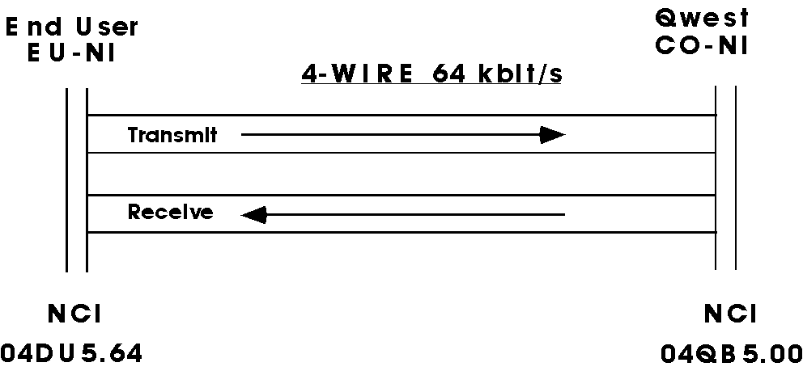
Figure 5-1: Typical Unbundled DDS Capable Loop

5.3 Unbundled Integrated Services Digital Network (ISDN) Basic Rate Interface (BRI) Capable Loop
The ISDN BRI Capable Loop is a CenturyLink facility with two-wire interfaces that provides connectivity from the CenturyLink serving Central Office Network Interface (CO-NI), generally a Distributing Frame (DF) to a Network Interface at the end user's location (EU-NI). The EU-NI is typically a Network Interface Device or NID. The NID divides the CenturyLink facility and the EU’s customer installation, i.e., inside wiring and customer premises equipment. This loop will meet the design requirements for ISDN BRI standards of 144 kbps customer useable data capacity that is channelized as 2B + D. The transmission path’s facility is consistent with Bellcore Technical Reference, TR-TSY-00393, ISDN Basic Access Digital Subscriber Lines and ANSI T1.601.1992, Telecommunications - Integrated Services Digital Network (ISDN) Basic Access Interface for Use on Metallic Loops for Application on the Network Side of the NT (Layer 1 Specification). The ISDN BRI Capable Loop may be conditioned when requested by the CLEC. They terminate using digital interfaces.
The ISDN BRI Capable Loop shall have one of the following configurations:
- Copper loop free of load coils that is technically qualified for ISDN BRI transmission without the need for additional equipment. A loop is qualified when its Expected Measured Loss (EML) is less than or equal to 40 dB at 40 kHz and its Actual Measured Loss (AML) is less than or equal to 42 dB at 40 kHz. Loss measurements will use 135 Ohm terminations.
- A Central Office based range extension unit with a long, copper loop free of load coils.
- A combination of a long, copper loop free of load coils, a mid-span regenerator and Central Office power unit.
- A combination of Subscriber Loop Carrier transmission paths and a qualified copper loop free of load coils.
There are some end user locations served by loop facilities and transmission equipment that are not compatible with the ISDN BRI technical requirements. CenturyLink shall process requests for ISDN BRI loop to these locations on an Individual Case Basis.
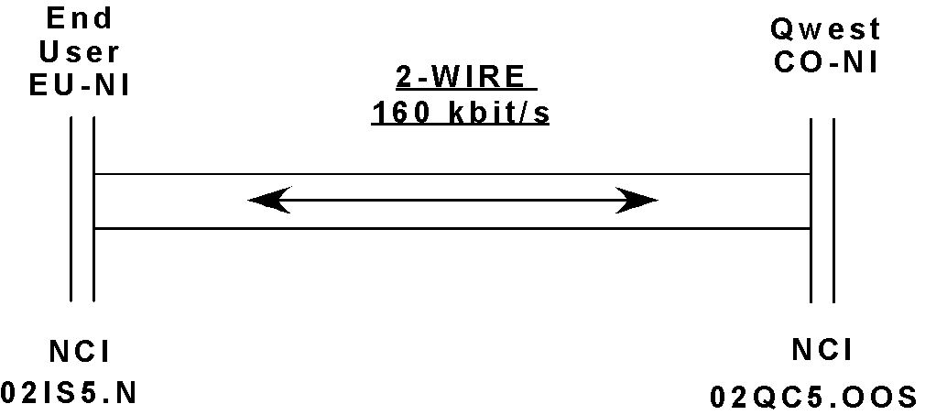Figure 5-2 illustrates a typical 2-Wire, Unbundled ISDN BRI Capable Loop configuration.
NC Code = AD--
Figure 5-2: Typical Unbundled ISDN BRI Capable Loop

5.4 Unbundled xDSL-I Capable Loop
The xDSL-I Capable Loop is a CenturyLink facility with two-Wire interfaces that provides connectivity from the CenturyLink serving Central Office Network Interface (CO-NI), generally a Distributing Frame (DF) to a Network Interface at the end user's location (EU-NI). The EU-NI is typically a Network Interface Device or NID. The NID divides the CenturyLink facility and the EU’s customer installation, i.e., inside wiring and customer premises equipment. This loop will meet the design requirements for Digital Subscriber Loop standards of 144 kbps customer useable data capacity that is not channelized. The transmission path’s facility is consistent with Bellcore Technical Reference, TR-TSY-00393, ISDN Basic Access Digital Subscriber Lines and ANSI T1.601.1992, Telecommunications - Integrated Services Digital Network (ISDN) Basic Access Interface for Use on Metallic Loops for Application on the Network Side of the NT (Layer 1 Specification). The xDSL-I Capable Loop may be conditioned when requested by the CLEC. Additionally, the facility is consistent with Bellcore Technical Reference, TR-NWT-000397. ISDN Basic Access Transport System Requirements, with the exception of all forms of access and use of the M1, M2 and M3 overhead bits. xDSL-I Capable Loops terminate using digital interfaces.
The xDSL-I Capable Loop shall have one of the following configurations:
- xDSL-I capable copper loop free of load coils that is technically qualified for BRI ISDN transmission without the need for additional equipment.
- A combination of a long xDSL-I capable copper loop free of load coils, a mid-span regenerator and Central Office power unit.
- A combination of Subscriber Loop Carrier transmission path and a qualified xDSL-I capable copper loop free of load coils.
There are some end user locations served by loop facilities and transmission equipment that are not compatible with the xDSL-I technical requirements. CenturyLink shall process requests for xDSL-I Capable Loop to these locations on an Individual Case Basis.
Figure 5-3 illustrates a typical 2-Wire, x DSL-I Capable Loop configuration.

NC Code = ADU-
Figure 5-3: Typical Unbundled xDSL-I Capable Loop

5.5 Testing Unbundled ISDN BRI Capable Loop) and Unbundled xDSL-I Capable Loop
These tests are done for bringing a circuit into service, either on completion of a new installation (acceptance) or after repair activity (repair verification). These are intrusive, out-of-service tests. In addition to tests that assure the facility is trouble free; an Actual Measured Loss (AML) test at 40 kHz shall be made.
The circuit under test shall be properly designed, having an Expected Measured Loss (EML) that is equal to or less than 40 dB at 40 kHz. The Actual Measured Loss (AML) at 40 kHz shall be less than or equal to 42 dB.
5.6 Unbundled DS1 Capable Loop
The Unbundled DS1 Capable Loop is a transmission path between a CO Network Interface at a DSX-1 panel or equivalent in a CenturyLink serving Central Office and the Network Interface at the end user location. The Unbundled DS1 Capable Loop transports bi-directional DS1 signals with a nominal transmission rate of 1.544 Mbit/s.
Unbundled DS1 Capable Loop will typically have one of the following configurations:
- Copper based span with HDSL or T-1 equipment.
- Transmission path of a fiber based system
- Combination of both fiber and copper based facilities.
There are some end user locations served by facilities and transmission equipment that are not compatible with DS1 transport technical requirements. CenturyLink shall process requests for Unbundled DS1 Capable Loop for these locations on an Individual Case Basis.
End User Network Interfaces shall be as described in Technical Publication 77375. The CO Network Interface at a DSX-1 panel may not be the physical, demarcation interface to the collocated Competitive Local Exchange Carrier (CLEC). The DSX-1 cross-connect may be the "Design-To" point as detailed in Technical Publication 77386, Interconnection and Collocation for Transport and Switched Unbundled Network Elements and Finished Services. The NCI code applied at the point of demarcation is 04QB9.11. An Interconnection Distribution Frame (ICDF) is commonly the point of demarcation. See Technical Publication 77386 for details. This code indicates that the signal is not necessarily a templated signal per ANSI T1.102. It may be attenuated, in one direction, by the length of cable from the CenturyLink DSX-1 and, in the other direction, by the length of cable from the CLEC's equipment. Performance shall meet end-to-end accuracy and availability objectives stated in ANSI Document T1.510-1999, Network Performance Parameters for Dedicated Digital Services.
Figure 5-4 illustrates a typical Unbundled DS1 Capable :Loop configuration.
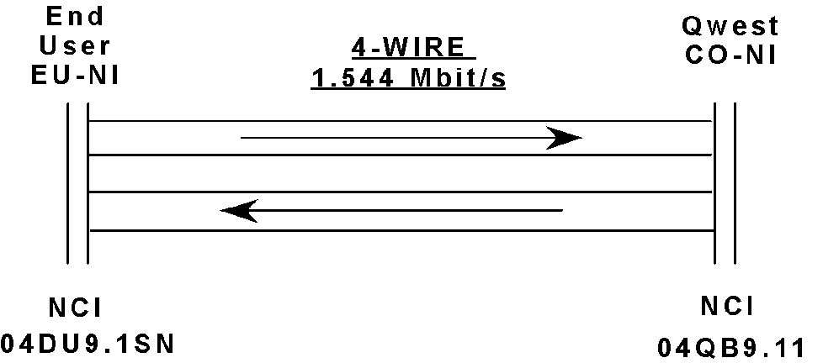

Figure 5-4: Typical Unbundled DS1 Capable Loop.

5.7 Unbundled DS3 Capable Loop
The Unbundled DS3 Capable Loop is a transmission path between a CO Network Interface at a DSX-3 panel or equivalent in a CenturyLink serving Central Office and the Network Interface at the end user location. The Unbundled DS3 Capable Loop transports bi-directional DS-3 signals with a nominal transmission rate of 44.736 Mbit/s. CenturyLink will deliver the DS3 service to the End User’s network interface consistent with Technical Publication 77324.
Unbundled DS3 Capable Loops will typically have the following configuration:
- Channel of a fiber based system
There are some end user locations served by loop facilities and transmission equipment that are not compatible with DS3 transport technical requirements. CenturyLink shall process requests for Unbundled DS3 Capable Loop for these locations on an Individual Case Basis.
Network Interfaces shall be as described in Technical Publication 77324. The CO Network Interface at a DSX-3 panel may not be the physical, demarcation interface to the collocated Competitive Local Exchange Carrier (CLEC). The DSX-3 cross-connect may be the "Design-To" point as detailed in Technical Publication 77386, Interconnection and Collocation for Transport and Switched Unbundled Network Elements and Finished Services. The NCI code applied at the point of demarcation is 04QB6.33. An Interconnection Distribution Frame (ICDF) is commonly the point of demarcation. See Technical Publication 77386 for details. This code indicates that the signal is not necessarily a templated signal per ANSI Standard T1.102. It may be attenuated, in one direction, by the length of cable from the CenturyLink DSX-3 and, in the other direction, by the length of cable from the CLEC's equipment. Performance shall meet end-to-end accuracy and availability objectives stated in ANSI Standard T1.510, Network Performance Parameters for Dedicated Digital Services.
Figure 5-5 illustrates a typical Unbundled DS3 Capable Loop configuration.

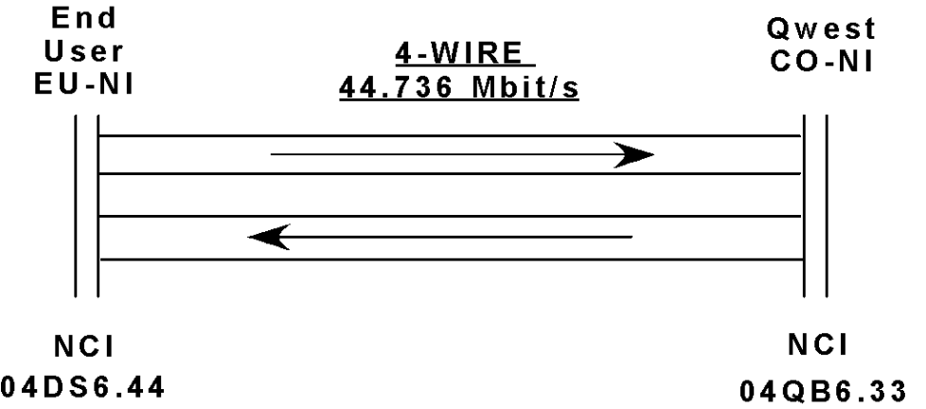

Figure 5-5: Typical Unbundled DS3 Capable Loop.

