Contents
13 Raised Floor Environments 13-2
13.1 Raised Floor Structure 13-3
13.1.1 Stringer-Less Raised Floors 13-4
13.1.2 Stringered Raised Floors 13-4
13.1.3 Structural Platforms 13-6
13.2 Equipment Layout Requirements 13-7
13.2.1 Equipment Aisle Spacing 13-7
13.2.2 Equipment Mounting 13-8
13.3 Engineering Requirements - Cable Distribution Systems 13-11
13.3.1 Cable Rack Requirements 13-11
13.3.2 Fiber Protection Systems –FPS (Fiber Duct) 13-11
13.3.3 Cabling Requirements 13-12
13.4 Grounding Requirements 13-13
13.4.1 Ground Bars 13-13
13.4.2 Ground Cabling 13-14

FIGURES
FIGURE 13.1 Stringer Raised Floor 13-4
FIGURE 13.2 Structural Platform 13-6
FIGURE 13.3 Equipment Lineups in a Raised Floor Environment 13-7
FIGURE 13.2 Equipment Mounting in Light Seismic Zone 13-8
FIGURE 13.4 Equipment Mounting in Heavy Seismic Zone 13-10

TABLES
TABLE 13.1 Raised Floor – Panel Design Support Limits 13-4

Raised Floor Environments
Raised floors typically provide an under-floor space for use either as an air plenum and/or a cable distribution system in support of network and data equipment.
This chapter provides generic requirements for raised floor systems and is not to be construed as a suggestion to modify or change any product requirements provided by the raised floor manufacturer’s specifications.
Engineering requirements associated with cable rack, fiber protection system, and cabling in an overhead environment shall adhere to the requirements outlined in other chapters of this document. Engineering requirements associated with placement under a raised floor environment are included in this chapter.
- Overhead cable rack and air distribution should be considered as the first choice when establishing a new area before considering a raised floor environment.
- Overhead cable rack and under-floor air distribution shall be considered as the standard design when establishing a new raised floor environment.
- New raised floor environments shall be limited for deployment with 7 foot framework and cabinets and shall avoided when requiring frameworks and/or cabinets taller than 7 feet. Taller frameworks and cabinets may contribute to potential overloading of the raised floor structure.
- Raised floors may be required as an alternative for providing overhead cable racking and/or overhead air distribution where site conditions limit overhead clearances, or additional cooling capacity is required. This determination is made through a coordination of the Real Estate project manager and the CenturyLink Planner or Design Engineer.
- Determination of the height required in a raised floor environment is dependent on several factors:
  - Site location including location within the building (floor and room).
  - Expected equipment structural (lb/s.f.), power (watts/s.f.) and heat dissipation loadings.
  - Cable rack placement – above frameworks and cabinets or under the floor.
  - Existing floor to ceiling clearance and the amount of building mechanical/electrical piping or conduit that could obstruct air flow or cable installations.
  - Aisle and egress including doors and ramp locations.
  - National, State, and Local requirements
- Coordination between CenturyLink Network Planner/Engineer, Real Estate Project Manager, Construction Project Manager, Facility Operations Manager and Design Consultants may be necessary to ensure proper design of the raised floor environment that meets the above requirements and optimizes the available floor space and balances capital costs and schedule constraints along with future operating expenses.

13.1 Raised Floor Structure
There are many types of commercially available floors that offer a wide range of structural strength and loading capabilities depending on the component construction and materials. The three general types of raised floor environments include: stringer-less, stringered, and structural platform. The height of these floors may vary, but the preferred pedestals are arranged in a 2-foot by 2-foot grid pattern to accept the floor tiles/panels.
- Raised floor material shall be comprised of non-combustible, CenturyLink Corporate Real Estate approved material.
- Floor panels containing bare galvanized steel pans shall not be used. Exposed galvanized metal may cause “zinc whiskers” on electronic circuits, leading to premature failure.
- Raised floors will require special engineering design to account for increased lateral loads.
- Finished floor heights are typically provided at 6 inches, 12 inches, 18 inches or 24 inches depending on under-floor clearance required. Increased raised floor heights may be necessary based on cooling and structural requirements.
- Panel size shall be a nominal 24 inches by 24 inches.
- Cutouts in panels shall not exceed 1/4 of the total panel surface.
- Floor panels supporting equipment shall be designed for the following weight requirements:

TABLE 13.1 Raised Floor – Panel Design Support Limits
 | Seismic Zone
 | Light | Heavy
Supporting Equipment  Minimum Concentrated Load (on 1 square inch)  Ultimate Load | 1500 lbs  4500 lbs | 3000 lbs  9000 lbs
Equipment Aisles  Minimum Concentrated Load (on 1 square inch)  Ultimate Load | 1500 lbs  4500 lbs | 1500 lbs  4500 lbs
Supporting Equipment -Rolling Load | 1500 lbs | 2000 lbs
Equipment Aisles -Rolling Load | 1500 lbs | 1500 lbs

- Raised floor environment shall be engineered for a minimum design floor loading of 110 lbs/sqft. This includes all necessary equipment, frameworks, cabinets, lighting, etc that will be placed on the raised floor environment. In no case shall the raised floor environment floor loading exceed the design floor loading of the sub-floor.
- In addition to the equipment, framework/cabinets, cable rack and cabling, raised floor component weights (floor panels, floor tiles, pedestals, etc) must be taken into consideration when determining the floor loading on the sub-floor.
- Panels shall be permanently marked with a stencil or color coding, indicating the manufacturers name, load rating, and the manufacture date.

Stringer-Less Raised Floors
This arrangement consists of an array of pedestals that provide the necessary height for routing cables and also serve to support each corner of the floor panels. This type of system provides maximum accessibility to the space under the floor, but is significantly weaker than stringered raised floors in supporting lateral loads, and are not recommended.

Stringered Raised Floors
This arrangement generally consists of an array of vertical steel pedestal assemblies, each comprised of a steel base plate, tubular upright and an adjustable head for leveling.
- Pedestals are generally installed in uniform grid size based on tile size and shall be fastened to the concrete floor.
- A matrix of horizontal steel stringers span across the top of the pedestal heads in orthogonal directions.
- The stringers are fastened to each pedestal head to form an interlocking design.
- Stringers and pedestals are used to support the floor tiles.
- Shorter stringers may be used in aisles and in areas along walls or columns where less strength is required.
FIGURE 13.1 Stringer Raised Floor
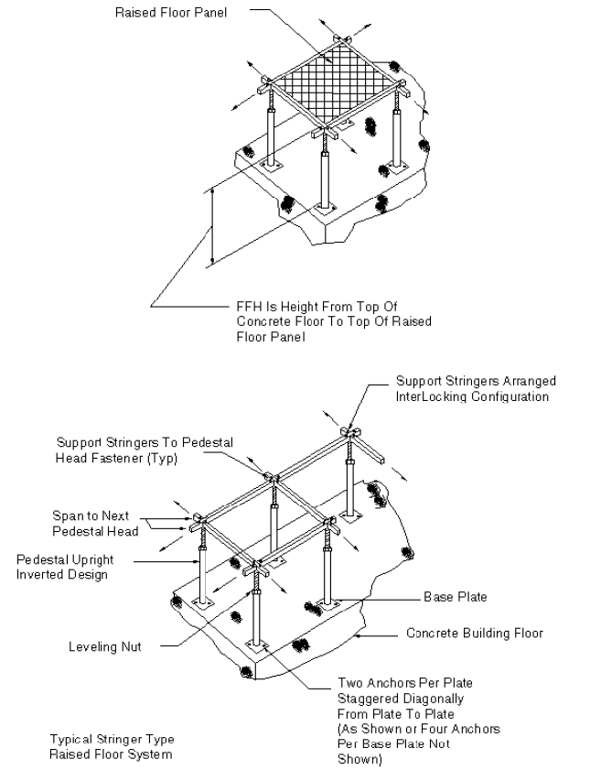

Structural Platforms
This arrangement consists of members constructed of steel angles or channels that are welded or bolted together to form a platform for supporting equipment. Structural platforms may or may not contain panels or stringers.
- Steel members are bolted or welded together and supported by pedestals with leveling feet.
- Steel plate floor panels are mounted to the steel members.

FIGURE 13.2 Structural Platform
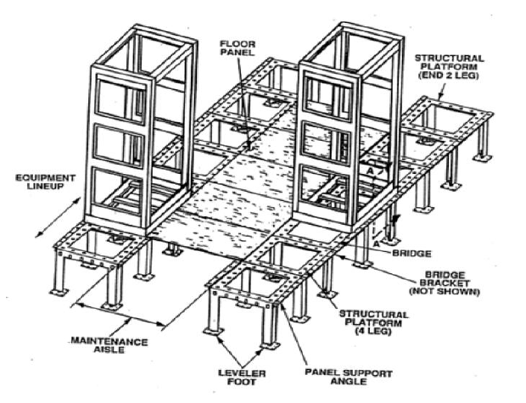

13.2 Equipment Layout Requirements
Raised floor environments may require access to the sub-floor for either cable distribution management or air distribution. As a result, it is necessary to provide an equipment layout that does not interfere with access.

Equipment Aisle Spacing
Equipment aisle spacing is primarily dicated by the size of floor tiles, but shall not be planned or engineered to less than the minimum aisle spacing standards outlinded in Chapter 2, Section 2.2.
- Equipment lineups shall be located so the front and rear aisle floor tiles can be removed for access. This will usually result in the front or rear of a bay aligning with a tile seam.
- Equipment lineups shall not be planned or engineered where they cross a tile seam, preventing the removal of floor tiles and blocking convenient access beneath the raised floor.
FIGURE 13.3 Equipment Lineups in a Raised Floor Environment
- Column stanchions shall be engineered along a tile seam wherever possible.
- Aisle floor panels must be fully accessible from the floor grid to facilitate access to the area below.

Equipment Mounting
All raised floor types shall be level prior to equipment installation. Raised floors not uniformly flat (greater than 1/32 inch difference between adjacent tiles) shall be brought into compliance prior to installation.

- Framework and cabinets may be secured to the raised floor environment using one of the following methods:
  - Threaded rod into the concrete floor.
  - Bolted into unistrut or u-channel mounted perpendicular to the equipment lineup under floor stringers and under floor tiles per raised floor manufacturer requirements.
  - Bolted directly to a steel equipment platform system per raised floor manufacturer requirements.
- Various methods may be deployed to secure framework and/or cabinets to the floor. The installation service provider shall verify the approved method prior to installation.

FIGURE 13.2 Equipment Mounting in Light Seismic Zone
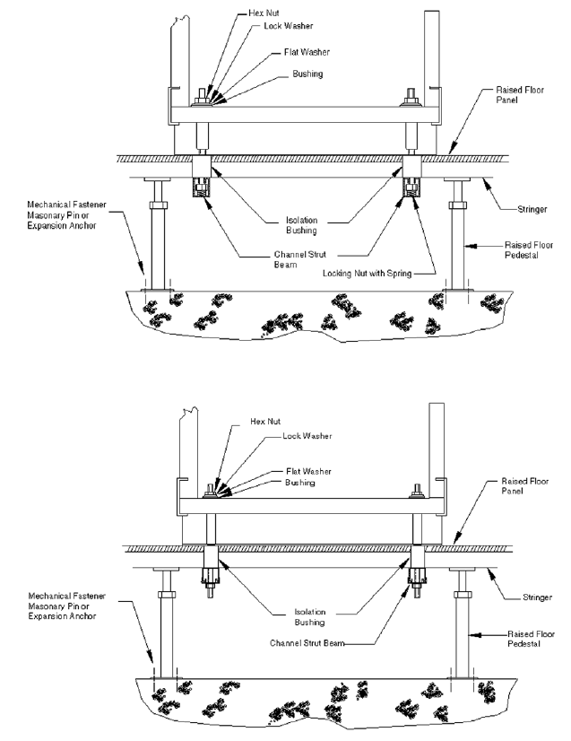
- Floor shims, leveling plates or leveling feet shall not be used to level equipment frames or cabinets.
- Stanchion columns shall not be attached to the raised floor system and shall be extended through the floor tile, and attached directly to the floor slab below the raised floor in all seismic zones to provide the necessary structural rigidity.
  - Floor tiles penetrated by stanchions must first be cut, finished and supported according to the raised floor manufacturer specifications.
- In heavy seismic zones (3,4) four threaded rods shall be used to secure equipment, using appropriately approved seismic anchors.
FIGURE 13.4 Equipment Mounting in Heavy Seismic Zone
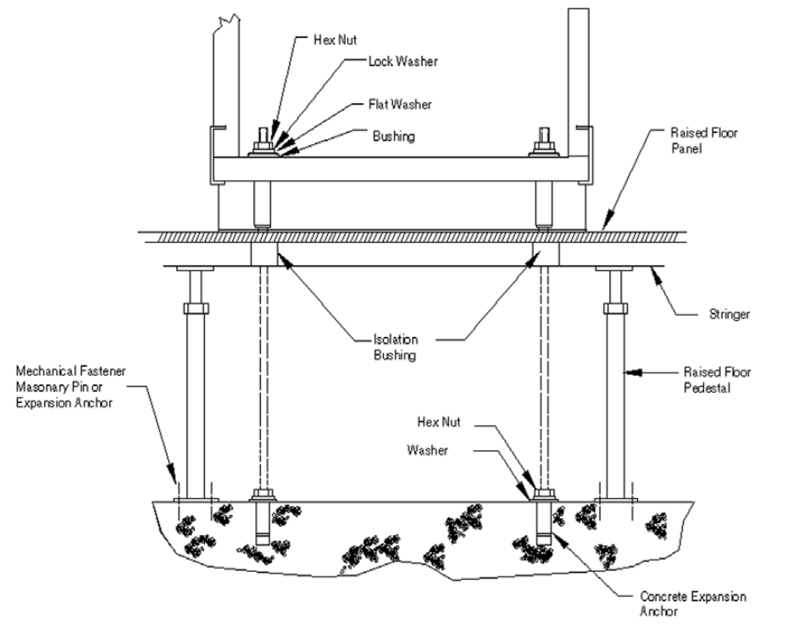
- Equipment mounted to a structural platform shall be bolted directly to the platform per the floor manufacturer specifications.

13.3 Engineering Requirements - Cable Distribution Systems
Cable in the under floor area is an alternative to when overhead cable rack cannot be provided. Cable distribution shall be provided by way of cable racking. The requirements outlined in this section identify the use of cable racking under the floor area. Existing locations with loose placement of cable shall provide cable racking in new areas when feasible.
- Overhead cable rack and air distribution should be considered as the first choice when establishing a new area before considering a raised floor environment.
- Overhead cable rack and under-floor air distribution shall be considered as the standard design when establishing a new raised floor environment.

Cable Rack Requirements
- Approved cable rack and cable rack material shall be used in a raised floor environment.
- Cable racks shall be segregated (fiber, power, switchboard) whenever possible.
- Cable rack shall be installed on u-channel, by direct attachment to the floor, or by using auxiliary framing. Cable racks shall be elevated from the floor by at least one inch.
- Cable rack shall be secured, anchored and supported every 5 feet.
- Bridges shall be constructed in instances where cables or cable racks cross.
- A 90-degree bend or equivalent is required when transitioning from a horizontal cable rack run to a vertical cable rack run.
- Cable rack shall be installed as a continuous route under the floor.
- Cable rack installed under raised floor shall be bonded to the raised floor ground system with a minimum #6 AWG green conductor.

Fiber Protection Systems –FPS (Fiber Duct)
- Fiber optic cable/jumpers shall be installed in segregated fiber optic protection systems (or dedicated fiber cable racks).
- Fiber optic protection systems shall be secured to the pedestal at the height specified by the CenturyLink design engineer.
- Fiber optic protection systems shall not be secured with plastic or nylon ties.

Cabling Requirements
- If the under floor area is also used for air distribution, plenum rated cable is required, or a cable plenum shall be constructed to house the cable.
  - Power cables shall be run in accordance with the NEC requirements, including the use of conduit or armored power cables. The NEC, in article 645 compliant under floor IT spaces allows up to a 15 foot AC power cord not in conduit.
- Data processing interconnecting cables and connecting cables do not require a plenum rating if the plenum meets the criteria of the National Fire Protection (NFPA) 70-645, and the plenum has a smoke detection system.
- Communications cable as defined in NFPA 70-800-51 must meet the listing requirement of types CMP, MPP, OFNP, OFCP, or FPLP for use in ducts, plenums, and other space used for environmental air.
- All cable in the under floor area shall be protected from sharp edges (i.e. angle iron, threaded rod mechanisms in pedestals) utilizing approved methods for cable protection.
- No stringers shall be removed when installing or removing cable in a stringer type raised floor environment.
- Switchboard cable shall be run in the front equipment aisles of the equipment lineup. Switchboard cables shall be bundled and secured to other switchboard cables at a minimum of every 6 feet.
- Primary distribution cables shall be run in the rear equipment aisle of the equipment lineup. Battery and battery return cables shall be run bundled with other power cable and run on dedicated cable rack.
- Secondary distribution power cables shall be run in the rear equipment aisle of the equipment lineup. Battery and battery return cables shall be run bundled with other power cable and run on dedicated cable rack, or segregated from other cables when possible.

Grounding Requirements
Grounding requirements for a raised floor environment shall also adhere to the general grounding requirements outlined in CenturyLink Technical Publication 77355, “Grounding Central Office and Remote Electronic Equipment Environments” and detailed engineering requirements outlined in Chapter 11, “Computer Room Ground Environment” of Technical Publication 77355.
A Signal Reference Ground (SRG) system shall form a ground reference for the raised floor equipment and at a minimum shall consist of a bolted or welded stringer raised floor support structure.

Ground Bars
- Ground bars serving the under-floor environment shall be located under raised floor tiles where complete access to the ground bar is unrestricted.
  - The ground bar shall not be mounted to any of the raised floor apparatus.
  - The ground bar shall be installed with a minimum 2 inch space between the bar and any building surface.
  - Cables not associated with the ground bar shall have a minimum clearance of 6 inches from the ground bar so as to not obstruct access.
  - The location of the ground bar shall be clearly marked on the floor tile directly above the ground bar. A secondary means for identifying the ground bar location may be located on a wall or building column, but in no cases shall the designation be fixed or attached to any temporary equipment, desk or other removable position.
  - A ground bar provided in a raised floor environment shall be an extension of the CO ground and fed by a 750kcmil, copper ground wire.
  - The SRG shall be connected to the under-floor ground bar with a #2 AWG, copper, stranded bare wire.

Ground Cabling
In existing facilities where a pedestal only floor is installed, a supplemental SRG must be installed and shall be composed of multiple runs of bare, stranded #2 AWG copper wire routed along each row of the raised floor pedestals in both directions, thus forming a grid. A copper cable SRG is also desirable even when there is a bolted or welded stringer system.
- Each wire run is bonded at the intersecting point of each perpendicular wire and the raised floor support pedestal by a mechanical connector that shall also tie the grid to the pedestal.
- Individual equipment frameworks or cabinets requiring a connection between the framework/cabinet and the SRG shall be made with a #6 AWG or an equivalent cross-sectional area of flat braided copper strapping, no longer than two feet in length.
Refer to Technical Publication 77355, Chapter 11 for additional engineering requirements.

