Contents
6. Cable Rack and Auxiliary Framing 12
6A. Cable Rack 12
6A.1 General 12
6A.2 Description and Sizes 13
6A.2.1 Ladder Cable Rack 13
6A.2.2 Bar Cable Rack 14
6A.2.3 Grid Type Rack 14
6A.3 Safe Loads 14
6A.4 Cabling 15
6A.4.1 Cable Pileup 15
6A.4.2 Support of Cable 17
6A.4.3 Secured and Unsecured Cable 17
6A.4.4 Cable Slack Storage 18
6A.4.5 Cable Protection 18
6A.4.6 Cable Routing and Transitions 19
6A.4.7 Running Wire in Conduit 20
6A.5 Engineering Requirements 20
6A.5.1 Cable Rack Capacities 22
6A.5.2 Cable Rack Assembly 25
6A.5.3 Cable Rack Support 27
6A.5.4 Cross-Aisle Cable Rack 30
6A.5.5 Vertical Cable Rack 30
6A.5.6 Bracing Cable Rack 31
6A.5.7 Cable Support Brackets 31
6A.5.8 Screen, Pan, and Brackets 32
6A.6 Power Cables and Racking 34
6A.7 Fiber Only Cable Rack 35
6A.8 Bar Type Cable Racking 38
6A.9 Cable Holes and Firestopping 38
6A.9.1 Cable Holes 38
6A.9.2 Firestopping 40
6A.9.3 Firestop Certification Labels 42

EXHIBITS

2-E1-1 STRAIGHT SECTIONS LADDER-TYPE CABLE RACK 50
2-E1-1D (A&M) STRAIGHT SECTIONS BAR-TYPE OVER-AISLE CABLE RACK 51
2-E1-1E (A&M) STRAIGHT SECTIONS BAR-TYPE CROSS-AISLE CABLE RACKS 52
2-E1-1F MOUNTING SNAP-ON CABLE BRACKETS ON LADDER-TYPE CABLE RACKS 53
2-E1-1G (A&M) STRAIGHT SECTIONS BAR-TYPE OVER-FRAME CABLE RACK 54
2-E1-1H (A&M) STRAIGHT SECTIONS BAR-TYPE CABLE RACK 55
2-E1-1J STRAIGHT SECTIONS MODIFIED LADDER-TYPE CABLE RACK FOR UNSECURED CABLING 56
2-E1-3 STRAIGHT CLAMP FOR STRINGERS OF DIFFERENT WIDTHS 58
2-E1-4 CORNER CLAMP FOR STRINGER OF SAME WIDTH 59
2-E1-5 CORNER CLAMP FOR STRINGERS OF DIFFERENT WIDTHS-LEFT 60
2-E1-6 CORNER CLAMP FOR STRINGERS OF DIFFERENT WIDTHS-RIGHT 61
2-E1-7 (DISCONTINUED) JUNCTION CORNER CLAMP FOR STRINGERS OF SAME WIDTH-LEFT 63
2-E1-8 (DISCONTINUED) JUNCTION CORNER CLAMP FOR STRINGERS OF SAME WIDTH-RIGHT 64
2-E1-9 45 DEGREE EDGE CLAMP FOR OUTSIDE TURN 65
2-E1-10 45 DEGREE EDGE CLAMP FOR INSIDE TURN 66
2-E1-11 90 DEGREE EDGE CLAMP FOR OUTSIDE TURN 67
2-E1-12 90 DEGREE EDGE CLAMP FOR INSIDE TURN 68
2-E1-13 SECURING END OF VERTICAL RACK 69
2-E1-13A TERMINATING VERTICAL CABLE RACK AT CABLE HOLE CHANNEL-TYPE SHEATHING 70
2-E1-13B TERMINATING VERTICAL CABLE RACK AT CABLE HOLE. ANGLE-TYPE SHEATHING - ADDITIONS ONLY. 71
2-E1-13C TYPICAL SUPPORT OF CABLE RACK UNDER SWITCHBOARD OR DESK CABLE TURNING SECTION. 73
2-E1-13D TYPICAL SUPPORT OF CABLE RACK IN CABLE SHAFT 74
2-E1-13E TYPICAL SUPPORT OF CABLE RACK TO CEILING AT CABLE HOLE USING U-CHANNEL 75
2-E1-16A (MD) EXTENSIONS FOR BAR-TYPE OVER-AISLE CABLE RACK 76
2-E1-17C (A&M) T-INTERSECTION BAR-TYPE OVER-AISLE TO BAR-TYPE CROSS-AISLE CABLE RACK SAME LEVEL 77
2-E1-17H T-INTERSECTION BAR-TYPE OVER-FRAME TO BAR-TYPE CROSS-AISLE CABLE RACK CROSS-AISLE CABLE RACK RAISED 2 INCHES TO CLEAR CONDUIT AND LIGHTING FIXTURES 78
2-E1-17J T-INTERSECTION BAR-TYPE OVER-AISLE TO BAR OR LADDER-TYPE CROSS- AISLE CABLE RACK RAISED 2 INCHES TO CLEAR CONDUIT AND LIGHTING FIXTURES. FULL LENGTH PLATES BAR-TYPE CABLE RACK SHOWN. 79
2-E1-18A T-INTERSECTION BAR-TYPE OVER-AISLE TO LADDER-TYPE CABLE RACK 80
2-E1-19A T-INTERSECTION LADDER-TYPE TO BAR-TYPE CABLE RACK 81
2-E1-20A JOINING BAR-TYPE TO LADDER-TYPE CABLE RACK OF THE SAME WIDTH. 82
2-E1-21A JOINING CABLE RACK OF VARYING WIDTH AND STRINGER SIZE. 83
2-E1-22A (DISCONTINUED) JOINING BAR-TYPE TO NARROWER LADDER-TYPE CABLE RACK. 84
2-E1-23 (DISCONTINUED) JOINING 10 INCH TO 1 FOOT 0 INCH OR 1 FOOT 0 INCH TO 1 FOOT 3 INCH CABLE RACKS IN THE SAME PLANE USING STRAIGHT CLAMPS-SMALLER RACK APPROXIMATELY IN THE CENTER. 85
2-E1-24 (DISCONTINUED) JOINING 10 INCH TO 1 FOOT 0 INCH OR 1 FOOT 0 INCH TO 1 FOOT 3 INCH CABLERACKS IN THE SAME PLANE USING STRAIGHT CLAMPS-SMALLER RACK AT ONE SIDE. 86
2-E1-25 CLOSING ENDS OF LADDER-TYPE OR BAR-TYPE CABLE RACK JUNCTIONS AND OFFSETS-LADDER-TYPE SHOWN. 87
2-E1-25C MOUNTING RUBBER BUMPERS ON EXPOSED ENDS OF CABLE RACK STRINGERS 88
2-E1-26 90 DEGREE TURN IN SAME PLANE 89
2-E1-27 T-INTERSECTION 90
2-E1-28 SMALL OFFSET LESS THAN WIDTH OF RACK AND IN SAME PLANE 91
2-E1-28A SMALL HORIZONTAL OFFSET LESS THAN WIDTH OF RACK WITH 2 INCH VERTICAL OFFSET BETWEEN RACKS 92
2-E1-29 OFFSET SAME AS WIDTH OF RACK AND IN SAME PLANE BAR AND LADDER-TYPE RACK. 93
2-E1-30 LARGE OFFSET LESS THAN WIDTH OF RACK AND IN SAME PLANE 94
2-E1-31 JOINING BAR AND LADDER-TYPE RACKS OF DIFFERENT WIDTHS IN SAME PLANE - SMALLER RACK APPROXIMATELY IN CENTER. 95
2-E1-32 JOINING BAR AND LADDER-TYPE RACKS OF DIFFERENT WIDTHS IN SAME PLANE - SMALLER RACK AT ONE SIDE. 96
2-E1-33 JOINING THREE RACKS OF DIFFERENT WIDTHS IN SAME PLANE 97
2-E1-34 CORNER BRACKET AT TURN OF INTERSECTION 98
2-E1-35 90 DEGREE OUTSIDE TURN FOR A RADIUS OF MORE THAN 6 INCHES 99
2-E1-36 90 DEGREE INSIDE TURN FOR A RADIUS OF MORE THAN 6 INCHES 100
2-E1-37 90 DEGREE INSIDE TURN FOR A RADIUS OF 6 INCHES OR LESS 101
2-E1-38 90 DEGREE OUTSIDE TURN FOR A RADIUS OF 6 INCHES OR LESS 102
2-E1-38H VERTICAL LADDER-TYPE CABLE RACK DROPPING OFF THE SIDE OF BAR-TYPE CABLE RACK-90 DEGREE OUTSIDE TURN OF 6 INCHES OR LESS. 103
2-E1-38J (A&M) VERTICAL LADDER-TYPE CABLE RACK DROPPING OFF THE SIDE OF BAR-TYPE CABLE RACK 90 DEGREE LARGE OUTSIDE RADIUS TURN. 104
2-E1-39 SMALL VERTICAL OFFSETS IN HORIZONTAL RACKS 105
2-E1-39 SMALL VERTICAL OFFSETS IN HORIZONTAL RACKS 106
2-E1-39 SMALL VERTICAL OFFSETS IN HORIZONTAL RACKS 107
2-E1-39 SMALL VERTICAL OFFSETS IN HORIZONTAL RACKS 108
2-E1-40 OFFSET GREATER THAN 9 INCHES IN PARALLEL PLANES USING 45 DEGREE EDGE CLAMPS-LADDER-TYPE CABLE RACKS 109
2-E1-40A ADJUSTABLE CABLE RACK SPLICE 110
2-E1-40B ADJUSTABLE CABLE RACK SPLICE, RIGHT ANGLE 110
2-E1-40C (A&M) OFFSET GREATER THAN 9 INCHES IN PARALLEL PLANES USING 45 DEGREE EDGE CLAMPS-BAR-TYPE CABLE RACKS 111
2-E1-41 ACUTE-ANGLE TURN IN SAME PLANE 112
2-E1-42 OBTUSE-ANGLE TURN IN SAME PLANE 113
2-E1-43 ACUTE-OR-OBTUSE-ANGLE TURN IN SAME PLANE 114
2-E1-52 OFFSETS IN EXPOSED VERTICAL CABLE RACKS 115
2-E1-52 OFFSETS IN EXPOSED VERTICAL CABLE RACKS 116
2-E1-52 OFFSETS IN EXPOSED VERTICAL CABLE RACKS 117
2-E1-53 OUTSIDE CABLE RACK TURN FOR POWER OR FIBER CABLE RUNS 118
2-E1-53A INSIDE CABLE RACK TURN FOR POWER OR FIBER CABLE RUNS 119
2-E1-54 CROSS-AISLE CABLE RACKS RUN NONCONTINUOUSLY OVER-AISLES AT HIGHER LEVEL THAN OVER-FRAME RACKS INTERSECTION 120
2-E1-54F CROSS-AISLE CABLE RACKS RUN CONTINUOUSLY OVER AISLE AT HIGHER OR LOWER LEVEL THAN LINEUP RACKS 122
2-E1-55 (DISCONTINUED) CABLE RACKS OVER AISLES WHERE CABLE IS NOT EXCEPTIONALLY HEAVY 123
2-E1-56 (DISCONTINUED) CABLE RACK FOR POWER CABLES WITHOUT MAIN-AISLE OR END-AISLE CABLE RACK (REPLACED BY EXHIBIT 2-E1-56B) 124
2-E1-56B POWER CABLE SUPPORT BRACKET FOR POWER CABLES WITHOUT MAIN-AISLE OR END-AISLE CABLE RACK 125
2-E1-56C (A&M) POWER CABLE SUPPORT BRACKET FOR SUPPORTING FRAME LINE POWER FEEDERS WHERE INTERMEDIATE FRAMES ARE OMITTED AND GAP EXCEEDS 3 FEET 0 INCHES-STEP-BY-STEP, NO. 1 CROSSBAR, AND CROSSBAR TANDEM SYSTEMS-11 FOOT 8 INCH OR 11 FOOT 9 1/2 INCH AUXILIARY FRAMING 126
2-E1-57E (A&M) POWER CABLE BRACKET ATTACHED TO BAR-TYPE OVER-AISLE CABLE RACK 127
2-E1-57F POWER CABLE BRACKET ATTACHED TO LADDER-TYPE CABLE RACK 128
2-E1-57G POWER CABLE SUPPORT BRACKET ATTACHED TO AUXILIARY FRAMING WITH RETAINING SPRING 129
2-E1-62G (A&M) LOCATION OF LADDER-TYPE CABLE RACK OVER CHANNEL-TYPE RELAY RACK-STEP-BY-STEP SYSTEMS 130
2-E1-62H (A&M) LOCATION OF LADDER-TYPE CABLE RACK OVER BULB-ANGLE TYPE FRAMES 131
2-E1-62J (A&M) LOCATION OF LADDER-TYPE CABLE RACK OVER BULB-ANGLE TYPE FRAMES ADJACENT TO BULB-ANGLE TYPE STEP-BY-STEP FRAMES 132
2-E1-62K LADDER-TYPE CABLE RACK OVER REAR OF CHANNEL-TYPE RELAY RACK- STEP- BY-STEP SYSTEMS-11 FOOT 8 INCH FRAMING-ADDITIONS ONLY 133
2-E1-62L (A&M) CABLE RACKS OVER AISLES WHERE CABLE IS NOT EXCEPTIONALLY HEAVY 134
2-E1-62M (A&M) LADDER-TYPE CABLE RACK OVER REAR OF BULB-ANGLE TYPE FRAMES ADJACENT TO CHANNEL-TYPE STEP-BY-STEP FRAMES 11 FOOT 8 INCH FRAMING-ADDITIONS ONLY 135
2-E1-62N LADDER-TYPE CABLE RACK OVER DUCT TYPE FRAMES-11 FOOT 6 INCH FRAMING 136
2-E1-62P LADDER-TYPE CABLE RACK OVER CABLE DUCT-TYPE FRAMES 11 FOOT 8 INCH 137
2-E1-62Q (A&M) LOCATION OF BAR-TYPE OVER-FRAME CABLE RACK OVER BULB-ANGLE TYPE FRAMES 138
2-E1-62R LOCATION OF BAR-TYPE OVER-FRAME CABLE RACK OVER CHANNEL-TYPE FRAMES-COMBINED OFFICES 139
2-E1-62S LADDER-TYPE CABLE RACK OVER CABLE DUCT-TYPE FRAMES-11 FOOT 9 1/2 INCH FRAMING 140
2-E1-62T (A&M) MULTILEVEL CABLE RACK SUPPORT OVER DUCT-TYPE FRAMES-11 FOOT 6 INCH FRAMING 141
2-E1-62U (A&M) MULTILEVEL CABLE RACK SUPPORT OVER DUCT-TYPE FRAMES-11 FOOT 8 INCH FRAMING 142
2-E1-62V (A&M) BAR-TYPE OVER-FRAME CABLE RACK OVER CABLE DUCT-TYPE FRAMES 11 FOOT 6 INCH FRAMING 143
2-E1-62W (A&M) BAR-TYPE OVER-FRAME CABLE RACK OVER CABLE DUCT-TYPE FRAMES-11 FOOT 8 INCH FRAMING 144
2-E1-63A CABLE RACK SUPPORTED BY AUXILIARY FRAMING OVER BULB-ANGLE TYPE SWITCH FRAMES-STEP-BY-STEP SYSTEMS-11 FOOT 8 INCH FRAMING 145
2-E1-63B (A&M) LADDER-TYPE CABLE RACK OVER REAR OF CHANNEL-TYPE STEP-BY-STEP FRAMES-11 FOOT 8 INCH FRAMING-ADDITIONS ONLY 146
2-E1-63C (A&M) LADDER-TYPE CABLE RACK OVER FRONT OF CHANNEL-TYPE STEP-BY-STEP FRAMES-11 FOOT 8 INCH FRAMING-ADDITIONS ONLY 147
2-E1-65 LADDER-TYPE CABLE RACK SUPPORTED BY LOW-TYPE AUXILIARY FRAMING 148
2-E1-65 (A&M) BAR-TYPE CABLE RACK SUPPORTED BY LOW-TYPE AUXILIARY FRAMING BAR- TYPE OVER-AISLE RACK SHOWN 149
2-E1-65C (A&M) CABLE RACK SUPPORTED BY LOW-TYPE AUXILIARY FRAMING DIRECTLY BELOW A CROSS STRAP-BAR-TYPE OVER-AISLE SHOWN 150
2-E1-66 CABLE RACK SUPPORTED WITH G-CLIPS ABOVE LOW-TYPE AUXILIARY FRAMING BY THREADED RODS 151
2-E1-66A CABLE RACK SUPPORTED ABOVE LOW-TYPE AUXILIARY FRAMING BY SPACERS 151
2-E1-66C CABLE RACK SUPPORTED WITH C-CLIPS ABOVE LOW-TYPE AUXILIARY FRAMING BY THREADED RODS 152
2-E1-67 MAIN OR X-AISLE CABLE RACK SUPPORTED BY ADDITIONAL AUXILIARY FRAMING BELOW REGULAR FRAMING-USING THREADED RODS ADDITIONS ONLY - REPLACED BY EXHIBIT 2-E1-67A 153
2-E1-67A MAIN-AISLE CABLE RACK SUPPORTED BY ADDITIONAL FRAMING BELOW REGULAR FRAMING-USING SPACERS 153
2-E1-68 (DISCONTINUED) MAIN OR X-AISLE CABLE RACK SUPPORTED BY ADDITIONAL AUXILIARY FRAMING ABOVE REGULAR FRAMING 154
2-E1-69 (A&M) CABLE RACKS OVER MAIN AISLES 155
2-E1-70 CABLE RACKS OVER END AISLES 156
2-E1-70A (A&M) CABLE RACKS ATTACHED TO TRAFFIC REGISTER CABINET 157
2-E1-71 (A&M) CABLE RACK ATTACHED TO POWER BOARD OR SIMILAR FRAME WORK 158
2-E1-72 HANGER ROD ATTACHED TO AUXILIARY FRAMING 159
2-E1-73 HANGER ROD ATTACHED DIRECTLY TO CEILING 159
2-E1-74 HANGER ROD OFFSET TO CLEAR CABLE RACK CLAMP, CABLE RACK STRAP, OR OTHER OBSTRUCTION 160
2-E1-75 HANGER ROD EXTENDED WITH SPLICED COUPLING 161
2-E1-76 SUPPORTING RACKS 5 INCHES WIDE 162
2-E1-77 G-CLIP CABLE RACK SUPPORT BELOW AUXILIARY FRAMING WITH HANGER RODS 163
2-E1-77B SUPPORT BAR-TYPE OVER-AISLE CABLE RACK WITH HANGER RODS 163
2-E1-77C C-CLIP CABLE RACK SUPPORT BELOW AUXILIARY FRAMING WITH HANGER RODS 164
2-E1-81 SUPPORTING ONE RACK ABOVE ANOTHER RACK-LARGE RACK ABOVE 164
2-E1-82 SUPPORTING ONE RACK ABOVE AND FROM ANOTHER RACK-LARGER RACK BELOW 165
2-E1-83 SUPPORTING ONE RACK ABOVE AND FROM ANOTHER RACK WITH G-CLIPS - RACKS SAME SIZE 166
2-E1-83C SUPPORTING ONE RACK ABOVE AND FROM ANOTHER RACK WITH C-CLIPS - RACKS SAME SIZE 167
2-E1-84 SUPPORTING ONE RACK ABOVE AND FROM ANOTHER RACK-CABLE RACKS AT RIGHT ANGLES 168
2-E1-85 SUPPORTING 5 INCH CABLE RACK EMBEDDED INSERT IN CEILING 169
2-E1-86 SUPPORTING 1 FOOT AND 1 FOOT 3 INCH CABLE RACKS FROM EMBEDDED OR EXPOSED CEILING CHANNEL 170
2-E1-87 SUPPORTING CABLE RACKS FROM EMBEDDED INSERT IN CEILING 171
2-E1-88 BRACING HANGER ROD-SUPPORTED CABLE RACK WITH ROD-TYPE BRACING 172
2-E1-89 BRACING HANGER ROD-SUPPORTED CABLE RACK WITH ANGLE TYPE BRACING 173
2-E1-90 PIPE SUPPORTED CABLE RACK OVER LOW-TYPE AUXILIARY FRAMING 174
2-E1-91 WALL SUPPORT BRACKET FOR 5 INCH-15 INCH CABLE RACK 175
2-E1-92 (PAGE 1 OF 2) SCREEN ASSEMBLE FOR UNDERSIDE OF 5 INCHES-30 INCHES LADDER-TYPE CABLE RACK 176
2-E1-92 (PAGE 2 OF 2) SCREEN ASSEMBLE FOR UNDERSIDE OF 5 INCHES-30 INCHES LADDER-TYPE CABLE RACK 177
2-E1-93 (DISCONTINUED) EXAMPLES OF CABLE RETAINING BRACKETS 178
2-E1-93A EXAMPLES OF TYPICAL CABLE RETAINING BRACKETS 179
2-E1-94 INSULATING JUNCTION FOR CABLE RACK 180
2-E1-95 CABLE SUPPORT BRACKET FROM CABLE RACK STRINGER OR AUXILIARY FRAMING 181
2-E1-96 FREE ENDED TURN SUPPORT 182
2-E1-98 BRACKET SUPPORT TO U-CHANNEL 183

TABLES
TABLE 6A.2 CABLE PILE-UP 29
TABLE 6A.3 STANDARD CABLE RACK SIZES AND CAPACITY 36
TABLE 6A.4 STANDARD POWER CABLE RACK SIZES AND CAPACITY 37
TABLE 6A.5 STANDARD FIBER CABLE RACK SIZES AND CAPACITY 38

6Cable Rack and Auxiliary Framing

6A. Cable Rack

6A.1 General
This unit covers engineering and installation requirements for cabling and cable rack in transmission and power equipment areas and above switching systems.

Any material referenced throughout the chapter refers to currently approved CenturyLink material.

- The information in this chapter is intended to address allowable engineering and installation practices. Practices that are not defined shall be verified with Common Systems Standards prior to engineering or installation.
- Cable rack shall be engineered for telecommunications equipment cabling (switchboard, fiber, and power). Other types of cabling such as AC cabling shall not be intermingled, routed, or supported on racks designated for these uses. Segregated cable rack for other uses shall be reviewed and approved by the CenturyLink representative responsible for common systems standards.
- The requirements for Cable Distribution Systems (also referred to as "Cableway" or "Compartment" type systems) above 7 foot high frames and fiber management systems are covered in Chapter 6, Unit F of this module.
- All measurements shown in exhibits indicate maximum or minimum allowable gap tolerances where cable rack and framing parts are joined.
- Self-drilling anchors shall not be used to secure frames or ironwork to ceilings, walls or floors. For attaching frames or ironwork to wooden ceilings, walls or floors, substitute appropriate lag bolts. Where embedded inserts or expansion anchors are shown substitute torque indicating anchors.
- Refer to the "Earthquake and Disaster Bracing" section for additional cable racking requirements in earthquake heavy zones.

Abandoned cable should be removed (mined) from cable runs, where practical, to maintain cable pileup limits and safe loads.
- Cabling and cable rack arrangements not specifically identified in this document shall adhere to the intent of the requirements and guidelines.
- Clamps, bolts, fabrications, etc. shall be assembled per the Exhibits unless prohibited by office conditions and shall be reviewed and approved by the CenturyLink representative responsible for common systems standards..
- Assemblies and components shall be produced by approved manufacturers only. Special components and/or assemblies shall be evaluated and approved following current CenturyLink process.

Refer to CenturyLink Technical Documents and Standard Configurations for additional information. Standard Configurations may include essential information, specific arrangements, approved products, or direction on applying engineering requirements.

6A.2 Description and Sizes
To prevent corrosion and facilitate grounding, cable rack sections should be of a non-corrosive plated type, or painted, preferably gray.
- All switchboard and power cable rack shall be painted gray. Fiber cable rack shall be painted orange. Cable rack specifically for a switch system, and within the "footprint" of the switch, can be per the manufacturer requirements and guidelines. This would not include via type cable rack to a distributing frame, BDFB, etc.
- The CenturyLink representative responsible for the approval of products for common systems may approve the use of other colors of paint.

Cable rack assembly hardware shall be of a non-corrosive plated type.
- Plating shall be able to be distinguished from non-plated components. For example, coloring added.
- Where hardware is intended for bonding purposes, refer to CenturyLink Technical Publication 77350, "Central Office Telecommunications Equipment Installation and Removal Guidelines" and CenturyLink Technical Publication 77355, "Grounding - Central Office and Remote Equipment Environment".

Exhibits in this unit apply to all ladder-type cable rack configurations.

6A.2.1 Ladder Cable Rack
Ladder-type cable rack is preferred for all new construction.
Ladder-type cable racks are manufactured in full length (9 feet 8-1/2 inches long) or in half-lengths (4 feet 5-1/2 inches long) and in various widths as shown in Exhibit 2-E1-1.
- The straps are 1 inch by 1/2 of an inch channel spaced on 9-inch centers and welded to the stringers. The first, last, and each alternate strap of the cable racks that are 2 feet 1 inch and 2 feet 6 inches in width are reinforced with a 1 inch by 1/4 of an inch bar.
- The actual construction of the stringers can be channel or solid. Tubular or hollow stringer type cable rack is prohibited.

The fabrication exhibits in this unit show solid stringers.

6A.2.2 Bar Cable Rack
Bar type cable rack is manufacturer discontinued (MD). Environments using bar type cable rack shall be extended using ladder type cable rack.

Bar-type cable racks, as shown in Exhibit 2-E1-1D, 1E, 1G and 1H, are examples of existing embedded base equipment and may be encountered during additions to those systems.
Bar-type cable racks are made of 1 inch by 3/16 of an inch bent steel cross-straps on 9-1/2 inch centers welded to stringers that have an outside dimension of 1-1/2 inches by 3/8 of an inch.
- The construction of the stringers may be channel, or solid.
- Solid stringers are illustrated in fabrication figures in this unit.
- Thin metal or plastic plates are to be provided for covering the bottom of the racks. Plastic type plates are preferred.

6A.2.3 Grid Type Rack
Grid type cable rack is manufactured in sections consisting of multiple 1 ½” stringers spaced at 12 inches on center and welded together in specified lengths. Straps consist of round tubes spaced 6 inches apart.

- Environments currently using grid type cable rack may continue to use the grid type cable rack to the logical conclusion of the environment.
- Grid type cable rack shall not be used in any new equipment environments, buildings or floors where grid has not already been established.
- Where feasible, grid type cable rack shall transition to ladder type cable rack.
- The manufacturer’s design requirements must be followed for the existing grid system.
- Equipment with high heat dissipation will require additional Real Estate evaluation to provide appropriate cooling support. Refer to Chapter 2, Table 2.1A, and Chapter 2, section 2.2.3 for heat dissipation requirements.
- CenturyLink heat dissipation processes and guidelines must be followed when placing high heat dissipation equipment in the grid type cable rack environment.

6A.3 Safe Loads
Safe loads for steel ceiling inserts, threaded rods, and lag screws, for the purpose of determining the spacing of supports other than normal, may be considered as follows:

SAFE LOADS
MATERIAL | POUNDS
5/8-11 threaded rods | 1200
Embedded Ceiling inserts (poured in place) | 1200
Beam Clamps | 800
5/8 inch expansion anchors | 480
3/8” lag screws for wood (2” or more in length) | 300
Framing bars (one pair 2 inches by 3/8 of an inch steel) or channels (one pair 2 inches by 9/16 of an inch by 3/16 of an inch steel) span between supports:
Up to 2 feet 0 inches | 2000
More than 2 feet 0 inches to 3 feet 0 inches | 1500
More than 3 feet 0 inches to 5 feet 0 inches | 1000
More than 5 feet 0 inches to 7 feet 0 inches | 700
More than 7 feet 0 inches to 8 feet 0 inches | 500
Embedded ceiling channel (U-type):
At one point | 2000
Where 2 or more loads are within 24 inches of each other, total load cannot be in excess of | 2000

6A.4 Cabling
Proper cabling practices and procedures are required to preserve safety and maintain service within the cabling environment. The following guidelines and requirements shall be implemented where possible.
Cable shall be supported using approved cable rack except as noted:
- Existing Fiber Duct - Fiber cable only (see chapter 6G)
- Conduit -. Planning and Engineering Guidelines approval may be required.
- Cable Brackets – Primarily used to support ground feeders or fiber cable. Support of other cable types requires Planning and Engineering Guidelines approval.

6A.4.1 Cable Pileup
The permissible pile-up of cabling on ladder-type cable racks for the normal and maximum spacing of supports is as follows:

TABLE 6A.2 CABLE PILE-UP

SECURED CABLE PILE-UP IN TERMS OF SWITCHBOARD
WIDTH OF CABLE RACK | SUPPORTS ON  5 FEET 1 INCH CENTERS | SUPPORTS ON  6 FEET 0 INCH CENTERS
5 inches to 12 inches | See note | See note
15 inches to 25inches | 12 inches | 10 inches
30 inches | 10 inches | 7 inches

UNSECURED CABLE PILE-UP IN TERMS OF SWITCHBOARD CABLE
WIDTH OF CABLE RACK | SUPPORTS ON  5 FEET 1 INCH CENTERS | SUPPORTS ON  6 FEET 0 INCH CENTERS
5 inches to 12 inches | See note | See note
15 inches to 25inches* | 12 inches | 12 inches
30 inches | 12 inches | 9 inches

SECURED CABLE PILE-UP IN TERMS OF POWER CABLE
WIDTH OF CABLE RACK | SUPPORTS ON  5 FEET 1 INCH CENTERS | SUPPORTS ON  6 FEET 0 INCH CENTERS
5 inches | See note | See note
12 inches to 25inches | 7 inches | 6 inches
30 inches | 6 inches | 5 inches

UNSECURED CABLE PILE-UP IN TERMS OF FIBER CABLE
WIDTH OF CABLE RACK | SUPPORTS ON  5 FEET 1 INCH CENTERS | SUPPORTS ON  6 FEET 0 INCH CENTERS
5 inches | 5 inches | 5 inches
12 inches to 30 inches | 7 inches | 6 inches

Note: The maximum cable pileup for a cable run is also limited to a height not to exceed the width of the cable rack for cable racks 12 inches or less and to the values given in the above table for wider racks.
*Cable pileup on unsecured switchboard cable rack for 15 inches to 25 inches may exceed the 12 inch pileup around corners, intersecting cable racks, or transitions from the cable rack.

Cable pileup on racks supported by wall mounted brackets shall be limited to no more than 2 inches for switchboard cable or fiber cable and 1 inch for power cable.
Cable pile-up on bar-type cable racks is limited by the height of the vertical bars, not to exceed the limits for ladder-type rack.
The permissible pile-up of vertical switchboard cable runs shall not exceed an ultimate pile-up of 5 inches for 5 inch wide cable rack or 12 inches for 12 inch and wider cable rack.
Runs of power cable smaller than No. 6 AWG are to be considered as roughly ten percent heavier than switchboard cable. Larger sizes of power cable are considered 5 times heavier than switchboard cable. The permissible pile-up on combined vertical and horizontal power cable racks is 7 inches. The maximum width of horizontal and vertical dedicated power cable racks shall be limited to 20 inches unless reinforced rack is used to accommodate extra weight.

6A.4.2 Support of Cable
Cable along cable routes spanning horizontal planes shall not exceed 9 inches without additional support.
- Usual lineup, via, and main aisle type cable runs shall be considered as a route. Cable extended from typical cable racking to a bay, DF vertical, or similar location would not be considered a cable route. Spur racks branched from racks to serve single or dual equipment frames or cabinets are not considered a cable route.

Sections of horizontal and vertical ladder-type cable rack shall be assembled so that support for the cabling is provided every 9 inches.
- At cable rack transitions, the cable rack will be assembled to provide support for the cable at 9 inch intervals as much as possible. Where the cable cannot be directly supported every 9 inches due to bend radius requirements, the cable shall be stitched together at 9 inch intervals using a Chicago stitch or similar securing method.

- At turns or junctions, in vertical or inverted horizontal cable runs, where proper support is not provided for the cables, 1/2 inch by 1 inch channel may be placed diagonally across the rack in a manner to provide proper support for the cables. The channel straps shall be secured with bolts at the corner clamps.
- At cable rack junctions and turns, where the radii on which the cables turn are so large that an additional support is required; or where cables are spread out to avoid excessive piling, a corner bracket shall be provided when possible, as shown in Exhibit 2-E1-34.

Cable leaving cable racks to equipment frames shall not be unsupported for a distance greater than 3 sheath feet.
- Where the distance exceeds 3 feet, additional cable support shall be provided Acceptable examples: Auxiliary framing, 1 inch steel support pipe, or existing cable rack stringers.

6A.4.3 Secured and Unsecured Cable
Cables secured to cable rack shall be sewn and, where practical, shall utilize the full width of the cable rack for each layer prior to securing additional layers. Additional layers shall be secured to the previous layers in a similar fashion.
Cables, run on cable rack with a vertical offset, shall be secured at the offsets per the standards for securing vertical cable in Technical Publication 77350.
- All cables run on vertical cable racking shall be secured.
- All cable racks that are not horizontal shall be considered vertical. i.e. for cable rack with a change of height level, the vertical transition section of the rack must follow vertical cable rack securing requirements.

Horizontal cable racks not equipped with screen or pan, and cable brackets, require the securing of cable.
- Switchboard Cable shall be run secured on cable rack not equipped with screen and brackets.
- Power cable shall be run secured on dedicated power cable rack.
- Power cables run on panned or screened cable rack shall be secured per standards in Technical Publication 77350.
- Fiber cable shall be run secured on standard orange (or gray where existing and labeled as “fiber optic cable only”) type cable racks or unsecured on orange fiber cable racks equipped with pan and brackets. Refer to Chapter 6 Unit F for additional requirements.
- For cable securing intervals and requirements, see CenturyLink Technical Publication 77350, (see Reference Chapter).
- Cables run on cable brackets, bars, or similar assemblies must be secured.

6A.4.4 Cable Slack Storage
Cable slack storage in any type of cable rack is strictly prohibited.
- All excess cable slack (multi-fiber cables and/or equipment fiber jumpers) shall be managed within an approved fiber management device specifically designed for fiber cable storage of the cable size being installed.
- Utilizing cable with connectors on one end and stub on the other so cables could be field cut to the appropriate length where possible.
- Utilizing cables with connectors on both ends require a more accurate measurement and shall be ordered based on the minimum size length available from the manufacturer.
- Refer to standard configuration guidelines for additional cable options.
- Customary cable slack for wide turns, cable rack offsets, and at break-off points to the equipment is acceptable.
- Letters of deviation will not be considered valid.

6A.4.5 Cable Protection
All cabling shall be protected from contact with sharp edges, such as those occurring at cable rack stringers and non-rounded straps, edges of duct type frames and all threaded rods within 3 inches of a cabling surface.
- Soft rubber power cable and all coaxial type cables shall be protected where they are secured to metal straps and brackets.
- Where separation of metallic continuity is required, effective insulation may be provided per Exhibit 2-E1-94.
- To protect cabling at T-intersections of bar-type cable racks and cross-aisle racks, finishing caps shall be installed on the ends of all cross-straps that project within the T-intersection area as shown in Exhibits 2-E1-17C, 17H, 17J and 2-E1-18A. The finishing caps shall be secured to the cable rack horns by coating the inside of the caps with an adhesive prior to placing the caps on the horns.
- Nuts and bolts not specifically identified in the Exhibits shall be installed so that they will not come in contact with or damage cable. The threaded end of an assembly should be pointed away from cabling.
- Cables shall be run to the inside of cable retaining brackets and shall not remain looped to the outside of a bracket.

6A.4.6 Cable Routing and Transitions
Incorrect cable routing and transitioning can block existing or future cable paths and inhibit the ultimate cable capacities of the racking system. Cable routing and transitioning not specifically identified in this document shall adhere to the intent of the following requirements.
- Transitioning from one cable rack to another at points other than at identified cable transition routes is prohibited. For example, cables cannot arbitrarily transition between racks, even when the racks are closer than nine inches to each other.

Cables shall be routed and secured so that they do not block future cable additions or adversely affect the ultimate cable pileup.
- When cable is routed from cable racks to equipment frames the cables shall transition off lineup cable racks only (cable rack parallel to the rows of equipment frames in the front or rear aisles).

- Cables shall not transition from main aisle or cross-aisle cable racks directly into equipment frames unless breaking off lineup cable racks is prevented by office conditions and no other option is available.

Where cables transition off from a cable rack they shall be routed over the side stringers or off the end of a cable rack that will not be extended at some future date.
- Cables shall not be routed "through" cable rack stringers or bay extenders.
- Cables shall not be routed from bay to bay without being routed into the overhead cable racking system unless directed by the Standard Configuration documentation.
- Conduit shall not be routed or supported on top of, or “in” cable rack nor will conduit be directly attached to the cable rack stingers where it will interfere with other intersecting cable racks. Exception: Cables that may need to access conduit for further routing outside the cable rack to termination points not in bays or frames. The end of an associated conduit may need to be supported from the top of a cable rack. Example: Alarm leads routed to a building alarm terminal strip.

Cables shall follow cable rack routing and shall not transition between cable racks except as noted.
The following are examples of cable rack arrangements of different elevations where cable transition from one cable rack to another is considered acceptable.
- Cable rack arrangements as provided for in Exhibits 2-E1-39, 54, 54F
- When transitioning between via cable rack and Cable Distribution Systems, refer to Chapter 6, Unit F.
- When it is necessary to transfer cables from one run to another, provide sufficient clearance at the transfer so that future cables may be installed on either cable rack without blockage.

The following are examples of cable rack arrangements for different elevations where cable transition from one cable rack to another is prohibited.
- EXHIBIT 2-E1-83, Transitions to or from one rack above another. This includes racks not positioned directly above but parallel to each other.
- EXHIBIT 2-E1-84, Transitions to or from racks at right angles and above.

6A.4.7 Running Wire in Conduit
Cables and/or wires may be run in conduit for the purpose of serving locations such as wall mounted terminal panels or Building Terminals, not equipment frames. .
- Conduit shall be extended to the cable rack in the proximity of the location served.
- Conduit used for these terminal panels or Building terminals shall be ended outside of, and within 9 inches of, the cable rack stringers.

6A.5 Engineering Requirements

Cable rack size (width) shall be engineered per equipment requirements and office conditions. Evaluate cable capacities for the areas and lineups to be served
- Cable racks shall be provided in the approved cable rack sizes identified in Table 6A.3. Existing equipment lineups utilizing cable rack sizes other than the standard sizes identified can be transitioned to the new standard size similar to Exhibits 2-E1-21A, 2-E1-31 and 2-E1-32 when feasible.
- Cable rack routes should be planned so that mixed equipment lineups, both present and future, could be accessed by switchboard, power, and fiber racks.
- New cable rack arrangements for cable rack sizes 24 inches and greater shall be engineering using auxiliary framing as the direct cable rack support structure regardless of type (switchboard, power, fiber) or earthquake zone.
- The use of G-clips or C-clips is prohibited for cable rack sizes 24 inches and greater.
- Space required for access to, or removal of, equipment shall be taken into consideration when determining the location of cable rack and supports.
- Cable rack shall be engineered and installed to accommodate cable bend radius of the largest typical cable at the maximum cable pileup. Refer to TP 77350, Standard Configurations, or manufacturers requirements for bend radius requirements.
- Cable rack shall not be located below the tops of windows, doors, or transoms so as to obstruct their proper operation.
- Parallel cable racks for differing functions (i.e. switchboard and power, power and fiber, etc.) should not be engineered adjacent to each other, at the same level, without adequate cable transition space on either side of the cable rack.
- Cable rack routes should avoid crossing Collocation cages. Note: Collocators must be notified when work (including running cable) is performed above their equipment space.
- Cable racks in main/egress aisles and in 7-foot Low Level environments shall be centered between lineups.
- Cable racks shall be within 1/2 inch of center for initial lineup build-outs.

Horizontal cable rack or troughs (cable routes) shall not be located below the top of equipment bays or frames including bay extenders.
- Where environments of differing heights intersect, such as 7 foot and 11 foot 6 inch, the cable racking of a 7 foot floor supported environment may encroach into the other environment as long as it does not interfere with rolling ladders and normalnetwork facility activities.

Cable racks shall be located and securely supported to accommodate the maximum cable pile-up allowed.
- A minimum 12 inches clearance is required above the top of a cable rack to the bottom of any obstruction to accommodate cable pileup and cable securing operations. Exceptions:

- Cable rack routes with a maximum pileup of less than 12 inches, such as power and fiber racks, may have a minimum clearance to obstructions where it will not impact ultimate cable pileup or securing operations. Allow 5 inches clearance for securing operations where necessary.
- Five inch wide cable rack where it is supported with 2-E1-85 type saddle brackets.
- Standard 12 inch high wall cable holes that will accommodate 10 inches of cable pileup with the cable rack extended through the cable hole.

- Components such as conduit, cable brackets, bracing, other cable rack, etc shall be arranged so as not to interfere with the ultimate cable pileup.

Cable racks shall not be located close to pipe, radiators, windows, doors, or any other equipment that may subject the cabling to detrimental conditions.
Ladder-type cable rack, engineered for horizontal applications, shall be installed with the cross-straps upward per cable racking exhibits.
- Cable rack with channel-type straps may be inverted to gain necessary cabling capacity due to fixed obstructions. Inverted cable racks must be equipped with panning and cable retaining brackets.
- Cable racks with reinforced straps may not be inverted.
- Cable racks shall be installed so that no excessive load or binding will be imposed on frames, racks, or other equipment attached or adjacent to the cable racks, unless such equipment is engineered to support the cable racks.
- Splicing of threaded rods per Exhibit 2-E1-75 is not approved. Exception: Threaded rods may be spliced where threaded rod studs are cast into the ceiling structure.

When cable rack and associated equipment are located within the isolated ground plane or PANI system, separation from all integrated ground plane members must be maintained as specified in CenturyLink Technical Publication 77355, "Grounding - Central Office and Remote Equipment Environment".
Cable rack engineered for support purposes other than usual cable support (i.e. switchboard, power, and fiber) may not need to adhere to certain engineering requirements such as pileup and/or cable rack support intervals. For example, air pressure hose support.

6A.5.1 Cable Rack Capacities
The cable capacity required to serve an equipment area or lineup can vary widely. Cable rack capacities should be evaluated when determining the size and/or number of cable racks required to supply a lineup of equipment or equipment area.
The following information shall be used to determine appropriate cable rack sizing.

TABLE 6A.3 STANDARD CABLE RACK SIZES AND CAPACITY
The upper number on the table below represents the approximate number of switchboard type cables and the lower number the approximate weight in pounds per linear foot.

NUMBERS OF MISCELLANEOUS SWITCHBOARD CABLES SECURED ON LADDER TYPE CABLE RACK AND APPROXIMATE WEIGHT OF CABLE

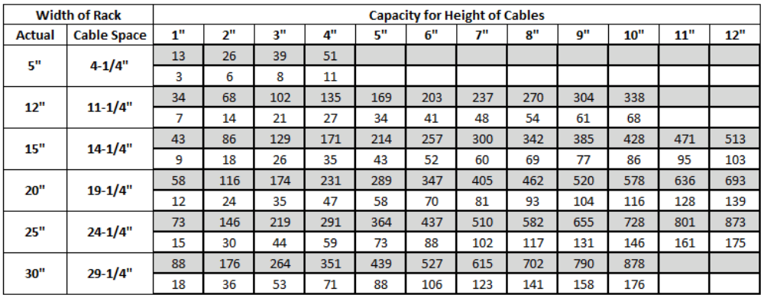

The capacities of the above table are based on approximately 3 cables or 150 pairs per square inch.
Reduce the approximate number and weight of cable in the above table by 25 percent when calculating cable capacities for unsecured cable rack.
When combining power and switchboard cable runs determine the ultimate pileup and width of cable racks by using the table above and converting power cables to terms of switchboard cables using the table below.

TABLE 6A.4 STANDARD POWER CABLE RACK SIZES AND CAPACITY
The upper number on the table below represents the approximate number of power type cables and the lower number the approximate weight in pounds per linear foot.

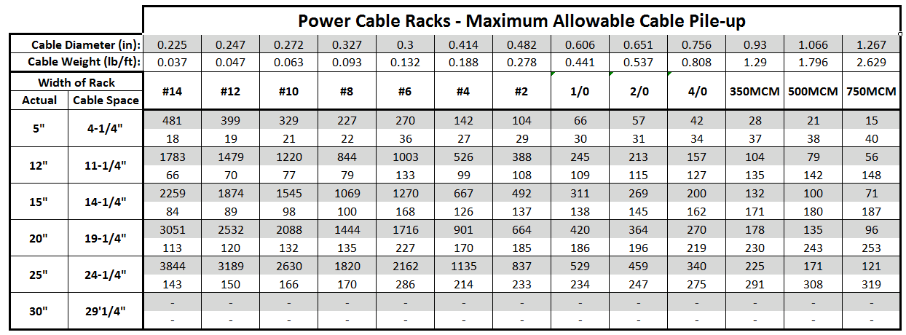

TABLE 6A.5 STANDARD FIBER CABLE RACK SIZES AND CAPACITY

The upper number on the tables below represents the approximate number of fiber type cables and the lower number the approximate weight in pounds per linear foot.

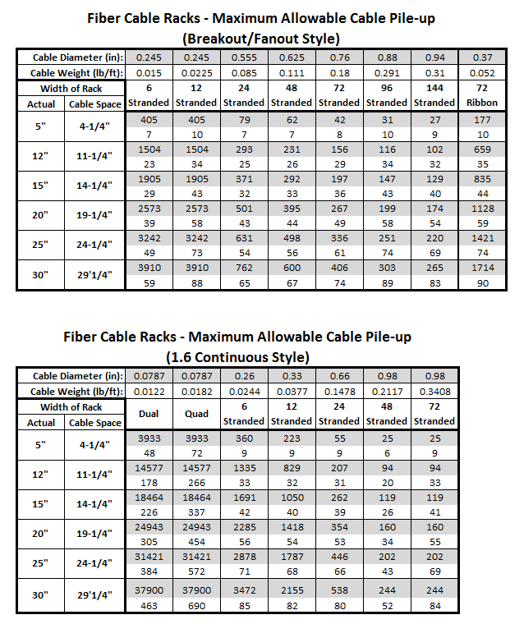

6A.5.2 Cable Rack Assembly
To maximize strength and rigidity, the longest length of sections and the fewest assemblies practical shall be employed in assembling cable racks.
- Some clips and plates tend to distort when nuts are tightened excessively. It is necessary, to prevent excessive distortion, that the tightening of nuts be stopped when perceptible bending is noted.
- Clamping details used to junction ladder-type cable racks are shown in Exhibits 2-E1-2 through 2-E1-12.
- The joining of sections of cable rack for usual conditions is shown in Exhibits 2-E1-23, 2-E1-24, 2-E1-26 through 2-E1-38, 2-E1-38H, 2-E1-39 through 2-E1-43.
- Exhibit 2-E1-39 covers arrangements for making small vertical offsets in horizontal racks.
- Ladder-type cable racks over the rear of channel-type frames supported by 11 foot 6 inch auxiliary framing shall be secured to ladder-type cable rack over the front of bulb-angle or channel-type frames supported by 11 foot 8 inch auxiliary framing as shown in Exhibit 2-E1-28A.
- Closing bars of the same width and thickness as the stringers of the cable racks, as shown in Exhibit 2-E1-25, shall be used at offsets as shown in Exhibit 2-E1-29 and to join cable racks of different widths as shown in Exhibits 2-E1-31 and 32.
- Closing bars used to junction cable racks of different widths and stringer sizes are shown in Exhibit 2-E1-21A.

SPLICING CABLE RACK: Splices shall be made as shown on Exhibits 2-E1-2, 2-E1-3 and 2-E1-94.
- No more than one splice shall be placed between any two adjacent points of support on horizontal runs.
- Multi-level and adjacent cable racks should stagger the splices, especially in heavy seismic zones.
- Cable rack splices shall not be construed as support
- A splice shall not be used beyond the last point of support when the end of a rack extends in cantilever fashion.

CORNER BRACKET: Corner brackets, per Exhibit 2-E1-34, are required at all right angle turns where the inside cable is turned on a radius greater than 8 inches.
- Corner brackets at right angle turns will be required on dedicated power or fiber cable racks.

HORIZONTAL AND VERTICAL OFFSETS: Edge clamps on cable rack assembled as shown in Exhibits 2-E1-35, 36, 37, 38, 40, 40A, 40B, and 40C shall not be subjected to any load other than the cabling at the turn or offset.
Offsets for horizontal cable racks are shown in Exhibits 2-E1-28, 29 and 30. Offsets for vertical cable racks are shown in Exhibits 2-E1-35, 36, 37, 38, 39, 40, 40A, 40B, and 40C.
Vertical cable rack offsets of 9 inches or less for switchboard or fiber cable and 12 inches or less for power cable in parallel planes shall be made as shown in Exhibit 2-E1-39.
- Transitions to/from fiber duct shall be at the same level (height) where possible.

Vertical cable rack offsets of greater than 9 inches in parallel planes shall be made using fixed degree edge clamps as shown in Exhibits 2-E1-35, 36, 37, 38, 40 and 40C.
- Vertical offsets per Exhibits 2-E2-40, 40A, 40B,and 40C are limited to a vertical offset of no more than 3 feet measured from top to top of the cable rack stringers.
- Where it is not practical to use fixed degree edge clamps for vertical offsets due to obstructions, adjustable clamps as shown in Exhibit 2-E1-40A or 40B may be utilized. Adjustable edge clamps shall be installed as close to 45 degrees as possible. Adjustable clamps shall be bolted as indicated in Exhibits 2-E1-40A and 2-E1-40B. For additional requirements when using adjustable offsets in earthquake heavy zones, refer to Chapter 6 Unit E of this Module.
- Vertical offsets in parallel planes shall be arranged so that they are positioned between supports for the horizontal rack. Supports shall not exceed 5 feet separation.
- Adjustable offsets per Exhibit 2 -E1-40A or 40B shall be installed as close to either a 45 or 90 degree angle as practicable.
- Adjustable offsets per Exhibit 2 -E1-40B are prohibited on power and fiber cable racks and at right angle turns where the inside cable is turned on a radius greater than 8 inches.
- Adjustable offsets per Exhibit 2-E1-40A and 2-E1-40B shall be bolted in all earthquake zones.

FINISHING DETAILS: The open ends of sections of cable racks and the protruding ends of supporting bars, shall be protected with rubber bumpers per Exhibit 2-E1-25C.
SPLIT NUTS: The use of split nuts, and associated split clips, is not approved.

6A.5.3 Cable Rack Support
Ladder and bar-type cable rack shall be supported from high or low-type auxiliary framing, other cable rack, threaded rods, stanchions, or approved wall or ceiling mounted brackets.
- High or low auxiliary framing structure shall not be supported from cable rack.

Horizontal cable racks shall be supported on approximately 5 foot centers, and in no case shall the spacing between supports exceed 6 feet.

- Supports exceeding 5 foot centers result in decreased ultimate cable capacity and shall not be engineered and/or installed without consulting Common Systems Standards.
- Each horizontal cable rack section shall have a least one point of support. Junctions (splices, T-intersections, etc.) and bracing fabrications shall not be considered a point of support.
- A support shall be provided within 36 inches of the free end of a cable rack.
- Note: The free end of a cable rack is the end that does not junction to another cable rack, or attached to the floor, wall, etc.
- Vertical cable racks that are supported on each end do not require additional support in the vertical section. Cable racks are considered vertical when they are at a 90 degree angle to the floor.

At intersections, where a free-ended cable rack is joined to a rigidly supported cable rack by corner clamps, as shown in Exhibits 2-E1-27 and 2-E1-34, supports shall be provided on the free-ended rack not more than 5 feet from the intersection.
- A rigidly supported cable rack is the section of rack between supports that does not consist of junction hardware such as corner clamps and splices.

At turns, offsets, and intersections having the equivalent of free-ended cable rack, such as in Exhibits 2-E1-26, 28, 28A, 29, 30, 31, 32, 33, 35, 36, 37, 38, 40, and 40C, the rack shall be supported such that the clamps will not carry an appreciable load.
- Exhibits similar to 2-E1-82, 83, 84 shall not be used to support cable rack from the equivalent of free-ended cable racks.
- Cable rack shall not be supported more than 20-inches above an auxiliary framing grid or another cable rack. Exhibits similar to 2-E1-62T, 62U, 66, 82, 83, 84.
- The portion of a cable rack from the last support to the free end shall not be used for ironwork support.

SUPPORT FROM OTHER CABLE RACKS: Ladder and bar-type cable rack shall be supported from other cable rack per Exhibits 2-E1-17C, 18A, 19A, 27, 54, 54F, and 97.
- Cable rack cross-straps shall not be used for support.

AUXILIARY FRAMING SUPPORT: Ladder and bar-type cable rack shall be supported from high or low type auxiliary framing per Exhibits 2-E1-65, 65B and 65C.
- Both stringers shall be J-bolted at each end of the run. J-Bolts should be provided on both stringers at each support. At a minimum one J-bolt is required at intermediate supports on alternate sides of the rack.

THREADED ROD SUPPORT: Ladder and bar-type cable rack shall be supported from threaded rods per Exhibits 2-E1-39, 66, 66C, 67, 74, 76, 77, 77C, 81 through 87, and 96.

- Cable racking supported by means of threaded rods shall be a maximum of 20 inches above auxiliary framing. (Examples can be found in Exhibits 2-E1-66, 2-E1-77, 2-E1-81, 2-E1-82, 2-E1-83, and 2-E1-95).
- Cable rack may be supported to an embedded ceiling insert, expansion anchor or U type channel, per Exhibits 2-E1-85, 86, 87 and Safe Loads Table.
- Cable rack or auxiliary framing support arrangements shall be such that threaded rods will not pass through cable racks.
- Threaded rod support 2-E1-76 shall not be used in heavy earthquake zones.
- C-CLIP SUPPORT: C-Clips shall be engineered in place of G-Clips for applicable support assemblies. G-Clips may be used for arrangements as identified below:
- G-Clips can be used when re-supporting rack with existing assemblies, relocating assemblies, or as necessary.
- C-Clips shall be installed at cable rack cross strap locations. If the cable rack or support location cannot be adjusted then G-Clips shall be used at cross strap locations.
- If both G-Clips and C-Clips would be used at a single support location, the C-Clips will be used on the cable rack providing the structural support. Example: use C-Clips on the lower cable rack when another cable rack is stilted above it.
- C-Clips shall be represented on Drawings by amending a “C” to the end of the Exhibit number used to identify the engineered assembly. For example, if G-Clips would normally be represented by Exhibit 2-E1-81, then C-Clips would be represented by “81C”

WALL BRACKET SUPPORT:
Ladder and bar-type cable rack, no greater than 12 inches in width, may be supported along walls using brackets per Exhibit 2-E1-91.
- Brackets may only be used on a limited basis where office conditions prevent the installation of other cable rack support options.
- Brackets shall be provided per requirements for supporting horizontal cable rack.
- Wall brackets shall support single level cable racking only.
- Wall brackets shall not be located below the top of frames within the maintenance area of a distributing frame, equipment frame, etc.

Ladder type cable rack may be supported vertically to walls with brackets per Exhibit 2-E2-97.

STANCHION SUPPORT: Ladder and bar-type cable rack may be supported using stanchions where auxiliary framing cannot be provided.
- Multiple level cable rack arrangements shall not be supported using stanchions. An exception is where an ironwork "grid" arrangement on 5 feet to 6 feet centers has been provided. Refer to Exhibit 2-E2-2F.
- Stanchions shall be placed at 5 feet intervals, not to exceed 6 feet, and located so as not to interfere with existing or future aisles or egress routes.
- Alternate stanchions shall be braced where more than one stanchion is required along a cable rack path.
- Stanchions arranged to form a grid of support per "Auxiliary Framing - Low, Floor Supported Environments" do not require additional bracing.
- Stanchions with abase 10 inches or smaller shall be anchored using two anchors in light seismic zones and four anchors in heavy seismic zones.
- Stanchions with bases larger than 10 inches shall be anchored using four anchors in all seismic zones.

Threaded rod extended from the top of a stanchion to the bottom of auxiliary framing shall not exceed 2 inches.
Where equipment frames are omitted, stanchions shall be provided where the gap between top supports exceeds 6 feet.
Only seismically tested and approved stanchions are allowed in heavy earthquake zones.

6A.5.4 Cross-Aisle Cable Rack
Cross-aisle cable rack shall be engineered when required and shall be located at a maximum of 20 feet intervals where not dictated by specific cable rack system arrangements or CenturyLink Standard Configuration documents.
- Cross-aisle cable rack shall be provided as to not interfere with the cabling entering or existing framework or cabinets below the cross-aisle racks. This may require smaller cross aisle racks to avoid this interference.
- High density cabling areas, such as distributing frames and DSX, should have cross-aisle cable rack at approximately 10 feet intervals.
- Cross-aisle cable racks shall only be placed for the first tier cable rack (usually switchboard). To avoid blocking of cable rack routes, cross-aisle racks shall not be installed for the additional tier racks when secondary tier cable racking varies or alternates between equipment lineups (i.e. power and fiber).

Ladder-type cross-aisle cable racks may be installed at the same level as the ladder-type over-frame racks, junctioned per Exhibit 2-E1-27, or at the high level shown in Exhibit 2-E1-54, where necessary to clear lighting, conduit or other obstructions.
- Cross-aisle cable racks must connect cable racks used for the same cable application (i.e. switchboard rack to switchboard rack) and shall be used for the same cable application as the racks connected to.
- Cross-aisle cable rack, five feet or less, may be supported using only T-intersection details per Exhibit 2-E1-27 or 2-E5-12G.

6A.5.5 Vertical Cable Rack
Refer to the "Cable Rack Assembly" and "Cable Rack Support" sections for requirements on vertical "offsets".
Vertical ladder-type cable racks arranged to attach directly to floors or to similar flat surfaces shall be terminated as shown in Exhibit 2-E1-13.
- When the foot of the rack does not present a hazard and space permits, the cable rack feet may be turned outward.

Vertical cable racks used to support cables passing through floors shall be supported at the floor and ceiling adjacent to the cable hole or slot as shown in Exhibit 2-E1-13A for cable holes equipped with channel sheathing or Exhibit 2-E1-13B for cable holes equipped with angle sheathing.
Vertical cable racks used to support cables in shafts shall be supported at each floor and ceiling as shown in Exhibit 2-E1-13D.

6A.5.6 Bracing Cable Rack
Hanger rods supporting continuous horizontal cable rack runs more than 2 feet below auxiliary framing or a ceiling and over 20 feet long shall be braced sidewise and endwise to prevent sway. Bracing shall be installed at approximately 20 feet intervals and, where practical, in a staggered arrangement on opposite stingers of the cable rack.
- An additional side brace shall be provided at the end of a cable rack run where the distance from the last brace is 10 feet or more.
- Cable rack installed horizontally shall be braced sidewise as shown in Exhibits 2-E1-88 and 2-E1-89.
- Vertical cable rack between floors will not normally require bracing; however, cable rack with unusual sway should be braced to the ceilings using methods similar to Exhibits 2-E1-88 and 89.

Hanger rods supporting second tier continuous horizontal cable rack runs stilted above auxiliary framing do not require bracing.

6A.5.7 Cable Support Brackets
Cable pileup in brackets shall adhere to the limitations listed in Tech Pub 77350.
Cable brackets or horns shall be mounted at approximately 12-inch intervals (when used with copper/power cable) with a maximum of 18 inch intervals.

Cable brackets or horns shall be mounted at approximately 6 inch intervals (when used with fiber cable) with a maximum of 9 inch intervals.

Compartment type cable brackets extending above the cable rack stringer shall not be used for the purpose of running cable that is required to be "separate" or "segregated". This includes power and fiber cables.

Cable rack “cable brackets” similar to Exhibit 2-E1-57E, 57F, or 57G may be mounted to cable rack or auxiliary framing.
- The above brackets may be used for all fused power cables or framework ground feeders.
- Power cables, ground feeders, and fiber cables shall not be run together on the same cable brackets.
- Different cable types shall not be mixed on the same cable brackets. i.e. SWBD and power, SWBD and fiber, etc.
- Cable brackets shall be installed with the bracket pointing toward the center of the cable rack where possible except where they would interfere with the ultimate cable pileup of other cable racks.

Cable support brackets, per Exhibit 2-E1-95, may be used for limited applications of dedicated cable runs. These brackets shall not be used for fiber cable.
- Cable support brackets shall be installed so as not to obstruct the ultimate cable pileup.
- Where cable support brackets are used for cable runs that are to be segregated, the cable must be supported a minimum 2 inches above the ultimate cable pileup.

6A.5.8 Screen, Pan, and Brackets
Panned or screened racks with cable retaining brackets are generally intended for high volume cabling routes which allow for free running of cables and limited securing.
Screen or Pan
- "Screen" generally applies to a metal plate supported to the underside of cable rack with clips (existing environments only).
- "Pan" generally applies to a plastic or metal plate placed on top of a cable rack.

- Pan or plates, placed on cable rack, shall be used where cables are to be run unsecured. Metal pan, except where included with bar type cable rack ordering codes, shall not be utilized on a going forward basis.
- Where a cable rack is terminated with rubber bumpers and plastic plate is utilized, the plate shall be moved back so that it terminates at the last cross-strap.
- Cable rack screen, supported beneath cable rack, shall be engineered only in light earthquake areas where the bottom cabling layer has become unsecured as in cable mining activities.
- Screened type cable rack per Exhibit 2-1E-92 shall not be used in heavy earthquake areas.

Cable Retaining Brackets (Cable Horns)
- "Brackets", when used with screen or pan, generally applies to cable retaining type brackets.
- Exhibit 2-E1-93 illustrates several types of discontinued cable retaining brackets Exhibit 2-E1-93A illustrates current typical cable brackets
- Compartment type cable brackets are restricted use. Contact Common Systems Standards for approval prior to installation.
- Cable retaining brackets are required on all cable rack, with unsecured cables, that do not include a compartmentalized cable way system.
- Secured type cable retaining brackets, per Exhibit 2-E1-93A, shall be engineered where possible.
- Cable retaining brackets shall be located on alternate straps of the cable racks.
- Install cable horns in a zigzag pattern similar to the following illustration. Cable horns shall be on approximately 18 inch centers on one side of the rack. Brackets should straddle the cable rack strap. Additional cable horns shall be located at cable rack intersections, turns, etc. as needed.
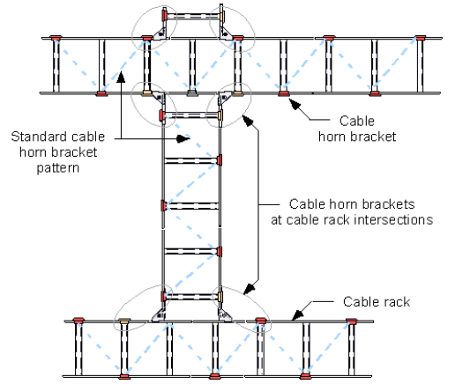
- At crossing points and points where cables drop off the racks, it may be necessary to locate additional brackets to add protection for the cable.
- Cable retaining brackets, where cable must be secured, shall be installed with the cable retaining bar to the inside of the cable rack stringer (side) and the cable retaining clamp to the outside of the stringer. See Exhibit 2-E1-93A.
- Cable retaining brackets shall not be installed on cable transitions (waterfalls) as the cables on this portion of a cable rack must be secured.
- Snap-on type cable horns are not designed to withstand impact loading and shall not be used to form troughs in which cables are pulled or dragged.

Cable Distribution Systems provide separation of free-running cables with limited securing, and are described in Unit F of this document.
The following cable retaining bracket heights are available per Exhibit 2-E1-93A.
- 5 inch high: Approved for use on all 5 inch wide cable racks. Maximum pileup on these racks is 5inches. These can also be used on wider cable racks where there is less than 8 inches clearance above the rack and cable pileup cannot exceed 5 inches.
- 8 inch high: Default cable horn bracket size. Use on main aisle or lineup cable rack where the cable pileup should not exceed 8". Cable rack kits that include cable horns and pan include the 8" cable horns.
- 12 inch high: Use on cable rack where the cable pileup would most likely exceed 8inches. This will occur on most main aisle cable racks in medium to large CO's and cable racks in high cable volume areas such as DSX lineups, Distributing Frames, and some via racking.
- Lineups approaching the 50 foot maximum length may also require 12 inch horns based on the type of equipment deployed.
- High volume cable routes though lineup cable racking normally using 8 inch horns will also need to be evaluated for the 12 inch horns.

6A.6 Power Cables and Racking
It is the intent of these requirements that power cables will be segregated from switchboard cable and separate power cable rack will be provided where space permits.
All Power cable with a 70 Ampere protection device or larger shall be run on separate, segregated cable rack or supported on brackets below existing cable rack.
- Power cables 350,000 (350KCMIL) or larger are prohibited on switchboard cable rack no matter what amperes they are fused at.
- Cables protected at less than 70 Amperes can be run on the same cable rack as switchboard cables if there is no space to provide a power cable rack.
- A Letter of Deviation shall not be accepted allowing cables protected 70 Amperes or above placed in the same cable rack as switchboard cables.

Power cable number 00 (2/0) or larger, shall not be unsupported for a distance greater than 3 sheath feet.
- This requirement shall only apply to vertical transitions between cable rack and frames, battery stands, etc.

POWER ONLY CABLE RACK: Cable rack engineered and/or installed for segregated power runs shall be solid stringer type only.
- Existing channel type cable rack is acceptable for running power cable.
- Power cable rack shall be supported utilizing auxiliary framing as illustrated per Exhibits 2-E1-65 and 77B.
- Power cable racks shall be sized based on required capacity and in no case shall exceed 25 inches in width. Additional auxiliary framing support structure may be required when power cable rack sizes greater than 20 inches are utilized.

Main power cable runs require considerable support, particularly at horizontal to vertical outside turns. The cable rack at such turns shall be of the type shown in Exhibit 2-E1-53.
- Turns in cable racks 20 inches wide may be assembled by bolting together, side by side, two 10 inch turns.
- Power cable rack turns are similar in general construction to ladder-type cable racks, except that the straps are formed to 7 and 14 inch outside radii of 90 degree turns, the straps being on the outside of the turns as shown in Exhibit 2-E1-53. Power cable rack turns are available in a variety of widths.

Extended vertical runs of power cable rack, in excess of three floors must have a minimum of 20 feet of horizontal cable rack provided on every third floor to alleviate cable weight build-up.
At the bottom of vertical cable racks that carry power cables exclusively, the intermediate cross-straps shall be removed when the uninterrupted rise exceeds two floors as shown in Exhibit 2-E1-36, to prevent damage to sagging power cables.

6A.7 Fiber Only Cable Rack
It is the intent of these requirements that fiber cables will be segregated from switchboard and power cable and separate fiber cable rack will be provided where space permits.
All fiber shall be run on separate, segregated cable rack or supported on brackets below existing cable rack.
- Fiber cables are prohibited on switchboard or power cable rack no matter what size fiber cable.
- Fiber cables may be run on fiber protection system (FPS) if segregated fiber cable rack is not feasible. Refer to Technical Publication 77351, Chapter 6, unit G for engineering requirements associated with the Fiber Protection System.
- A Letter of Deviation shall not be accepted allowing fiber cables to be placed in the same cable rack as switchboard or power cables.

- Fiber cable shall not be unsupported for a distance greater than 3 sheath feet.
- This requirement shall only apply to vertical transitions between cable rack and frames.

FIBER ONLY CABLE RACK:

GRAY FIBER CABLE RACK: Gray fiber cable rack is allowed in the following conditions:
  - Existing equipment lineups only in which the gray fiber cable rack may be extended to the end of the equipment lineup.
  - Gray fiber cable rack must not be equipped with pan or screen to allow fiber cables to remain visible at all times.
  - Gray fiber cable rack must be labeled as “Fiber Optic Cable Only” on the outside of each stringer every five feet.

ORANGE FIBER CABLE RACK: Orange fiber cable rack is the approved cable rack dedicated for fiber optic cables and may be equipped with brackets and the approved fire rated pan. The bright coloring eliminates the requirement for stenciling or labeling necessary on gray cable racks.
  - All existing equipment lineups with established orange fiber cable rack.
  - All new equipment lineups.
  - May be equipped with pan and brackets for all horizontal cable rack run. When not equipped with pan and brackets, the fiber cables shall be tied to the cable rack cross bars using the approved securing method.

- Existing channel type cable rack is acceptable for running fiber cable.
- Fiber cable racks shall be sized based on required capacity and in no case shall exceed 25 inches in width as the equipment lineup rack and 30 inches in width as the main aisle rack.
- Fiber cable rack sized less than 24 inches may be supported utilizing C-clips as illustrated per Exhibits 2-E1-66A, 66 and 66C.
- Fiber cable rack sized 24 inches and greater shall be supported utilizing auxiliary framing as illustrated per Exhibits 2-E1-65 and 77B.
- All bend radii must be preserved. Corner brackets on each horizontal turn and 90 degree turns for vertical drops will be engineered, installed and reflected on the drawing records.
- Fiber cable rack shall adhere to a minimum 12 inch clearance above the top of the cable rack to the bottom of any obstruction to accommodate cable pileup and cable securing operations with the following exceptions:
- Cable rack routes with a maximum pileup of less than 12 inches, such as power and fiber racks, may have a minimum clearance to obstructions where it will not impact ultimate cable pileup or securing operations. Allow 5 inches clearance for securing operations where necessary.
- Five inch wide cable rack where it is supported with 2-E1-85 type saddle brackets.
- Standard 12 inch high wall cable holes that will accommodate 10 inches of cable pileup with the cable rack extended through the cable hole.

Main fiber cable runs require considerable support, particularly at horizontal to vertical outside turns. The cable rack at such turns shall be of the type shown in Exhibit 2-E1-53.
- Turns in cable racks 20 inches wide may be assembled by bolting together, side by side, two 10 inch turns.
- Fiber cable rack turns are similar in general construction to ladder-type cable racks, except that the straps are formed to 7 and 14 inch outside radii of 90 degree turns, the straps being on the outside of the turns as shown in Exhibit 2-E1-53. Fiber cable rack turns are available in a variety of widths.

Extended vertical runs of fiber cable rack, in excess of three floors must have a minimum of 20 feet of horizontal cable rack provided on every third floor to alleviate cable weight build-up.

SECURING FIBER CABLE:

Fiber cables shall be secured appropriately based on the following requirements and requirements outlined in the CenturyLink Installation Standard 77350.
- Cable ties to secure fiber optic cables are prohibited for any application
  - Lacing cord used with fiber sheeting is the preferred securing method which allow for maximum use of allotted cable space.
  - Plastic cable ties degrade, become brittle, and break over time. Sharp edges may damage cable jacketing and places the fibers at risk for damage.
- At the bottom of vertical cable racks that carry fiber cables exclusively, the intermediate cross-straps shall be removed when the uninterrupted rise exceeds two floors as shown in Exhibit 2-E1-36, to prevent damage to sagging fiber cables.
- Fiber cables of all sizes must be secured for all transitions and vertical routes, wrapping with fiber sheeting where it is tied with cord within the overhead cable support system.
- Fiber cables of all sizes must be secured to every 4th cross strap in horizontal applications and to every cross strap in vertical applications on non-panned and bracketed cable rack.
- Fiber cables may be run unsecured on orange, panned and bracketed ladder rack only. Similar size cables should be loosely bundled with fiber sheeting and lacing cord
- Running single and dual fiber cables on un-panned ladder rack is not approved.
  - Increase optical attenuation is introduced to circuits when single and dual fiber cables less than 2.0mm outer diameter are routed and secured to ladder rack cross straps
    - Placement of new dedicated fiber cable rack equipped with approved fire rated pan shall be considered as a first choice.
    - Fiber duct attached to the cable rack stringer or cable support brackets may be considered.
      - Care must be taken to consider the entire route when selecting the fiber duct support options so as to not obstruct existing cable rack or force a change of level.
      - Solid fiber duct is required for all horizontal applications.
    - As a last result, singles and duals may be run on existing un-panned ladder rack that cannot be retro-fitted with the approved fire rated pan or new dedicated fiber cable rack shall not be added.

CABLE BRACKET: Refer to the section "Engineering Requirements - Cable Support Brackets" for requirements.

6A.8 Bar Type Cable Racking
Bar type cable racks shall only be provided where extending existing bar rack in older ironwork arrangements such as those for Crossbar or Step-by-Step. New lineups should be of ladder type rack where bar type cable racks were not previously provided.

6A.9 Cable Holes and Firestopping

6A.9.1 Cable Holes
- The recommended method of fire/smoke stopping is accomplished with approved intumescent and endothermic materials identified by CenturyLink Standard Configuration documents and Fire Life and Safety Practices.
- All reference to a cable hole or firestopping in this document are associated for use with network cabling only.
- Locations of cable holes shall be coordinated between Network Engineering and CenturyLink Real Estate through the approved process. Cable holes shall be provided by CenturyLink Real Estate.
- Cable holes used during the course of any CenturyLink project shall be modified as necessary to meet the current level of standards outlined in this section.
- The Engineering Judgement from the firestopping manufacturer shall be followed when modifying existing or establishing new unique or non-standard cable holes.
- Firestopping assemblies shall comply with the manufacturer’s UL listed drawings.
- All cable holes shall be temporarily closed at the end of each working day, or whenever it is anticipated that no additional cable will be run that same day and tagged per CenturyLink Technical Publication requirements.
- Cable holes shall be defined as the following:
  - OCCUPIED CABLE HOLES pertain to openings in floors and walls with cable passing through them.
  - UNOCCUPIED CABLE HOLES pertain to openings in floors and walls without cable passing through them.

CABLE HOLE CAPACITIES: Firestop material manufacturer requirements always include maximum limits on cable hole fill for the firestop material warranty to be valid. Cable hole capacities shall be limited per manufacturer requirements based on the individual manufacturer’s UL listed drawings.

- “F” ratings, as defined by UL, is the amount of time a fire stopping assembly can endure extended fire before it is breached (fire gets through). “F” ratings must meet or exceed the existing rating of the wall or floor.
- “T” rating, as defined by UL, is the amount of time a fire stopping assembly can resist the passage of heat through a fire stopping system. “T” ratings must meet or exceed the minimum rating of the floor.

6A.9.1A Cable Hole - Floors

CABLE HOLE ANGLE IRON OR CHANNEL FRAME: Cable holes shall be curbed with a welded structural steel angle or channel frame and drilled to accept a cover and bolting material. Curbine shall be capable of supporting vertical cable racking and load.
- Cable hole curb shall be positioned as shown in firestop manufacturer UL listed drawings.

Joints between the cable hole curbing and the floor shall be made functionally air and water tight by filling with the firestop manufacturer’s product requirements.

CABLE RACK SUPPORT:
- Cable rack shall be supported at floor cable holes per Exhibits 2-E1-13A, 13B, 13C, 13D and 13E.
- The addition of U-channel per Exhibit 2-E1-13E is requested through CenturyLink Real Estate.

CABLE HOLE COVERS:
- Floor and wall covers shall be secured to the sheathing or fascia with 1/4-20 fasteners and 1-1/4 inch fender washers. Covers shall be cut to fit as closely as practical to fit around the cable bundle per firestop manufacturer requirements.
- Where possible, cable hole safety steel covers shall be cut to allow a straight cable path through the cable hole. Appropriate modifications to the intumescent sheets are required when routing cables through the cable hole to closely match the profile and adhere to the maximum gap allowed in the manufacturer approved UL listed drawing.

WELDED STRUCTURAL STEEL ANGLE OR CHANNEL FRAMES:
- Cable holes shall be provided with a welded structural steel angle or channel frame at floor penetrations for the attachment of cable hole, covers, firestop materials.
- Must be equipped with a minimum collard depth of 3 inches.

All cable holes or slots through the floor which are accessible by personnel for any reason must be provided with a top cover made of steel, regardless of the technology employed.
- Top floor opening covers shall be required and shall be a minimum of 10 gauge steel.

6A.9.1B Cable Hole - Walls

An approved manufacturer’s UL listed drawing shall be applied for firestopping of occupied wall cable openings for all types of fire rated walls and partitions.

FASCIA ANGLES:
- Cable holes shall be provided with fascia angles at wall penetrations for the attachment of cable hole, covers and firestop materials.
- The addition of fascia angles is requested through CenturyLink Real Estate.
- Fascia angles shall be tapped to accept a minimum of 1/4-20 type threaded fasteners.
- Fascia angles or other components of a wall cable hole shall not be used for cable rack attachment or support.

6A.9.2 Firestopping
- Firestopping shall be installed by an approved contractor whom is trained by the appropriate firestop system manufacturer.
- All references to firestopping in this document are associated for use with network cabling only.
- All firestopping material must be provided by the same firestop manufacturer within a single cable hole. Different firestop manufacturer’s product cannot be mixed within the same cable hole.
- A primary firestopping manufacturer shall be established for each facility where possible and going forward all new cable holes shall utilize that primary firestopping manufacturer.
All cable holes or slots, whether occupied or unoccupied, in a fire rated wall or floor will be sealed with approved firestop materials.
- Enclosed cable distribution systems, including fiber protection systems and conduit, shall be terminated no less than 3 inches prior to where it passes through a floor or wall cable hole penetration. The cable system shall be arranged so that only the cable passes through the floor or wall opening. The opening shall then be enclosed per the appropriate firestop methods.

- Materials must be applied according to firestop system manufacturer’s UL listed drawing for the appropriate “F” rating.
- Refer to CenturyLink Technical Publication 77350 and the manufacturer’s UL listed drawings for proper installation of firestop material and managing of cables through the cable hole.

CABLE HOLE CAPACITY: Cable holes shall not be filled beyond the approved capacity on the UL listed drawing or Engineering Judgement to allow for firestop to operate effectively.
- Cable holes nearing or surpassing capacity will be brought to the attention of the CenturyLink Engineering representative immediately.

CABLE SLEEVE: Cable hole sleeves shall use a high temperature material between the cable bundle and edge of the sleeve as well as any other openings.
SLOTS AND HOLES FOR DISTRIBUTING FRAMES: Cable holes and slots shall be upgraded to the approved intumescent and endothermic materials where practical.
- Traditional Cable Holes - Occupied distributing and protector frame slots that have not been upgraded shall have the space between the stub cables or bundles and the slot filled a minimum of three inches thick mineral wool batting material to the full depth of the slot or 12 inches. Voids between the cables may be filled with high temperature material. No bottom cover is required. The top cover should be secured in place and the batting compressed from below, adding additional wool to assure a tight fit around the cables and to obtain the depth required.
- Slots beneath protector and distributing frames do not require steel top covers or require certification labels to allow for personnel access.
- Unoccupied cable slots may be closed using either of the methods described in the previous paragraphs for occupied cable slots.

CABLE HOLES WITH WOOL BAGS:
Occupied cable holes utilizing wool bag type firestop materials shall be upgraded to preferred materials when opened for a cabling addition or as soon as practical.
- All cable holes and slots that utilize mineral wool bags must be provided with steel cover plates on both sides of the enclosure.
- Unoccupied wall openings may use approved mineral wool bags in place of approved intumescent and endothermic materials; however, the wool bags must be replaced when the hole is activated.
- Secure the first cover to the ceiling or wall opening. Pack mineral wool bags tightly to the thickness of the wall or floor and install the second steel cover.

6A.9.3 Firestop Certification Labels
Certification labels shall be provided across the edge of all cable hole covers to verify that the opening has been properly firestopped according to CenturyLink Policy. Label placement shall assure that the label will be destroyed when a cover is removed.
PERMANENTLY CLOSED HOLES:
- Certification labels shall be approximately 3 inches high by 6 inches long, pressure sensitive, predominantly red or with a red border. Printing shall be in obvious contrast to its background.
- Certification labels shall contain the following statement in bold lettering; "FIRESTOPPED CABLE HOLE NOTICE" followed by the statement "This cable hole has been firestopped in accordance with CenturyLink Technical Publication 77350". Labels shall also provide fields for the following entries:
- Project Number
- Vendor/Organization
- Date Closed
- UL Listed Fire Assembly Number or Engineering Judgement (EJ) number.
- Responsible Party Contact Information.

TEMPORARILY CLOSED HOLES:
- A label, approximately 3 inches high by 6 inches long, pressure sensitive, predominantly green or with a green border shall identify the closure as part of an on going cabling operation.
- Label printing shall be in obvious contrast to its background.
- Certification labels shall contain, in bold lettering, the words "CABLE HOLE OPENED" and the statement "This hole is to be temporarily closed at the end of each working day or when no additional cable is to be run that same day and shall conform to CenturyLink Technical Publication 77350". Labels shall also provide fields for the following entries:
- Project Number.
- Vendor/Organization
- Date Closed
- UL Listed Fire Assembly Number or Engineering Judgement (EJ) number.
- Responsible Party Contact Information

    - 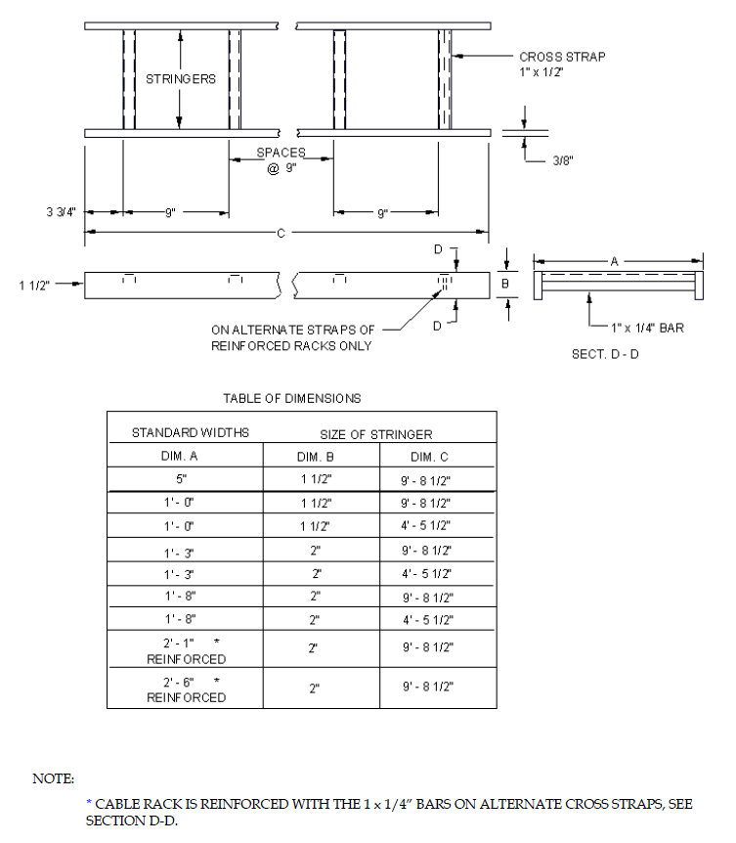
EXHIBIT 2-E1-1
2-E1-1 STRAIGHT SECTIONS LADDER-TYPE CABLE RACK

- 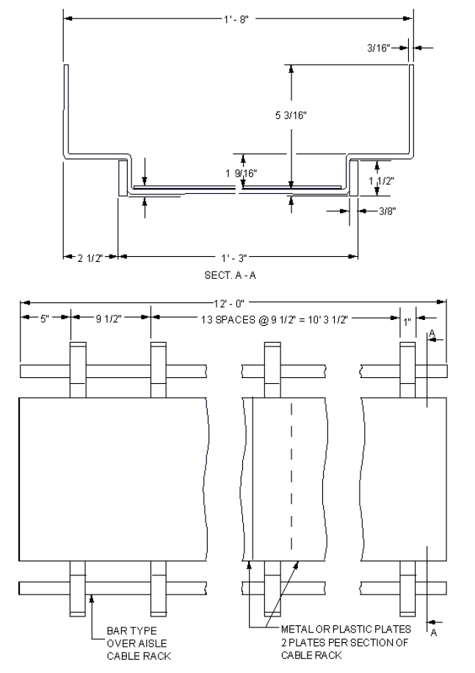

- EXHIBIT 2-E1-1D (A&M)
2-E1-1D (A&M) STRAIGHT SECTIONS BAR-TYPE OVER-AISLE CABLE RACK
- 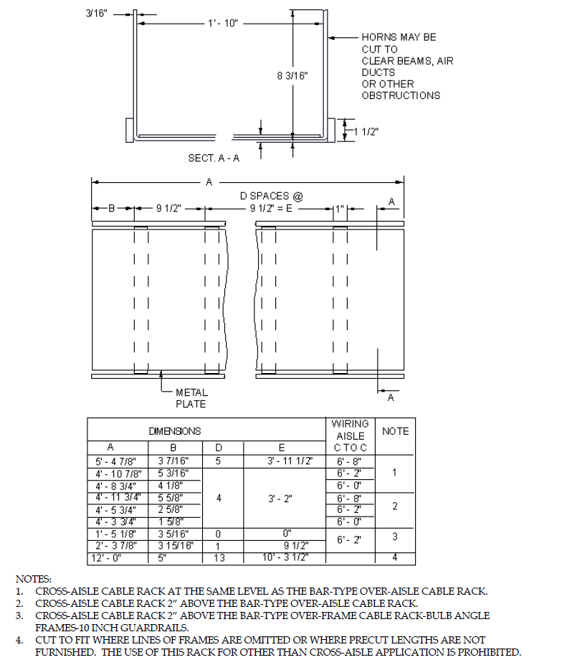

EXHIBIT 2-E1-1E (A&M)
2-E1-1E (A&M) STRAIGHT SECTIONS BAR-TYPE CROSS-AISLE CABLE RACKS

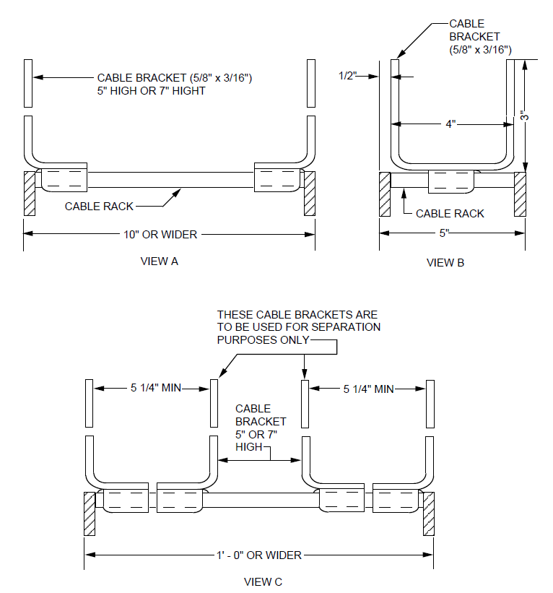

EXHIBIT 2-E1-1F
2-E1-1F MOUNTING SNAP-ON CABLE BRACKETS ON LADDER-TYPE CABLE RACKS

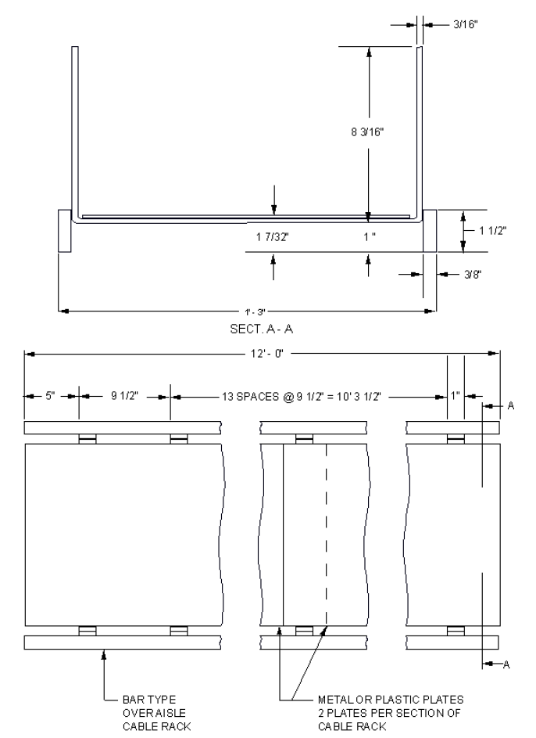
EXHIBIT 2-E1-1G (A&M)
2-E1-1G (A&M) STRAIGHT SECTIONS BAR-TYPE OVER-FRAME CABLE RACK
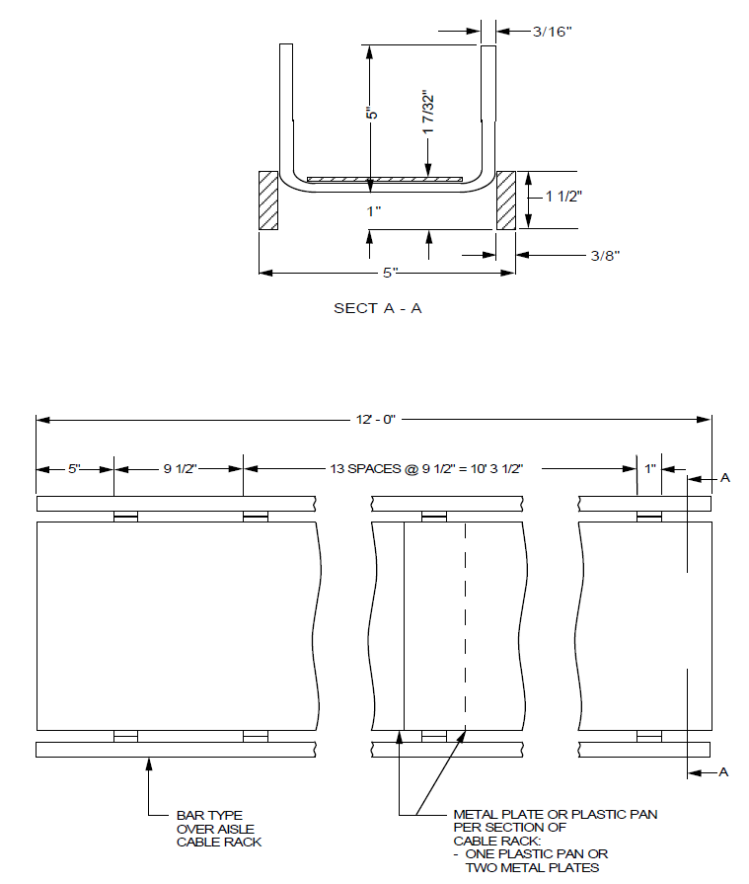

EXHIBIT 2-E1-1H (A&M)
2-E1-1H (A&M) STRAIGHT SECTIONS BAR-TYPE CABLE RACK

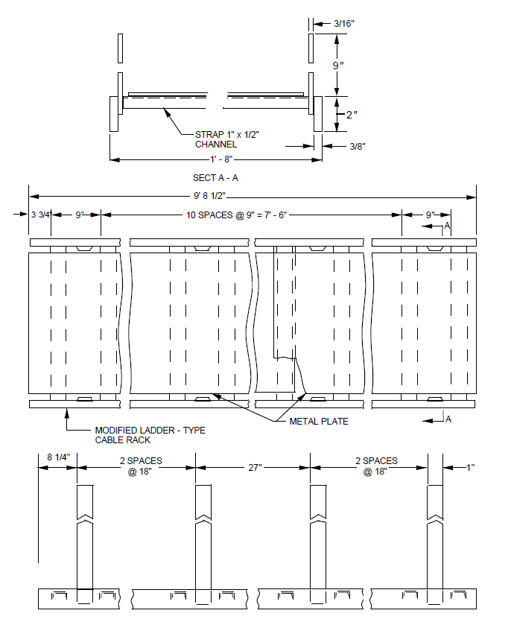
EXHIBIT 2-E1-1J
2-E1-1J STRAIGHT SECTIONS MODIFIED LADDER-TYPE CABLE RACK FOR UNSECURED CABLING

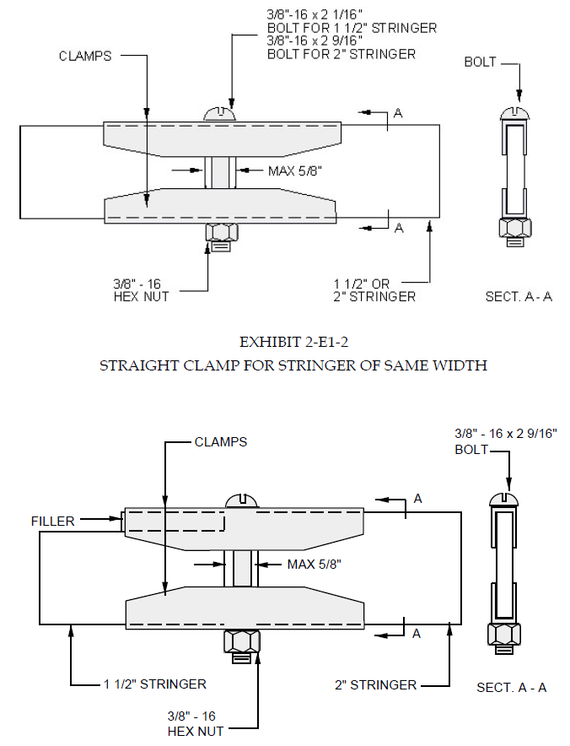
EXHIBIT 2-E1-3
2-E1-3 STRAIGHT CLAMP FOR STRINGERS OF DIFFERENT WIDTHS
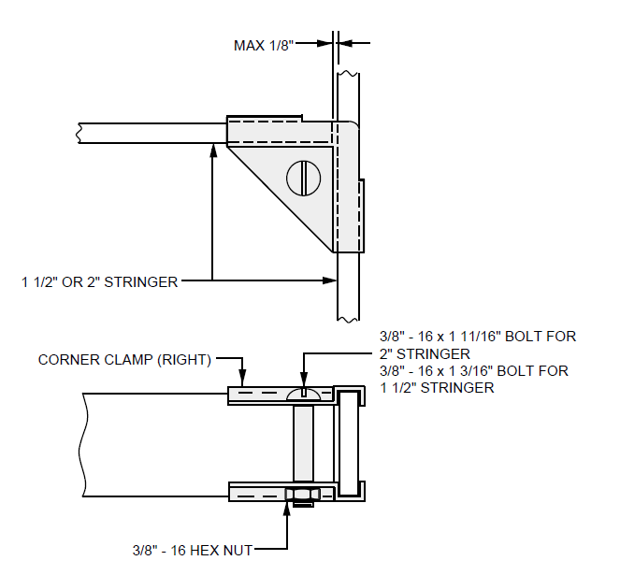

EXHIBIT 2-E1-4
2-E1-4 CORNER CLAMP FOR STRINGER OF SAME WIDTH

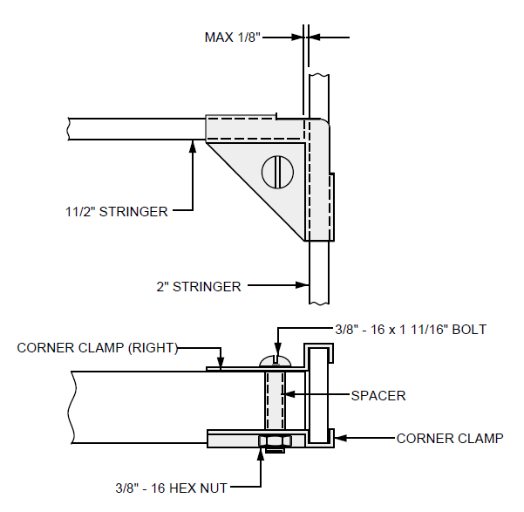

EXHIBIT 2-E1-5
2-E1-5 CORNER CLAMP FOR STRINGERS OF DIFFERENT WIDTHS-LEFT

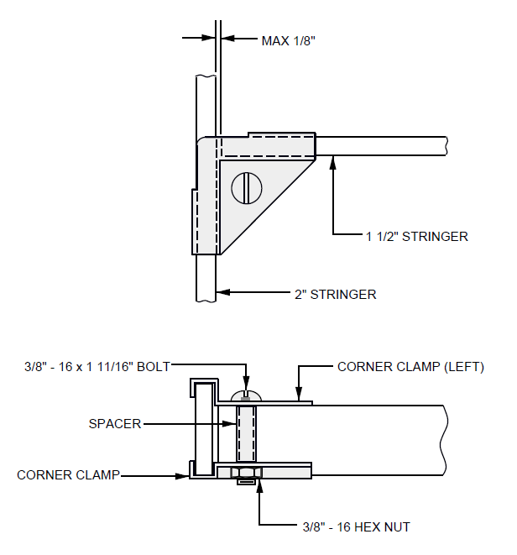

EXHIBIT 2-E1-6
2-E1-6 CORNER CLAMP FOR STRINGERS OF DIFFERENT WIDTHS-RIGHT

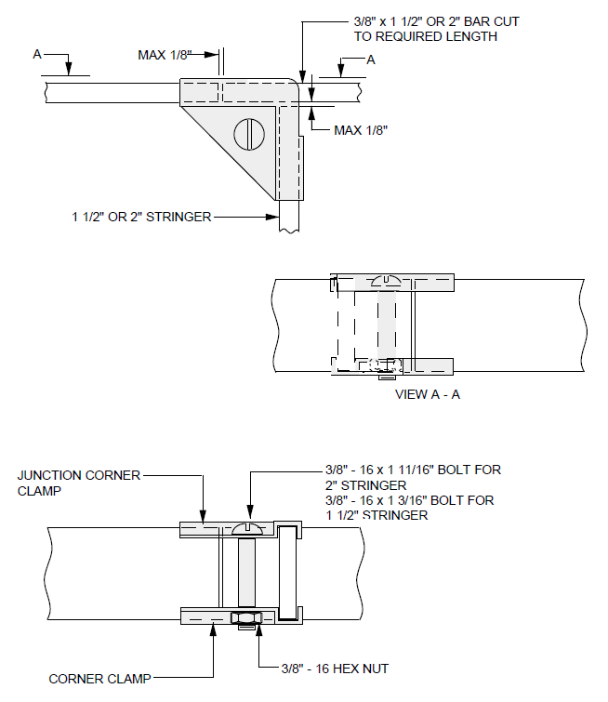

EXHIBIT2-E1-7 (DISCONTINUED)
2-E1-7 (DISCONTINUED) JUNCTION CORNER CLAMP FOR STRINGERS OF SAME WIDTH-LEFT

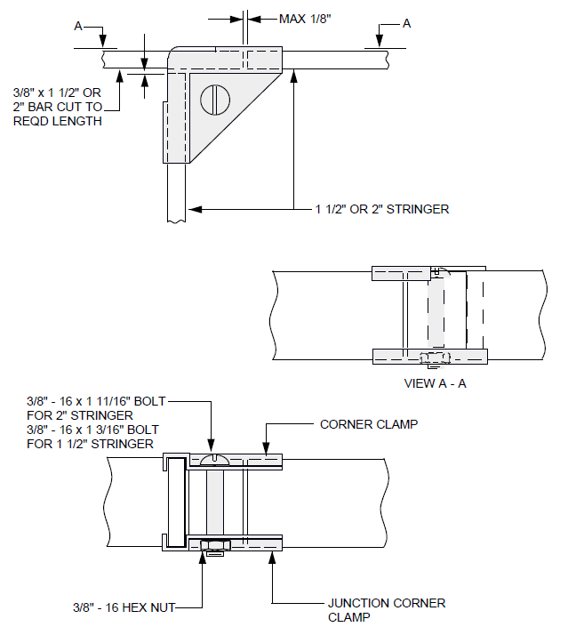

EXHIBIT 2-E1-8 (DISCONTINUED)
2-E1-8 (DISCONTINUED) JUNCTION CORNER CLAMP FOR STRINGERS OF SAME WIDTH-RIGHT

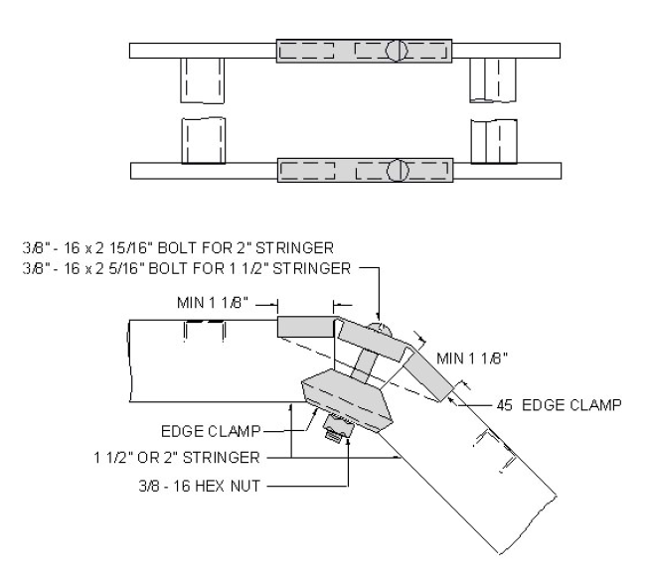

EXHIBIT 2-E1-9
2-E1-9 45 DEGREE EDGE CLAMP FOR OUTSIDE TURN

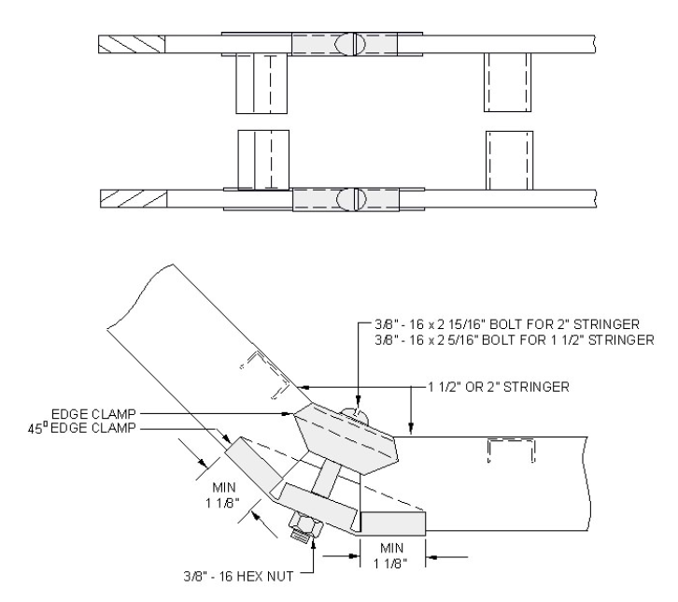

EXHIBIT 2-E1-10
2-E1-10 45 DEGREE EDGE CLAMP FOR INSIDE TURN

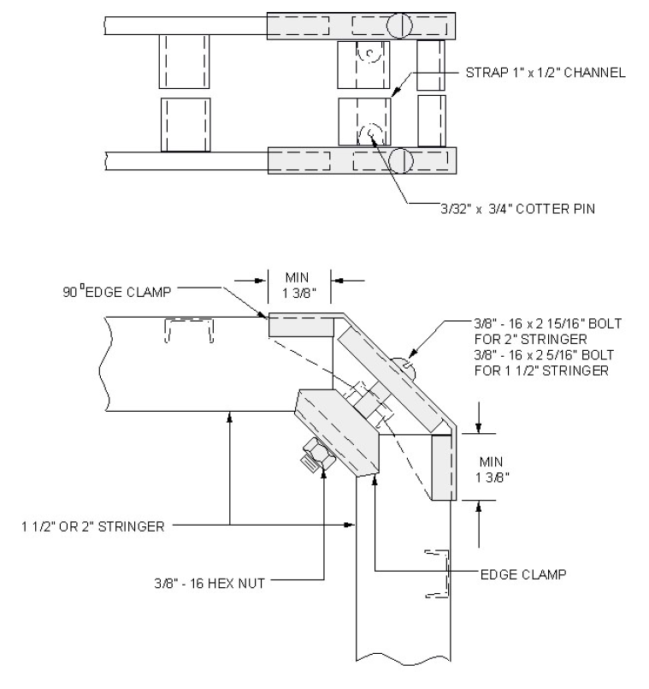

EXHIBIT 2-E1-11
2-E1-11 90 DEGREE EDGE CLAMP FOR OUTSIDE TURN

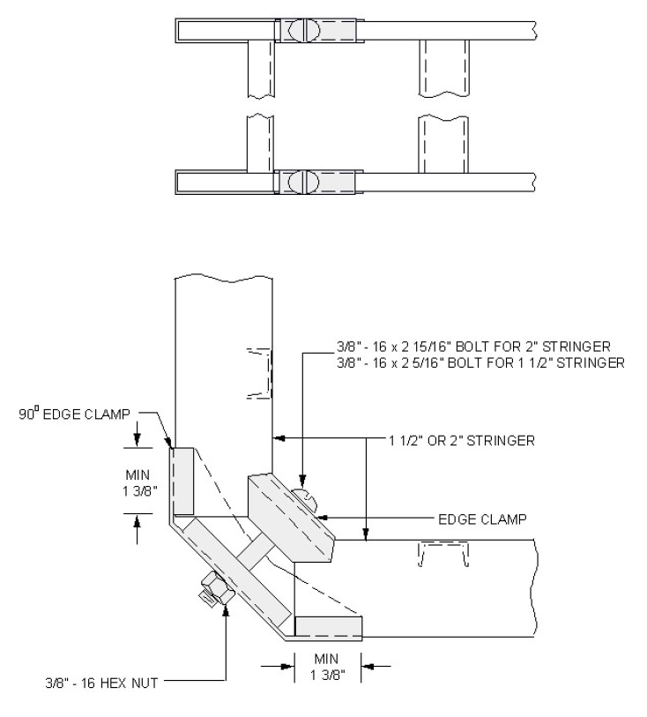

EXHIBIT 2-E1-12
2-E1-12 90 DEGREE EDGE CLAMP FOR INSIDE TURN

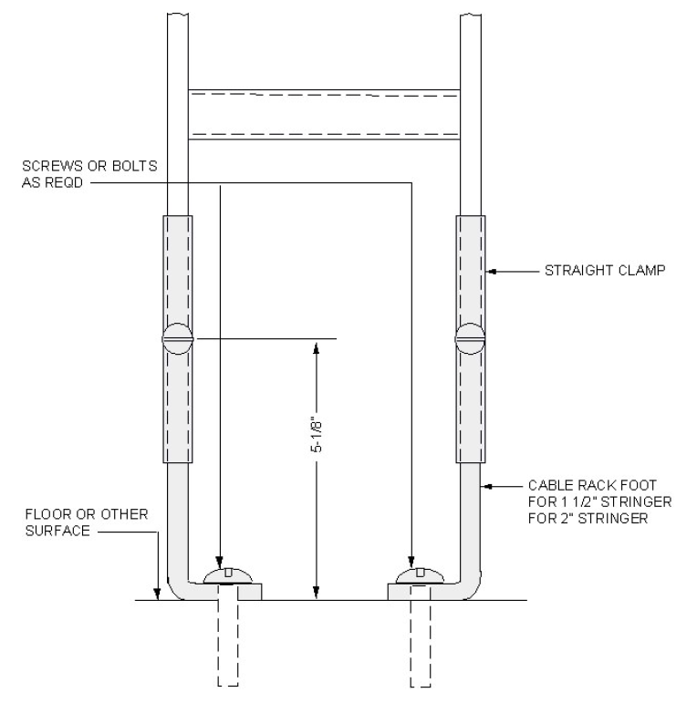

EXHIBIT 2-E1-13
2-E1-13 SECURING END OF VERTICAL RACK

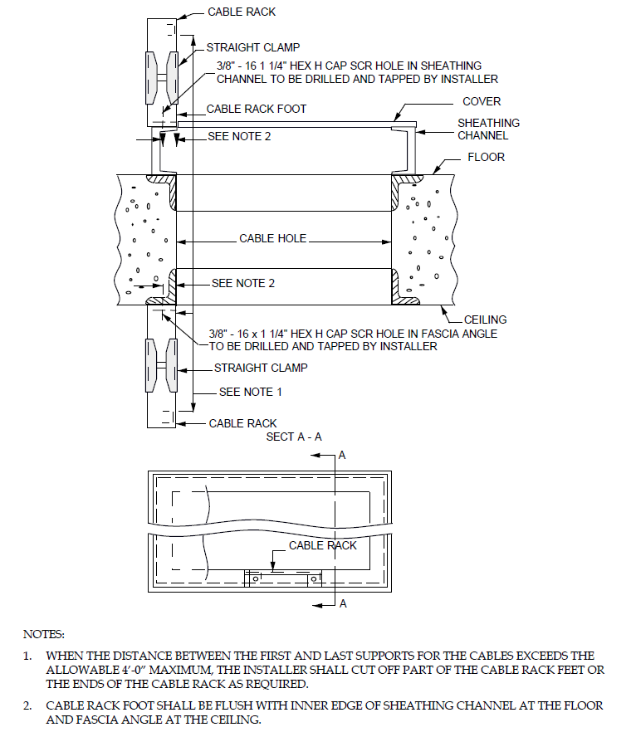

EXHIBIT 2-E1-13A
2-E1-13A TERMINATING VERTICAL CABLE RACK AT CABLE HOLE CHANNEL-TYPE SHEATHING

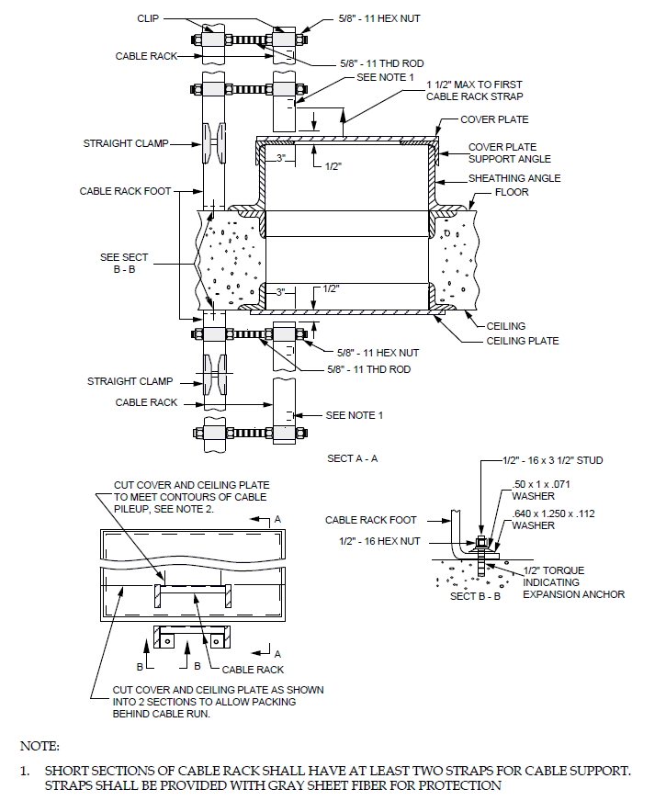
EXHIBIT 2-E1-13B
2-E1-13B TERMINATING VERTICAL CABLE RACK AT CABLE HOLE. ANGLE-TYPE SHEATHING - ADDITIONS ONLY.

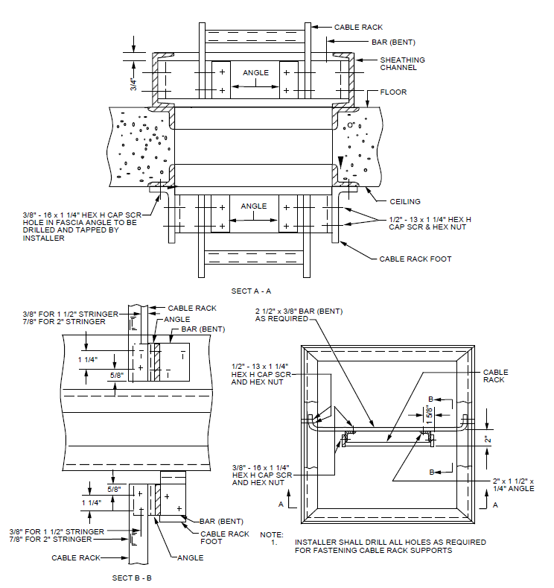

EXHIBIT 2-E1-13C
2-E1-13C TYPICAL SUPPORT OF CABLE RACK UNDER SWITCHBOARD OR DESK CABLE TURNING SECTION.

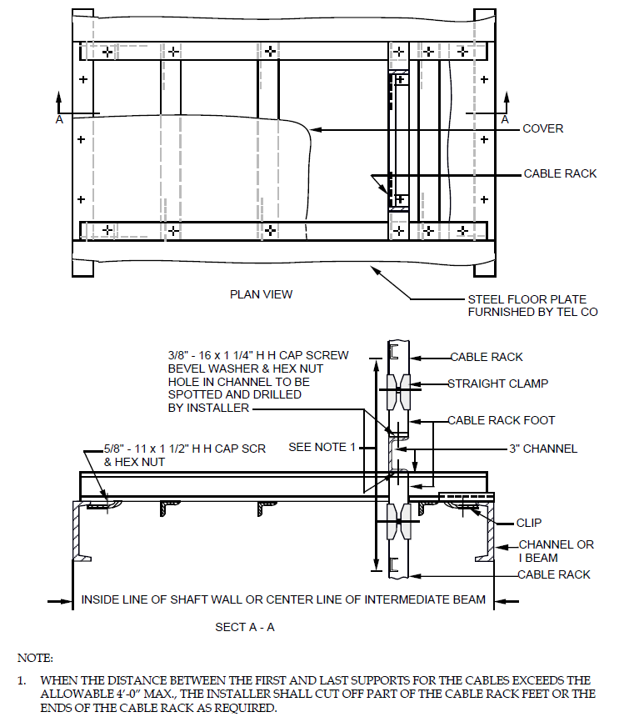

EXHIBIT 2-E1-13D
2-E1-13D TYPICAL SUPPORT OF CABLE RACK IN CABLE SHAFT

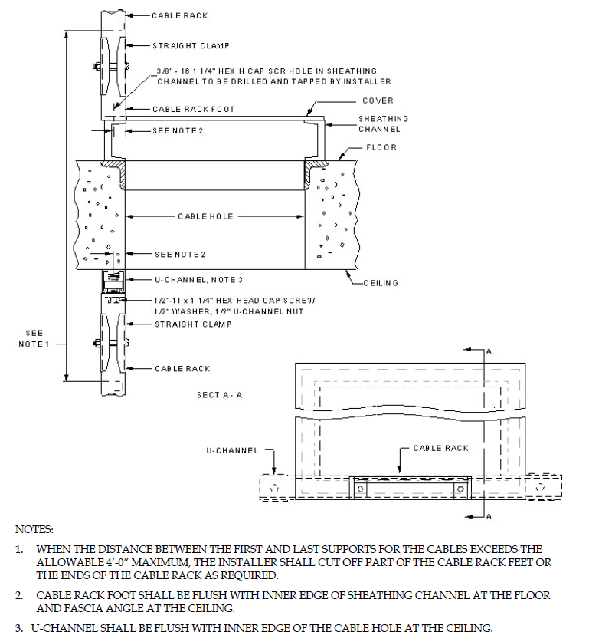

EXHIBIT 2-E1-13E
2-E1-13E TYPICAL SUPPORT OF CABLE RACK TO CEILING AT CABLE HOLE USING U-CHANNEL

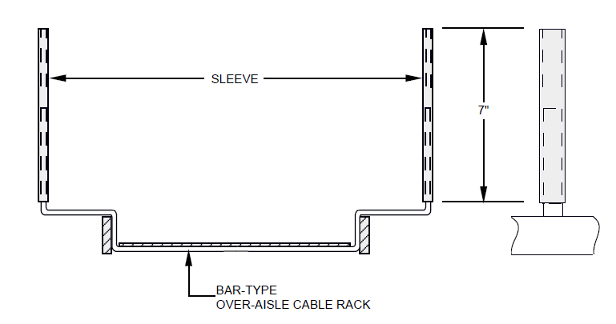

EXHIBIT 2-E1-16A (MD)
2-E1-16A (MD) EXTENSIONS FOR BAR-TYPE OVER-AISLE CABLE RACK

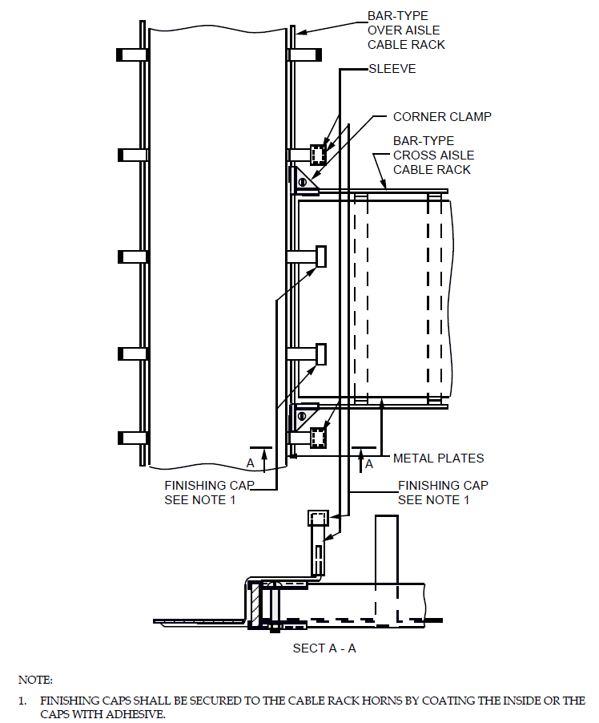
EXHIBIT 2-E1-17C (A&M)
2-E1-17C (A&M) T-INTERSECTION BAR-TYPE OVER-AISLE TO BAR-TYPE CROSS-AISLE CABLE RACK SAME LEVEL

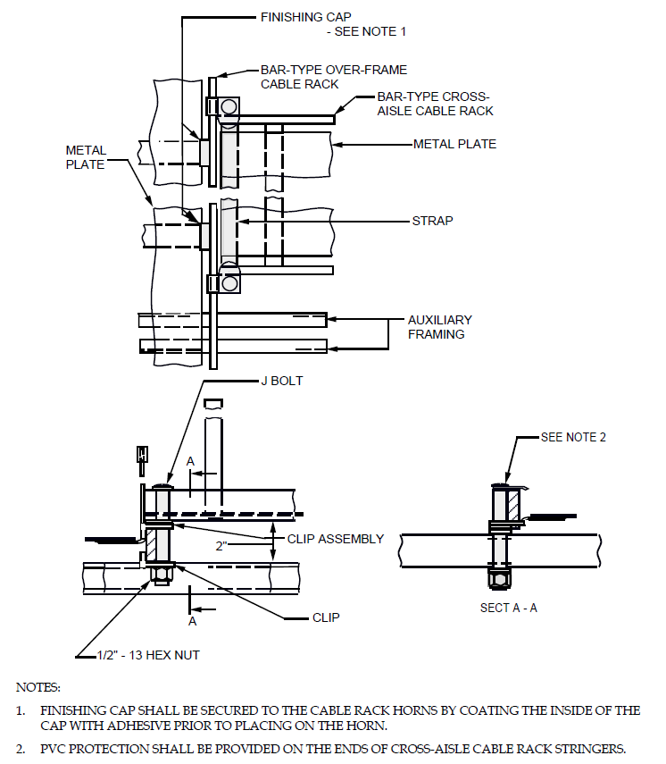

EXHIBIT 2-E1-17H (A&M)
2-E1-17H T-INTERSECTION BAR-TYPE OVER-FRAME TO BAR-TYPE CROSS-AISLE CABLE RACK CROSS-AISLE CABLE RACK RAISED 2 INCHES TO CLEAR CONDUIT AND LIGHTING FIXTURES

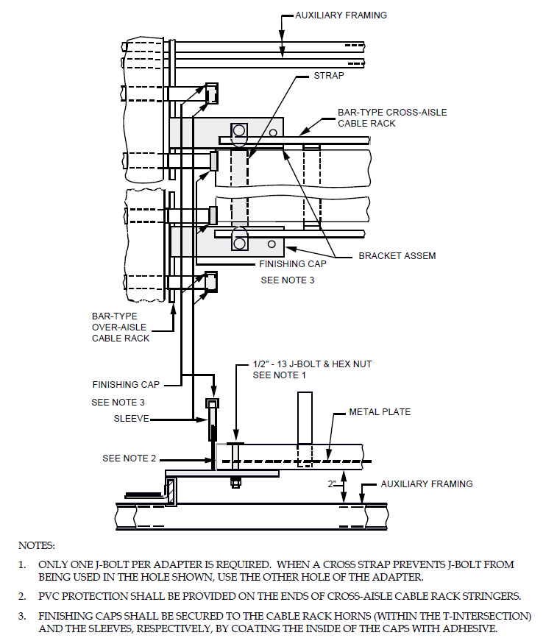

EXHIBIT 2-E1-17J (A&M)
2-E1-17J T-INTERSECTION BAR-TYPE OVER-AISLE TO BAR OR LADDER-TYPE CROSS- AISLE CABLE RACK RAISED 2 INCHES TO CLEAR CONDUIT AND LIGHTING FIXTURES. FULL LENGTH PLATES BAR-TYPE CABLE RACK SHOWN.
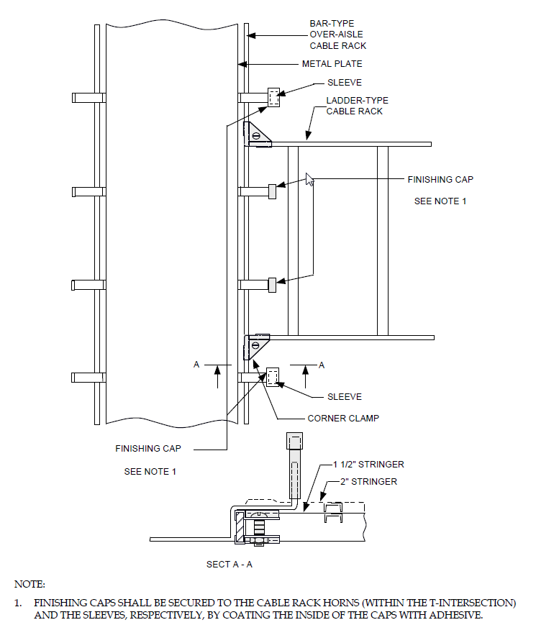

EXHIBIT 2-E1-18A
2-E1-18A T-INTERSECTION BAR-TYPE OVER-AISLE TO LADDER-TYPE CABLE RACK

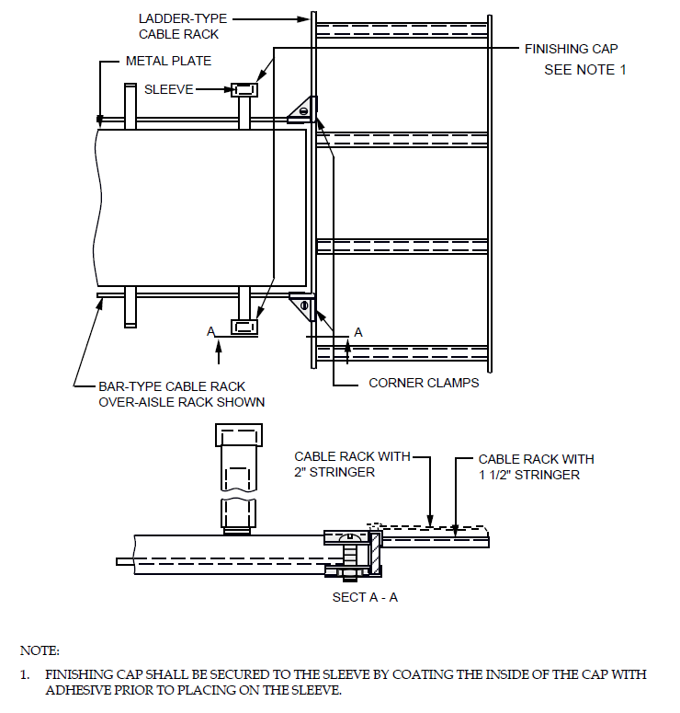

EXHIBIT 2-E1-19A
2-E1-19A T-INTERSECTION LADDER-TYPE TO BAR-TYPE CABLE RACK

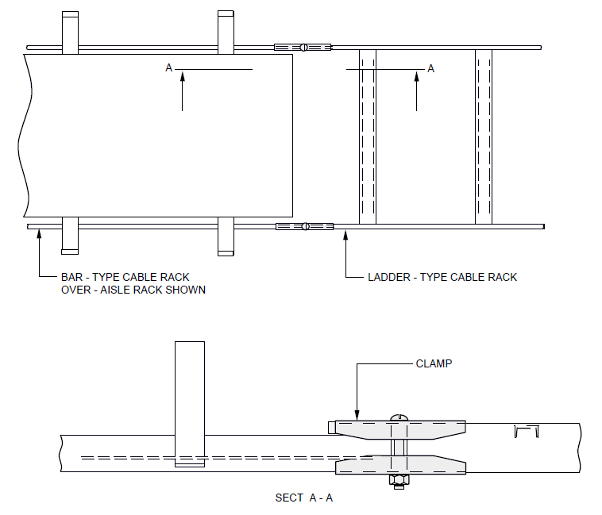
EXHIBIT 2-E1-20A
2-E1-20A JOINING BAR-TYPE TO LADDER-TYPE CABLE RACK OF THE SAME WIDTH.

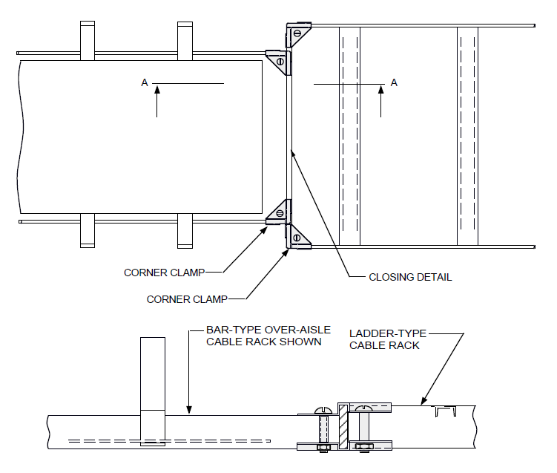

EXHIBIT 2-E1-21A
2-E1-21A JOINING CABLE RACK OF VARYING WIDTH AND STRINGER SIZE.

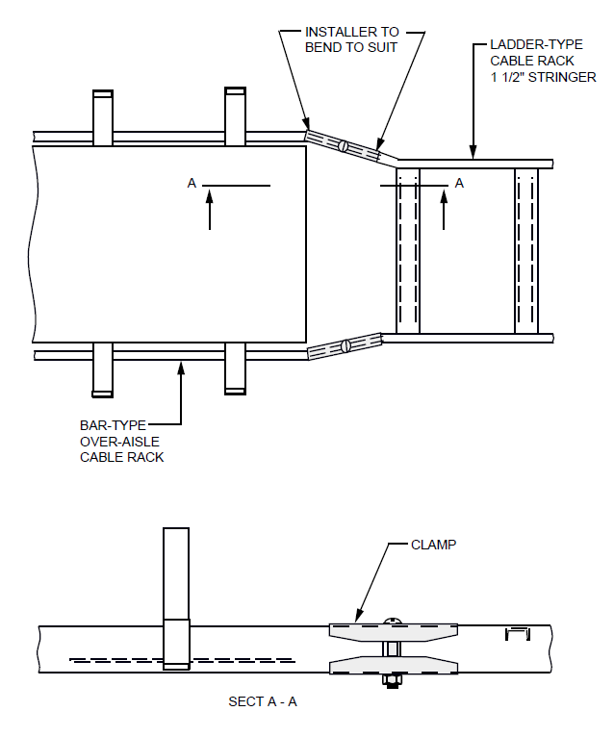
EXHIBIT 2-E1 22A (DISCONTINUED)
2-E1-22A (DISCONTINUED) JOINING BAR-TYPE TO NARROWER LADDER-TYPE CABLE RACK.

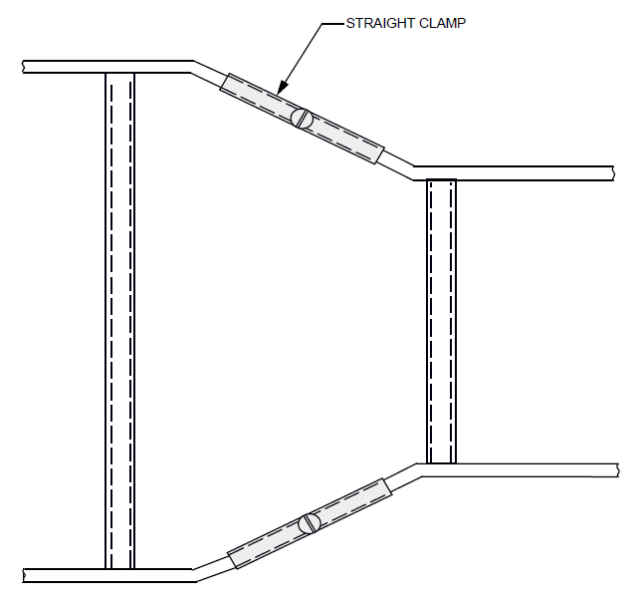

EXHIBIT 2-E1-23 (DISCONTINUED)
2-E1-23 (DISCONTINUED) JOINING 10 INCH TO 1 FOOT 0 INCH OR 1 FOOT 0 INCH TO 1 FOOT 3 INCH CABLE RACKS IN THE SAME PLANE USING STRAIGHT CLAMPS-SMALLER RACK APPROXIMATELY IN THE CENTER.

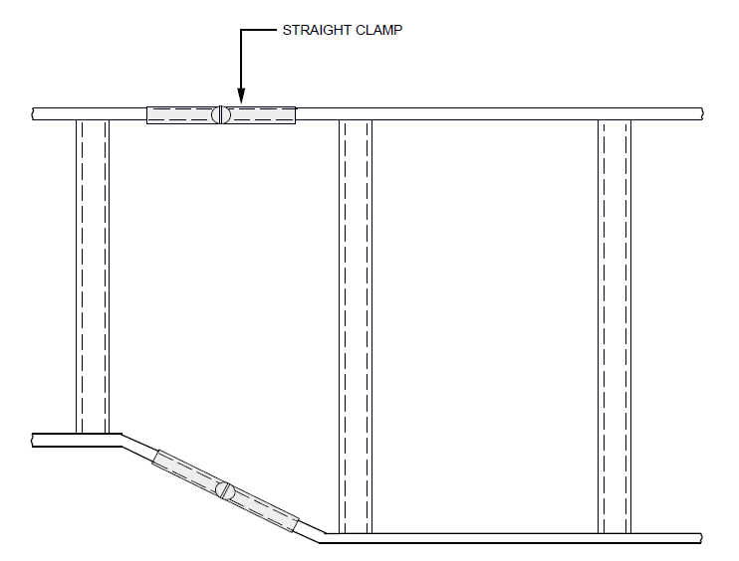

EXHIBIT 2-E1-24 (DISCONTINUED)
2-E1-24 (DISCONTINUED) JOINING 10 INCH TO 1 FOOT 0 INCH OR 1 FOOT 0 INCH TO 1 FOOT 3 INCH CABLERACKS IN THE SAME PLANE USING STRAIGHT CLAMPS-SMALLER RACK AT ONE SIDE.

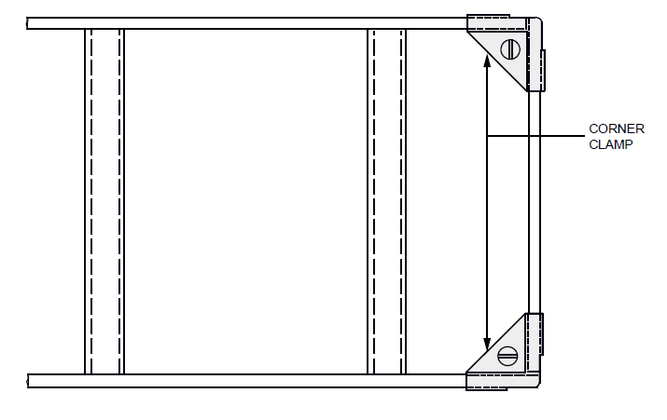

EXHIBIT 2-E1-25
2-E1-25 CLOSING ENDS OF LADDER-TYPE OR BAR-TYPE CABLE RACK JUNCTIONS AND OFFSETS-LADDER-TYPE SHOWN.

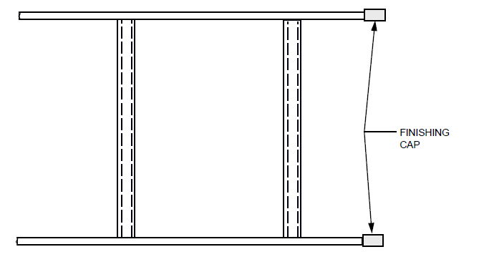

EXHIBIT 2-E1-25C
2-E1-25C MOUNTING RUBBER BUMPERS ON EXPOSED ENDS OF CABLE RACK STRINGERS

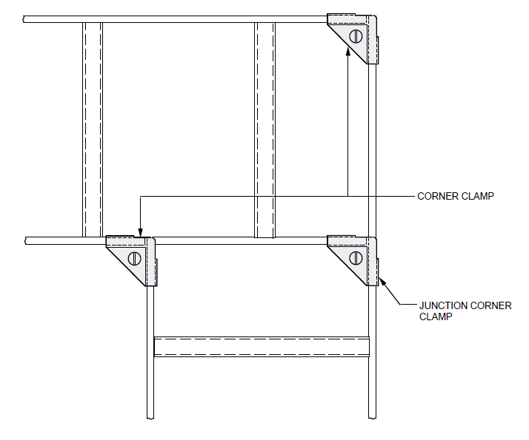

EXHIBIT 2-E1-26
2-E1-26 90 DEGREE TURN IN SAME PLANE

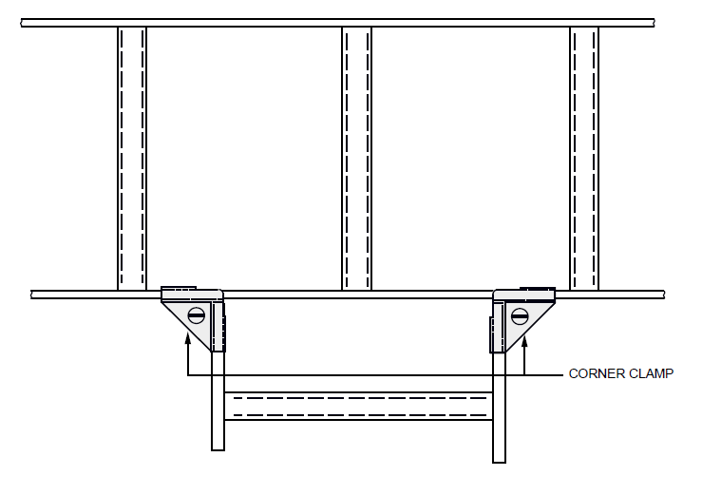

EXHIBIT 2-E1-27
2-E1-27 T-INTERSECTION

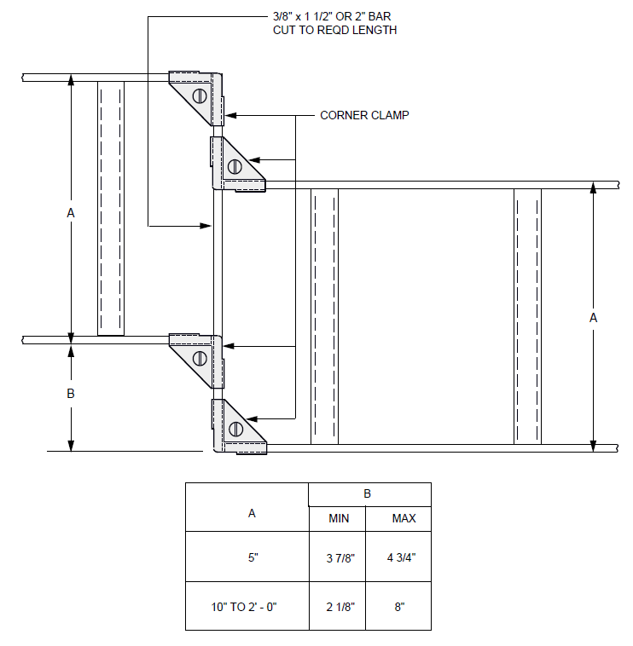

EXHIBIT 2-E1-28
2-E1-28 SMALL OFFSET LESS THAN WIDTH OF RACK AND IN SAME PLANE

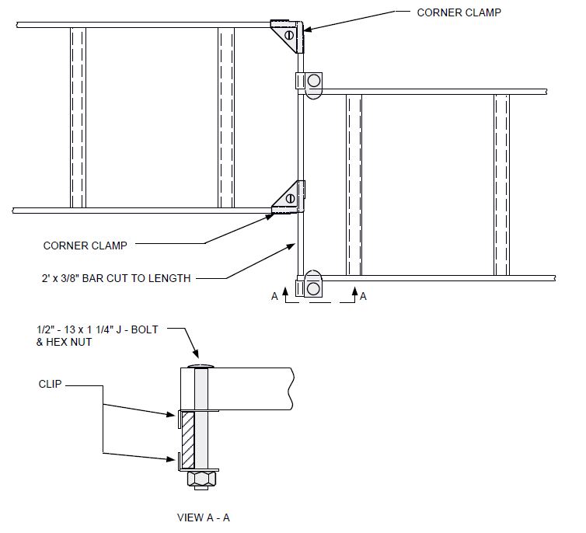

EXHIBIT 2-E1-28A
2-E1-28A SMALL HORIZONTAL OFFSET LESS THAN WIDTH OF RACK WITH 2 INCH VERTICAL OFFSET BETWEEN RACKS

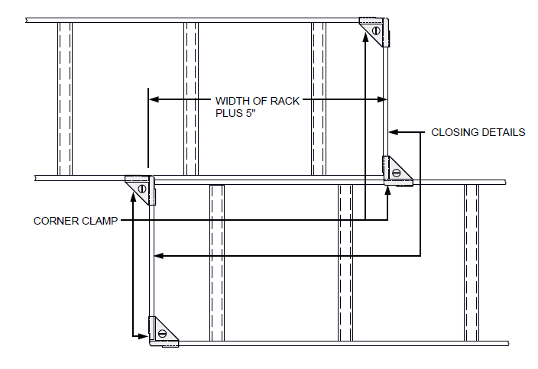

EXHIBIT 2-E1-29
2-E1-29 OFFSET SAME AS WIDTH OF RACK AND IN SAME PLANE BAR AND LADDER-TYPE RACK.

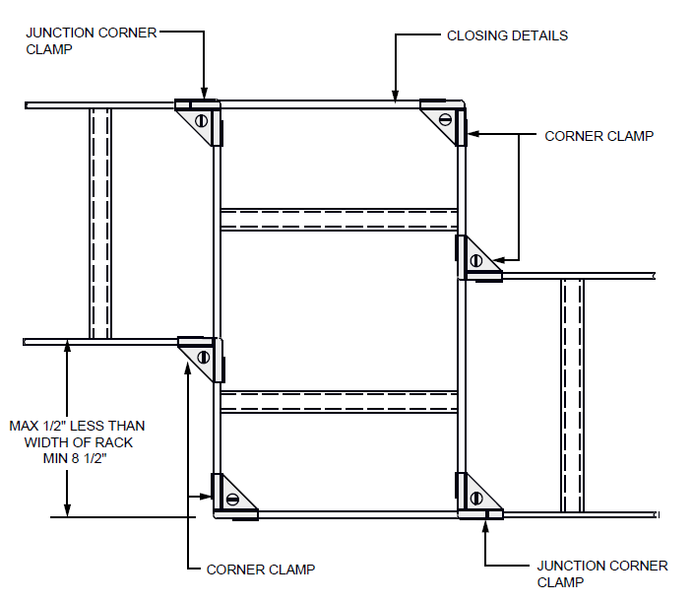

EXHIBIT 2-E1-30
2-E1-30 LARGE OFFSET LESS THAN WIDTH OF RACK AND IN SAME PLANE

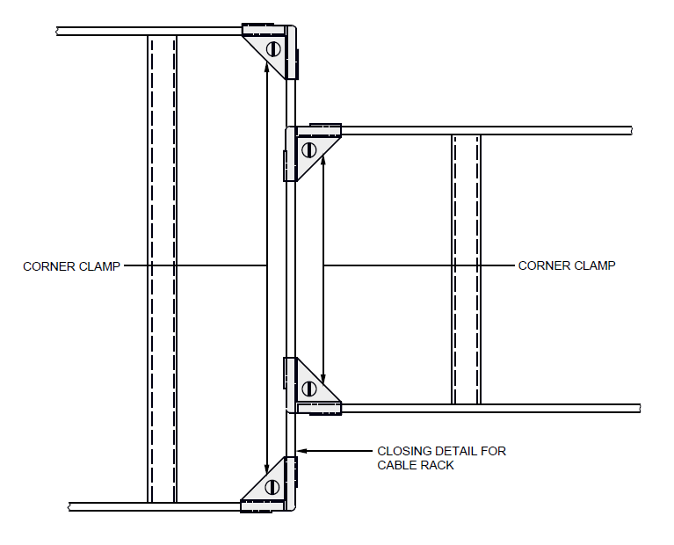

EXHIBIT 2-E1-31
2-E1-31 JOINING BAR AND LADDER-TYPE RACKS OF DIFFERENT WIDTHS IN SAME PLANE - SMALLER RACK APPROXIMATELY IN CENTER.

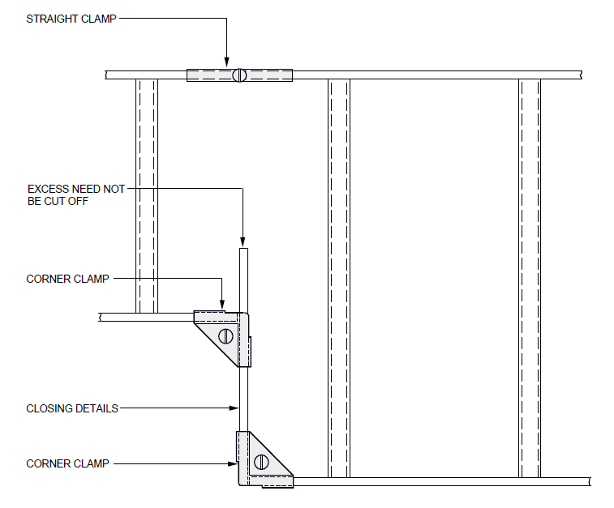

EXHIBIT 2-E1-32
2-E1-32 JOINING BAR AND LADDER-TYPE RACKS OF DIFFERENT WIDTHS IN SAME PLANE - SMALLER RACK AT ONE SIDE.

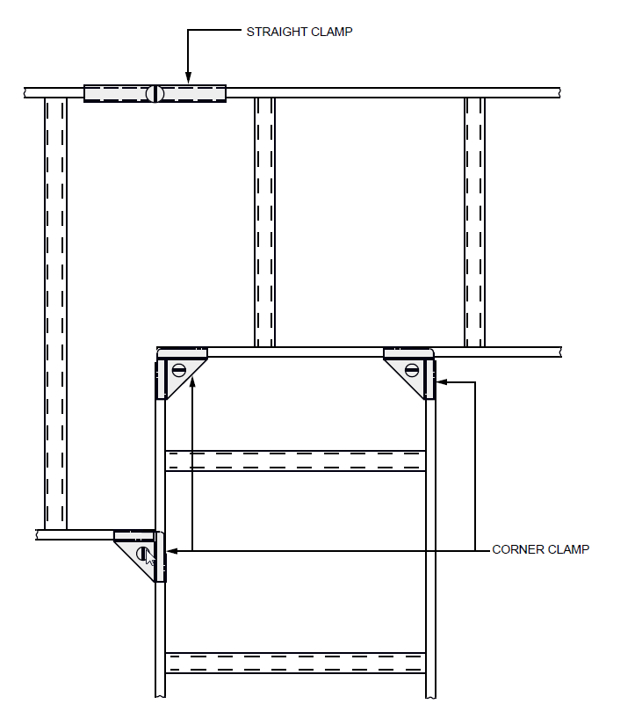

EXHIBIT 2-E1-33
2-E1-33 JOINING THREE RACKS OF DIFFERENT WIDTHS IN SAME PLANE

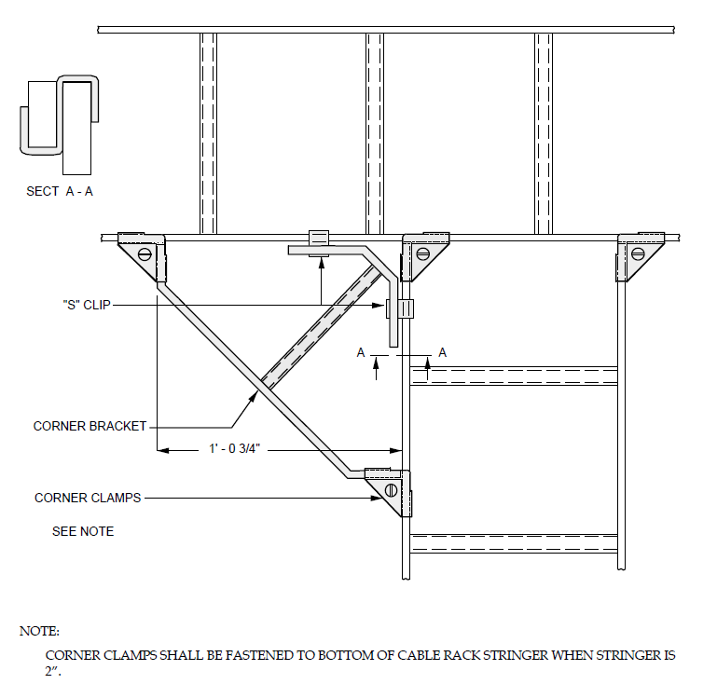

EXHIBIT 2-E1-34
2-E1-34 CORNER BRACKET AT TURN OF INTERSECTION

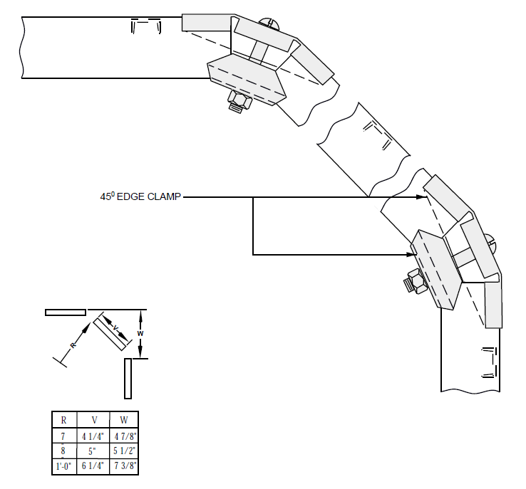

EXHIBIT 2-E1-35
2-E1-35 90 DEGREE OUTSIDE TURN FOR A RADIUS OF MORE THAN 6 INCHES

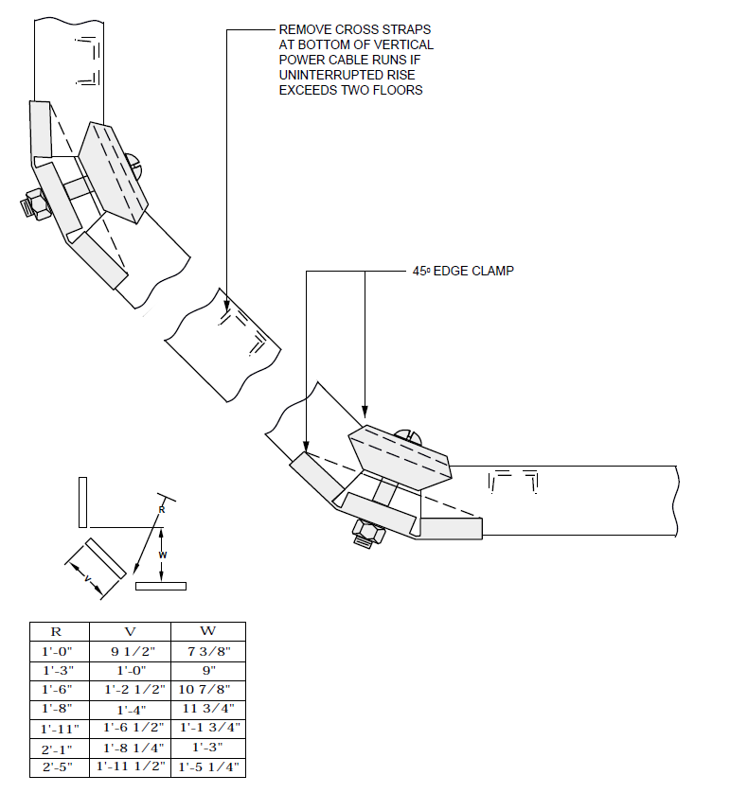

EXHIBIT 2-E1-36
2-E1-36 90 DEGREE INSIDE TURN FOR A RADIUS OF MORE THAN 6 INCHES

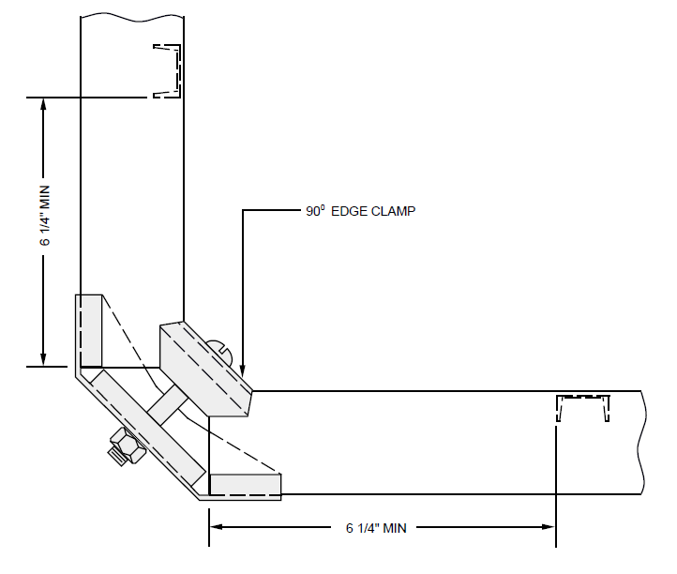

EXHIBIT 2-E1-37
2-E1-37 90 DEGREE INSIDE TURN FOR A RADIUS OF 6 INCHES OR LESS

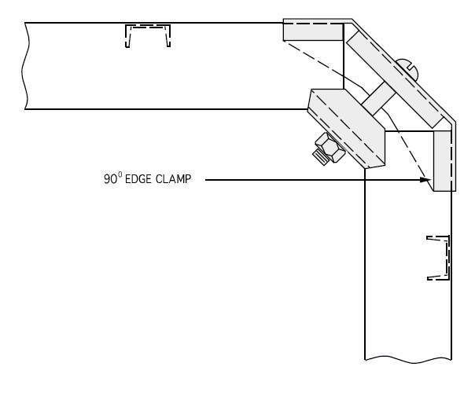

EXHIBIT 2-E1-38
2-E1-38 90 DEGREE OUTSIDE TURN FOR A RADIUS OF 6 INCHES OR LESS

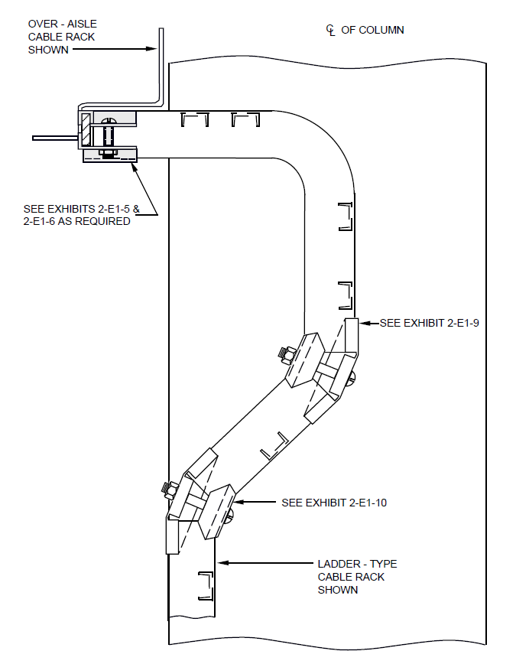
EXHIBIT 2-E1-38H
2-E1-38H VERTICAL LADDER-TYPE CABLE RACK DROPPING OFF THE SIDE OF BAR-TYPE CABLE RACK-90 DEGREE OUTSIDE TURN OF 6 INCHES OR LESS.

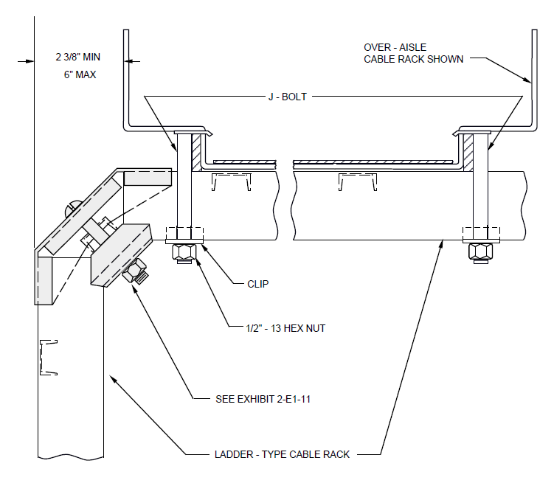

EXHIBIT 2-E1-38J (A&M)
2-E1-38J (A&M) VERTICAL LADDER-TYPE CABLE RACK DROPPING OFF THE SIDE OF BAR-TYPE CABLE RACK 90 DEGREE LARGE OUTSIDE RADIUS TURN.

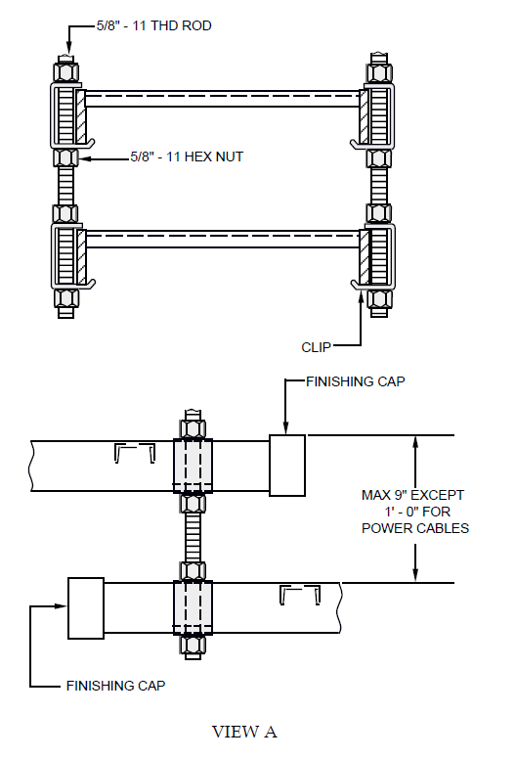
EXHIBIT 2-E1-39
2-E1-39 SMALL VERTICAL OFFSETS IN HORIZONTAL RACKS
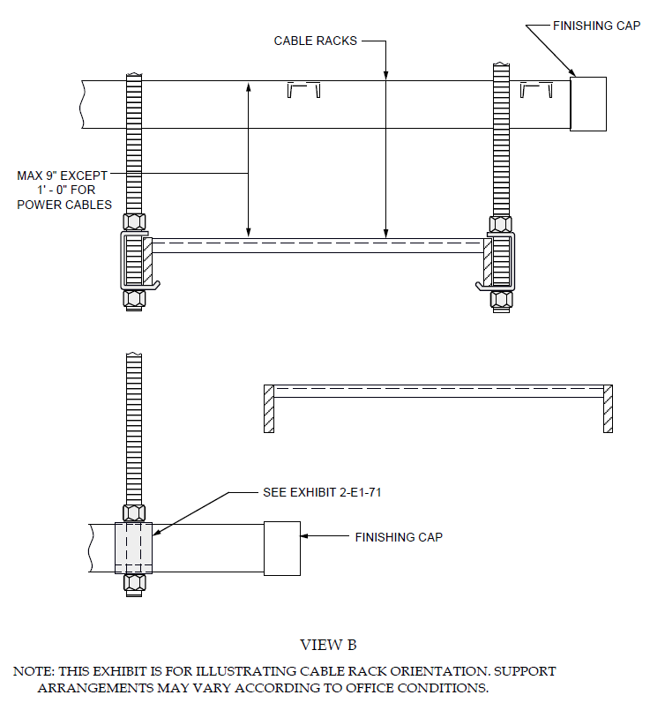

EXHIBIT 2-E1-39
2-E1-39 SMALL VERTICAL OFFSETS IN HORIZONTAL RACKS

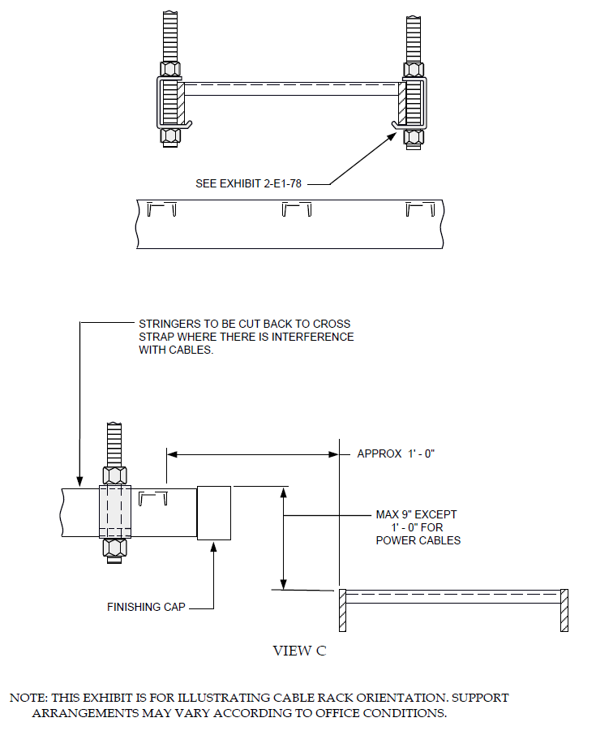
EXHIBIT 2-E1-39
2-E1-39 SMALL VERTICAL OFFSETS IN HORIZONTAL RACKS

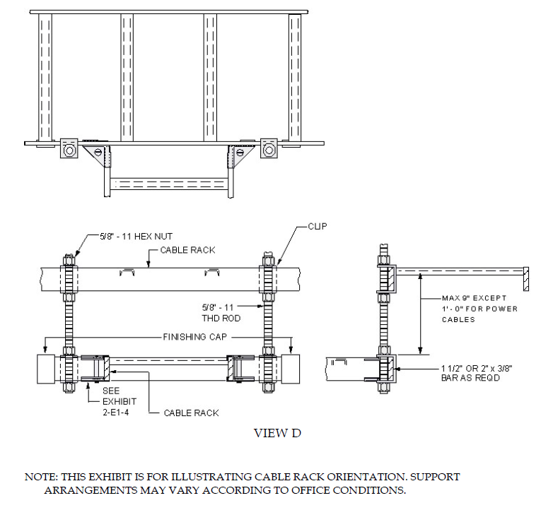

EXHIBIT 2-E1-39
2-E1-39 SMALL VERTICAL OFFSETS IN HORIZONTAL RACKS

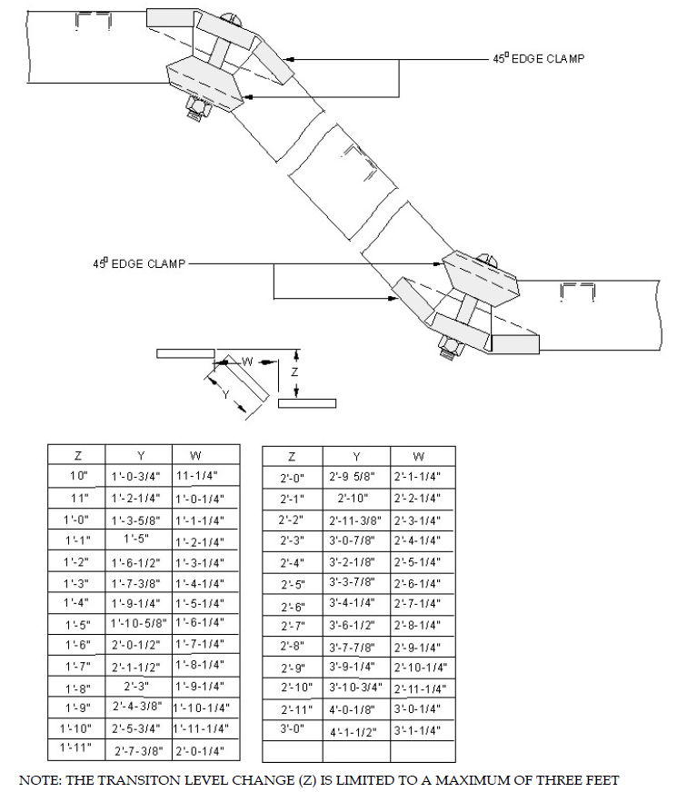

EXHIBIT 2-E1-40
2-E1-40 OFFSET GREATER THAN 9 INCHES IN PARALLEL PLANES USING 45 DEGREE EDGE CLAMPS-LADDER-TYPE CABLE RACKS

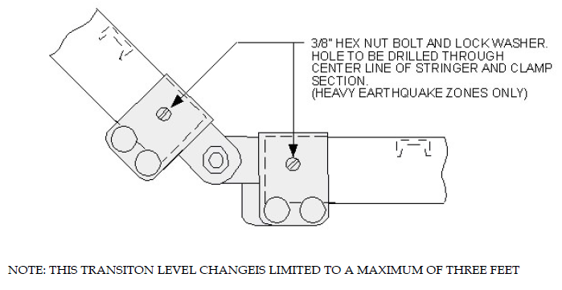
2-E1-40A
2-E1-40A ADJUSTABLE CABLE RACK SPLICE

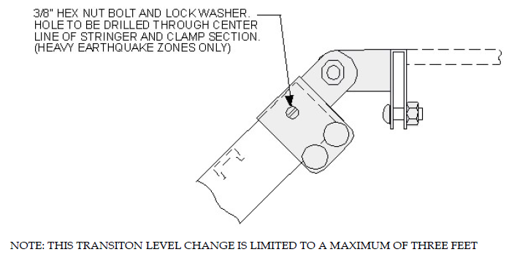

2-E1-40B
2-E1-40B ADJUSTABLE CABLE RACK SPLICE, RIGHT ANGLE

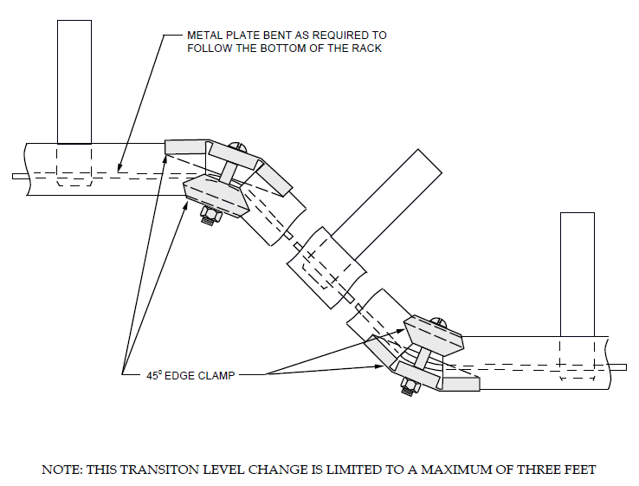

EXHIBIT 2-E1-40C (A&M)
2-E1-40C (A&M) OFFSET GREATER THAN 9 INCHES IN PARALLEL PLANES USING 45 DEGREE EDGE CLAMPS-BAR-TYPE CABLE RACKS

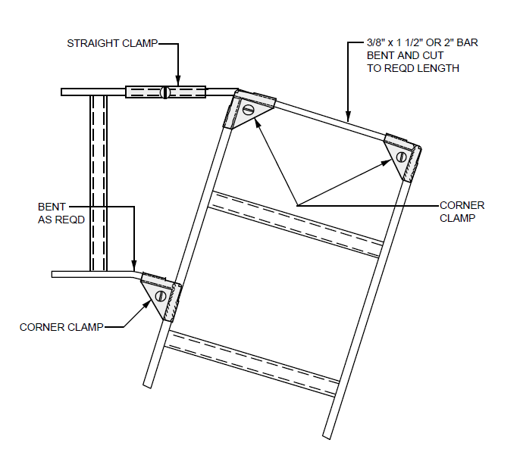

EXHIBIT 2-E1-41
2-E1-41 ACUTE-ANGLE TURN IN SAME PLANE

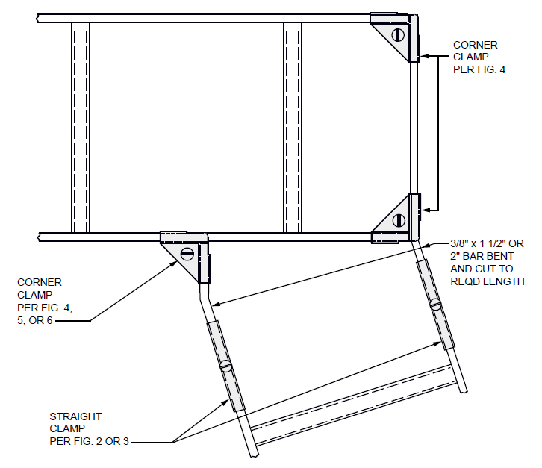

EXHIBIT 2-E1-42
2-E1-42 OBTUSE-ANGLE TURN IN SAME PLANE

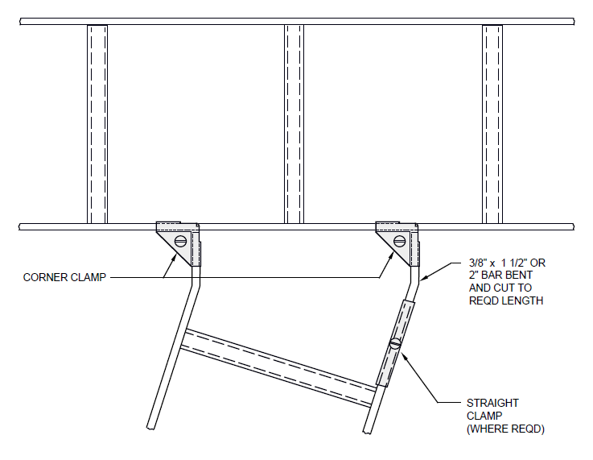

EXHIBIT 2-E1-43
2-E1-43 ACUTE-OR-OBTUSE-ANGLE TURN IN SAME PLANE

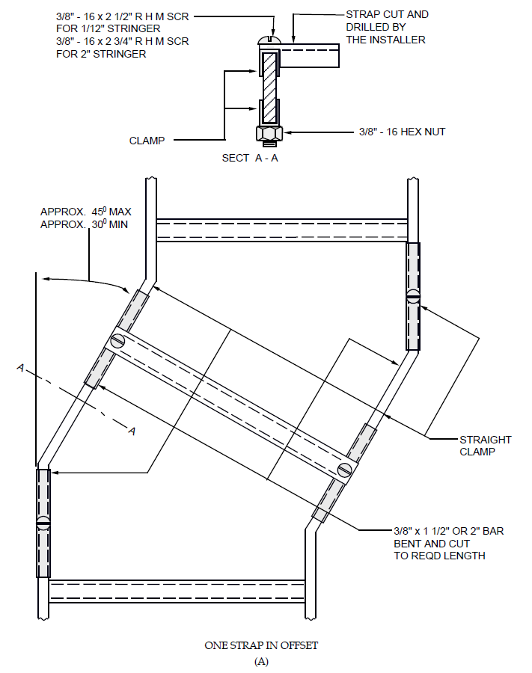

EXHIBIT 2-E1-52
2-E1-52 OFFSETS IN EXPOSED VERTICAL CABLE RACKS
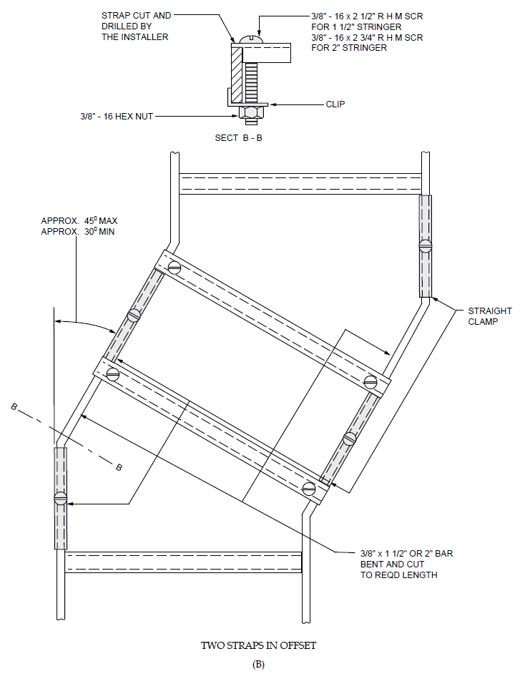
EXHIBIT 2-E1-52
2-E1-52 OFFSETS IN EXPOSED VERTICAL CABLE RACKS

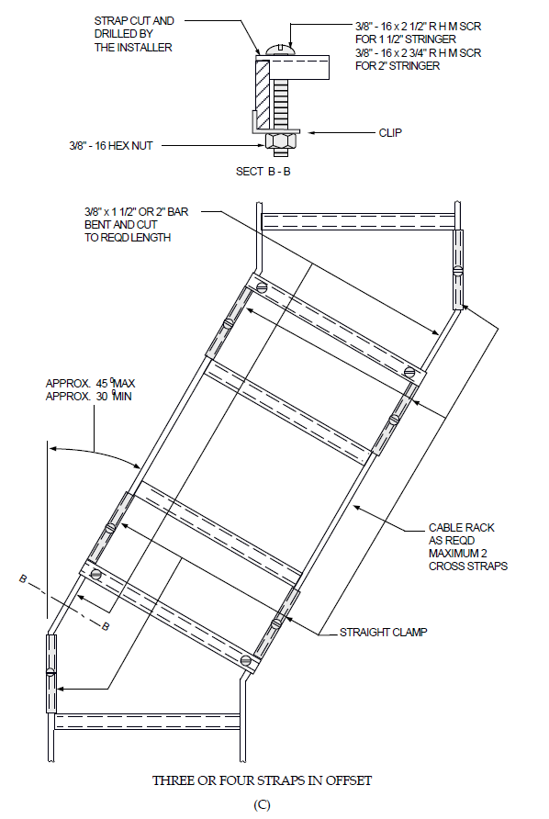
EXHIBIT 2-E1-52
2-E1-52 OFFSETS IN EXPOSED VERTICAL CABLE RACKS

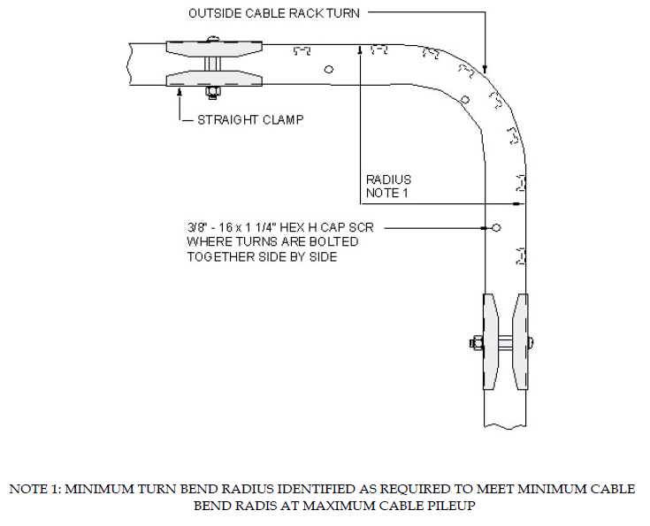

EXHIBIT 2-E1-53
2-E1-53 OUTSIDE CABLE RACK TURN FOR POWER OR FIBER CABLE RUNS

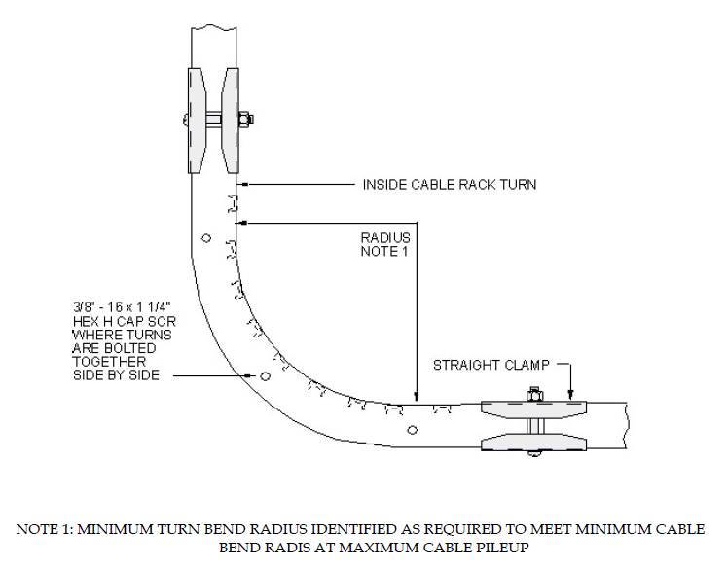

EXHIBIT 2-E1-53A
2-E1-53A INSIDE CABLE RACK TURN FOR POWER OR FIBER CABLE RUNS

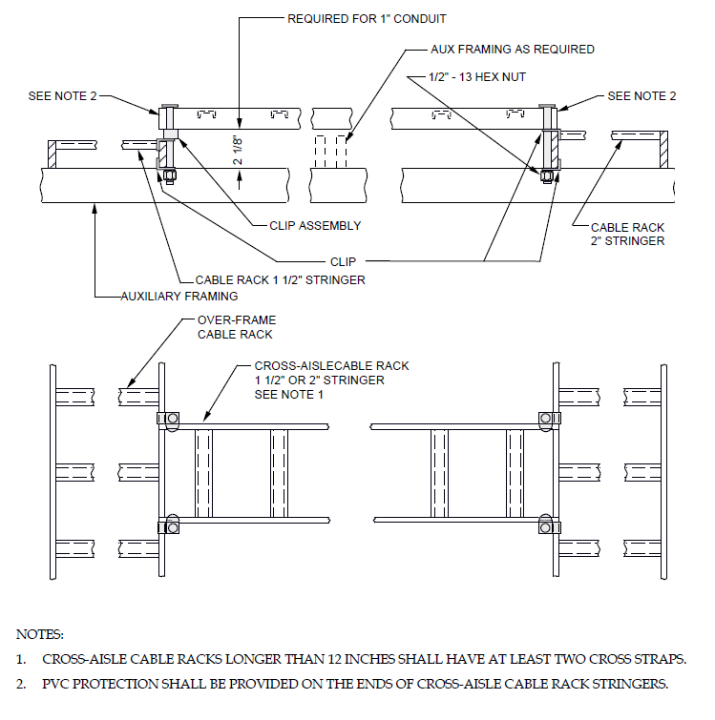

EXHIBIT 2-E1-54
2-E1-54 CROSS-AISLE CABLE RACKS RUN NONCONTINUOUSLY OVER-AISLES AT HIGHER LEVEL THAN OVER-FRAME RACKS INTERSECTION

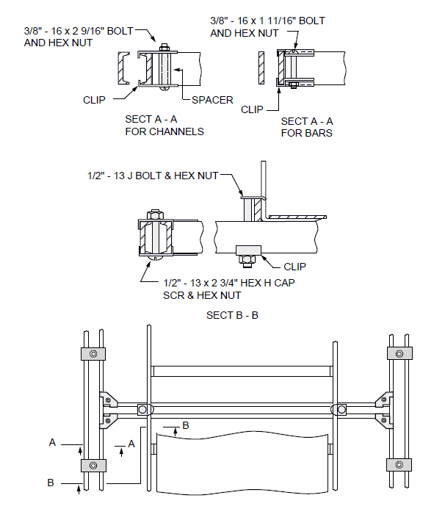
EXHIBIT 2-E1-54E (A&M)
2-E1-54E (A&M) BAR-TYPE CROSS-AISLE CABLE RACKS SUPPORTED BY AUXILIARY FRAMING WHERE A ROW OF FRAMES IS OMITTED

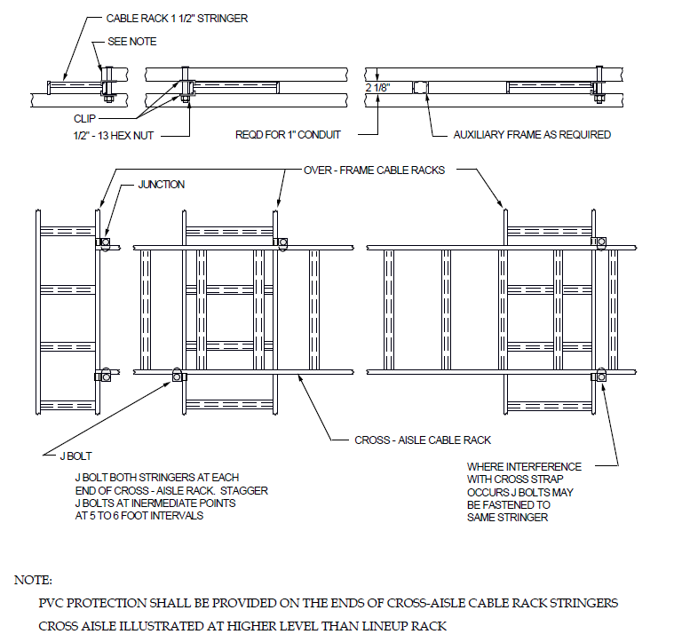

EXHIBIT 2-E1-54F
2-E1-54F CROSS-AISLE CABLE RACKS RUN CONTINUOUSLY OVER AISLE AT HIGHER OR LOWER LEVEL THAN LINEUP RACKS

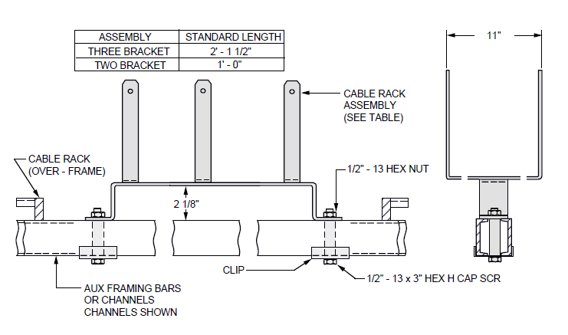

EXHIBIT 2-E1-55 (DISCONTINUED)
2-E1-55 (DISCONTINUED) CABLE RACKS OVER AISLES WHERE CABLE IS NOT EXCEPTIONALLY HEAVY

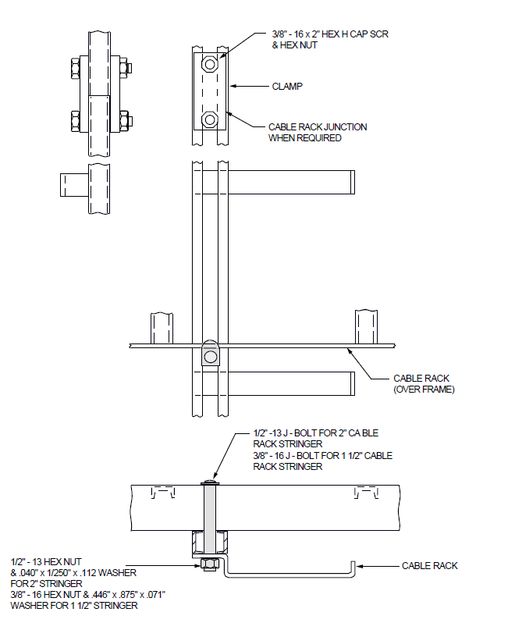
EXHIBIT 2-E1-56 (DISCONTINUED)
2-E1-56 (DISCONTINUED) CABLE RACK FOR POWER CABLES WITHOUT MAIN-AISLE OR END-AISLE CABLE RACK (REPLACED BY EXHIBIT 2-E1-56B)
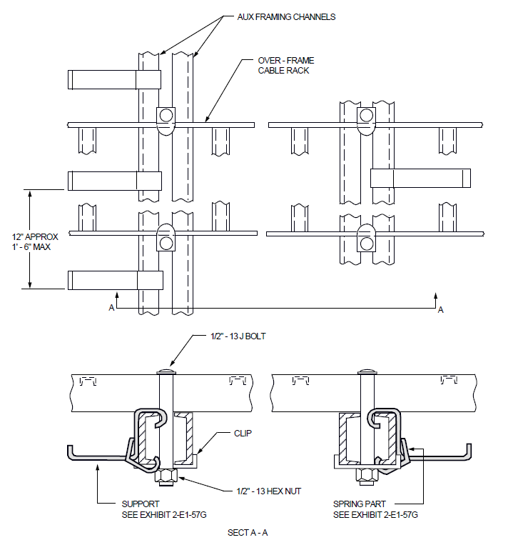

EXHIBIT 2-E1-56B
2-E1-56B POWER CABLE SUPPORT BRACKET FOR POWER CABLES WITHOUT MAIN-AISLE OR END-AISLE CABLE RACK

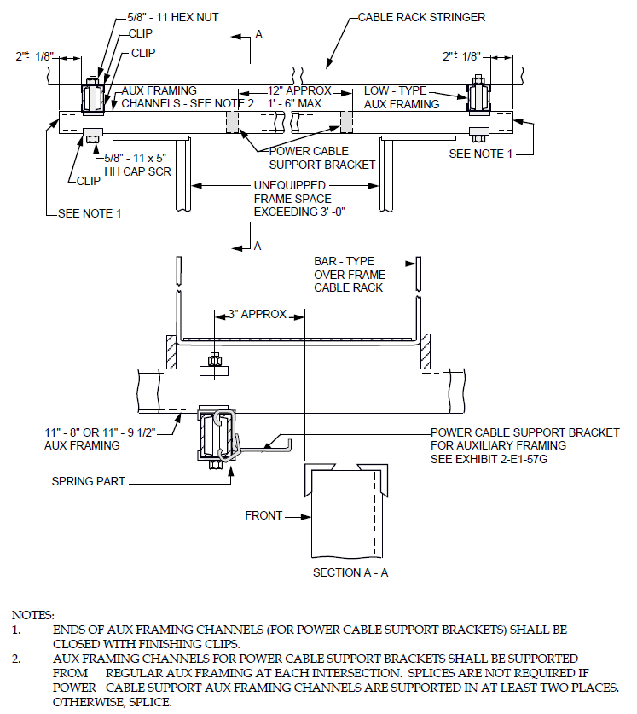

EXHIBIT 2-E1-56C (A&M)
2-E1-56C (A&M) POWER CABLE SUPPORT BRACKET FOR SUPPORTING FRAME LINE POWER FEEDERS WHERE INTERMEDIATE FRAMES ARE OMITTED AND GAP EXCEEDS 3 FEET 0 INCHES-STEP-BY-STEP, NO. 1 CROSSBAR, AND CROSSBAR TANDEM SYSTEMS-11 FOOT 8 INCH OR 11 FOOT 9 1/2 INCH AUXILIARY FRAMING
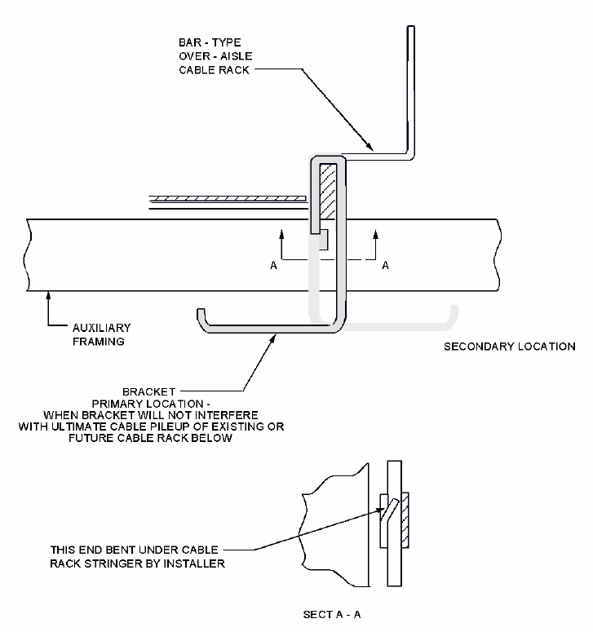

EXHIBIT 2-E1-57E (A&M)
2-E1-57E (A&M) POWER CABLE BRACKET ATTACHED TO BAR-TYPE OVER-AISLE CABLE RACK

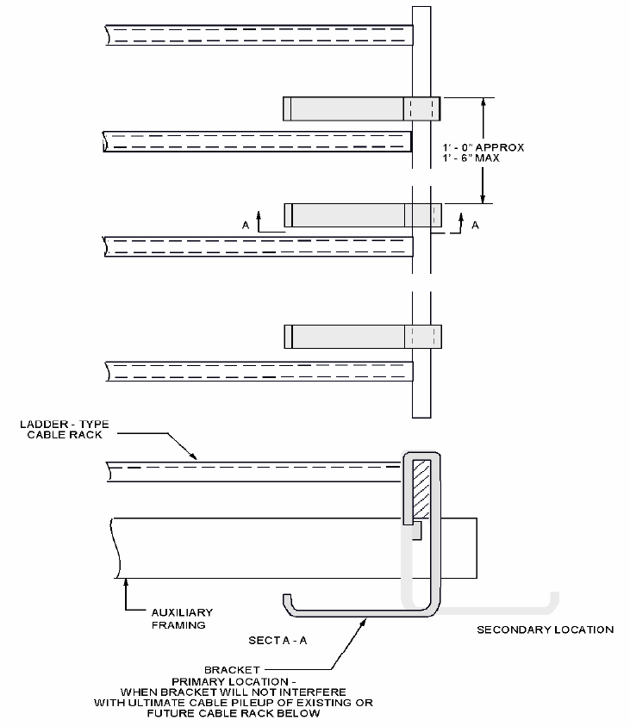

EXHIBIT 2-E1-57F
2-E1-57F POWER CABLE BRACKET ATTACHED TO LADDER-TYPE CABLE RACK

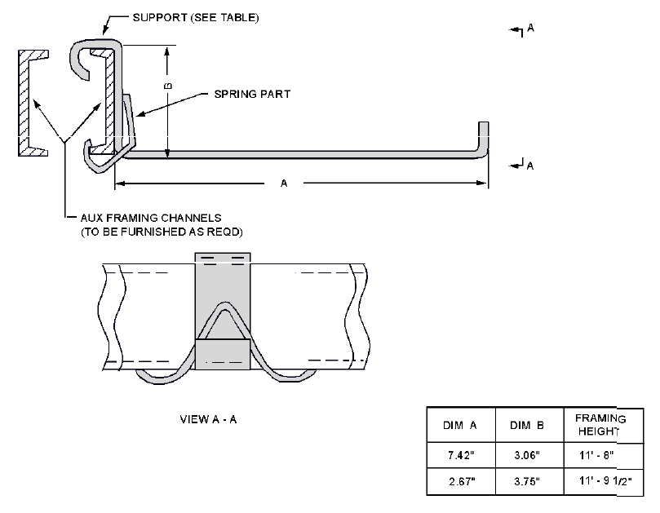

EXHIBIT 2-E1-57G
2-E1-57G POWER CABLE SUPPORT BRACKET ATTACHED TO AUXILIARY FRAMING WITH RETAINING SPRING

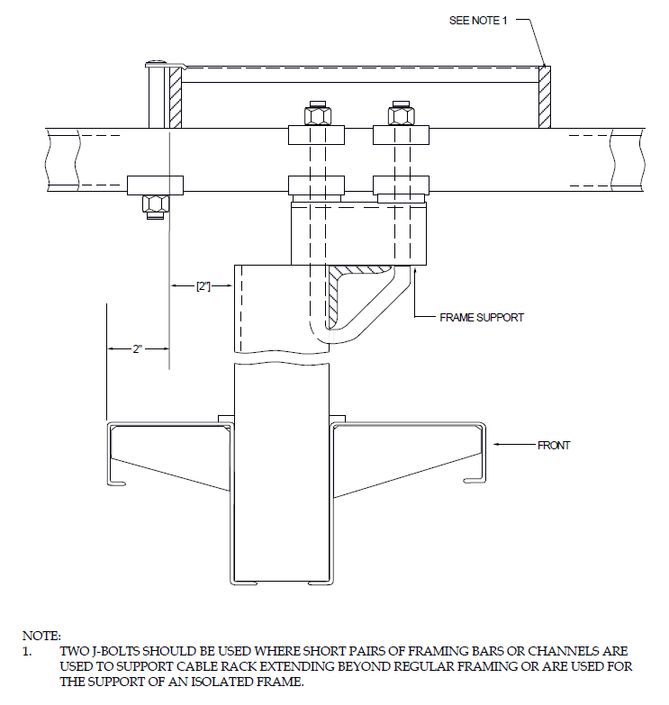

EXHIBIT 2-E1-62G (A&M)
2-E1-62G (A&M) LOCATION OF LADDER-TYPE CABLE RACK OVER CHANNEL-TYPE RELAY RACK-STEP-BY-STEP SYSTEMS

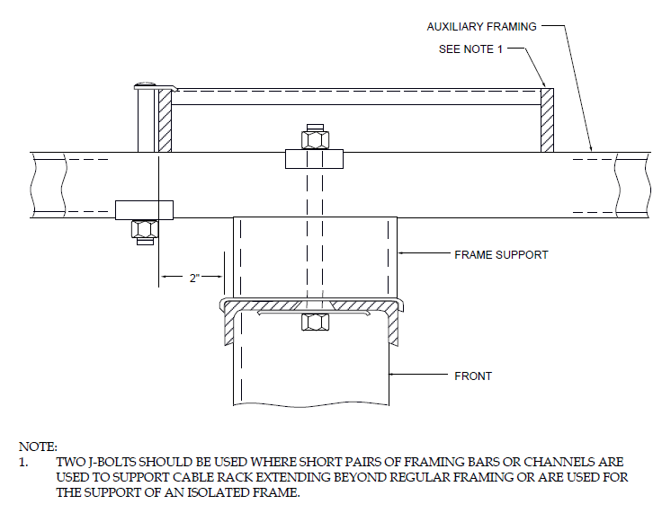

EXHIBIT 2-E1-62H (A&M)
2-E1-62H (A&M) LOCATION OF LADDER-TYPE CABLE RACK OVER BULB-ANGLE TYPE FRAMES

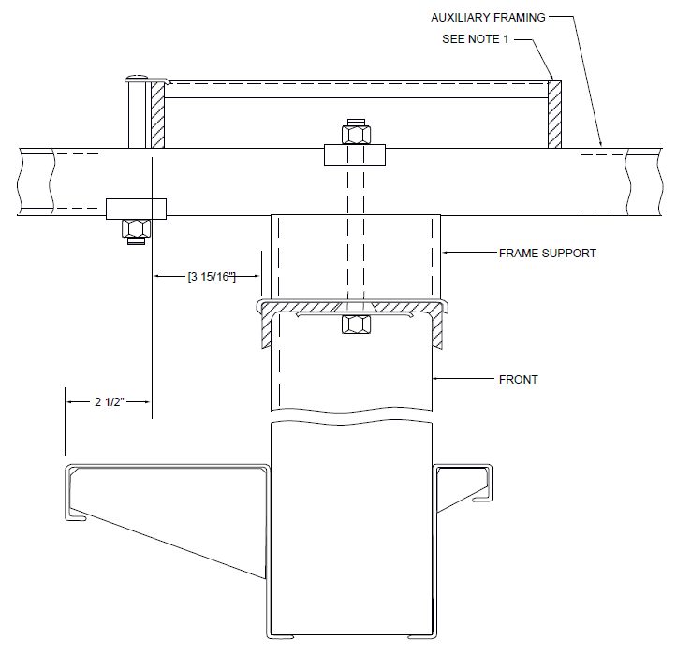

EXHIBIT 2-E1-62J (A&M)
2-E1-62J (A&M) LOCATION OF LADDER-TYPE CABLE RACK OVER BULB-ANGLE TYPE FRAMES ADJACENT TO BULB-ANGLE TYPE STEP-BY-STEP FRAMES

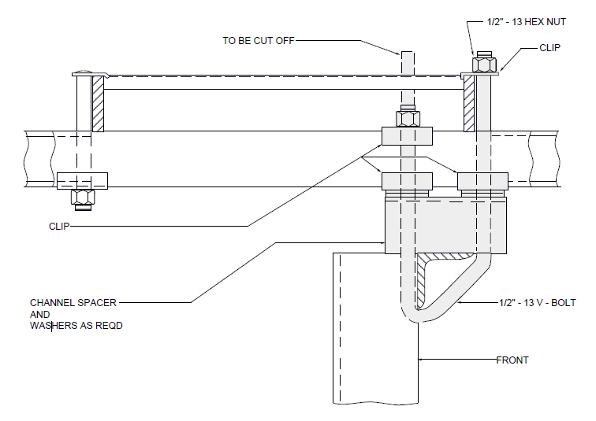

EXHIBIT 2-E1-62K
2-E1-62K LADDER-TYPE CABLE RACK OVER REAR OF CHANNEL-TYPE RELAY RACK- STEP- BY-STEP SYSTEMS-11 FOOT 8 INCH FRAMING-ADDITIONS ONLY

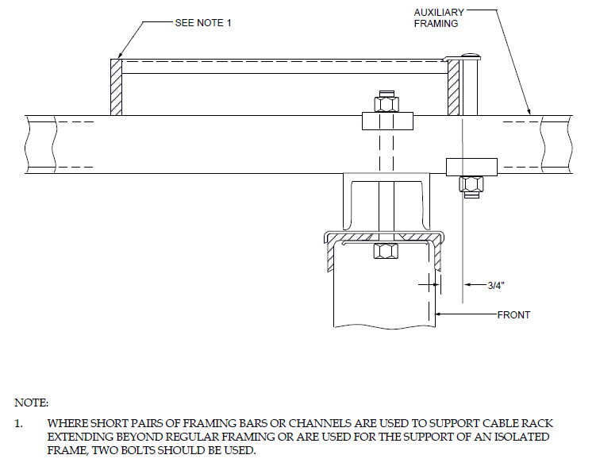

EXHIBIT 2-E1-62L (A&M)
2-E1-62L (A&M) CABLE RACKS OVER AISLES WHERE CABLE IS NOT EXCEPTIONALLY HEAVY

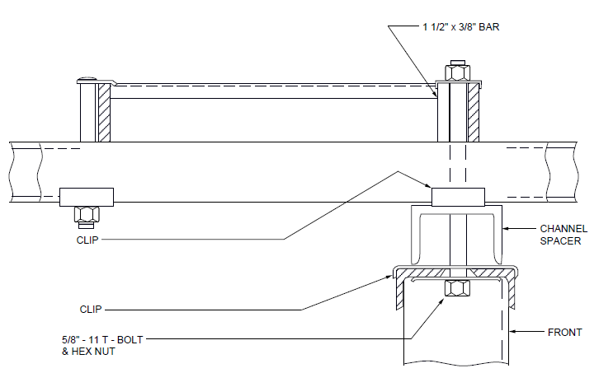

EXHIBIT 2-E1-62M (A&M)
2-E1-62M (A&M) LADDER-TYPE CABLE RACK OVER REAR OF BULB-ANGLE TYPE FRAMES ADJACENT TO CHANNEL-TYPE STEP-BY-STEP FRAMES 11 FOOT 8 INCH FRAMING-ADDITIONS ONLY

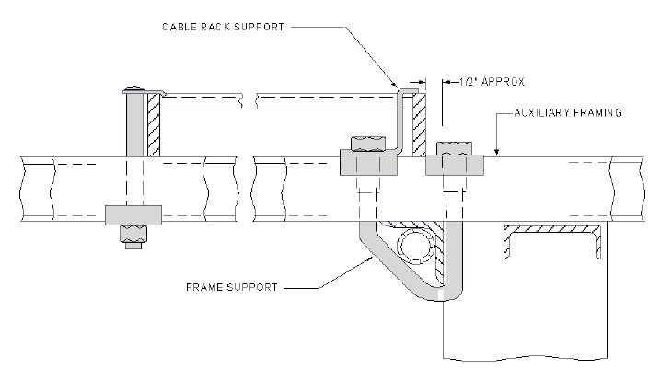

EXHIBIT 2-E1-62N
2-E1-62N LADDER-TYPE CABLE RACK OVER DUCT TYPE FRAMES-11 FOOT 6 INCH FRAMING

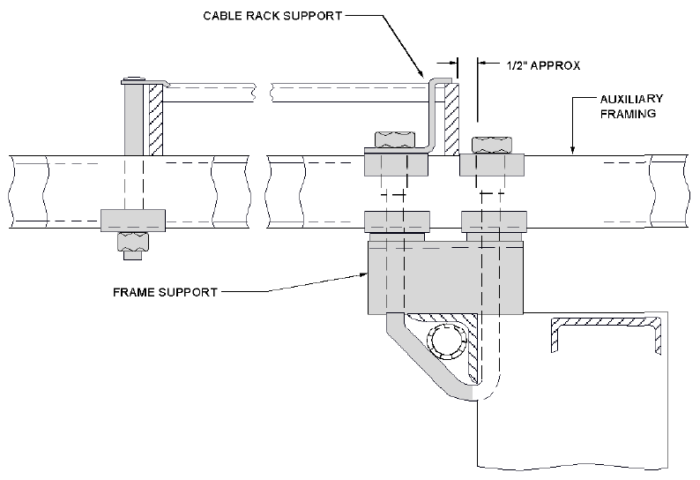

EXHIBIT 2-E1-62P
2-E1-62P LADDER-TYPE CABLE RACK OVER CABLE DUCT-TYPE FRAMES 11 FOOT 8 INCH

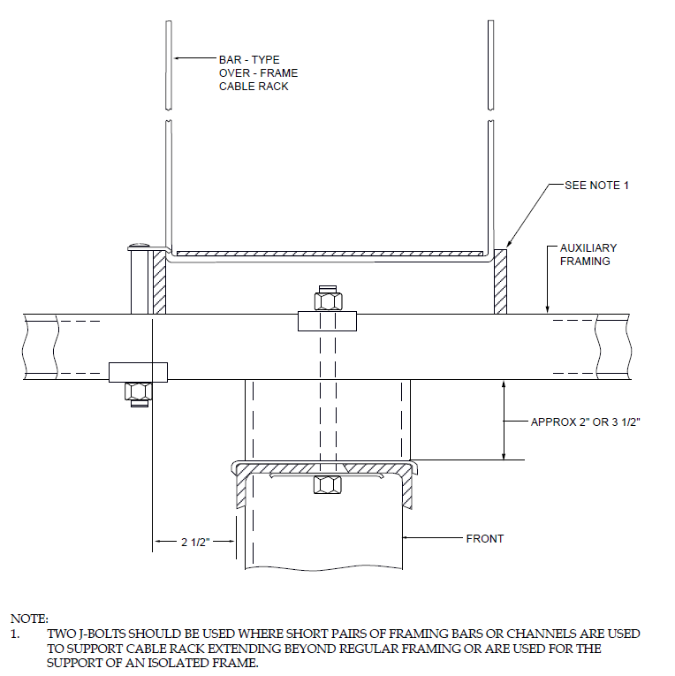

EXHIBIT 2-E1-62Q (A&M)
2-E1-62Q (A&M) LOCATION OF BAR-TYPE OVER-FRAME CABLE RACK OVER BULB-ANGLE TYPE FRAMES

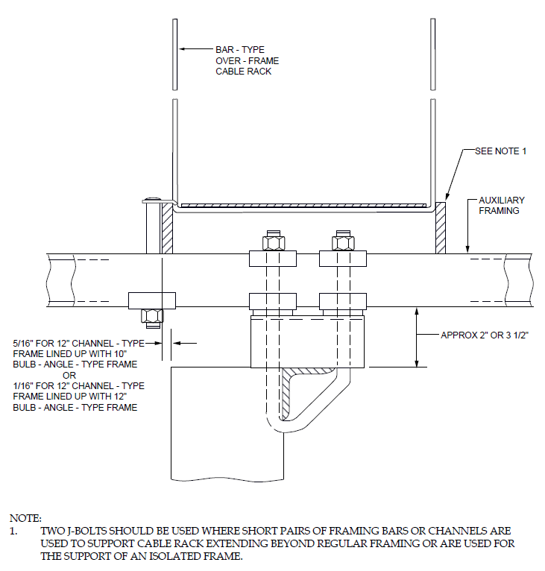

EXHIBIT 2-E1-62R (A&M)
2-E1-62R LOCATION OF BAR-TYPE OVER-FRAME CABLE RACK OVER CHANNEL-TYPE FRAMES-COMBINED OFFICES

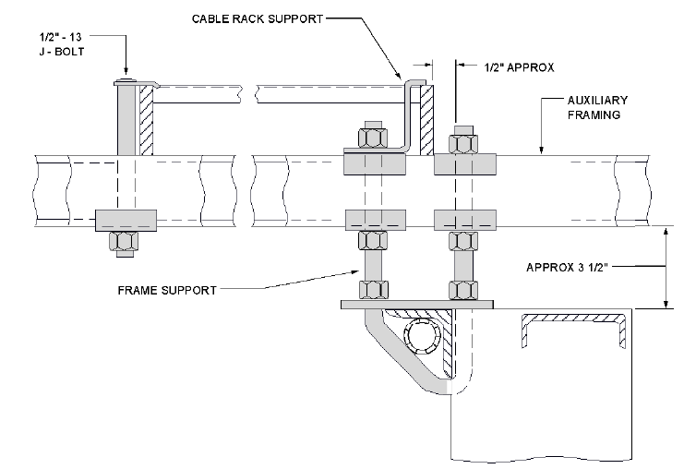

EXHIBIT 2-E1-62S
2-E1-62S LADDER-TYPE CABLE RACK OVER CABLE DUCT-TYPE FRAMES-11 FOOT 9 1/2 INCH FRAMING

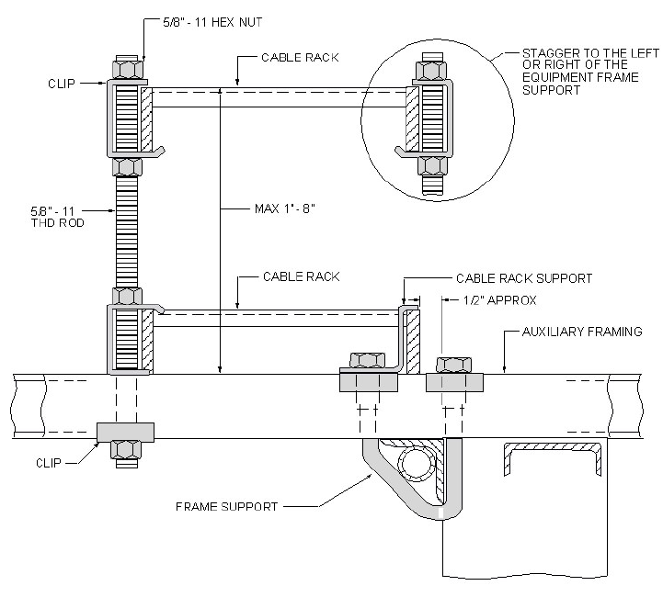

EXHIBIT 2-E1-62T (A&M)
2-E1-62T (A&M) MULTILEVEL CABLE RACK SUPPORT OVER DUCT-TYPE FRAMES-11 FOOT 6 INCH FRAMING

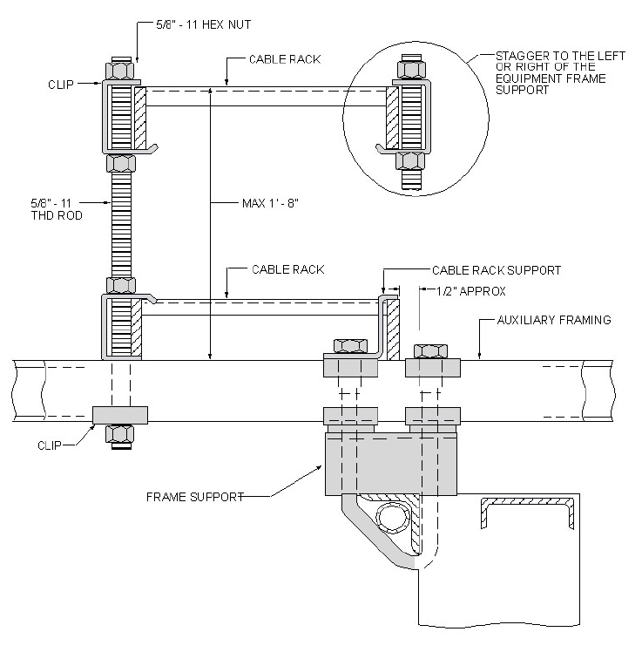

EXHIBIT 2-E1-62U (A&M)
2-E1-62U (A&M) MULTILEVEL CABLE RACK SUPPORT OVER DUCT-TYPE FRAMES-11 FOOT 8 INCH FRAMING

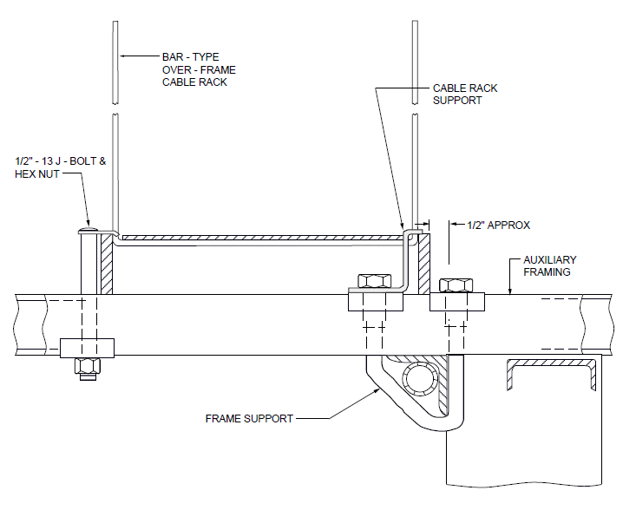

EXHIBIT 2-E1-62V (A&M)
2-E1-62V (A&M) BAR-TYPE OVER-FRAME CABLE RACK OVER CABLE DUCT-TYPE FRAMES 11 FOOT 6 INCH FRAMING

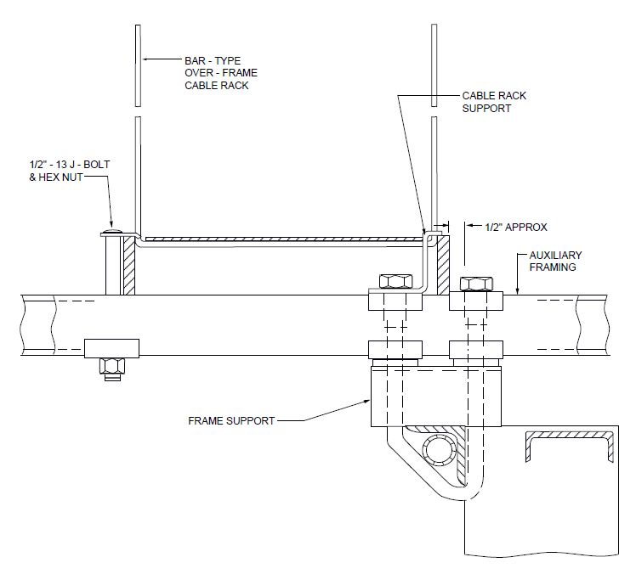

EXHIBIT 2-E1-62W (A&M)
2-E1-62W (A&M) BAR-TYPE OVER-FRAME CABLE RACK OVER CABLE DUCT-TYPE FRAMES-11 FOOT 8 INCH FRAMING

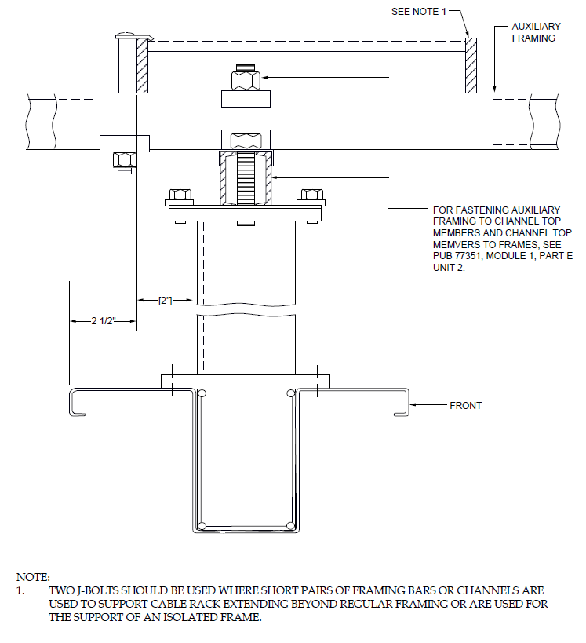

EXHIBIT 2-E1-63A (A&M)
2-E1-63A CABLE RACK SUPPORTED BY AUXILIARY FRAMING OVER BULB-ANGLE TYPE SWITCH FRAMES-STEP-BY-STEP SYSTEMS-11 FOOT 8 INCH FRAMING

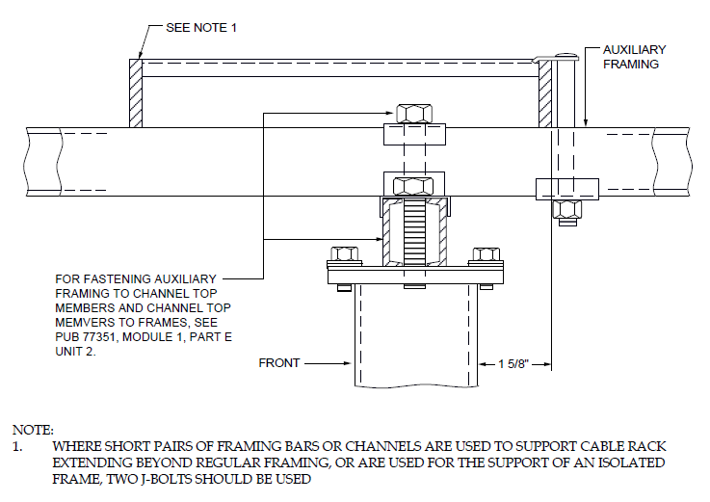

EXHIBIT 2-E1-63B (A&M)
2-E1-63B (A&M) LADDER-TYPE CABLE RACK OVER REAR OF CHANNEL-TYPE STEP-BY-STEP FRAMES-11 FOOT 8 INCH FRAMING-ADDITIONS ONLY

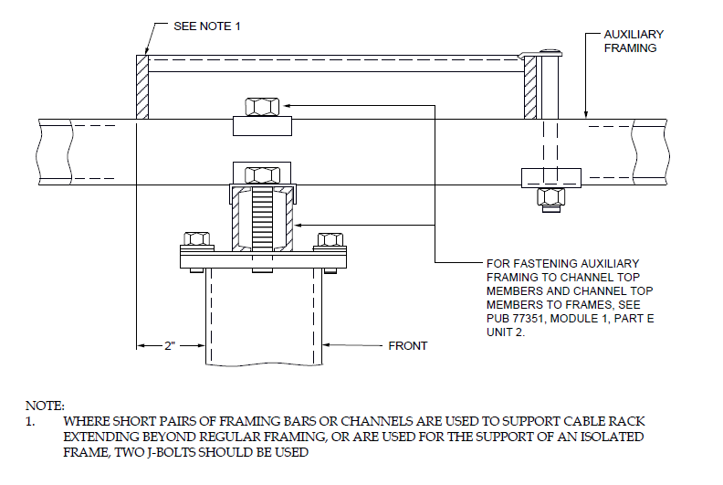

EXHIBIT 2-E1-63C (A&M)
2-E1-63C (A&M) LADDER-TYPE CABLE RACK OVER FRONT OF CHANNEL-TYPE STEP-BY-STEP FRAMES-11 FOOT 8 INCH FRAMING-ADDITIONS ONLY

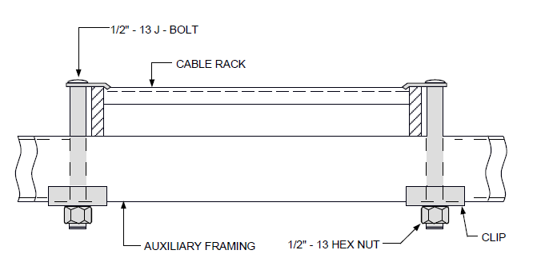

EXHIBIT 2-E1-65
2-E1-65 LADDER-TYPE CABLE RACK SUPPORTED BY LOW-TYPE AUXILIARY FRAMING

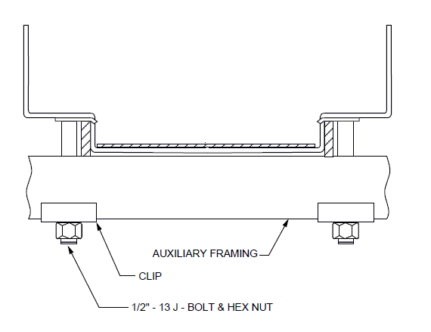

EXHIBIT 2-E1-65B (A&M)
2-E1-65 (A&M) BAR-TYPE CABLE RACK SUPPORTED BY LOW-TYPE AUXILIARY FRAMING BAR- TYPE OVER-AISLE RACK SHOWN

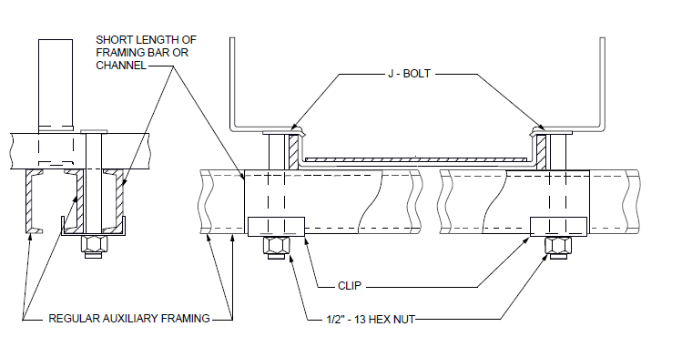

EXHIBIT 2-E1-65C (A&M)
2-E1-65C (A&M) CABLE RACK SUPPORTED BY LOW-TYPE AUXILIARY FRAMING DIRECTLY BELOW A CROSS STRAP-BAR-TYPE OVER-AISLE SHOWN
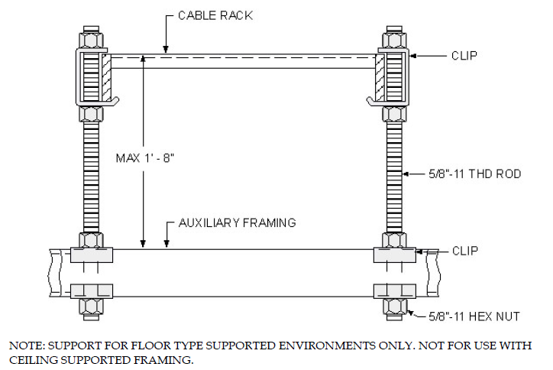
EXHIBIT 2-E1-66
2-E1-66 CABLE RACK SUPPORTED WITH G-CLIPS ABOVE LOW-TYPE AUXILIARY FRAMING BY THREADED RODS

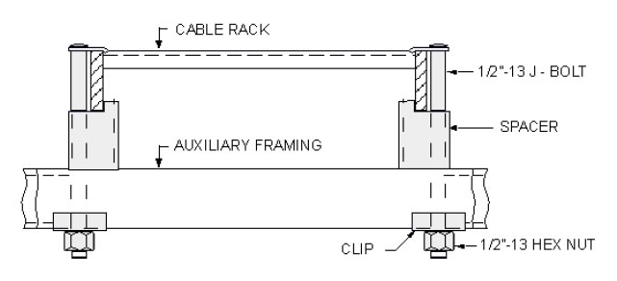
EXHIBIT 2-E1-66A
2-E1-66A CABLE RACK SUPPORTED ABOVE LOW-TYPE AUXILIARY FRAMING BY SPACERS

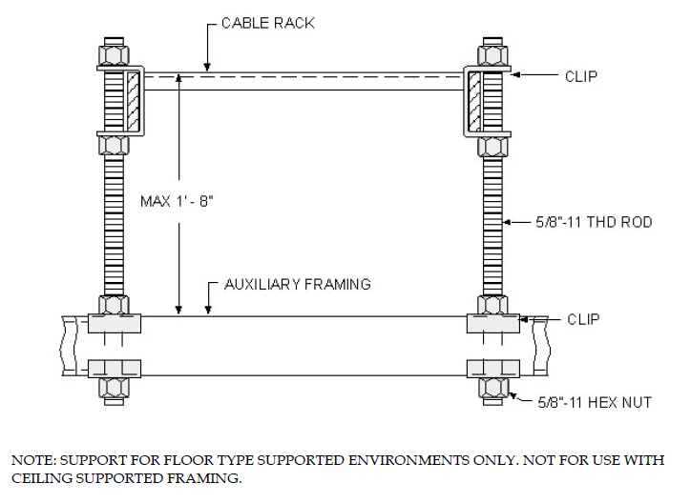

EXHIBIT 2-E1-66C
2-E1-66C CABLE RACK SUPPORTED WITH C-CLIPS ABOVE LOW-TYPE AUXILIARY FRAMING BY THREADED RODS

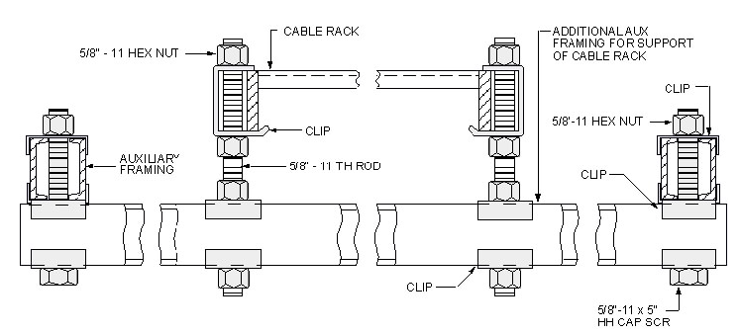
EXHIBIT 2-E1-67
2-E1-67 MAIN OR X-AISLE CABLE RACK SUPPORTED BY ADDITIONAL AUXILIARY FRAMING BELOW REGULAR FRAMING-USING THREADED RODS ADDITIONS ONLY - REPLACED BY EXHIBIT 2-E1-67A

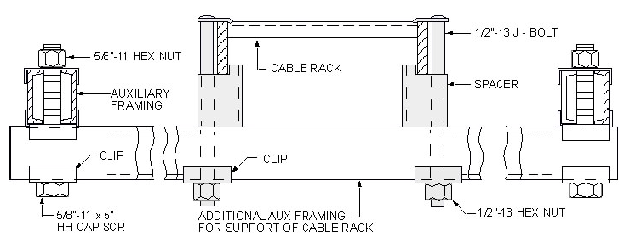

EXHIBIT 2-E1-67A
2-E1-67A MAIN-AISLE CABLE RACK SUPPORTED BY ADDITIONAL FRAMING BELOW REGULAR FRAMING-USING SPACERS

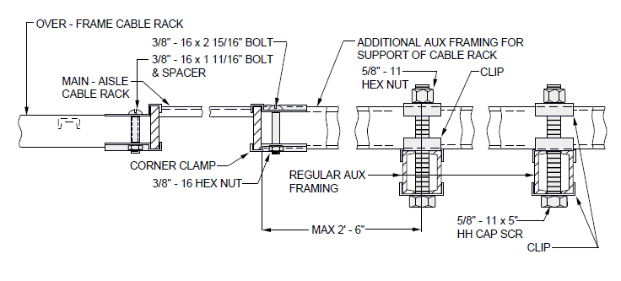

EXHIBIT 2-E1-68 (DISCONTINUED)
2-E1-68 (DISCONTINUED) MAIN OR X-AISLE CABLE RACK SUPPORTED BY ADDITIONAL AUXILIARY FRAMING ABOVE REGULAR FRAMING

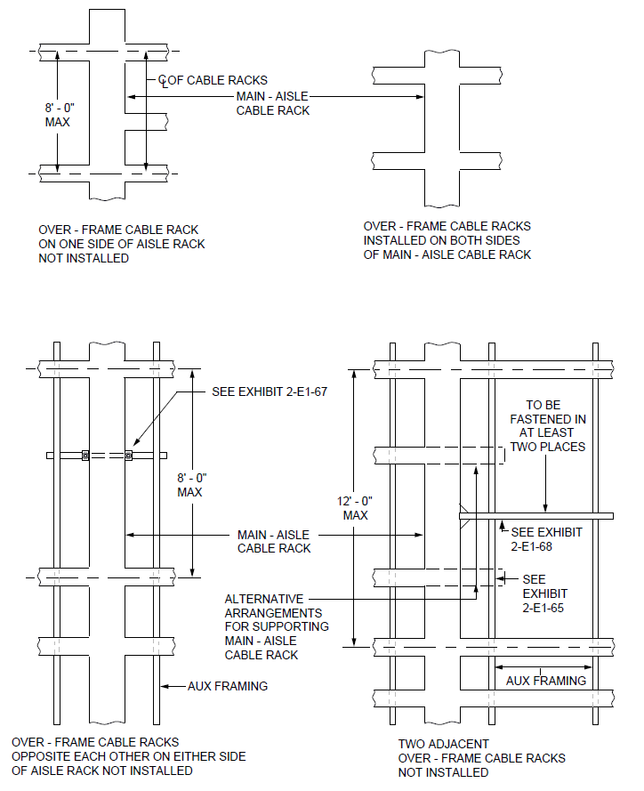
EXHIBIT 2-E1-69 (A&M)
2-E1-69 (A&M) CABLE RACKS OVER MAIN AISLES

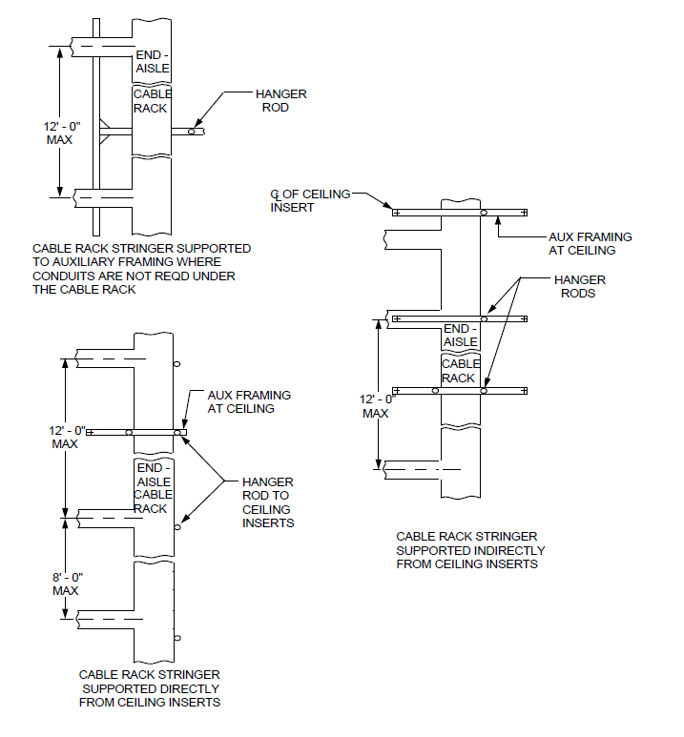

EXHIBIT 2-E1-70 (A&M)
2-E1-70 CABLE RACKS OVER END AISLES

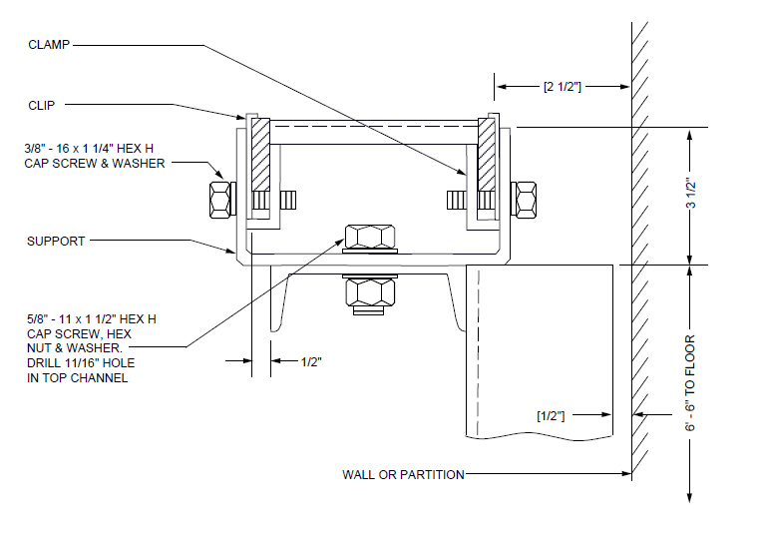

EXHIBIT 2-E1-70A (A&M)
2-E1-70A (A&M) CABLE RACKS ATTACHED TO TRAFFIC REGISTER CABINET

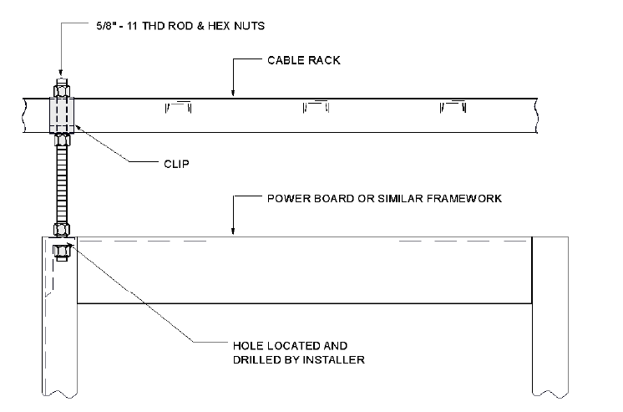

EXHIBIT 2-E1-71 (A&M)
2-E1-71 (A&M) CABLE RACK ATTACHED TO POWER BOARD OR SIMILAR FRAME WORK

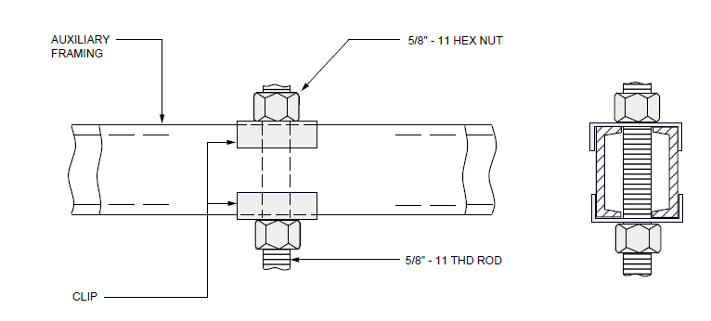
EXHIBIT 2-E1-72
2-E1-72 HANGER ROD ATTACHED TO AUXILIARY FRAMING

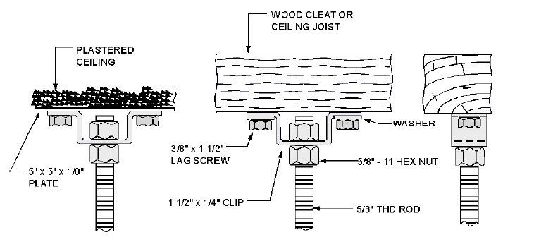
EXHIBIT 2-E1-73
2-E1-73 HANGER ROD ATTACHED DIRECTLY TO CEILING

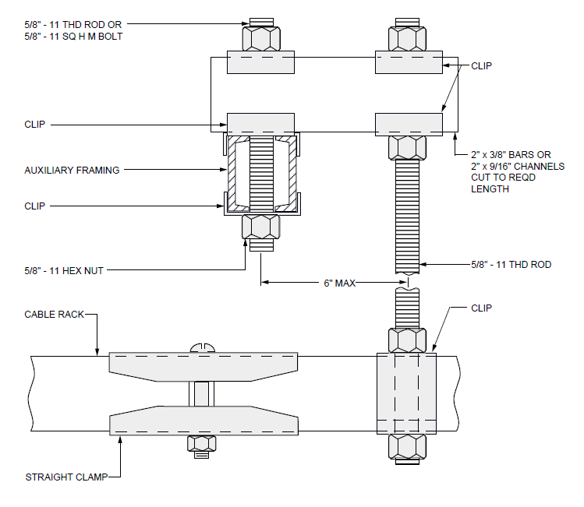

EXHIBIT 2-E1-74
2-E1-74 HANGER ROD OFFSET TO CLEAR CABLE RACK CLAMP, CABLE RACK STRAP, OR OTHER OBSTRUCTION

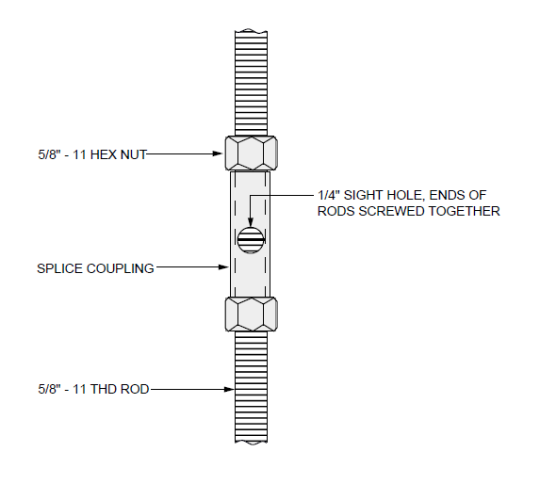

EXHIBIT 2-E1-75
2-E1-75 HANGER ROD EXTENDED WITH SPLICED COUPLING

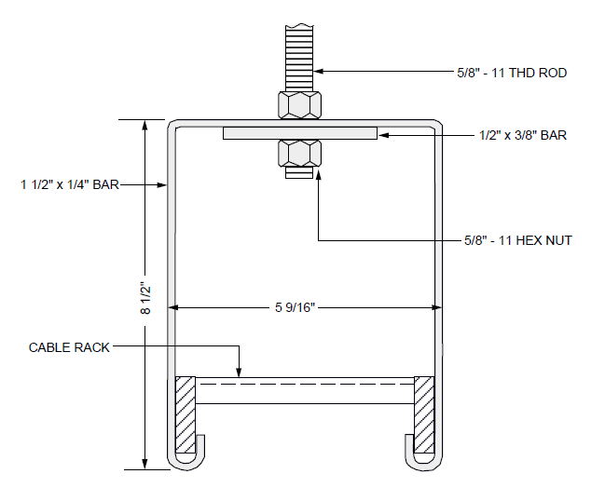

EXHIBIT 2-E1-76
2-E1-76 SUPPORTING RACKS 5 INCHES WIDE

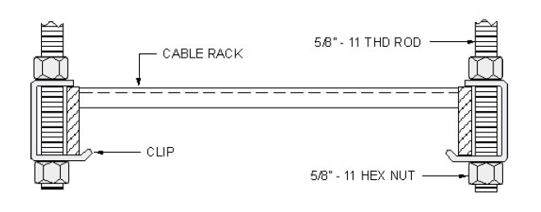
EXHIBIT 2-E1-77
2-E1-77 G-CLIP CABLE RACK SUPPORT BELOW AUXILIARY FRAMING WITH HANGER RODS

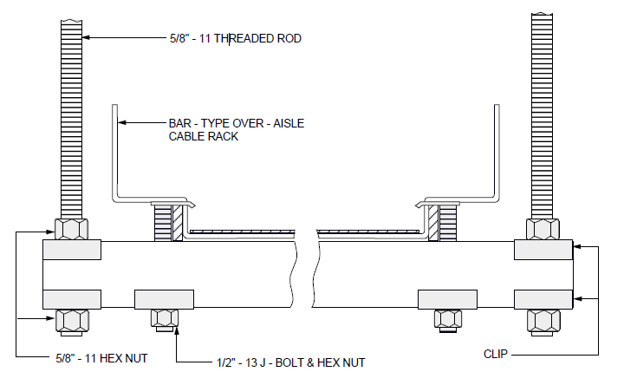

EXHIBIT 2-E1-77B
2-E1-77B SUPPORT BAR-TYPE OVER-AISLE CABLE RACK WITH HANGER RODS

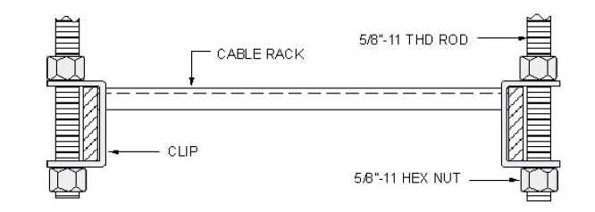
EXHIBIT 2-E1-77C
2-E1-77C C-CLIP CABLE RACK SUPPORT BELOW AUXILIARY FRAMING WITH HANGER RODS

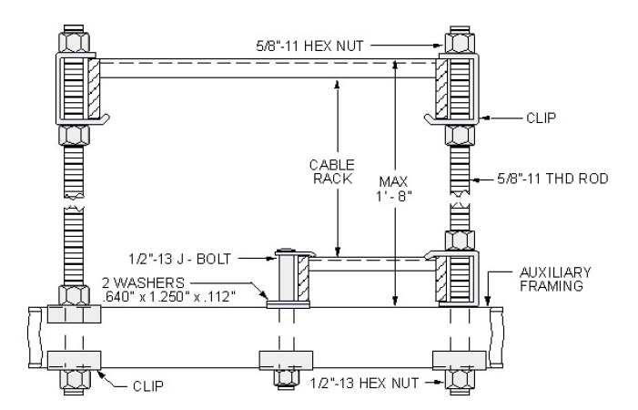

EXHIBIT 2-E1-81
2-E1-81 SUPPORTING ONE RACK ABOVE ANOTHER RACK-LARGE RACK ABOVE
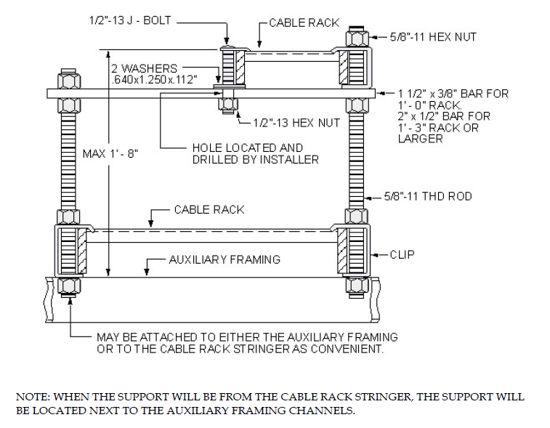

EXHIBIT 2-E1-82
2-E1-82 SUPPORTING ONE RACK ABOVE AND FROM ANOTHER RACK-LARGER RACK BELOW

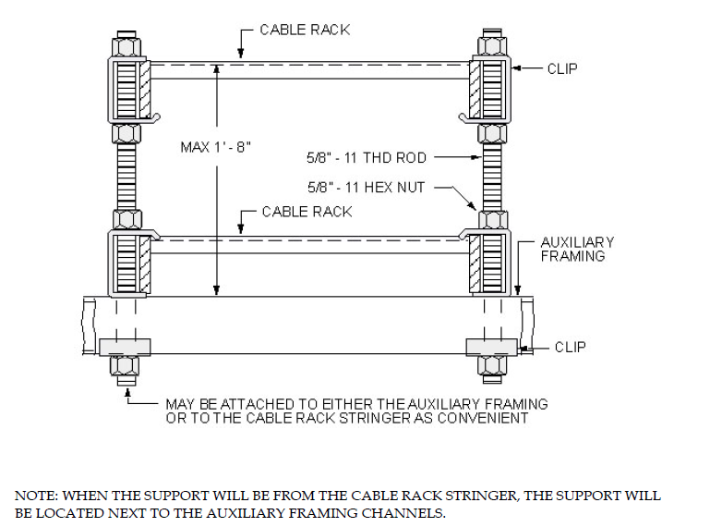

EXHIBIT 2-E1-83
2-E1-83 SUPPORTING ONE RACK ABOVE AND FROM ANOTHER RACK WITH G-CLIPS - RACKS SAME SIZE

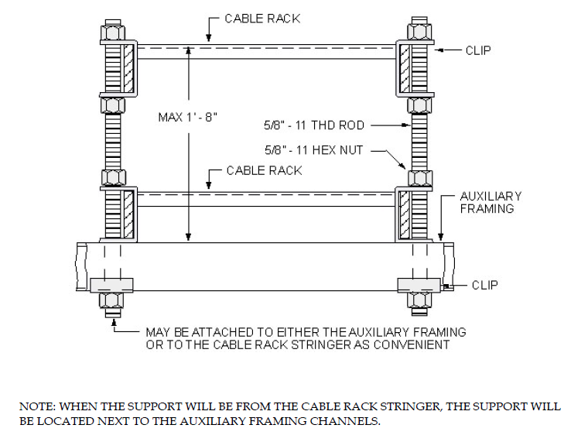

EXHIBIT 2-E1-83C
2-E1-83C SUPPORTING ONE RACK ABOVE AND FROM ANOTHER RACK WITH C-CLIPS - RACKS SAME SIZE

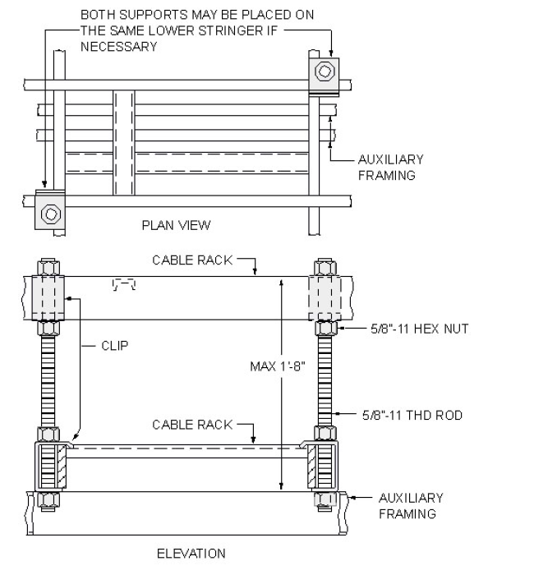

EXHIBIT 2-E1-84
2-E1-84 SUPPORTING ONE RACK ABOVE AND FROM ANOTHER RACK-CABLE RACKS AT RIGHT ANGLES
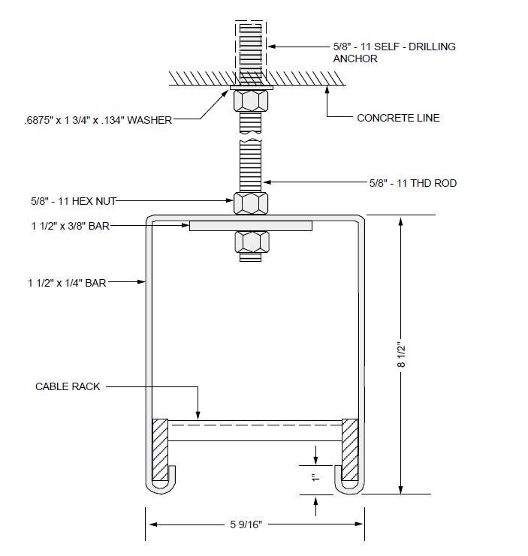

EXHIBIT 2-E1-85
2-E1-85 SUPPORTING 5 INCH CABLE RACK EMBEDDED INSERT IN CEILING

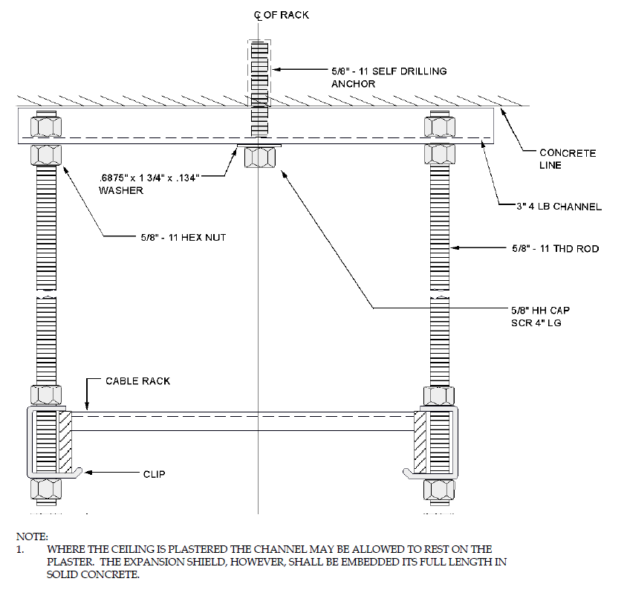

EXHIBIT 2-E1-86
2-E1-86 SUPPORTING 1 FOOT AND 1 FOOT 3 INCH CABLE RACKS FROM EMBEDDED OR EXPOSED CEILING CHANNEL

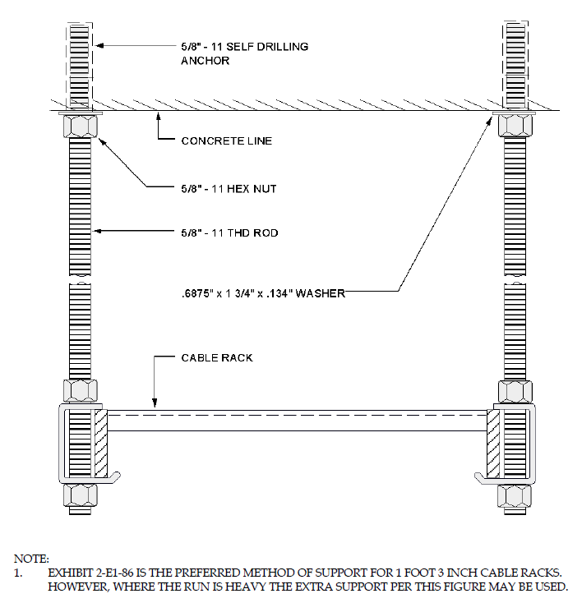
EXHIBIT 2-E1-87
2-E1-87 SUPPORTING CABLE RACKS FROM EMBEDDED INSERT IN CEILING

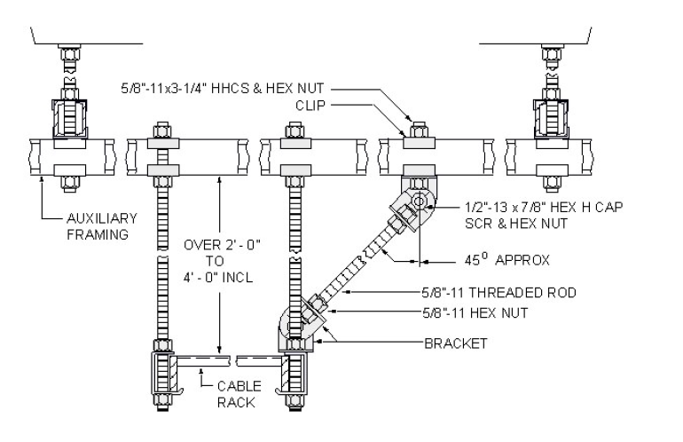

EXHIBIT 2-E1-88
2-E1-88 BRACING HANGER ROD-SUPPORTED CABLE RACK WITH ROD-TYPE BRACING

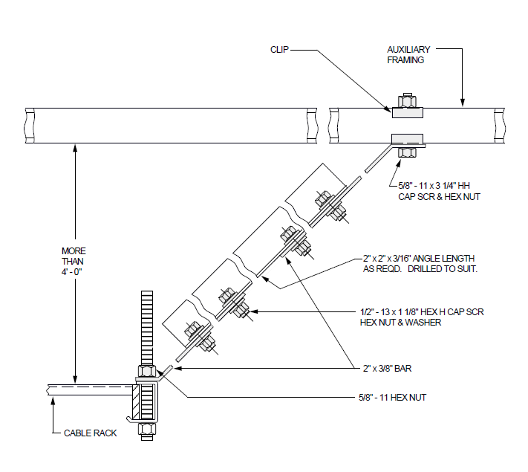

EXHIBIT 2-E1-89
2-E1-89 BRACING HANGER ROD-SUPPORTED CABLE RACK WITH ANGLE TYPE BRACING

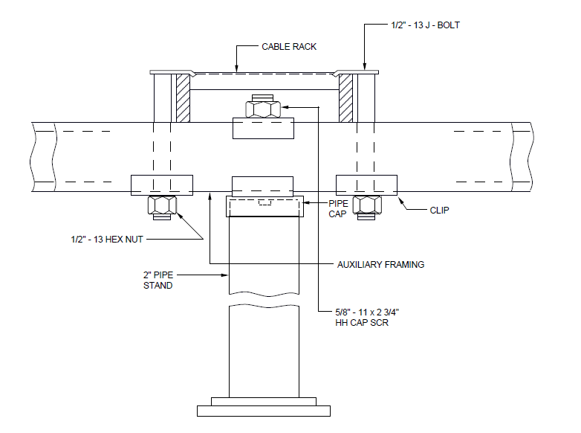

EXHIBIT 2-E1-90
2-E1-90 PIPE SUPPORTED CABLE RACK OVER LOW-TYPE AUXILIARY FRAMING

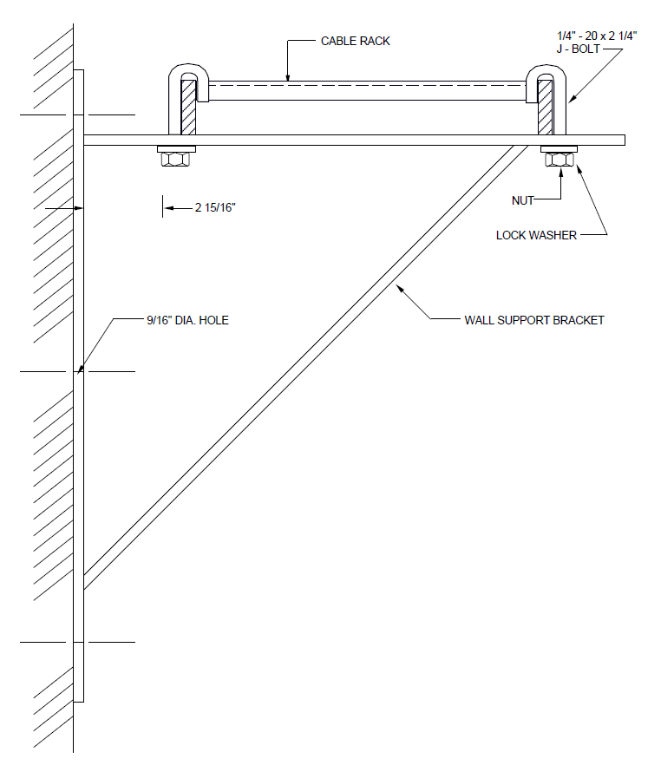
EXHIBIT 2-E1-91
2-E1-91 WALL SUPPORT BRACKET FOR 5 INCH-15 INCH CABLE RACK

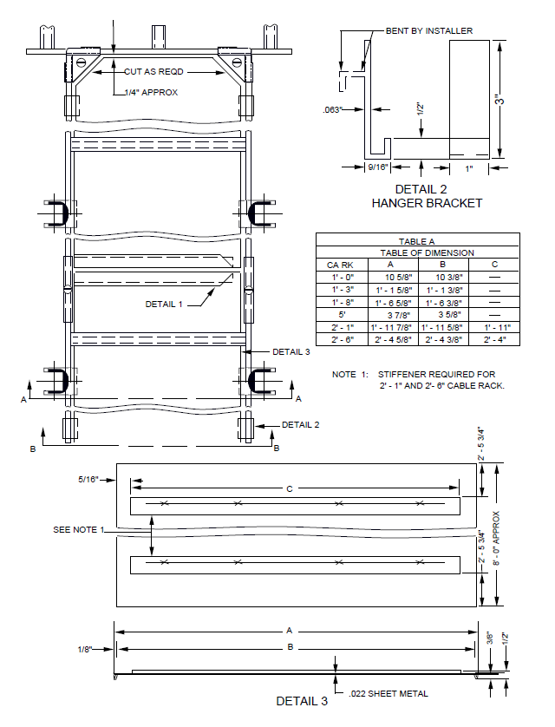
EXHIBIT 2-E1-92 (PAGE 1 OF 2)
2-E1-92 (PAGE 1 OF 2) SCREEN ASSEMBLE FOR UNDERSIDE OF 5 INCHES-30 INCHES LADDER-TYPE CABLE RACK

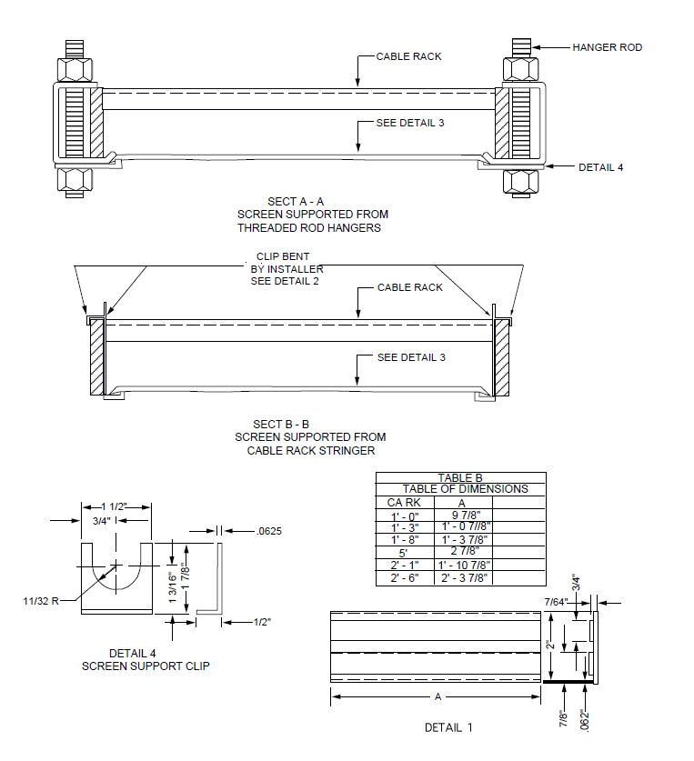

EXHIBIT 2-E1-92 (PAGE 2 OF 2)
2-E1-92 (PAGE 2 OF 2) SCREEN ASSEMBLE FOR UNDERSIDE OF 5 INCHES-30 INCHES LADDER-TYPE CABLE RACK

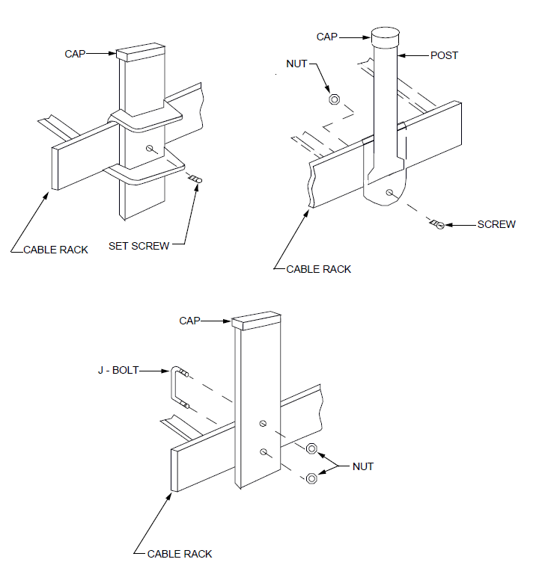

EXHIBIT 2-E1-93 (DISCONTINUED)
2-E1-93 (DISCONTINUED) EXAMPLES OF CABLE RETAINING BRACKETS

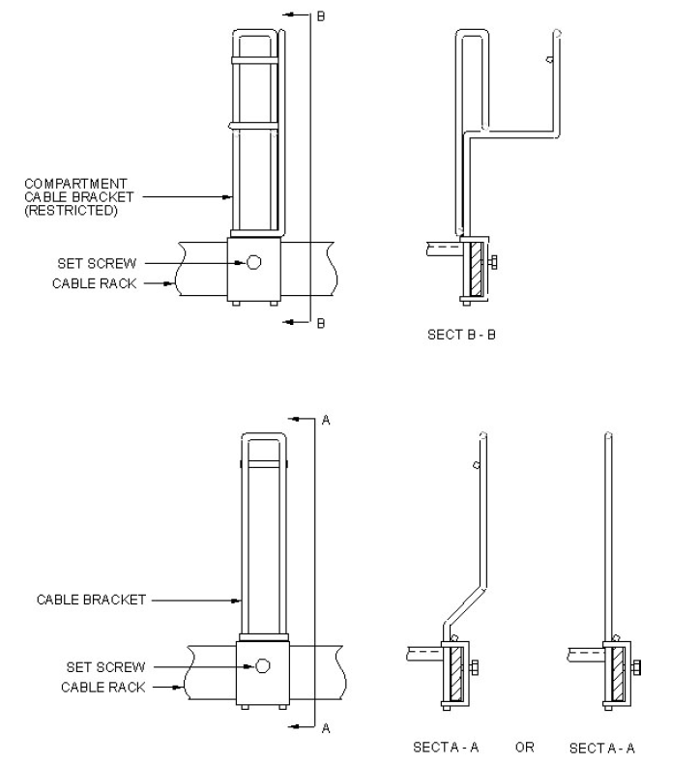

EXHIBIT 2-E1-93A
2-E1-93A EXAMPLES OF TYPICAL CABLE RETAINING BRACKETS

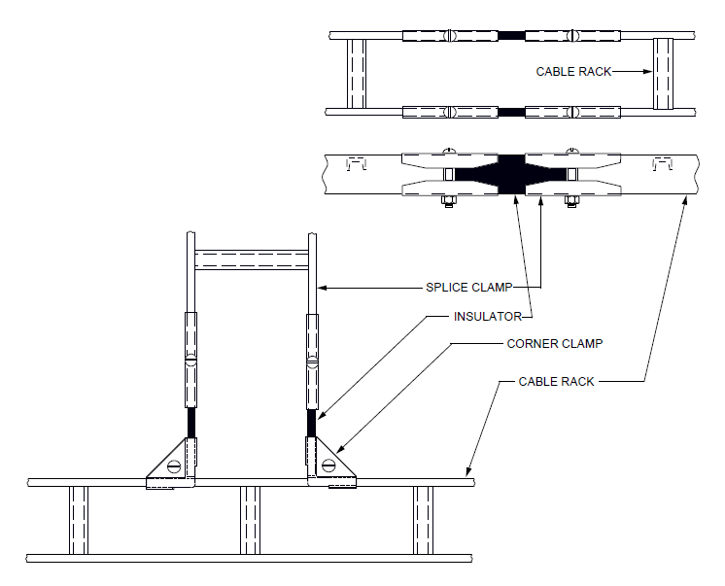

EXHIBIT 2-E1-94
2-E1-94 INSULATING JUNCTION FOR CABLE RACK

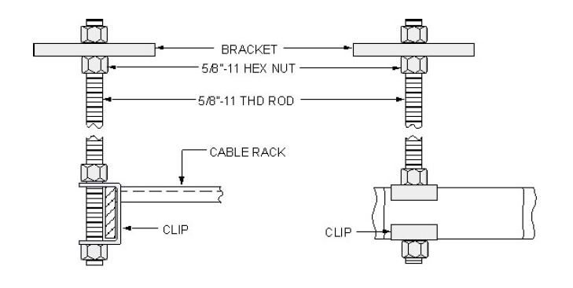

EXHIBIT 2-E1-95
2-E1-95 CABLE SUPPORT BRACKET FROM CABLE RACK STRINGER OR AUXILIARY FRAMING

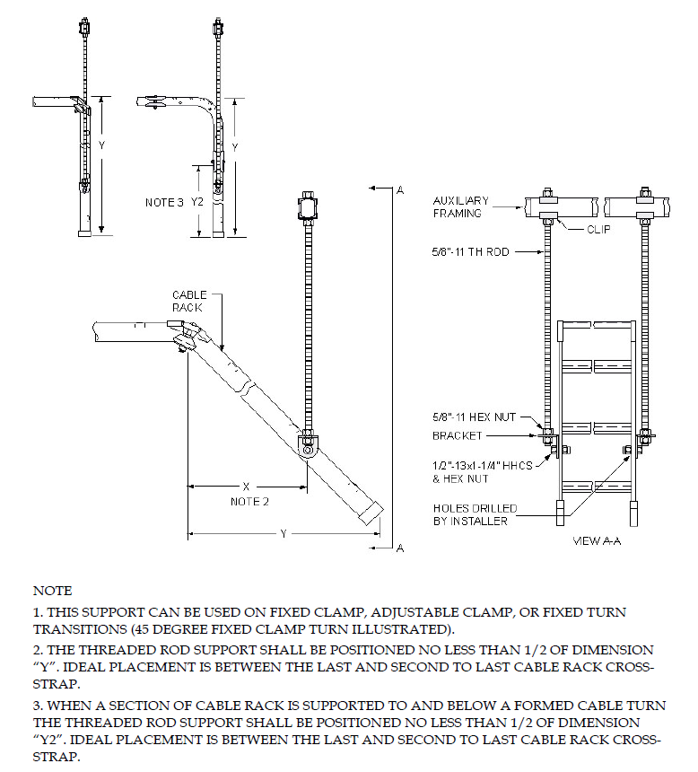

EXHIBIT 2-E1-96
2-E1-96 FREE ENDED TURN SUPPORT

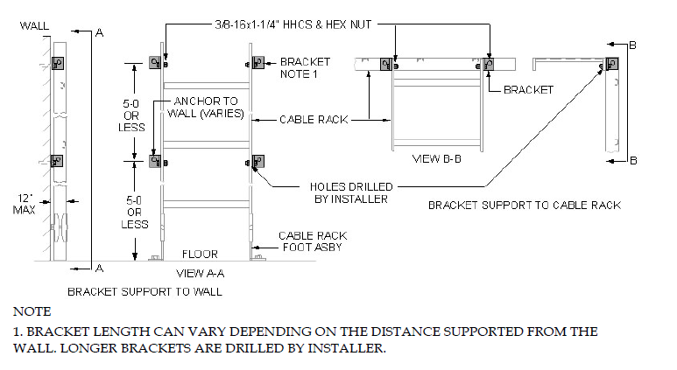
EXHIBIT 2-E1-97
BRACKET SUPPORT TO WALL OR CABLE RACK

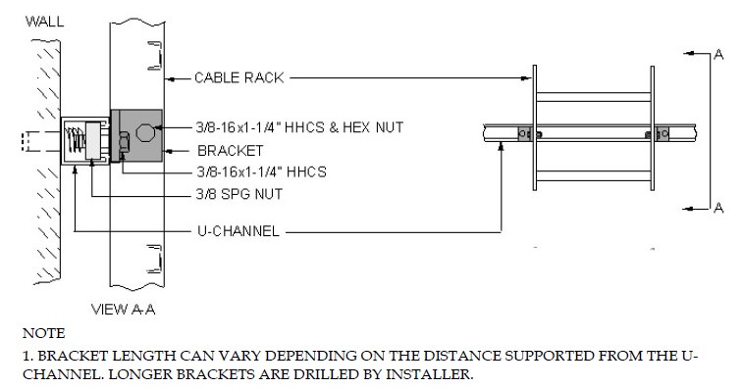

EXHIBIT 2-E1-98
2-E1-98 BRACKET SUPPORT TO U-CHANNEL

