Contents
6. Cable Rack and Auxiliary Framing 7
6B. Auxiliary Framing - Low Type 7
6B.1 General 7
6B.2 Descriptions of Auxiliary Framing 8
6B.3 Engineering Requirements 9
6B.3.1 Auxiliary Framing Support 10
6B.3.2 Extending Auxiliary Framing 11
6B.3.3 Splicing Auxiliary Framing 11
6B.3.4 Auxiliary Framing at Cable Holes 12
6B.4 Top Support Arrangements 12
6B.4.1 Floor Supported Environments 13
6B.4.2 Ceiling or Wall Supported Environments 13
6B.5 Floor Supported Environments 15
6B.5.1 Ironwork Support 16
6B.6 Ceiling or Wall Supported Environments 16
6B.7 Stanchions 18

TABLES
TABLE 6B.1 AUXILIARY FRAMING FASTENED TO FRAMES 24
TABLE 6B.2 AUXILIARY FRAMING BRACING REQUIREMENTS 30

EXHIBITS

2-E2-1 TYPICAL ARRANGEMENT OF AUXILIARY FRAMING AND CABLE RACK FOR 7-0 LOW LEVEL ENVIRONMENT AT A MAIN AISLE 26
2-E2-1A (A&M) TYPICAL ARRANGEMENT OF AUXILIARY FRAMING FOR COMBINED STEP-BY-STEP AND TOLL OFFICE-11 FOOT 8 INCH FRAMING-LADDER-TYPE CABLE RACK OVER LINE-UP OF FRAMES-HISTORICAL ONLY 27
2-E2-2A (A&M) TYPICAL ARRANGEMENT OF AUXILIARY FRAMING FOR NO. 1 CROSSBAR AND NO.4 TOLL SWITCHING OFFICES 11 FOOT 8 INCH FRAMING-LADDER-TYPE CABLE RACK OVER LINEUP OF FRAMES 28
2-E2-2B (A&M) TYPICAL ARRANGEMENT OF AUXILIARY FRAMING FOR NO. 5 CROSSBAR OFFICES WITHOUT PREARRANGED PATTERN OF CEILING INSERTS 29
2-E2-2C (A&M) TYPICAL ARRANGEMENT OF AUXILIARY FRAMING FOR CROSSBAR, AND STEP-BY-STEP OFFICES-ALSO COMBINED CROSSBAR AND TOLL OR STEP-BY-STEP AND TOLL OFFICE-11 FOOT 9 and 1/2 INCH FRAMING-BUILDING COLUMNS AND CEILING INSERTS PREARRANGED TO FACILITATE PRECABLING 30
2-E2-2D (A&M) TYPICAL ARRANGEMENT OF AUXILIARY FRAMING FOR NO. 4A TOLL SWITCHING OFFICES-11 FOOT 9 and 1/2 INCH FRAMING-4A WIDE CABLE RACK 31
2-E2-2E TYPICAL BRACING SCHEME – LIGHT 32
2-E2-2F TYPICAL STANCHION ARRANGEMENT 33
2-E2-2G TYPICAL 7FT LOW LEVEL STANCHION, FRAMEWORK OR CABINET SUPPORT 34
2-E2-3 TYPICAL AUXILIARY FRAMING 35
2-E2-4A (A&M) TYPICAL ARRANGEMENT OF AUXILIARY FRAMING FOR NO. 11 OFFICES-11 FOOT 8 INCH FRAMING-OVER FRAME CABLE RACKS 35
2-E2-5 AUXILIARY FRAMING FASTENED TO UNDERSIDE OF CABLE RACK 36
2-E2-6 AUXILIARY FRAMING FASTENED DIRECTLY TO TOP ANGLES 37
2-E2-6A AUXILIARY FRAMING FOR TOP-ANGLE FRAMES IN LINE WITH STEP-BY-STEP FRAMES-9 FOOT AND 11 FOOT 6 INCH FRAMING-ADDITIONS ONLY 38
2-E2-6F AUXILIARY FRAMING ATTACHED TO 1-INCH JUNCTION PIPE EXTENDED BEYOND THE END OF CABLEDUCT-TYPE FRAME 7 FOOT AND 11 FOOT 6 INCH FRAMING 40
2-E2-6G AUXILIARY FRAMING FASTENING FOR CERTAIN CROSSBAR FRAMES 41
2-E2-6H (A&M) JUNCTIONING TOPS OF ADJACENT CERTAIN CROSSBAR FRAMES 42
2-E2-6J AUXILIARY FRAMING ATTACHED DIRECTLY TO CABLE DUCT-TYPE FRAMES OR TO JUNCTION PIPE AT LOCATION OF FIXTURE FRAME 7 FOOT AND 11 FOOT 6 INCH AUXILIARY FRAMING 43
2-E2-6L SUPPORT FOR FRAME JUNCTION PIPE EXTENDING BEYOND END OF CABLE DUCT-TYPE FRAME-9 FOOT 3 and 1/2 INCH, 11 FOOT 7 and 1/2 INCH, 11 FOOT 8 INCH, AND 11 FOOT 9 and 1/2 INCH AUXILIARY FRAMING 44
2-E2-6M AUXILIARY FRAMING ATTACHED TO CABLE DUCT-TYPE FRAME OR TO JUNCTION PIPE AT LOCATION OF FUTURE FRAME-9 FOOT 2 INCH AND 11 FOOT 8 INCH AUXILIARY FRAMING 45
2-E2-6R AUXILIARY FRAMING FASTENED TO CABLE DUCT-TYPE FRAME OR TO JUNCTION PIPE AT LOCATION OF FUTURE FRAME-9 FOOT 3 and 1/2 INCH AND 11 FOOT 9 and 1/2 INCH AUXILIARY FRAMING 46
2-E2-7 AUXILIARY FRAMING FASTENED TO TOP-ANGLES AT A LOWER LEVEL 47
2-E2-7A AUXILIARY FRAMING FASTENED TO SINGLE TOP-ANGLE FRAMES 7 FOOT 2 INCH, 9 FOOT 2 INCH, AND 11 FOOT 8 INCH FRAMING 48
2-E2-7B V-BOLT FRAME SUPPORT ASSEMBLY 49
2-E2-7C AUXILIARY FRAMING FASTENED TO SINGLE TOP-ANGLE FRAMES-9 FOOT 2 INCH AND 11 FOOT 8 INCH FRAMING SUPPORT OFFSET TO CLEAR FRAME UPRIGHT 50
2-E2-7D V-BOLT FRAME SUPPORT OFFSET TO CLEAR FRAME UPRIGHT 51
2-E2-7E AUXILIARY FRAMING FASTENED TO SINGLE TOP-ANGLE FRAMES-11 FOOT 9 and 1/2 INCH FRAMING 52
2-E2-8 SUPPORT OF ENDS OF AUXILIARY FRAMING-EXTENSIONS OF BAR OR CHANNELS BEYOND THE LAST LINE OF FRAMES 53
2-E2-8C AUXILIARY FRAMING SUPPORTED AT WALLS 54
2-E2-9 (A&M) SPLICING AUXILIARY FRAMING-2 INCHES BY 3/8 OF AN INCH BARS TO 2 INCHES BY 3/8 OF AN INCH BARS 55
2-E2-9A (DISCONTINUED) SPLICING AUXILIARY FRAMING-CHANNELS TO CHANNELS 56
2-E2-9B SPLICING AUXILIARY FRAMING-CHANNELS TO BARS 57
2-E2-9C SPLICING AUXILIARY FRAMING-2 BY 1/2 INCH BARS TO 2 BY 3/8 INCH BARS 58
2-E2-9D ARRANGEMENT FOR EXTENDING BAR OR CHANNEL FRAMING TO ELIMINATE NECESSITY OF CUTTING BACK EXISTING FRAMING 59
2-E2-9E JUNCTIONING LOW-TO HIGH-LEVEL FRAMING 60
2-E2-9F SINGLE-LEVEL AUXILIARY FRAMING INTERSECTION OF PRIMARY AND SECONDARY BARS OR CHANNELS 61
2-E2-9G SINGLE-LEVEL AUXILIARY FRAMING JUNCTION OF PRIMARY AND SECONDARY BARS OR CHANNELS 62
2-E2-9H SPLICING AUXILIARY FRAMING 11 FOOT 8 INCH AND 11 FOOT 9 and 1/2 INCH FRAMING 63
2-E2-9J SPLICING AUXILIARY FRAMING-CHANNELS TO CHANNELS USING 3-HOLE SPLICE PLATES 64
2-E2-9K SPLICING AUXILIARY FRAMING-CHANNELS TO BARS-USING 3-HOLE SPLICE PLATES 65
2-E2-9L SPLICING AUXILIARY FRAMING-TYPICAL APPLICATIONS-USING 3-HOLE SPLICE PLATES 66
2-E2-9M ARRANGEMENT FOR EXTENDING BAR OR CHANNEL FRAMING WITH CHANNEL FRAMING-ELIMINATING NECESSITY OF CUTTING BACK EXISTING FRAME 67
2-E2-10 FINISHING CLIPS ON AUXILIARY FRAMING 68
2-E2-11 PIPE STAND SUPPORT OF AUXILIARY FRAMING 69
2-E2-11A PIPE STAND SUPPORT OF AUXILIARY FRAMING (A&M) 70
2-E2-11B (A&M) JUNCTIONING ADJACENT FRAME UPRIGHTS WITH CHANNEL TOP MEMBERS-BULB-ANGLE OR CHANNEL-TYPE STEP-BY-STEP SWITCH FRAMES-BULB-ANGLE TYPE SHOWN 71
2-E2-11C (A&M) JUNCTIONING ADJACENT FRAME UPRIGHTS WITH CHANNEL TOP MEMBER-WHERE A FRAME HAS BEEN ADDED TO AN EXISTING LINE-UP-BULB-ANGLE OR CHANNEL-TYPE STEP-BY-STEP SWITCH FRAMES-BULB-ANGLE TYPE SHOWN 72
2-E2-11D (A&M) FASTENING 2 INCH CHANNEL TOP MEMBERS AT END OF LINE-UP OR AT AN INTERMEDIATE UPRIGHT OF A FRAME-BULB-ANGLE OR CHANNEL-TYPE STEP-BY-STEP SWITCH FRAMES-BULB ANGLE UPRIGHT AT END OF LINE SHOWN 73
2-E2-11E (A&M) JUNCTIONING ADJACENT FRAME UPRIGHTS HAVING 2 INCH CHANNEL TOP MEMBER WITH AUXILIARY FRAMING OVER ONE OF THE UPRIGHTS-BULB-ANGLE OR CHANNEL-TYPE STEP-BY-STEP FRAMES-BULB-ANGLE TYPE SHOWN 11 FOOT 8 INCH FRAMING 74
2-E2-11F (A&M) FASTENING 2 INCH CHANNEL TOP MEMBERS TO UPRIGHT AT END OF LINE-UP WITH AUXILIARY FRAMING OVER THE UPRIGHT-BULB-ANGLE OR CHANNEL-TYPE STEP-BY-STEP SWITCH FRAMES-BULB-ANGLE TYPE SHOWN-11 FOOT 9 INCH FRAMING 75
2-E2-11G (A&M) AUXILIARY FRAMING ATTACHED WITH JUNCTION PLATE TO TWO ADJACENT BULB-ANGLE UPRIGHTS IN 11 FOOT 6 INCH FRAMING AREA-STEP-BY-STEP OFFICES 76
2-E2-11H (A&M) JUNCTIONING ADJACENT FRAME UPRIGHTS WITH CHANNEL-TYPE TOP MEMBERS BULB-ANGLE TO CHANNEL-TYPE STEP-BY-STEP SWITCH FRAMES 77
2-E2-11J DOUBLE-LEVEL AUXILIARY FRAMING-FASTENING CHANNEL OVER CHANNEL 78
2-E2-11K (A&M) JUNCTIONING ADJACENT FRAME UPRIGHTS HAVING 2 INCH CHANNEL TOP MEMBERS WITH AUXILIARY FRAMING OVER ONE OF THE UPRIGHTS-BULB-ANGLE OR CHANNEL-TYPE STEP-BY-STEP SWITCH FRAMES-BULB-ANGLE-TYPE SHOWN-11 FOOT 9 and 1/2 INCH FRAMING 79
2-E2-11L (A&M) FASTENING 2 INCH CHANNEL TOP MEMBERS TO UPRIGHT AT END OF LINE-UP WITH AUXILIARY FRAMING OVER THE UPRIGHT BULB-ANGLE OR CHANNEL-TYPE STEP-BY-STEP SWITCH FRAMES-BULB-ANGLE-TYPE SHOWN-11 FOOT 9 and 1/2 INCH FRAMING 80
2-E2-11M (A&M) AUXILIARY FRAMING ATTACHED TO 2 INCH CHANNEL TOP MEMBERS OF STEP-BY-STEP SWITCH FRAMES-FASTENING BETWEEN FRAME UPRIGHTS 11 FOOT 9 and 1/2 INCH FRAMING 81
2-E2-12B (A&M) JUNCTIONING TOP ANGLES OF BULB-ANGLE-TYPE FRAMES 82
2-E2-12C (A&M) AUXILIARY FRAMING ATTACHED DIRECTLY TO TOP ANGLES OF BULB-ANGLE-TYPE FRAMES 83
2-E2-12F (A&M) AUXILIARY FRAMING ATTACHED TO TOP ANGLES OF BULB-ANGLE-TYPE FRAMES-11 FOOT 9 and 1/2 INCH AUXILIARY FRAMING 84
2-E2-12G (A&M) AUXILIARY FRAMING ATTACHED TO TOP ANGLES OF BULB-ANGLE-TYPE FRAMES-7 FOOT 2 INCH AND 11 FOOT 8 INCH AUXILIARY FRAMING 85
2-E2-13 AUXILIARY FRAMING RAISED AND EXTENDED OVER STEP-BY-STEP DISTRIBUTING FRAMES-11 FOOT 6 INCH FRAMING-ADDITIONS ONLY 86
2-E2-15B (A&M) ISOLATED STEP-BY-STEP FRAMES SUPPORTED FROM ONE CABLE RACK 11 FOOT 8 INCH FRAMING 87
2-E2-15C (A&M) ISOLATED STEP-BY-STEP FRAMES SUPPORTED FROM ONE CABLE RACK 11 FOOT 9 and 1/2 INCH FRAMING 88
2-E2-15D (A&M) ISOLATED NO. 1 CROSSBAR FRAME SUPPORTED FROM BAR-TYPE OVER-AISLE CABLE RACK 11 FOOT 9 and 1/2 INCH FRAMING 89
2-E2-15E (A&M) ISOLATED NO. 1 CROSSBAR FRAME SUPPORTED FROM BAR-TYPE OVER-FRAME CABLE RACK 11 FOOT 9 and 1/2 INCH FRAMING 90
2-E2-15F (A&M) ISOLATED NO.1 CROSSBAR AND NO. 4 TOLL SWITCHING FRAMES SUPPORTED FROM ONE CABLE RACK-11 FOOT 8 INCH FRAMING 91
2-E2-16B (A&M) ISOLATED CROSSBAR FRAMES SUPPORTED FROM ONE CHANNEL-TYPE CABLE RACK-ADDITIONS ONLY 92
2-E2-16C (A&M) ISOLATED CROSSBAR FRAMES SUPPORTED FROM ONE BAR-TYPE CABLE RACK 93
2-E2-18 AUXILIARY FRAMING OVER BATTERY CONTROL BOARDS 94
2-E2-18A AUXILIARY FRAMING ATTACHED DIRECTLY TO TOP-ANGLES OF BATTERY DISTRIBUTING FUSE BOARDS-11 FOOT 6 INCH FRAMING 95
2-E2-18B AUXILIARY FRAMING ATTACHED TO TOP-ANGLES OF BATTERY DISTRIBUTION FUSE BOARDS-11 FOOT 8 INCH FRAMING 96
2-E2-18C AUXILIARY FRAMING ATTACHED TO TOP-ANGLES OF BATTERY DISTRIBUTION FUSE BOARDS-11 FOOT 9 and 1/2 INCH FRAMING 97
2-E2-18D AUXILIARY FRAMING OVER BATTERY CONTROL BOARDS EQUIPPED WITH REAR DOORS 98
2-E2-19 AUXILIARY FRAMING OVER GENERATOR CONTROL PANELS 99
2-E2-20 AUXILIARY FRAMING SUPPORT OF BUS BARS AT BATTERY STANDS 100
2-E2-21 AUXILIARY FRAMING SUPPORT OF RETURN BUS BARS AT 7FT BDFB 101
2-E2-23 (DISCONTINUED) BRACING AUXILIARY FRAMING TO COLUMNS HISTORICAL ONLY 102
2-E-23C FINISHING CAPS ON AUXILIARY FRAMING 103
2-E2-24 BRACING OF AUXILIARY FRAMING WITH SINGLE BRACE 104
2-E2-25 BRACING OF AUXILIARY FRAMING WITH SINGLE-ROD BRACES 105
2-E2-25A BRACING OF AUXILIARY FRAMING WITH DOUBLE - ANGLE BRACES 106
2-E2-26A FASTENING AUXILIARY FRAMING BRACE TO EMBEDDED CEILING CHANNEL 107
2-E2-27 DOUBLE-LEVEL AUXILIARY FRAMING-ISOLATING TWO LEVELS OF CHANNEL 108
2-E2-28 AUXILIARY FRAMING SUPPORT FOR SHORT BUS BARS ABOVE BATTERY STANDS 109
2-E2-29 DOUBLE FRAMING ATTACHED TO WALLS WHERE ANGLE IS DRILLED 110
2-E2-30 SUPPORTING FRAME WITH THREADED ROD FROM FRAMING 111
2-E2-31 BRACING FRAMES FROM AUXILIARY FRAMING 112
2-E2-31A (DISCONTINUED) BRACING LOW LEVEL ENVIRONMENT FRAMES 113
2-E2-32 TYPICAL FRAMEWORK AND IRONWORK ARRANGEMENT FOR A 7’-0” FLOOR SUPPORTED SYSTEM 114
2-E2-32A TYPICAL ATTACHMENT OF AUXILIARY FRAMING TO UNEQUAL FLANGE CABLE DUCT TYPE FRAMEWORK 115
2-E2-32B TYPICAL METHOD OF INSTALLING HANGER ROD OFF-SET TO MAINTAIN GUARD RAIL ALIGNMENT 116
2-E2-32C TYPICAL METHOD OF SUPPORTING AUXILIARY FRAMING OVER A 7’-0” BDFB 117
2-E2-32D TYPICAL METHOD OF SUPPORTING AUXILIARY FRAMING OVER A 7’-0” CABINET 117
2-E2-33 (A&M) LOW-LEVEL CABLE RACKING (TYPICAL IRONWORK LAYOUT) 118
2-E2-33A (A&M) TYPICAL METHOD OF SUPPORTING FRAMEWORK IN A 7’-0” LOW LEVEL ENVIRONMENT 119

6. Cable Rack and Auxiliary Framing

6B. Auxiliary Framing - Low Type

6B.1 General
This unit covers the engineering of auxiliary framing over line-ups of transmission and power equipment. Refer to the chapter on high type framing for additional requirements on ceiling suspended auxiliary framing.
Auxiliary framing requirements, methods of support and assembly, along with Exhibits in this chapter, illustrate approved methods of providing auxiliary framing in a Network Facility.
Alternate methods of auxiliary framing support and assembly, not identified herein, are generally not approved. Authorization shall be obtained from the CenturyLink representative for Common Systems Standards prior to providing custom arrangements.
- Low type auxiliary framing in earlier environments such as Crossbar and Step-by-Step is the framing directly above and perpendicular to the equipment lineups.
- One inch galvanized support pipe is provided perpendicular to the auxiliary framing and is an integral part of the rigidity of low type auxiliary framing for environments other than the 7 foot floor support.
- Where bracing is required, low-level framing is braced directly to walls or ceiling components. Restrictions on bracing to walls are contained in the chapters on auxiliary framing.
- Where multiple levels of framing are required also refer to the chapter on high type framing.

Auxiliary framing shall be provided for support of equipment, cable racks, frame lighting and other apparatus in the Network Facility.
- Framing parts shall be directly butted. All measurements shown in Exhibits indicate maximum or minimum allowable gap tolerances.
- Some clips and plates tend to distort when nuts are tightened excessively. Tightening of nuts should be stopped when perceptible bending is noted.

Safe load limitations for embedded ceiling inserts, expansion anchors, hanger rods, and auxiliary framing are covered in the unit on Cable Rack Requirements.
Self-drilling anchors shall not be used to secure frames or secure ironwork to ceilings, walls or floors. Substitute appropriate lag bolts for attaching frames or ironwork to wooden ceilings, walls, or floors. Where embedded inserts or expansion anchors are shown substitute torque indicating anchors.
Refer to the "Auxiliary Framing - High Type" section for additional requirements concerning "Ceiling Fastening Arrangements" or "Ceiling Hanger Rods".
- Refer to the "Earthquake and Disaster Bracing" section for additional auxiliary framing requirements in earthquake heavy zones.
- Auxiliary framing arrangements not specifically identified in this document shall adhere to the intent of the requirements and guidelines.
Refer to CenturyLink Technical Documents and Standard Configurations for additional information. Standard Configurations may include essential information, specific arrangements, approved products, or direction on applying engineering requirements.

6B.2 Descriptions of Auxiliary Framing
One inch channel type auxiliary framing is 1 inch by 2 inches and is manufactured in various lengths.
- One inch channel is oriented with the 2 inch flat side to the bottom as illustrated in Exhibit 2-E2-3 and may be encountered in some hut environments

Parallel bar type auxiliary framing is usually 2 inches by 3/8 of an inch and is manufactured in various lengths.
- Bars are paired as illustrated in Exhibit 2-E2-3 and may be encountered in some old Central Office and small CDO environments.
- Some small office environments use 1-1/2 inch by 3/8 inch bar. These bars may be single or paired. They shall not be used for auxiliary framing type support applications without Planning and Engineering Guidelines Common Systems approval.

Parallel channel type auxiliary framing is 2 inches by 9/16 of an inch by 3/16 of an inch and is manufactured in various lengths.
- Channels are paired with the backs of the channels to the outside as shown in Exhibit 2-E2-3.
- In order to obtain maximum rigidity, framing bars or channels shall be installed in stock lengths (20 feet) wherever possible.

Note: It is the intent of this document to maintain the rigidity of the ironwork support system as much as possible. This includes installing auxiliary framing in full sections and replacing short sections of framing where appropriate. For example, where 15 feet of framing is required it is not recommended to splice 10 feet and 5 feet together. An exception could be where framing is cut back to allow for future growth and stagger splices. The 5 feet section would then be replaced when extending the framing.
To prevent corrosion, framing bars and channel should be a non-corrosive plated type, or painted, preferably gray. Framing bar and channel assembly hardware shall be of a non-corrosive plated type.

- Plating should be colored to be distinguished from non-plated components

Where channels and hardware are intended to provide an electrical bond, refer to CenturyLink Technical Publication 77350, "Central Office Telecommunications Equipment Installation and Removal Guidelines" and CenturyLink Technical Publication 77355, "Grounding - Central Office and Remote Equipment Environment".

6B.3 Engineering Requirements
The requirements in this section apply to both high and low type auxiliary framing.
- The surrounding space required to access, add, or remove equipment and components, shall be taken into consideration when determining locations of auxiliary framing and supports.

Auxiliary framing shall not be located within the maintenance area of an equipment environment.
- The maintenance area is defined as that area below the top of the framework (including extenders) and in a front or rear aisle (guard rail to guard rail).
- Where environments of differing heights, such as 7 foot and 11 foot 6 inch, intersect, the auxiliary framing of the 7 foot floor supported environment may encroach into the other environment as long as it does not interfere with rolling ladders and normal operations or installation activities.

Auxiliary framing shall be engineered and installed for the ultimate layout or arrangement whenever possible.
- Framing bars or channels for an area covered by continuous rows of framing shall be approximately the same level.

Separate areas of primary and secondary framing, where possible, should be of a consistent design so that when extended to each other and joined they shall be of a constant level.
- Auxiliary framing used exclusively for the support of cable rack shall be consistent with existing levels of framing where possible.

Framing bars or channels shall, at a minimum, be flush with clips similar to Exhibit 2-E2-9E.
In the placing of auxiliary framing a minimum clearance of 6 inches shall be maintained between the ends of the framing bars or channels and any building obstruction.
When auxiliary framing and associated equipment are located within the isolated ground plane, separation from all integrated ground plane members must be maintained as specified in CenturyLink Technical Publication 77355, "Grounding - Central Office and Remote Equipment Environment".
THREADED RODS: Auxiliary framing support arrangements shall be such that threaded rods will not pass through cable racks.

STIFFENING CLIPS: Channels are not as rigid as bars and may become bent during installation. Where required, additional clips shall be provided to hold the channels parallel similar to Exhibit 2-E2-10.

FINISHING DETAILS: Low type bars or channels shall be equipped with finishing caps, Exhibit 2-E2-23C, or clips, Exhibit 2-E2-10, except where bars or channels are within 6 inches of a wall, column, or vertical surface.

VENDER SPECIFIC FRAMING ARRANGEMENTS: Framing arrangements for the support of frameworks and system racking for switch systems, such as #5ESS and DMS, shall be per individual system requirements. Via racking support required for these systems shall be per CenturyLink requirements.

6B.3.1 Auxiliary Framing Support
Auxiliary framing shall be located on centers of approximately 5 feet, and in no case exceed 6 feet.
- Auxiliary framing shall be located so that they will not interfere with cable rack, supports, cabling, lighting fixtures, conduit, or other equipment.
- Each auxiliary framing section shall have a least one point of support. Junctions and bracing fabrications shall not be considered a point of support.
- Framing bars or channels shall be located so that they do not exceed 2 feet 6 inches from last point of support. Where this distance exceeds 2 feet 6 inches, the framing shall be extended to the next row of primary bars, channels, or hanger rod.
- No pair of bars or channels used for the direct support of vertical loads shall have fewer than two points of support.

Note: A "vertical load" may be a load either "pushing" down on auxiliary framing from above, or a load "pulling" on the auxiliary framing from below. Cable rack and most auxiliary framing arrangements would exert vertical loads. Conduit, used for equipment lighting and outlets, is an example of a component that would not exert a vertical load.
- Auxiliary framing shall not be supported from the ceiling by ventilating ducts or other obstructions. The framing shall be supported from the main ceiling (u-channel, inserts, etc.), beams, or girders.

Low-level framing shall be supported to high-level framing, as shown in Exhibit 2-E2-9E.
Where pairs of auxiliary framing bars or channels running at right angles to each other are at the same level and are to be junctioned, the fastenings shall be made as shown in Exhibits 2-E2-9F and 2-E2-9G
ISOLATION: Where isolation between two levels of channel is required, assembly shall be similar to Exhibit 2-E2-27. See Chapter 6 Unit F of this module for applications over Cable Distribution Systems.

6B.3.2 Extending Auxiliary Framing
Where only one additional lineup of frames can be installed, the auxiliary framing shall be extended to allow for cable rack, ladder track, lighting conduit, etc.
Auxiliary framing shall be extended similar to Exhibit 2-E2-9M.
- An alternate method of extending bar or channel framing for additions to existing equipment, which eliminate the necessity for cutting back the existing bars or channels, is shown in Exhibit 2-E2-9D. This method is prohibited where existing framing sections are less than 6 feet long to the end or to a splice point. Framing sections shorter than 6 feet shall be replaced with stock sections.

Framing bars or channels shall extend approximately 3 inches beyond the last set of clips, to provide for splicing where additional framing would be ultimately installed.
Support for auxiliary framing, in buildings where ceiling support systems cannot be added, may be installed per Exhibit 2-E2-29 by attaching auxiliary framing to outside block or framed walls.
- Consideration of this method must be addressed prior to completion of the building construction to assure that proper load requirements have been met for the attachment of the wall channel or wood plates. All wood must meet CenturyLink Environmental Standards for fire treated lumber.
- Attachment to a wall should be made when no other means of support is available (ceiling inserts, unistrut, floor supported stanchions)

6B.3.3 Splicing Auxiliary Framing
Auxiliary framing shall be spliced using 3-hole splice plates as shown in Exhibit 2-E2-9J.
- The splices shall be staggered as shown in Exhibit 2-E2-9M to obtain a rigid junction.
- Multi-level framing shall stagger the splicing, especially in heavy seismic zones.
- Splices in the same aisle of adjacent pairs of bars or channels of auxiliary framing shall be avoided. Splices shall be placed at least one aisle apart and positioned as to not interfere with clips used to fasten ladder tracks, lighting conduit, or cable racks.
- The use of 3-hole splice plates permits splicing at support locations such as lighting, cable rack, tops of frames, ladder track, etc. Exhibit 2-E2-9L illustrates common applications.
- A space may be left between the ends of paired channels to compensate for variations in length provided that a minimum overlap of 2 inches is maintained at the clip.
Where required, alternate pairs of existing channels shall be cut back just beyond the next to the last row of frames, so that added channels can be fastened to the last two
rows of existing frames to obtain a rigid junction. Subsequent splices in auxiliary framing bars shall be staggered.
• 11 foot 8 inch framing extended by 11 foot 9 and 1/2 inch framing shall be spliced to the existing 11 foot 8 inch framing per Exhibit 2-E2-9H. Staggering is not required.

6B.3.4 Auxiliary Framing at Cable Holes
Auxiliary framing shall be provided at cable holes and other openings in floors or walls as required for the support of cable rack.
- Care shall be taken that framing will not interfere with the cabling at these openings.
- Cable hole structure shall not be used as a means of support for auxiliary framing.

6B.4 Top Support Arrangements
All frames or cabinets shall have top support.
- Frameworks require a minimum of two top supports per bay, while cabinets require four (one on each of the cabinet's four corners)
- Distributing frames shall be supported at approximately 5-foot intervals, consistent with auxiliary framing arrangements.
- All frames, bays, and cabinets shall not be free standing but shall include top support to an overhead structure.

Top support shall be understood to mean: fastening with approved hardware to bars, channel or cable rack, independent of the frame itself, which are so constructed as to maintain the top positioning of the frame.
- Junction hardware between frames or frame base filler details (spacers) shall not be considered as top support.

In some cases, the top angles of adjacent frames in a line-up cannot be junctioned, as for example adjacent frames facing in opposite directions or adjacent frames separated from each other for cabling reasons with frame base filler details. Where the top angle junctions cannot be made, the frames involved shall be attached to the framework support structure so that each frame has at least two points of top support.
Frames that extends more than 2 feet 6 inches beyond the regular auxiliary framing support need to be supported to the cable rack.
Isolated frames must be provided with two top supports. Isolated frames shall be understood to mean frames that cannot be fastened to adjacent frames with junctioning hardware.
Top support references for discontinued switch systems (Step-by-Step and Crossbar) and older frameworks (channel and bulb-angle) have been removed from this publication. Exhibits have been retained for additions and maintenance only.

6B.4.1 Floor Supported Environments
Low type framing engineered in conjunction with 7-foot floor supported systems shall be located above framework lineups as illustrated in Exhibits 2-E2-32.
- Auxiliary framing shall be placed no more than 8 inches above the top of the framework (as measured from the top of the framework to the bottom of the auxiliary framing) per Exhibit 2-E2-2G.
- Frameworks shall be supported per Exhibit 2-E2-32A.
- Frameworks requiring an offset shall be supported per Exhibit 2-E2-32B.
- Framework shall be supported per Exhibit 2-E2-33A in a U-channel system.
- A BDFB shall be supported per Exhibit 2-E2-32C.
- Distributing frames shall be ceiling supported.

6B.4.2 Ceiling or Wall Supported Environments
Support pipe shall be utilized where practical for top support of 8 foot, 9 foot, 10 foot, and 11 foot 6 inch tall frameworks. Support pipes shall be 1 inch galvanized steel and installed in 20 foot stock lengths wherever possible. See Exhibits 2-E2-6F, 6J, 6L, 6M, and 6R.
- The 1-inch junction pipe shall be attached to auxiliary framing at intervals of 5 feet, not to exceed 6 feet.
- Where the 1-inch junction pipe extends beyond the end of the cable duct-type frames, the end of the pipe shall be capped with a finishing cap.

Where auxiliary framing does not align with the top of equipment frames, support may be provided per Exhibits 2-E2-30 and 2-E2-31. This configuration should be provided only where standard auxiliary framing methods cannot be employed.
When framing bars or channels do not align with the top of a frame or when additional framing is required, such as in the case of an isolated frame, short pairs of bar or channel shall be added above the frame.
In Network Facilities where frames having installed in regular rows and are of a uniform height, the auxiliary framing shall be fastened to the frames per the following Exhibits.
TABLE 6B.1 AUXILIARY FRAMING FASTENED TO FRAMES
Frame/Framing Height | Primary | Alternate
Duct-Type Frameworks w/top angles
7-0, 9-0, 11-6 | 2-E2-6J | 2-E2-6
7-2, 9-2, 11-8 | 2-E2-6M | 2-E2-7A, 2-E27C
7-3 ½, 9-3 ½, 11-9 ½ | 2-E2-6R | 2-E2-7E
Distributing Frames*
7-0, 9-0, 11-6 | 2-E2-6 | -
7-2, 9-2, 11-8 | 2-E2-7A | 2-E2-7C
7-3 ½, 9-3 ½, 11-9 ½ | 2-E2-7E | 2-E2-7D
BDFB
7-0, 9-0, 11-6 | 2-E2-18A
7-2, 9-2, 11-8 | 2-E2-18B
7-3 ½, 9-3 ½, 11-9 ½ | 2-E2-18C
* The auxiliary framing used for supporting distributing frames more than 11 feet 6 inches high shall be engineered in accordance with the requirements for high-type auxiliary framing.
- In offices where the auxiliary framing level is 11 feet 6 inches above the floor, the framing may be extended to include 11 foot 6 inch distributing frames. The level of the framing over the distributing frames where a partial cross-arm extends the terminal strip on the vertical side to within 3 inches of the top shall be raised as shown in Exhibit 2-E2-13.
- Where an 11 foot 6 inch distributing frame, equipped with jack boxes above the vertical side, is supported by low-type auxiliary framing, the framing shall be located to avoid interference with the mounting of the boxes.

Where a frame or line-up extends more than 2 feet 6 inches beyond the last auxiliary framing bars or channels, it shall be attached to the cable rack with short pieces of framing, as shown in Exhibits 2-E2-5 and per appropriate top support.
CONVENTIONAL DISTRIBUTING FRAMES: Distributing Frames (DF) and Protector Frames (PF) shall be ceiling or wall supported and braced.

BDFB: Auxiliary framing over a BDFB or power board shall be installed where required for the support of bus bars or a cable rack above the power board.

BDFB RETURN BUSBARS: An example of auxiliary framing arrangement at the BDFB to support the BDFB return bars is shown in Exhibit 2-E2-21.

POWER BOARD: The auxiliary framing shall be fastened to supports attached to the power board, as shown in Exhibit 2-E2-18. Where the power board is equipped with rear doors, the auxiliary framing support must be mounted on top of the bay with a bracket as shown in Exhibit 2-E2-18D.

BATTERY BUS BARS: An example of auxiliary framing arrangements at battery stands to support bus bars and cable rack is shown in Exhibit 2-E2-20. Short pairs of bus bars over battery stands shall be supported per Exhibit 2-E2-28.

6B.5 Floor Supported Environments
Floor supported systems are generally considered to be framing arrangements above 7 foot frames and not attached to a ceiling, wall, or column supported auxiliary framing system.
Floor supported environments will be engineered where conditions permit.
- Less than two parallel lineups are not sufficient for framework or racking support.

- Ceiling supported environments and floor support arrangements per Exhibit 2-E2-33 and 2-E2-33A shall be discontinued where practical
- An area of existing high level auxiliary framing does not preclude the engineering of a 7 feet low-level environment.

Areas usually appropriate for the engineering of a 7 foot environment include:
- Areas where a minimum of two adjacent parallel lineups can be engineered for an initial planned lineup length of at least ten feet (based on ironwork supported at 5 foot intervals). Actual length of lineup ironwork will exceed 10 feet.

- Lineups should be facing each other when establishing a new floor supported environment.
- Adequate space and clearance must be available to transition from an existing environment (8 foot, 9 foot, 10 foot, 11 foot 6) to the 7 foot environment.

Areas inappropriate for engineering of a 7 foot environment include:
- Single lineups.
- Existing partial lineups of 9 foot or 11 foot 6 inch bays.
- Where only one lineup can be planned in the area available and adjacent lineups are not planned for removal.
- In small offices with established 9-0 or 11-6 environments and small areas for equipment growth.
- Individual lineups engineered with more than one support environment (i.e. 7 foot with 11 foot 6) within the same lineup is prohibited.

Floor supported environments are dependent on the rigidity of the ironwork arrangement (i.e. cable rack and auxiliary framing). In order to obtain maximum rigidity, cable rack and framing bars shall be installed in stock lengths or the longest lengths practical wherever possible.
- Splicing multiple short lengths of framing is prohibited. When extending framing where there is existing short lengths of framing bars (less than approximately 6 feet sections) the short bars shall be removed and replaced with the longer bars (stock lengths) where appropriate.

6B.5.1 Ironwork Support
Auxiliary framing above 7-foot floor supported systems shall be supported by bays, framework stanchions, and/or approved stanchions per the following requirements and guidelines:
Note: Equipped bays may be used in place of any pipe or framework stanchion. Also, framework stanchions may be used as equipment bays.
- Auxiliary framing shall run parallel to and above the lineups as illustrated in Exhibit 2-E2-32 and consistent with designed aisle spacing. Secondary framing shall be run above and perpendicular to the lineup framing and supported on centers of approximately 5 feet and in no cases shall exceed 6 feet. Initial secondary framing shall be engineered approximately 10 inches in from the main aisle reference line per Exhibit 2-E2-3.

  - A recommended clearance of approximately 8 inches shall be provided between the bottom of the framing and the tops of the frames for floor supported toll offices per Exhibit 2-E2-32.
  - Typical approved stanchions shall be 7 feet 6 inches in height and at no time shall the exposed threaded rod at the top of the stanchion exceed 2 inches.
  - Framework stanchions shall be included at a future lineup where light switches are necessary for equipment lighting.
  - Framework stanchions and approved pipe type stanchions shall be located similar to Exhibit 2-E2-2F.

6B.6 Ceiling or Wall Supported Environments
Ceiling, wall, or column supported framework environments shall be discontinued where practical (refer to the section on Floor Supported Environments) except above Distributing Frames and Power Rooms.
- Ceiling support: Ironwork level(s) and bracing extend from the top of frameworks to the ceiling. May include column bracing in older environments (column bracing is no longer an approved method of support).
- Wall support: Framing extends to walls for support but usually not to ceilings. May include column bracing in older environments (column bracing is no longer an approved method of support).

The following requirements will be applied where completing existing ceiling or wall supported lineups.
- Framework additions shall be supported in a manner similar to that used for existing frames.
- Where existing ceiling supported environments must be extended, standard arrangements of framing, racking, lighting, etc shall be followed.
- Framing bars or channels for an area covered by continuous rows of framing shall be approximately the same level.
- Secondary framing shall be used to add stiffening to the primary framing where cable racks have not been provided or extended.

In general, regular auxiliary framing shall not be placed over main or end aisles. Where support of main or end aisle cable racks extending into or across aisles is required, the framing shall be arranged as indicated in the unit covering cable racks.
- Uprights of frames in offices having 11 foot 8 inch or 11 foot 9 and 1/2 inch framing shall be tied together at the top with 2 inch framing channels in stock lengths, wherever practicable.

- When auxiliary framing is slightly offset (approximately 1 inch) over junctions of frames, it is permissible to employ a supplementary framing bar or channel similar to Exhibits 2-E2-7C or 2-E2-7D.

Auxiliary framing that is adjacent to main or end cross-aisle cable rack shall be located as close to the frame uprights as practicable except at aisles containing conduit runs, cable brackets, or cable rack. In those cases the framing shall be set back a minimum of 9 inches from the extreme end of the line-up.
- Exceptions occur in Network Facilities where the auxiliary framing has been set back a minimum of 6 inches. In these instances, the additional framing shall be installed to conform to the existing arrangement. In offices where bar-type cable racks are employed, the horns of the cable racks shall be located no closer than 3 inches to the auxiliary framing.

Locating the auxiliary framing under ceiling inserts will facilitate supporting the framing structure where frames are omitted. In the installation of 11 foot 8 inch or 11 foot 9 and 1/2 inch framing, it is the practice to install auxiliary framing and cable racks prior to the erection of the frames. By locating alternate lines or sets of auxiliary framing immediately under the ceiling inserts, the auxiliary framing and cable rack can be temporarily supported by means of hanger rods.

6B.7 Stanchions
Auxiliary framing may be supported by approved stanchions in floor supported equipment environments or when necessary to provide additional support in ceiling supported environments where ironwork and cabling safe loads may have been exceeded.
- Pipe stanchions are no longer the approved stanchion for cable rack and auxiliary framing support and shall not be re-used when removed or relocated from its original position.
- For measuring purposes, stanchions shall be dimensioned from the stanchion base when measuring aisle space and dimensioned from the stanchion upright when close to walls, columns or other obstructions where aisle space would not be applicable.
- Only seismically approved stanchions are allowed in heavy seismic zones.
- Stanchions shall be engineered so that the stanchion base will be located entirely within the equipment base footprint for the lineup. Exception For cabinet lineups the stanchion base may extend approximately 2 inches into an equipment aisle.
- Stanchions shall be placed at approximately 5 feet intervals, and located so as not to interfere with existing or future aisles or egress route.
- The preferred location of stanchions in floor supported environments is next to the intersection of the primary and secondary framing as shown in Exhibit 2-E2-2G (not directly below the intersection using the same threaded rod for support).
- Column type stanchions with a 10 inch or smaller square base shall be anchored using two anchors in light seismic zones and four anchors in heavy seismic zones.

- Column type stanchions with square bases larger than 10 inches shall be anchored using four anchors in all seismic zones.
- The height of column type stanchions shall be matched to the height of the auxiliary framing being supported and at no time shall the exposed threaded rod at the top of the stanchion exceed 2 inches. This allowance will provide for fluctuations in the floor while keeping the environment level.
- When a column stanchion cannot be installed next to the intersection of primary and secondary auxiliary framing due to fluctuations in the floor level the column stanchion may be relocated under the higher auxiliary framing. A threaded rod may be used in this circumstance. In this case the distance from the top of a column type stanchion to the bottom of auxiliary framing shall not exceed 2 inches.
- Stanchions, as illustrated in Exhibit 2-E2-11, may be used to support framing bars or channels in those buildings where ceilings cannot be used for support. The stanchion arrangement must provide a rigid support system.
- In limited circumstances, and as a last resort, stanchion arrangements supporting ironwork may include attachment to walls.

6B.8 Bracing
FLOOR SUPPORTED ENVIRONMENTS: Floor supported auxiliary framing structures do not require bracing when appropriately engineered and installed per requirements.
- Bracing is required where the established heights of ironwork arrangements have been exceeded. This is not applicable to those areas where minor adjustments are made for variations in the floor.

CEILING SUPPORTED ENVIRONMENTS: The entire auxiliary framing structure shall be braced with ceiling braces of the threaded rod or angle type. The braces shall be located at approximate building column intervals or about 20 feet in both directions in a building not having columns. Both primary and secondary framing shall be braced. Refer to Exhibit 2-E2-2E.
Where ceiling type braces are used to brace low-level framing the braces shall be attached to the ceiling and to the auxiliary framing as follows:

TABLE 6B.2 AUXILIARY FRAMING BRACING REQUIREMENTS

DISTANCE BETWEEN CEILING AND AUXILIARY FRAMING | TYPE OF BRACE | EXHIBIT
1 foot 6 inches or less | Single-rod brace | 2-E2-24
Over 1 foot 6 inches through 4 feet | Double-rod brace | 2-E2-25
Over 4 feet * | Double-angle brace | 2-E2-25A

* Provide high type framing and bracing where distances between auxiliary framing and ceilings exceed 5 feet.
The above bracing requirements address only situations between low type (primary and secondary) auxiliary framing and ceilings. Refer to Auxiliary Framing - High Type for bracing requirements for multiple levels of auxiliary framing.
While Exhibits 2-E2-25 and 2-E2-25A show double braces sloping from the same point of attachment to the auxiliary framing, it may be necessary to attach these braces at separate points along the framing in order to avoid interference. In such cases, the points of attachment to the auxiliary framing shall be kept as close as possible. Another alternative may be braces sloping from a common point on the ceiling to two points on the auxiliary framing.
Where continuous rows of embedded ceiling channel are provided, the braces shall be fastened as shown in Exhibits 2-E2-26A.
BRACING TO WALLS: Support for 9 foot and higher auxiliary framing, in buildings where ceiling anchoring systems cannot be provided, may be obtained per Exhibit 2-E2-8C, attaching auxiliary framing to outside block or framed walls.
BRACING TO COLUMNS: Supports attached to columns are not approved.

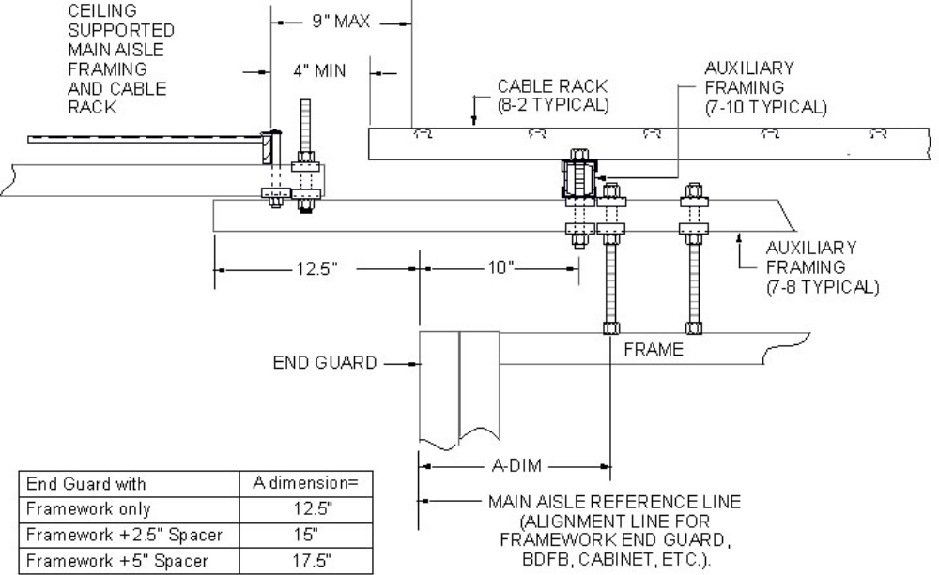

EXHIBIT 2-E2-1
2-E2-1 TYPICAL ARRANGEMENT OF AUXILIARY FRAMING AND CABLE RACK FOR 7-0 LOW LEVEL ENVIRONMENT AT A MAIN AISLE

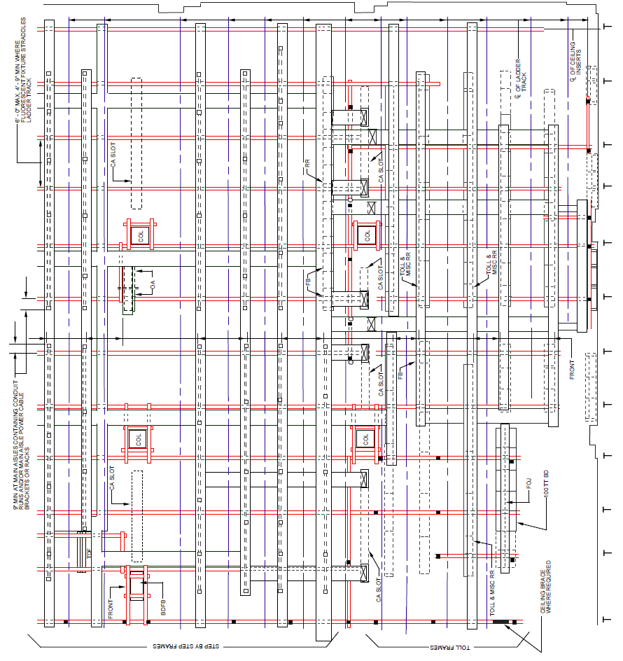

EXHIBIT 2-E2-1A (A&M)
2-E2-1A (A&M) TYPICAL ARRANGEMENT OF AUXILIARY FRAMING FOR COMBINED STEP-BY-STEP AND TOLL OFFICE-11 FOOT 8 INCH FRAMING-LADDER-TYPE CABLE RACK OVER LINE-UP OF FRAMES-HISTORICAL ONLY
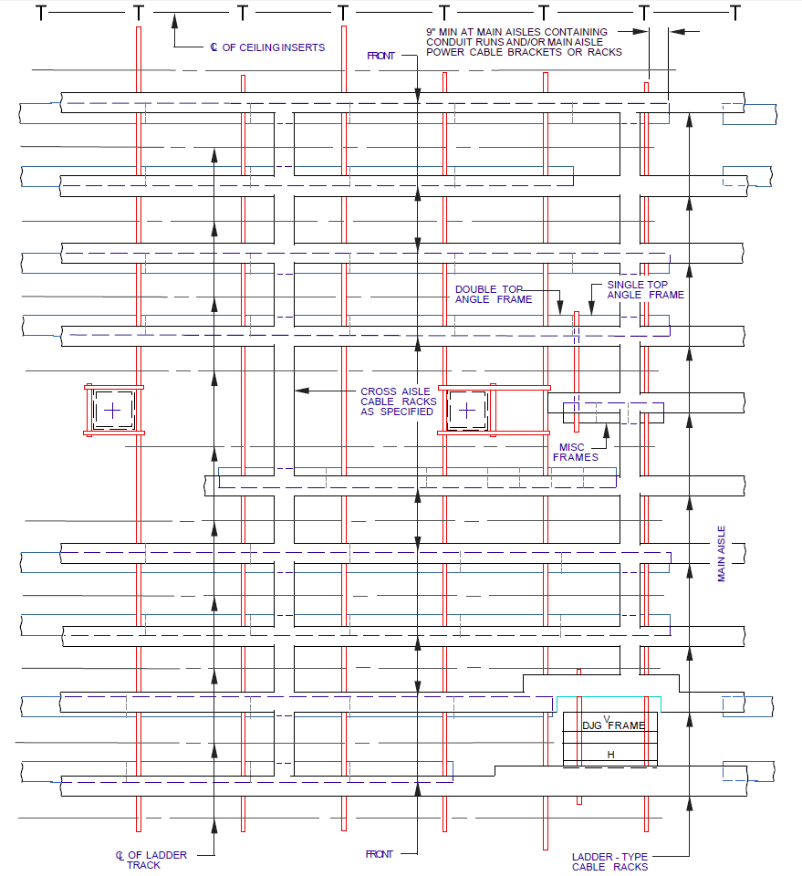

EXHIBIT 2-E2-2A (A&M)
2-E2-2A (A&M) TYPICAL ARRANGEMENT OF AUXILIARY FRAMING FOR NO. 1 CROSSBAR AND NO.4 TOLL SWITCHING OFFICES 11 FOOT 8 INCH FRAMING-LADDER-TYPE CABLE RACK OVER LINEUP OF FRAMES
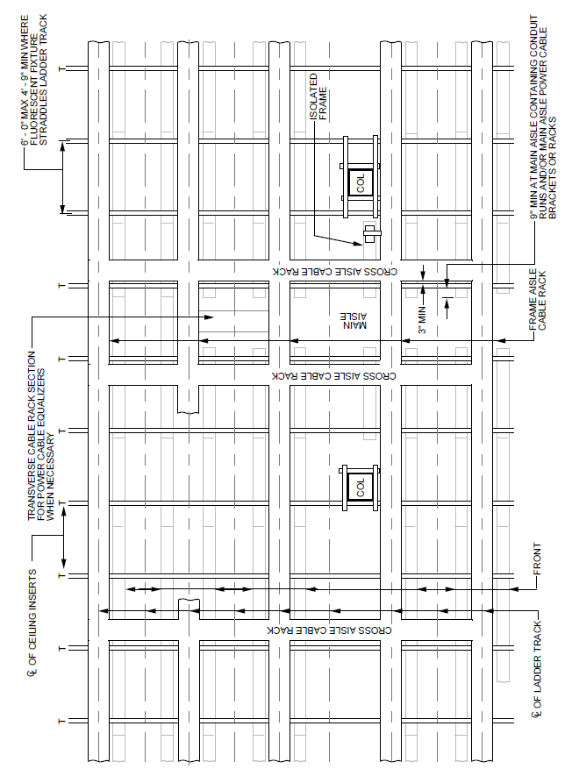
EXHIBIT 2-E2-2B (A&M)
2-E2-2B (A&M) TYPICAL ARRANGEMENT OF AUXILIARY FRAMING FOR NO. 5 CROSSBAR OFFICES WITHOUT PREARRANGED PATTERN OF CEILING INSERTS
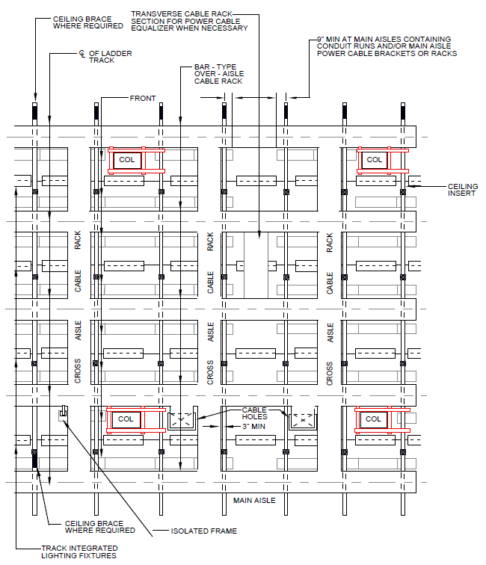
EXHIBIT 2-E2-2C (A&M)
2-E2-2C (A&M) TYPICAL ARRANGEMENT OF AUXILIARY FRAMING FOR CROSSBAR, AND STEP-BY-STEP OFFICES-ALSO COMBINED CROSSBAR AND TOLL OR STEP-BY-STEP AND TOLL OFFICE-11 FOOT 9 and 1/2 INCH FRAMING-BUILDING COLUMNS AND CEILING INSERTS PREARRANGED TO FACILITATE PRECABLING
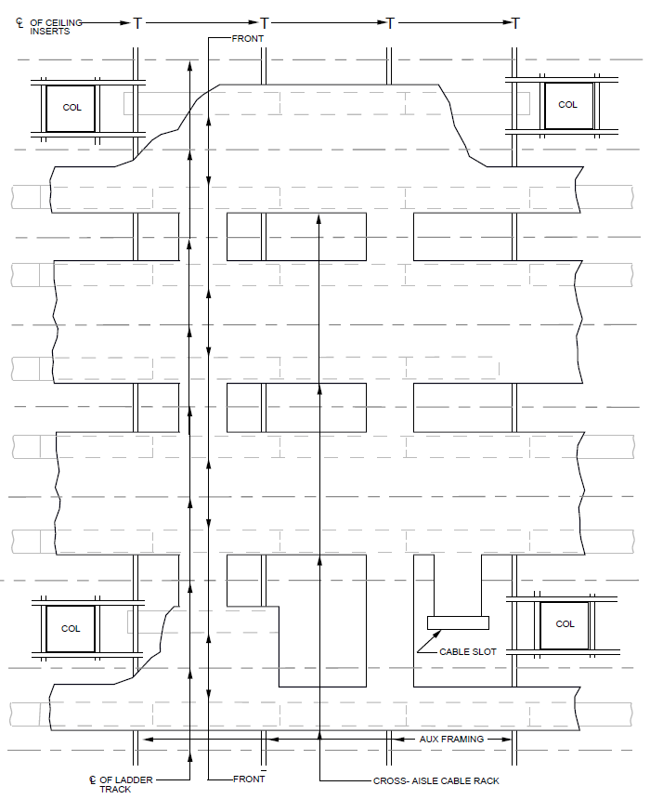
EXHIBIT 2-E2-2D (A&M)
2-E2-2D (A&M) TYPICAL ARRANGEMENT OF AUXILIARY FRAMING FOR NO. 4A TOLL SWITCHING OFFICES-11 FOOT 9 and 1/2 INCH FRAMING-4A WIDE CABLE RACK
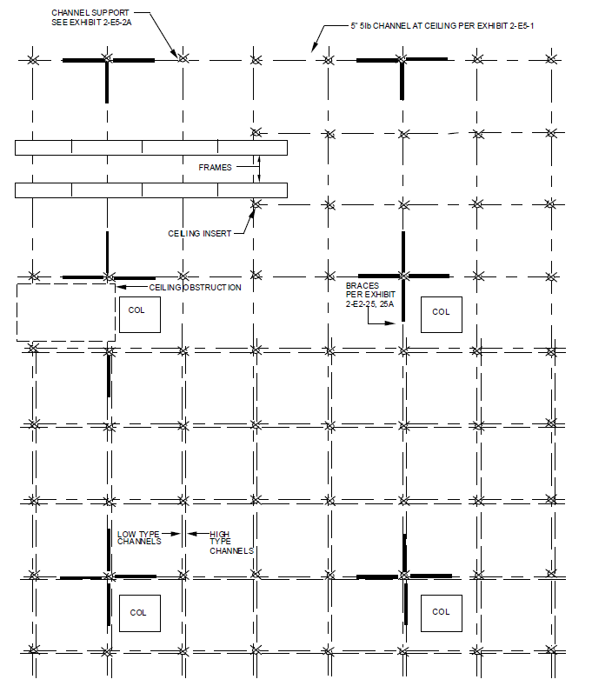

EXHIBIT 2-E2-2E
2-E2-2E TYPICAL BRACING SCHEME – LIGHT

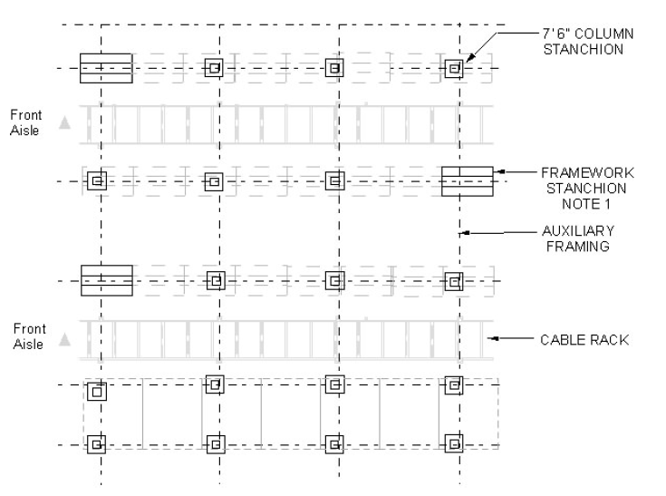

EXHIBIT 2-E2-2F
2-E2-2F TYPICAL STANCHION ARRANGEMENT

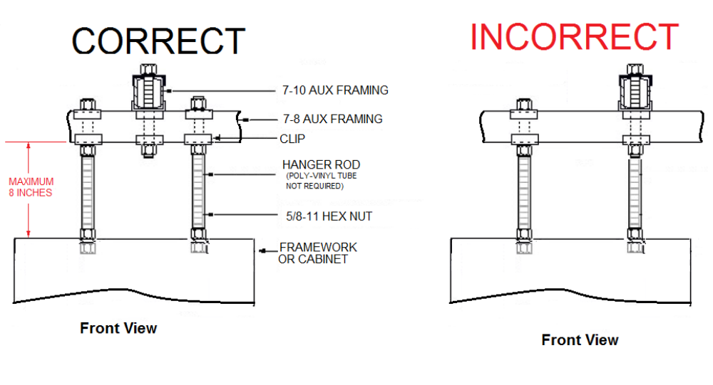

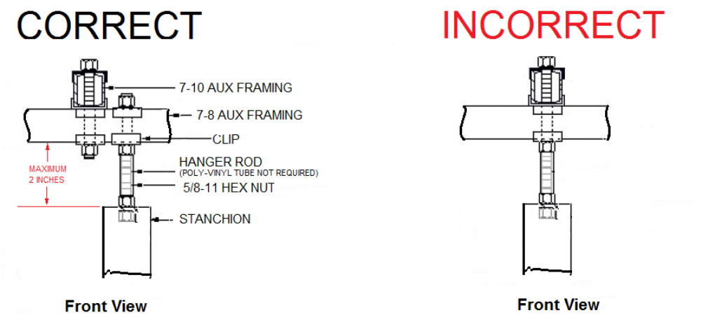
NOTE: STANCHION, FRAMEWORK AND CABINET TOP SUPPORT SHALL BE INSTALLED OFFSET FROM THE 7-8 AND 7-10 INTERSECTION AS TO NOT UTILIZE THE SAME THREADED ROD FROM THE TOP SUPPORT TO THE 7-10 AUXILIARY FRAMING.
EXHIBIT 2-E2-2G
2-E2-2G TYPICAL 7FT LOW LEVEL STANCHION, FRAMEWORK OR CABINET SUPPORT
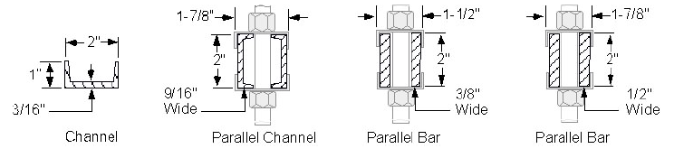
EXHIBIT 2-E2-3
2-E2-3 TYPICAL AUXILIARY FRAMING

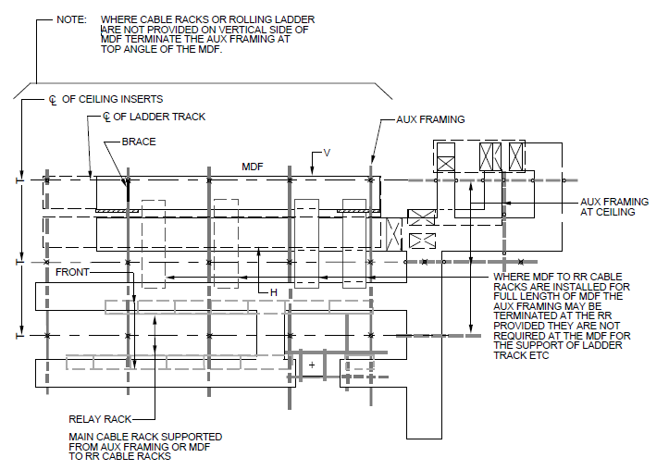
EXHIBIT 2-E2-4A (A&M)
2-E2-4A (A&M) TYPICAL ARRANGEMENT OF AUXILIARY FRAMING FOR NO. 11 OFFICES-11 FOOT 8 INCH FRAMING-OVER FRAME CABLE RACKS

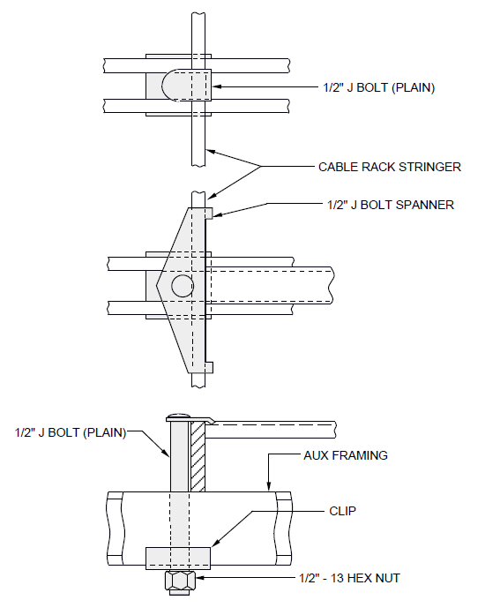

EXHIBIT 2-E2-5
2-E2-5 AUXILIARY FRAMING FASTENED TO UNDERSIDE OF CABLE RACK

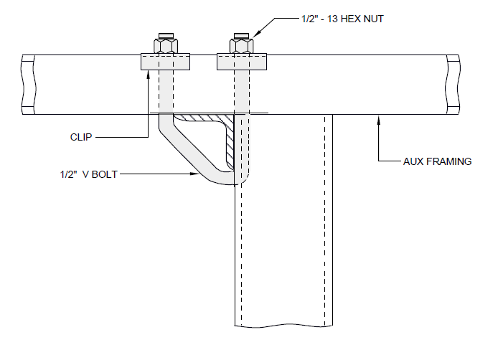

EXHIBIT 2-E2-6
2-E2-6 AUXILIARY FRAMING FASTENED DIRECTLY TO TOP ANGLES

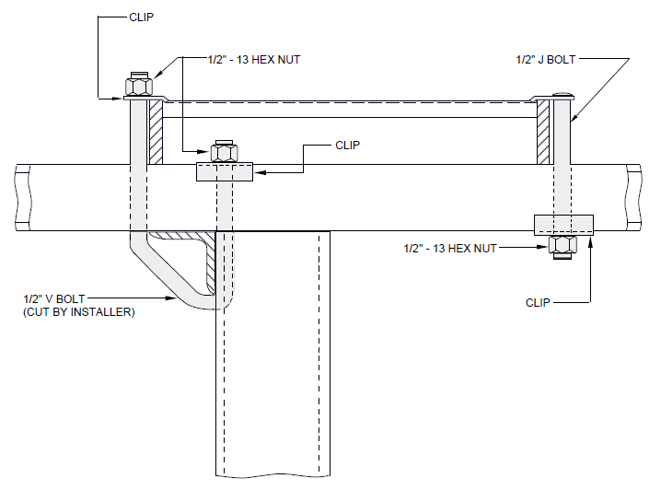

EXHIBIT 2-E2-6A
2-E2-6A AUXILIARY FRAMING FOR TOP-ANGLE FRAMES IN LINE WITH STEP-BY-STEP FRAMES-9 FOOT AND 11 FOOT 6 INCH FRAMING-ADDITIONS ONLY

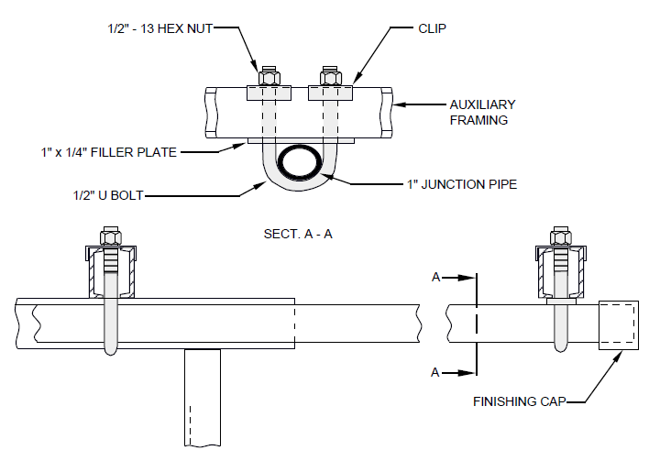

EXHIBIT 2-E2-6F
2-E2-6F AUXILIARY FRAMING ATTACHED TO 1-INCH JUNCTION PIPE EXTENDED BEYOND THE END OF CABLEDUCT-TYPE FRAME 7 FOOT AND 11 FOOT 6 INCH FRAMING

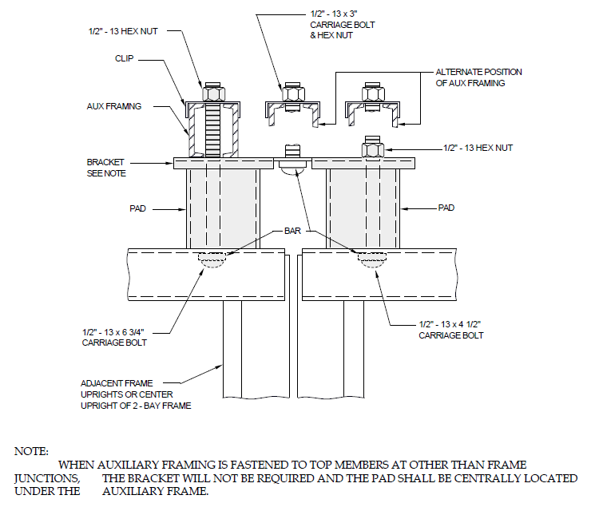

EXHIBIT 2-E2-6G
2-E2-6G AUXILIARY FRAMING FASTENING FOR CERTAIN CROSSBAR FRAMES

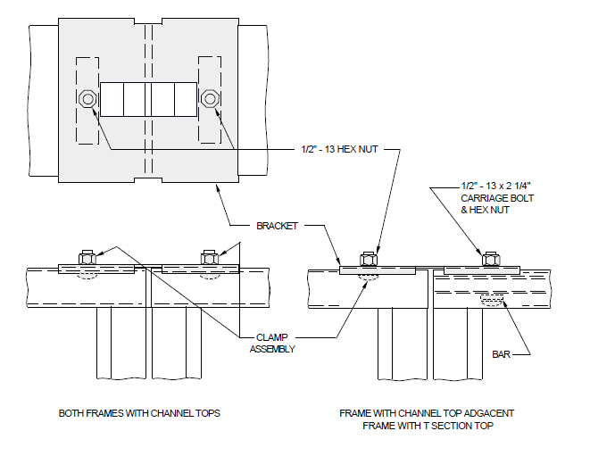

EXHIBIT 2-E2-6H (A&M)
2-E2-6H (A&M) JUNCTIONING TOPS OF ADJACENT CERTAIN CROSSBAR FRAMES

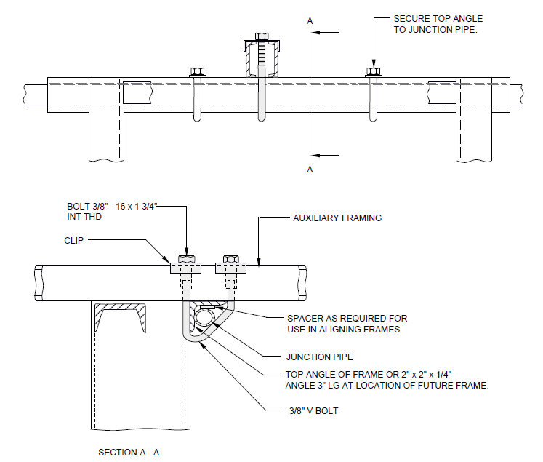

EXHIBIT 2-E2-6J
2-E2-6J AUXILIARY FRAMING ATTACHED DIRECTLY TO CABLE DUCT-TYPE FRAMES OR TO JUNCTION PIPE AT LOCATION OF FIXTURE FRAME 7 FOOT AND 11 FOOT 6 INCH AUXILIARY FRAMING

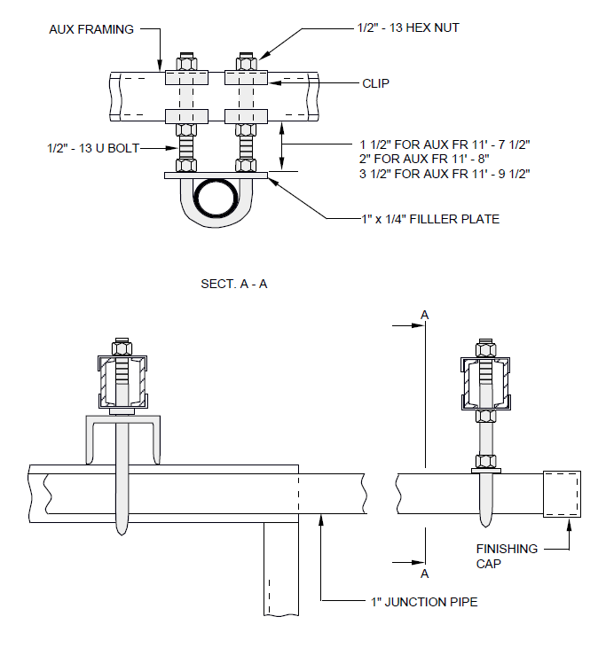
EXHIBIT 2-E2-6L
2-E2-6L SUPPORT FOR FRAME JUNCTION PIPE EXTENDING BEYOND END OF CABLE DUCT-TYPE FRAME-9 FOOT 3 and 1/2 INCH, 11 FOOT 7 and 1/2 INCH, 11 FOOT 8 INCH, AND 11 FOOT 9 and 1/2 INCH AUXILIARY FRAMING

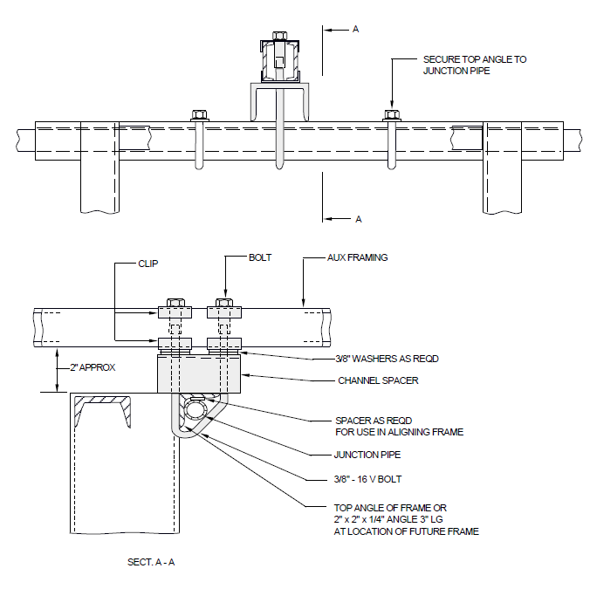

EXHIBIT 2-E2-6M
2-E2-6M AUXILIARY FRAMING ATTACHED TO CABLE DUCT-TYPE FRAME OR TO JUNCTION PIPE AT LOCATION OF FUTURE FRAME-9 FOOT 2 INCH AND 11 FOOT 8 INCH AUXILIARY FRAMING

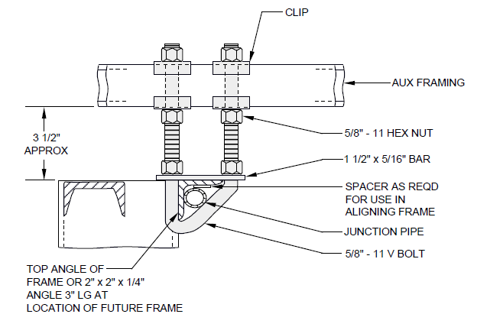

EXHIBIT 2-E2-6R
2-E2-6R AUXILIARY FRAMING FASTENED TO CABLE DUCT-TYPE FRAME OR TO JUNCTION PIPE AT LOCATION OF FUTURE FRAME-9 FOOT 3 and 1/2 INCH AND 11 FOOT 9 and 1/2 INCH AUXILIARY FRAMING

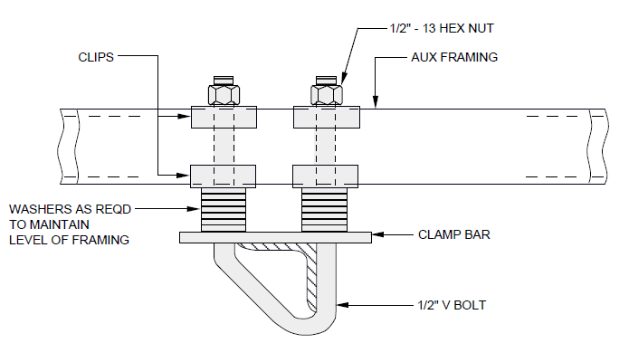

EXHIBIT 2-E2-7
2-E2-7 AUXILIARY FRAMING FASTENED TO TOP-ANGLES AT A LOWER LEVEL

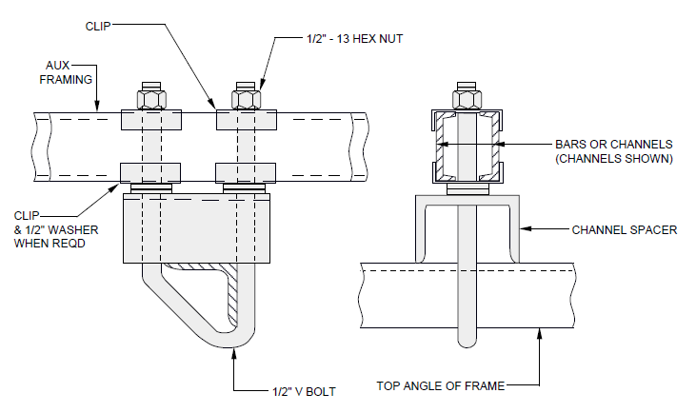

EXHIBIT 2-E2-7A
2-E2-7A AUXILIARY FRAMING FASTENED TO SINGLE TOP-ANGLE FRAMES 7 FOOT 2 INCH, 9 FOOT 2 INCH, AND 11 FOOT 8 INCH FRAMING

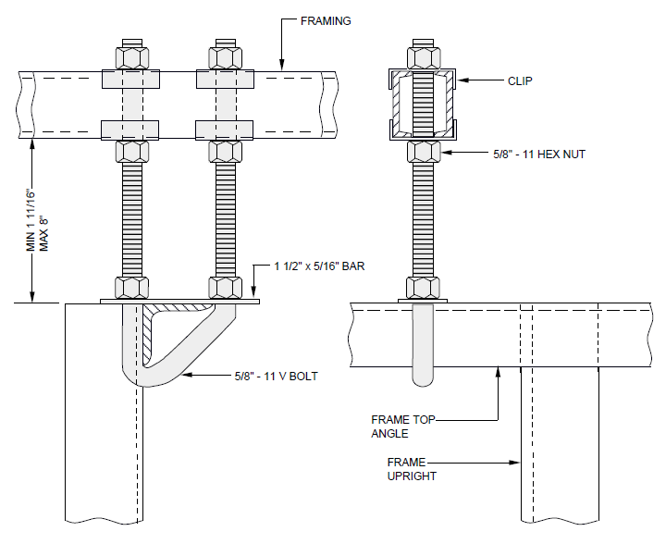

EXHIBIT 2-E2-7B
2-E2-7B V-BOLT FRAME SUPPORT ASSEMBLY

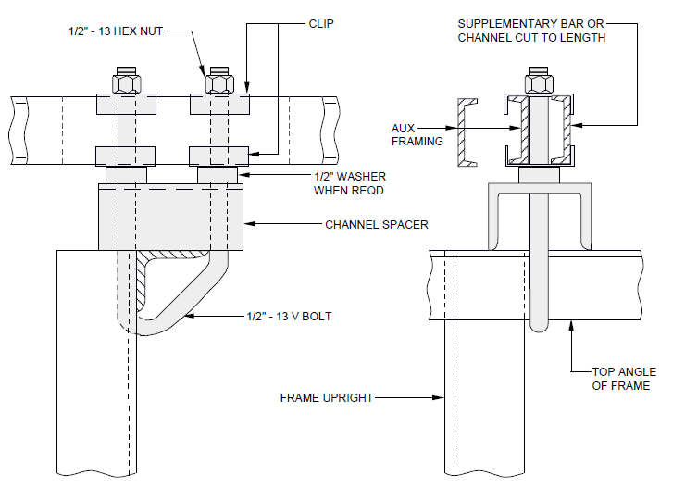

EXHIBIT 2-E2-7C
2-E2-7C AUXILIARY FRAMING FASTENED TO SINGLE TOP-ANGLE FRAMES-9 FOOT 2 INCH AND 11 FOOT 8 INCH FRAMING SUPPORT OFFSET TO CLEAR FRAME UPRIGHT

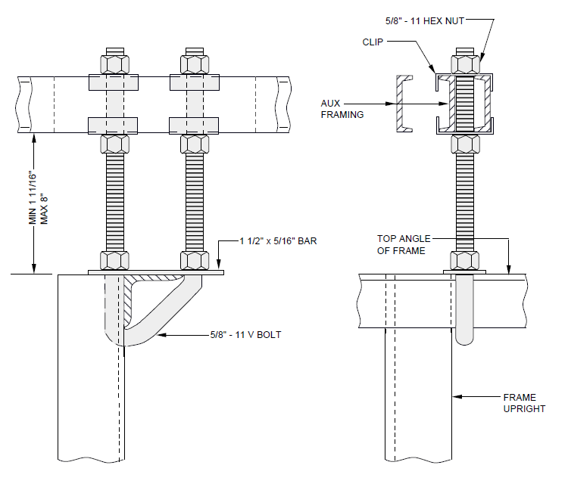

EXHIBIT 2-E2-7D
2-E2-7D V-BOLT FRAME SUPPORT OFFSET TO CLEAR FRAME UPRIGHT

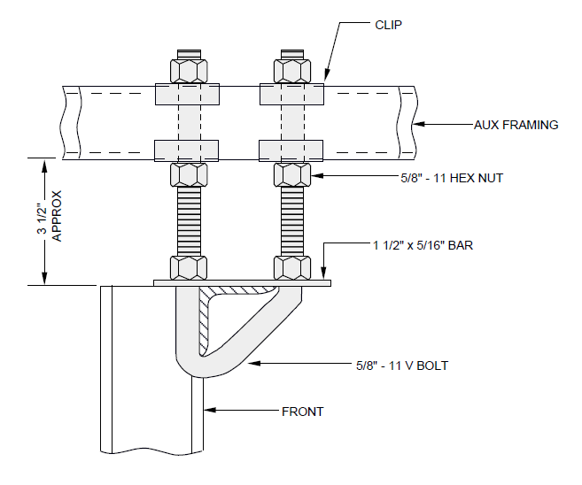

EXHIBIT 2-E2-7E
2-E2-7E AUXILIARY FRAMING FASTENED TO SINGLE TOP-ANGLE FRAMES-11 FOOT 9 and 1/2 INCH FRAMING

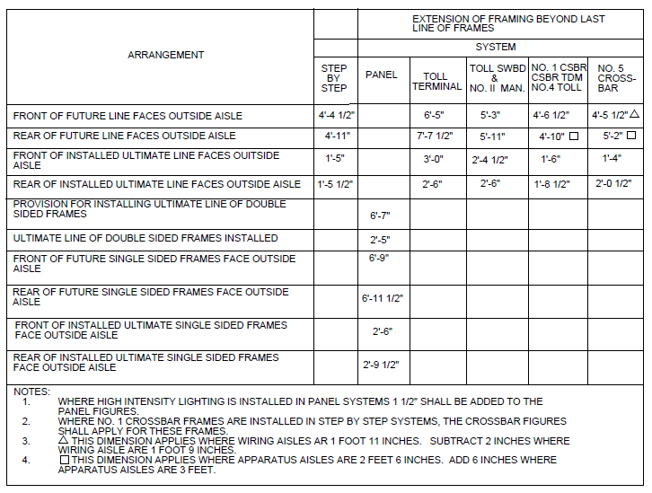

EXHIBIT 2-E2-8
2-E2-8 SUPPORT OF ENDS OF AUXILIARY FRAMING-EXTENSIONS OF BAR OR CHANNELS BEYOND THE LAST LINE OF FRAMES

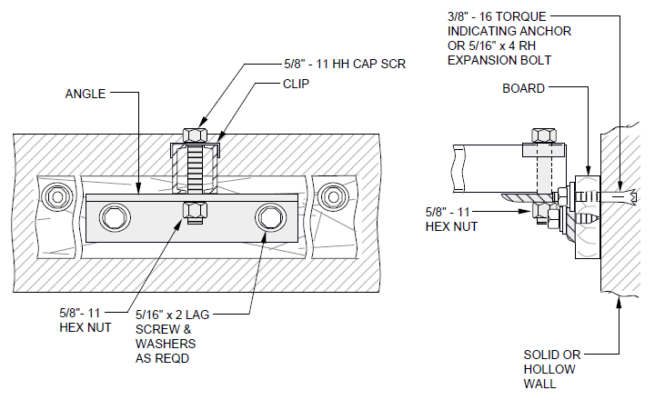

EXHIBIT 2-E2-8C
2-E2-8C AUXILIARY FRAMING SUPPORTED AT WALLS

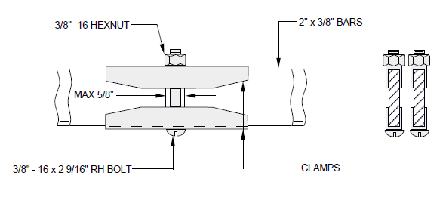

EXHIBIT 2-E2-9 (A&M)
2-E2-9 (A&M) SPLICING AUXILIARY FRAMING-2 INCHES BY 3/8 OF AN INCH BARS TO 2 INCHES BY 3/8 OF AN INCH BARS

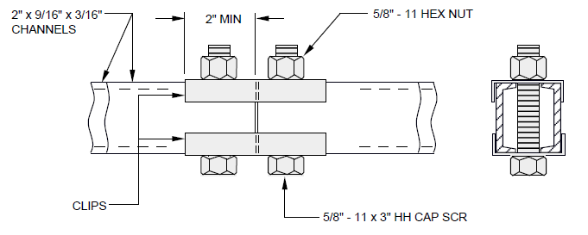

EXHIBIT 2-E2-9A (DISCONTINUED)
2-E2-9A (DISCONTINUED) SPLICING AUXILIARY FRAMING-CHANNELS TO CHANNELS

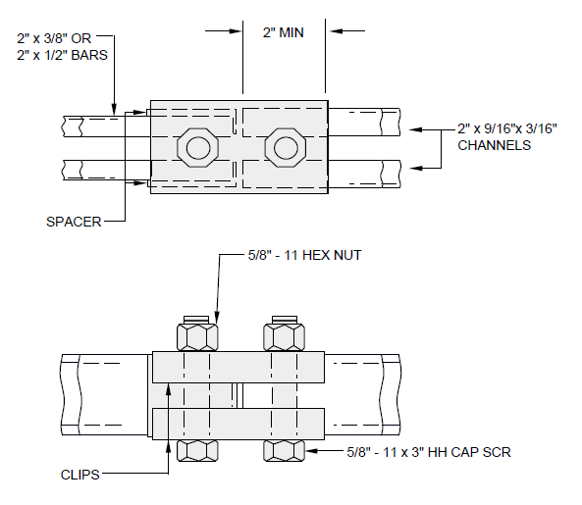

EXHIBIT 2-E2-9B (DISCONTINUED)
2-E2-9B SPLICING AUXILIARY FRAMING-CHANNELS TO BARS

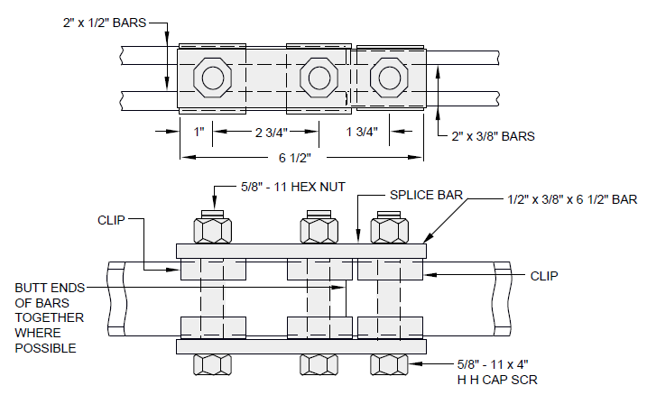

EXHIBIT 2-E2-9C
2-E2-9C SPLICING AUXILIARY FRAMING-2 BY 1/2 INCH BARS TO 2 BY 3/8 INCH BARS

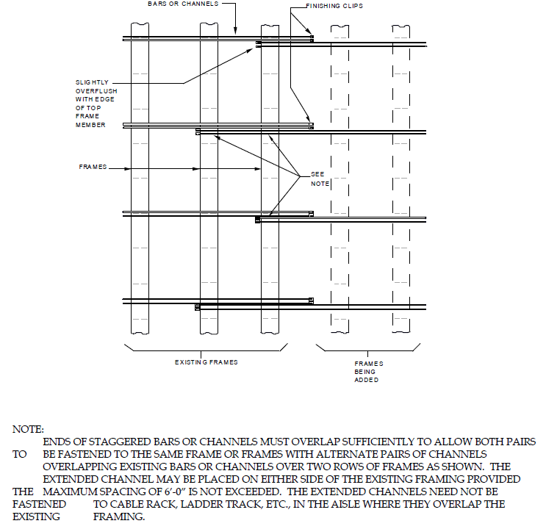

EXHIBIT 2-E2-9D
2-E2-9D ARRANGEMENT FOR EXTENDING BAR OR CHANNEL FRAMING TO ELIMINATE NECESSITY OF CUTTING BACK EXISTING FRAMING

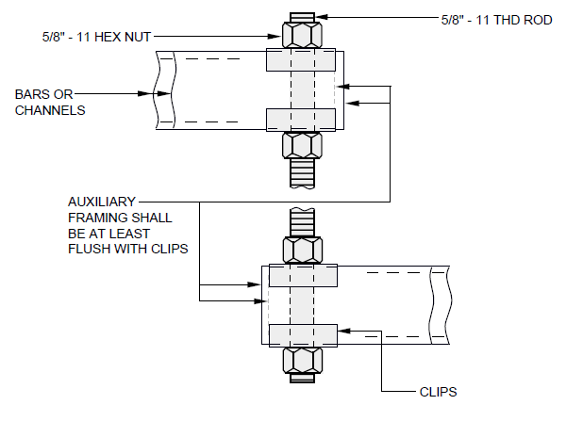

EXHIBIT 2-E2-9E
2-E2-9E JUNCTIONING LOW-TO HIGH-LEVEL FRAMING

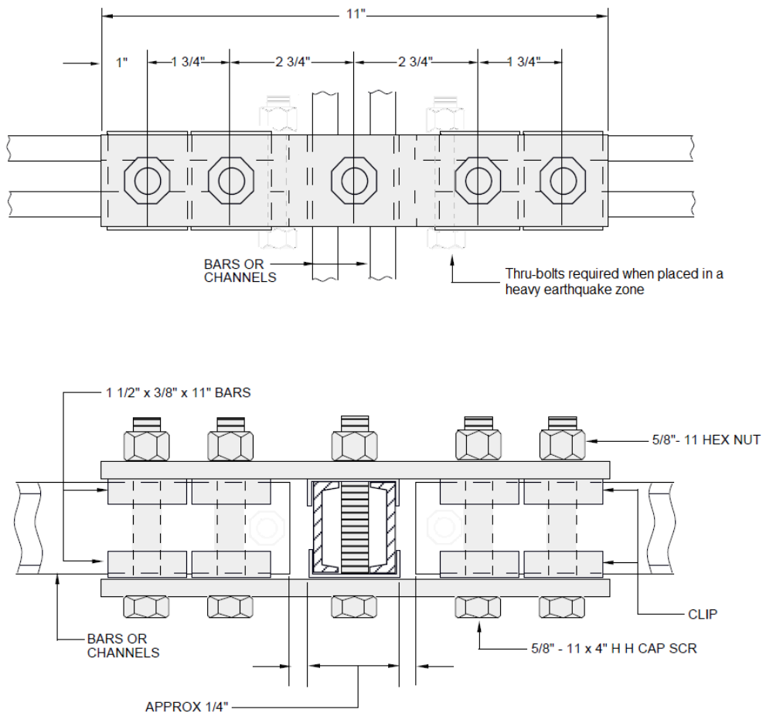

EXHIBIT 2-E2-9F
2-E2-9F SINGLE-LEVEL AUXILIARY FRAMING INTERSECTION OF PRIMARY AND SECONDARY BARS OR CHANNELS

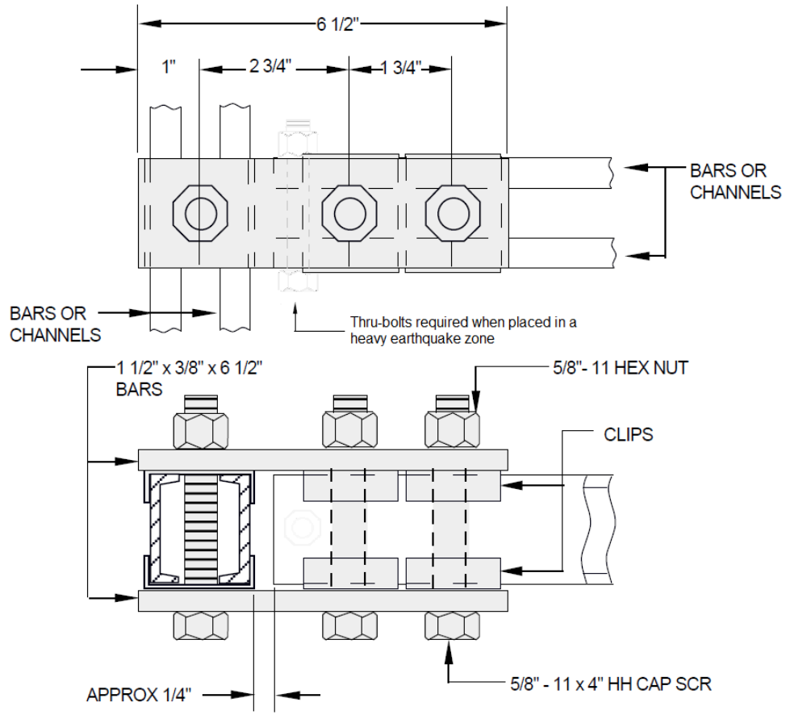

EXHIBIT 2-E2-9G
2-E2-9G SINGLE-LEVEL AUXILIARY FRAMING JUNCTION OF PRIMARY AND SECONDARY BARS OR CHANNELS

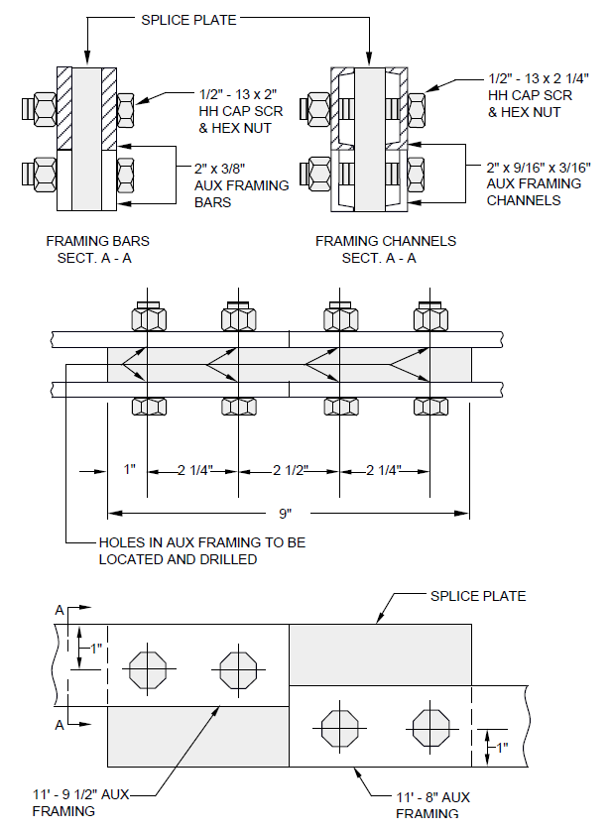
EXHIBIT 2-E2-9H
2-E2-9H SPLICING AUXILIARY FRAMING 11 FOOT 8 INCH AND 11 FOOT 9 and 1/2 INCH FRAMING

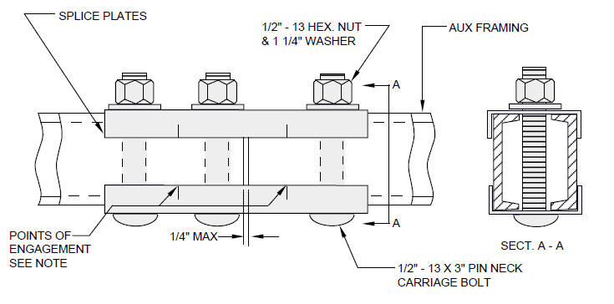

EXHIBIT 2-E2-9J
2-E2-9J SPLICING AUXILIARY FRAMING-CHANNELS TO CHANNELS USING 3-HOLE SPLICE PLATES

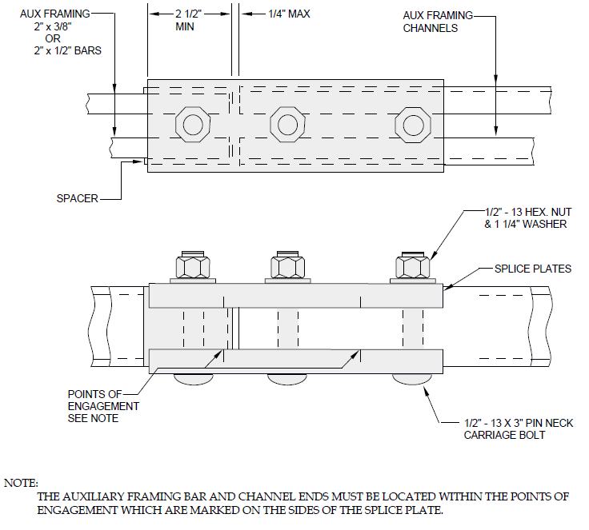

EXHIBIT 2-E2-9K
2-E2-9K SPLICING AUXILIARY FRAMING-CHANNELS TO BARS-USING 3-HOLE SPLICE PLATES

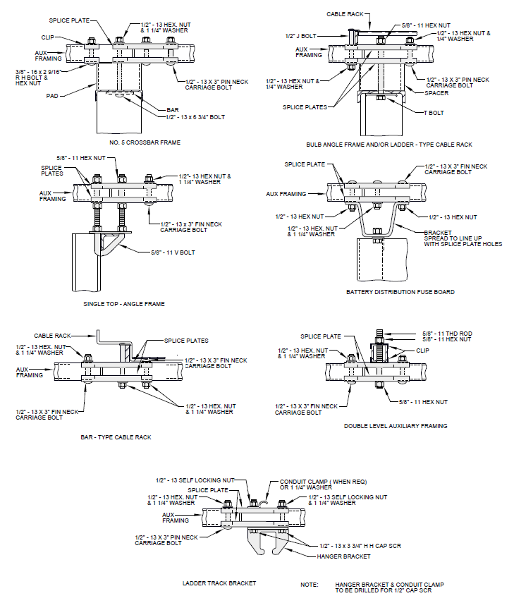

EXHIBIT 2-E2-9L
2-E2-9L SPLICING AUXILIARY FRAMING-TYPICAL APPLICATIONS-USING 3-HOLE SPLICE PLATES

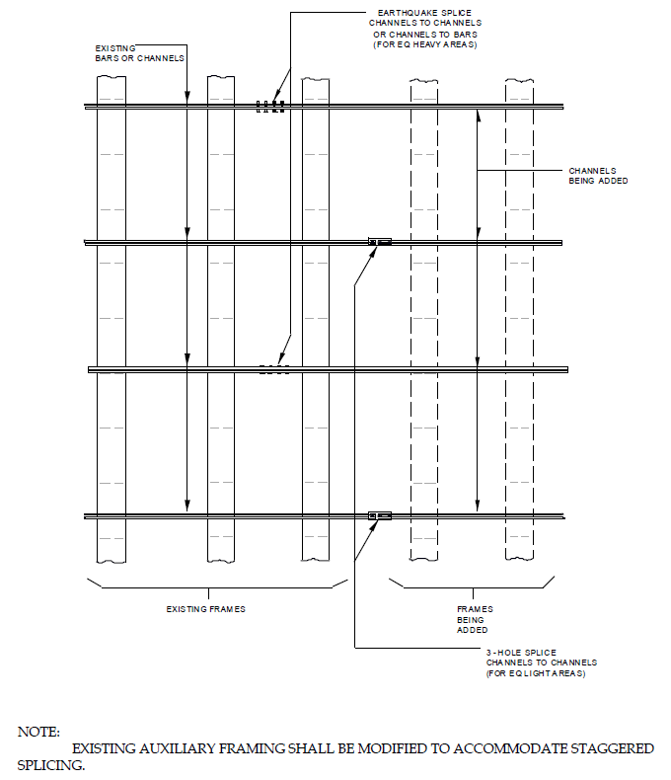

EXHIBIT 2-E2-9M
2-E2-9M ARRANGEMENT FOR EXTENDING BAR OR CHANNEL FRAMING WITH CHANNEL FRAMING-ELIMINATING NECESSITY OF CUTTING BACK EXISTING FRAME

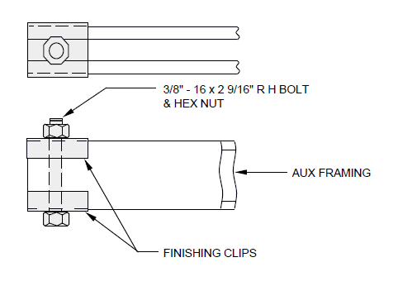

EXHIBIT 2-E2-10
2-E2-10 FINISHING CLIPS ON AUXILIARY FRAMING

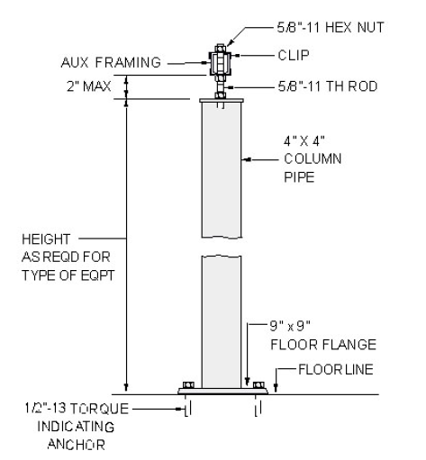

EXHIBIT 2-E2-11
2-E2-11 PIPE STAND SUPPORT OF AUXILIARY FRAMING

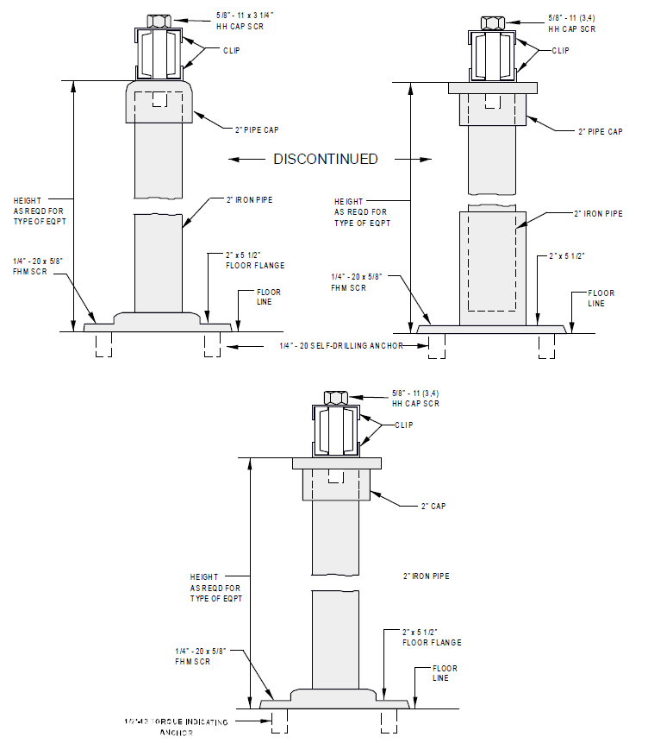

EXHIBIT 2-E2-11A
2-E2-11A PIPE STAND SUPPORT OF AUXILIARY FRAMING (A&M)

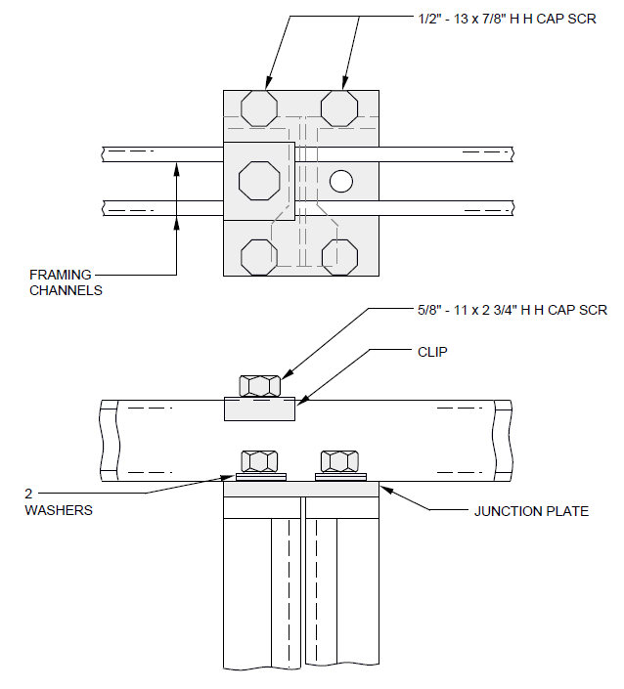

EXHIBIT 2-E2-11B (A&M)
2-E2-11B (A&M) JUNCTIONING ADJACENT FRAME UPRIGHTS WITH CHANNEL TOP MEMBERS-BULB-ANGLE OR CHANNEL-TYPE STEP-BY-STEP SWITCH FRAMES-BULB-ANGLE TYPE SHOWN

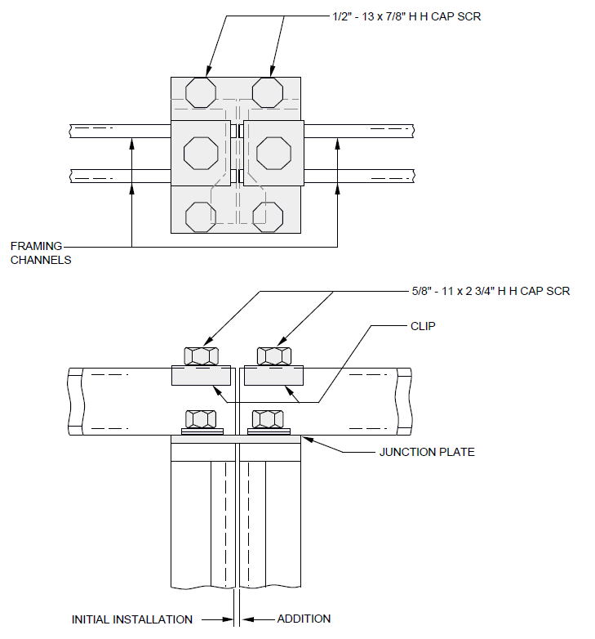

EXHIBIT 2-E2-11C (A&M)
2-E2-11C (A&M) JUNCTIONING ADJACENT FRAME UPRIGHTS WITH CHANNEL TOP MEMBER-WHERE A FRAME HAS BEEN ADDED TO AN EXISTING LINE-UP-BULB-ANGLE OR CHANNEL-TYPE STEP-BY-STEP SWITCH FRAMES-BULB-ANGLE TYPE SHOWN

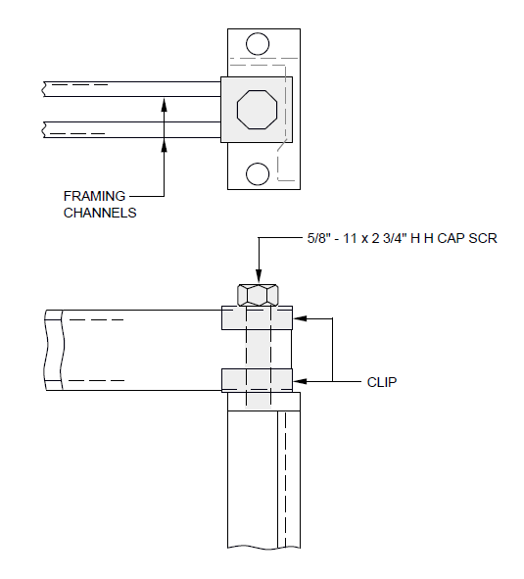
EXHIBIT 2-E2-11D (A&M)
2-E2-11D (A&M) FASTENING 2 INCH CHANNEL TOP MEMBERS AT END OF LINE-UP OR AT AN INTERMEDIATE UPRIGHT OF A FRAME-BULB-ANGLE OR CHANNEL-TYPE STEP-BY-STEP SWITCH FRAMES-BULB ANGLE UPRIGHT AT END OF LINE SHOWN

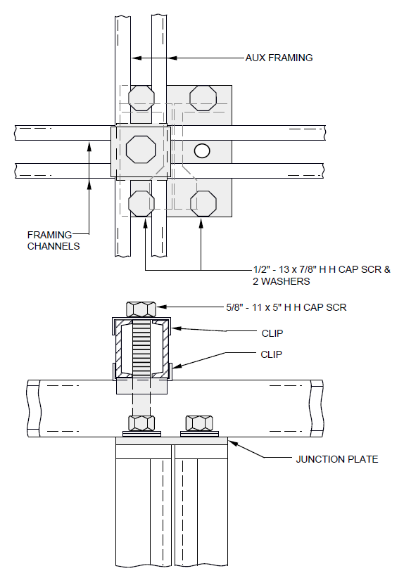
EXHIBIT 2-E2-11E (A&M)
2-E2-11E (A&M) JUNCTIONING ADJACENT FRAME UPRIGHTS HAVING 2 INCH CHANNEL TOP MEMBER WITH AUXILIARY FRAMING OVER ONE OF THE UPRIGHTS-BULB-ANGLE OR CHANNEL-TYPE STEP-BY-STEP FRAMES-BULB-ANGLE TYPE SHOWN 11 FOOT 8 INCH FRAMING

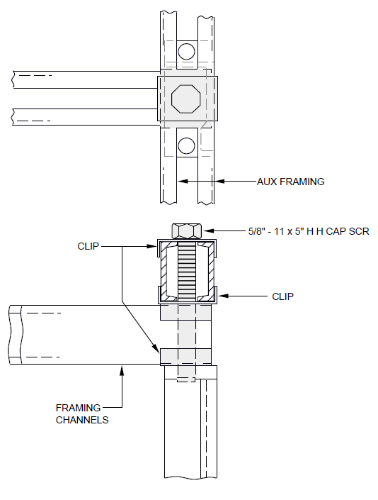
EXHIBIT 2-E2-11F (A&M)
2-E2-11F (A&M) FASTENING 2 INCH CHANNEL TOP MEMBERS TO UPRIGHT AT END OF LINE-UP WITH AUXILIARY FRAMING OVER THE UPRIGHT-BULB-ANGLE OR CHANNEL-TYPE STEP-BY-STEP SWITCH FRAMES-BULB-ANGLE TYPE SHOWN-11 FOOT 9 INCH FRAMING

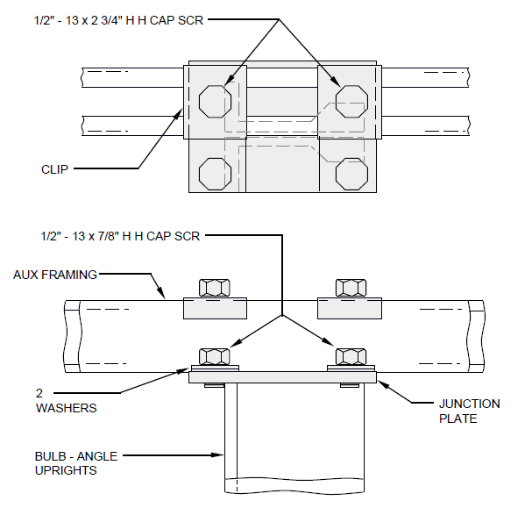

EXHIBIT 2-E2-11G (A&M)
2-E2-11G (A&M) AUXILIARY FRAMING ATTACHED WITH JUNCTION PLATE TO TWO ADJACENT BULB-ANGLE UPRIGHTS IN 11 FOOT 6 INCH FRAMING AREA-STEP-BY-STEP OFFICES

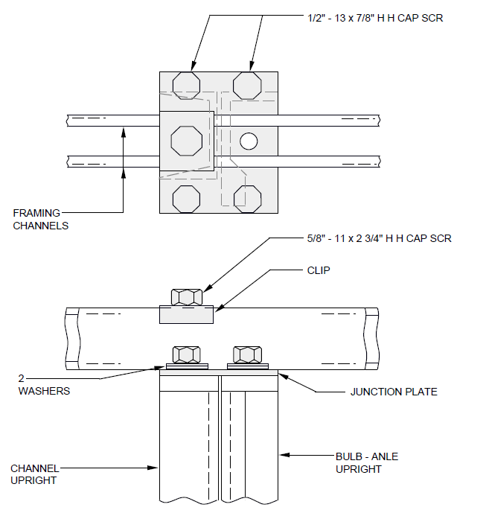

EXHIBIT 2-E2-11H (A&M)
2-E2-11H (A&M) JUNCTIONING ADJACENT FRAME UPRIGHTS WITH CHANNEL-TYPE TOP MEMBERS BULB-ANGLE TO CHANNEL-TYPE STEP-BY-STEP SWITCH FRAMES

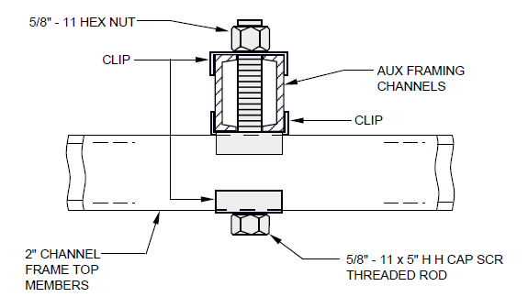

EXHIBIT 2-E2-11J
2-E2-11J DOUBLE-LEVEL AUXILIARY FRAMING-FASTENING CHANNEL OVER CHANNEL

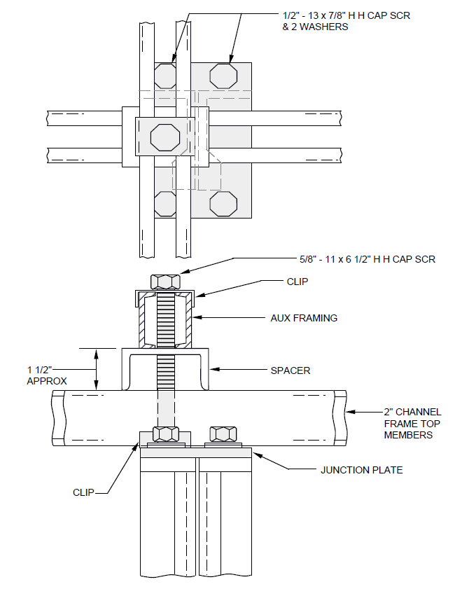
EXHIBIT 2-E2-11K (A&M)
2-E2-11K (A&M) JUNCTIONING ADJACENT FRAME UPRIGHTS HAVING 2 INCH CHANNEL TOP MEMBERS WITH AUXILIARY FRAMING OVER ONE OF THE UPRIGHTS-BULB-ANGLE OR CHANNEL-TYPE STEP-BY-STEP SWITCH FRAMES-BULB-ANGLE-TYPE SHOWN-11 FOOT 9 and 1/2 INCH FRAMING

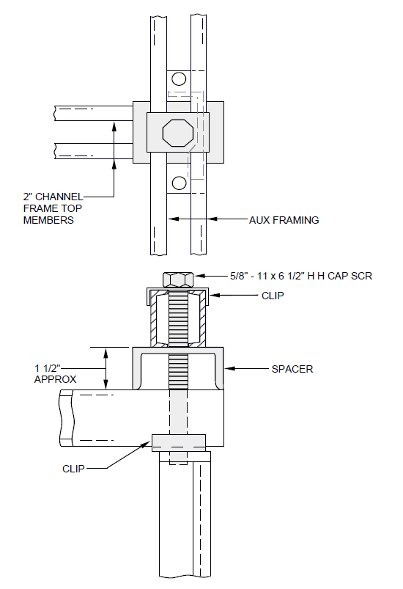
EXHIBIT 2-E2-11L (A&M)
2-E2-11L (A&M) FASTENING 2 INCH CHANNEL TOP MEMBERS TO UPRIGHT AT END OF LINE-UP WITH AUXILIARY FRAMING OVER THE UPRIGHT BULB-ANGLE OR CHANNEL-TYPE STEP-BY-STEP SWITCH FRAMES-BULB-ANGLE-TYPE SHOWN-11 FOOT 9 and 1/2 INCH FRAMING

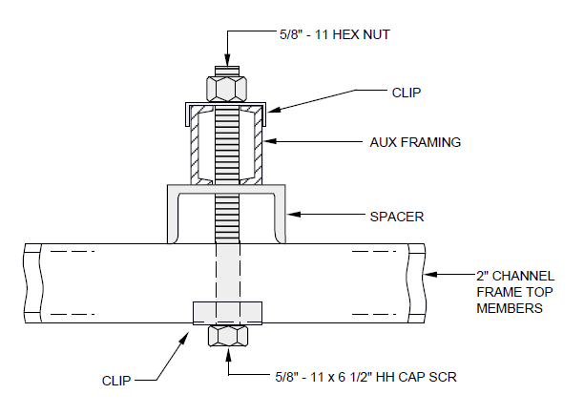

EXHIBIT 2-E2-11M (A&M)
2-E2-11M (A&M) AUXILIARY FRAMING ATTACHED TO 2 INCH CHANNEL TOP MEMBERS OF STEP-BY-STEP SWITCH FRAMES-FASTENING BETWEEN FRAME UPRIGHTS 11 FOOT 9 and 1/2 INCH FRAMING

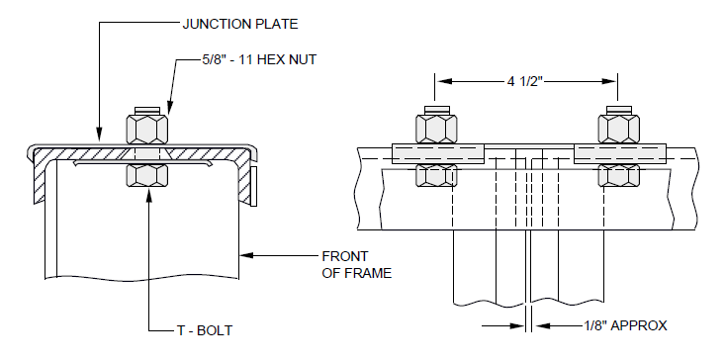

EXHIBIT 2-E2-12B (A&M)
2-E2-12B (A&M) JUNCTIONING TOP ANGLES OF BULB-ANGLE-TYPE FRAMES

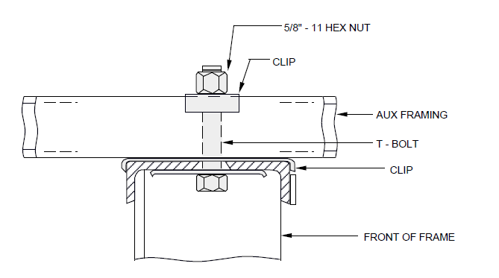

EXHIBIT 2-E2-12C (A&M)
2-E2-12C (A&M) AUXILIARY FRAMING ATTACHED DIRECTLY TO TOP ANGLES OF BULB-ANGLE-TYPE FRAMES

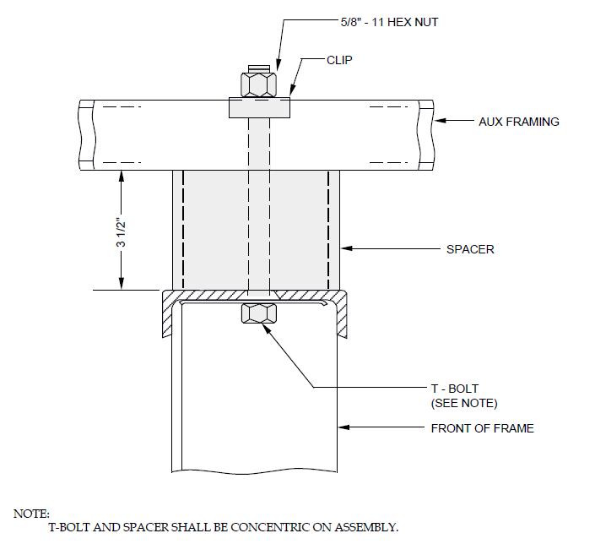

EXHIBIT 2-E2-12F (A&M)
2-E2-12F (A&M) AUXILIARY FRAMING ATTACHED TO TOP ANGLES OF BULB-ANGLE-TYPE FRAMES-11 FOOT 9 and 1/2 INCH AUXILIARY FRAMING

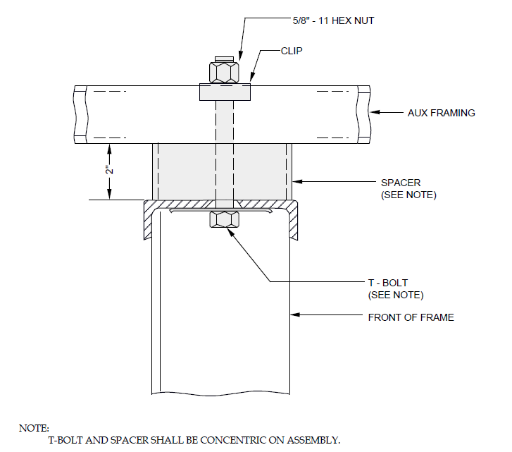

EXHIBIT 2-E2-12G (A&M)
2-E2-12G (A&M) AUXILIARY FRAMING ATTACHED TO TOP ANGLES OF BULB-ANGLE-TYPE FRAMES-7 FOOT 2 INCH AND 11 FOOT 8 INCH AUXILIARY FRAMING

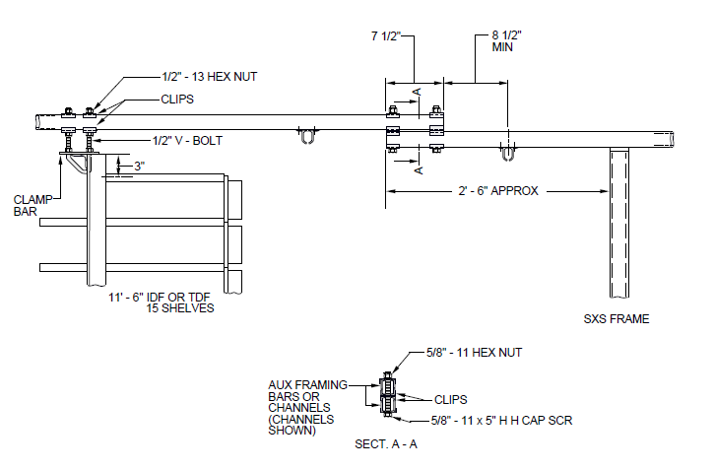

EXHIBIT 2-E2-13
2-E2-13 AUXILIARY FRAMING RAISED AND EXTENDED OVER STEP-BY-STEP DISTRIBUTING FRAMES-11 FOOT 6 INCH FRAMING-ADDITIONS ONLY

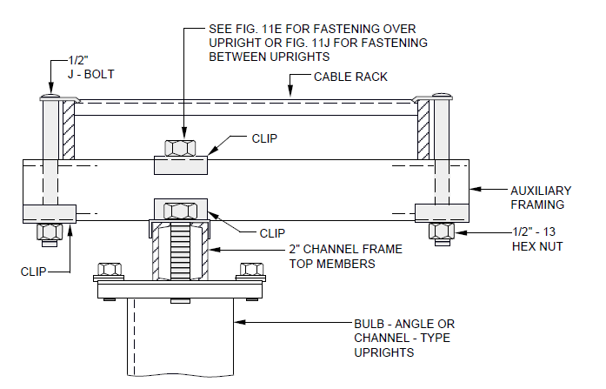

EXHIBIT 2-E2-15B (A&M)
2-E2-15B (A&M) ISOLATED STEP-BY-STEP FRAMES SUPPORTED FROM ONE CABLE RACK 11 FOOT 8 INCH FRAMING

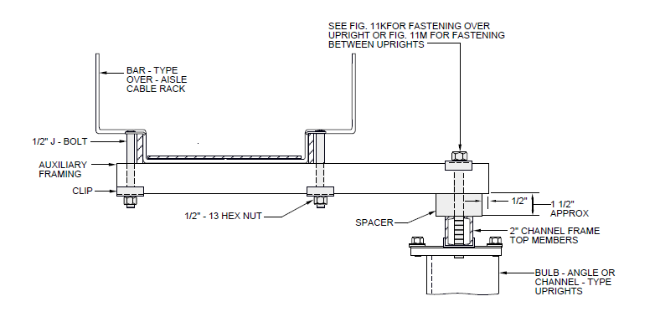

EXHIBIT 2-E2-15C (A&M)
2-E2-15C (A&M) ISOLATED STEP-BY-STEP FRAMES SUPPORTED FROM ONE CABLE RACK 11 FOOT 9 and 1/2 INCH FRAMING

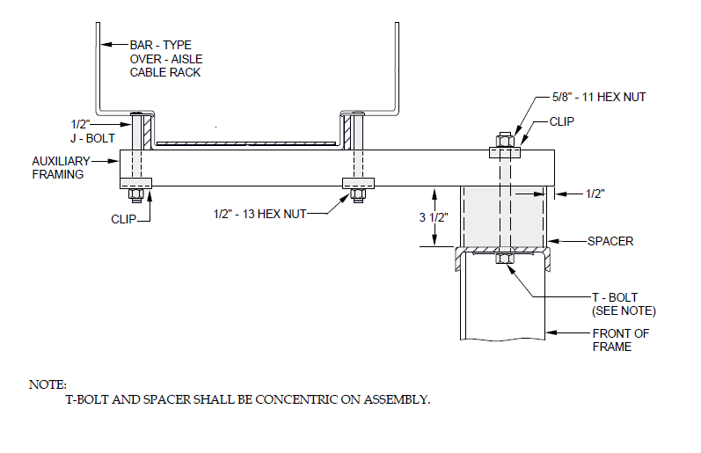

EXHIBIT 2-E2-15D (A&M)
2-E2-15D (A&M) ISOLATED NO. 1 CROSSBAR FRAME SUPPORTED FROM BAR-TYPE OVER-AISLE CABLE RACK 11 FOOT 9 and 1/2 INCH FRAMING

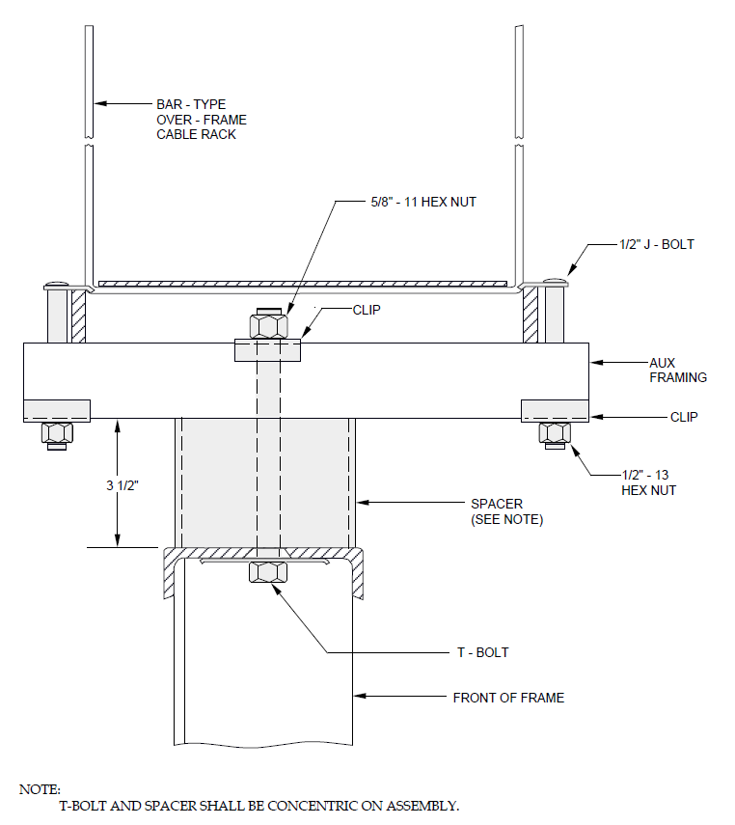

EXHIBIT 2-E2-15E (A&M)
2-E2-15E (A&M) ISOLATED NO. 1 CROSSBAR FRAME SUPPORTED FROM BAR-TYPE OVER-FRAME CABLE RACK 11 FOOT 9 and 1/2 INCH FRAMING

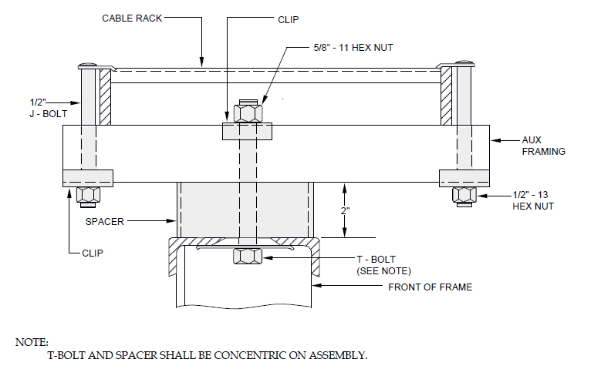

EXHIBIT 2-E2-15F (A&M)
2-E2-15F (A&M) ISOLATED NO.1 CROSSBAR AND NO. 4 TOLL SWITCHING FRAMES SUPPORTED FROM ONE CABLE RACK-11 FOOT 8 INCH FRAMING

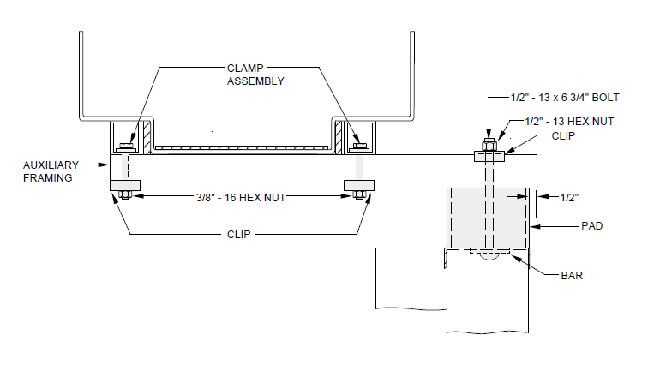

EXHIBIT 2-E2-16B (A&M)
2-E2-16B (A&M) ISOLATED CROSSBAR FRAMES SUPPORTED FROM ONE CHANNEL-TYPE CABLE RACK-ADDITIONS ONLY

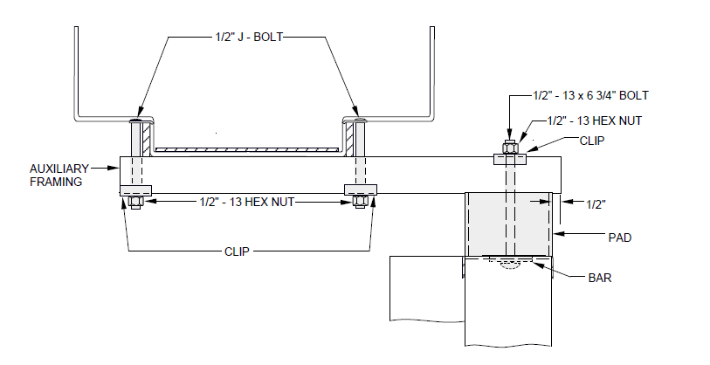

EXHIBIT 2-E2-16C (A&M)
2-E2-16C (A&M) ISOLATED CROSSBAR FRAMES SUPPORTED FROM ONE BAR-TYPE CABLE RACK

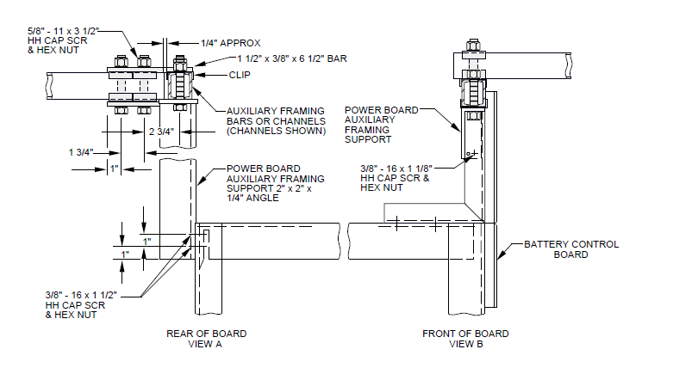

EXHIBIT 2-E2-18
2-E2-18 AUXILIARY FRAMING OVER BATTERY CONTROL BOARDS

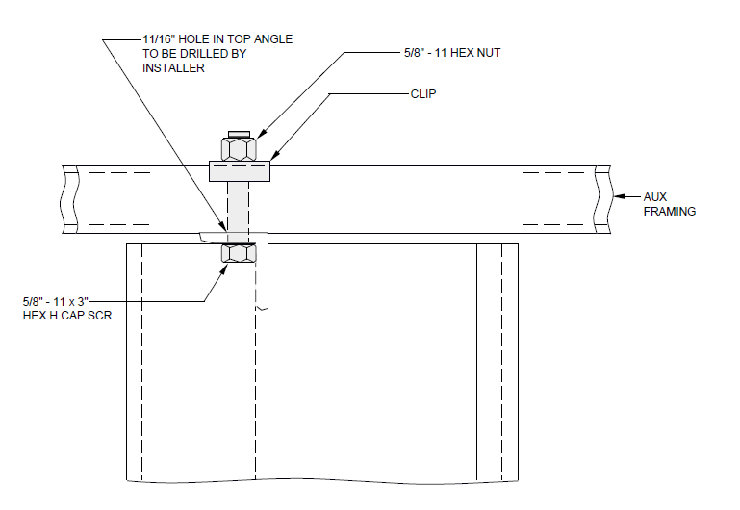

EXHIBIT 2-E2-18A
2-E2-18A AUXILIARY FRAMING ATTACHED DIRECTLY TO TOP-ANGLES OF BATTERY DISTRIBUTING FUSE BOARDS-11 FOOT 6 INCH FRAMING

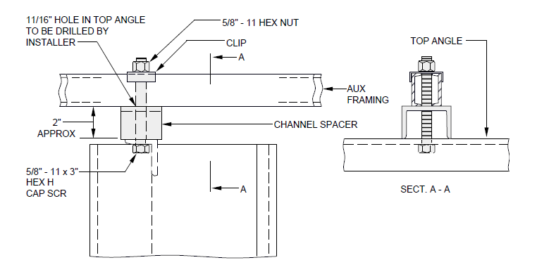

EXHIBIT 2-E2-18B
2-E2-18B AUXILIARY FRAMING ATTACHED TO TOP-ANGLES OF BATTERY DISTRIBUTION FUSE BOARDS-11 FOOT 8 INCH FRAMING

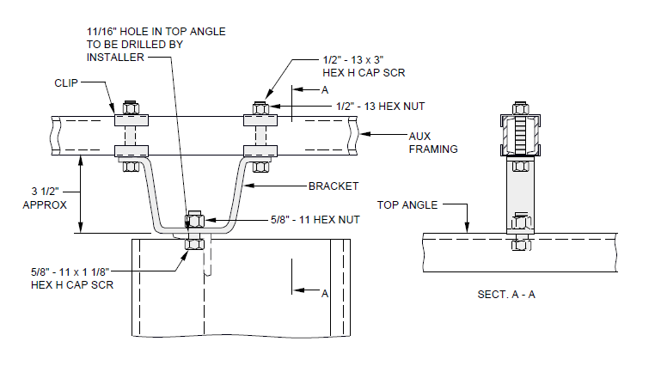

EXHIBIT 2-E2-18C
2-E2-18C AUXILIARY FRAMING ATTACHED TO TOP-ANGLES OF BATTERY DISTRIBUTION FUSE BOARDS-11 FOOT 9 and 1/2 INCH FRAMING

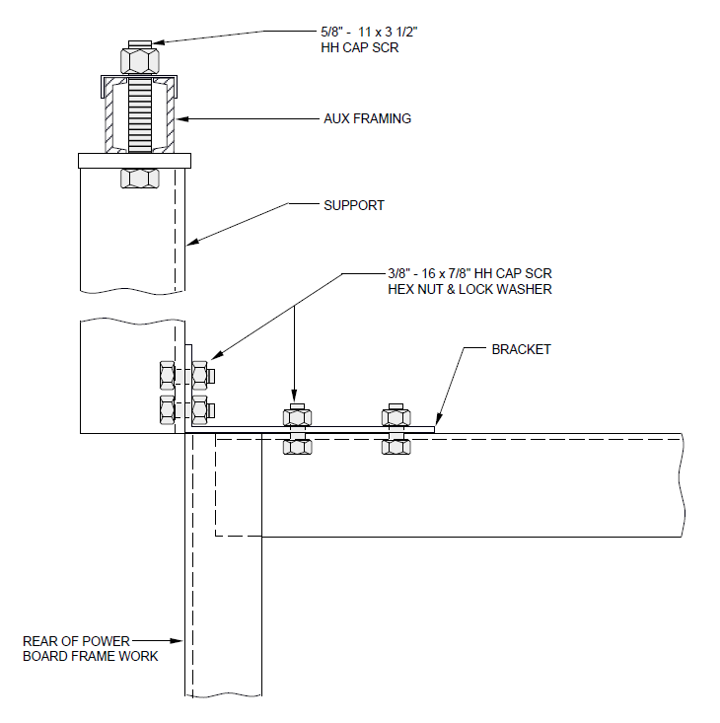

EXHIBIT 2-E2-18D
2-E2-18D AUXILIARY FRAMING OVER BATTERY CONTROL BOARDS EQUIPPED WITH REAR DOORS

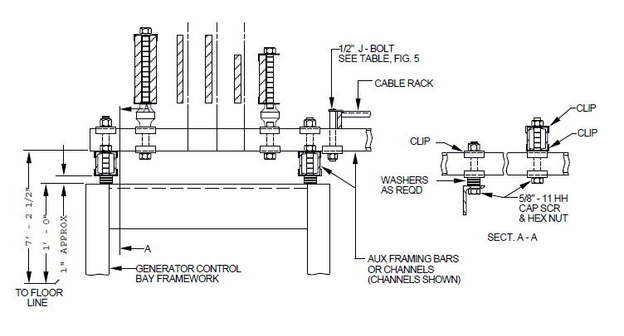

EXHIBIT 2-E2-19
2-E2-19 AUXILIARY FRAMING OVER GENERATOR CONTROL PANELS

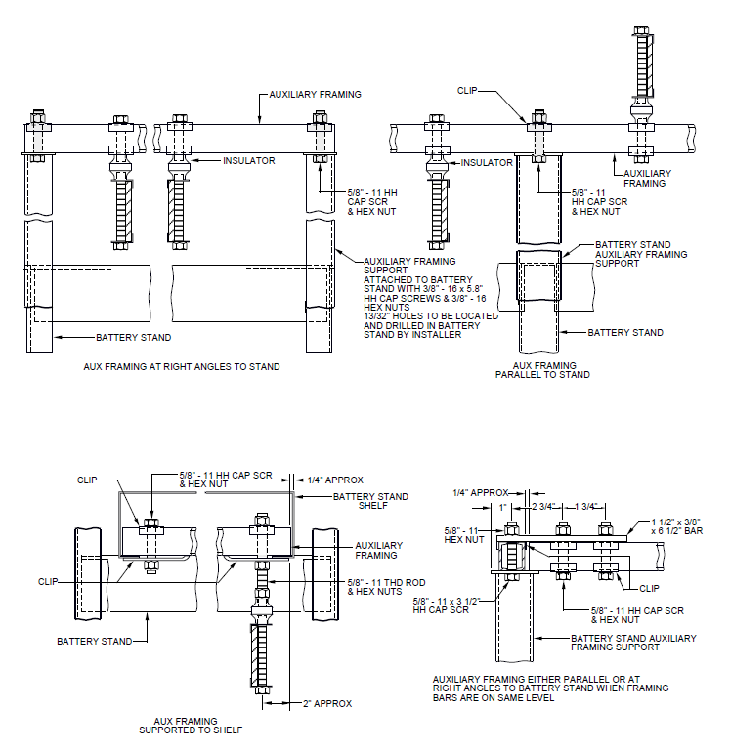

EXHIBIT 2-E2-20
2-E2-20 AUXILIARY FRAMING SUPPORT OF BUS BARS AT BATTERY STANDS

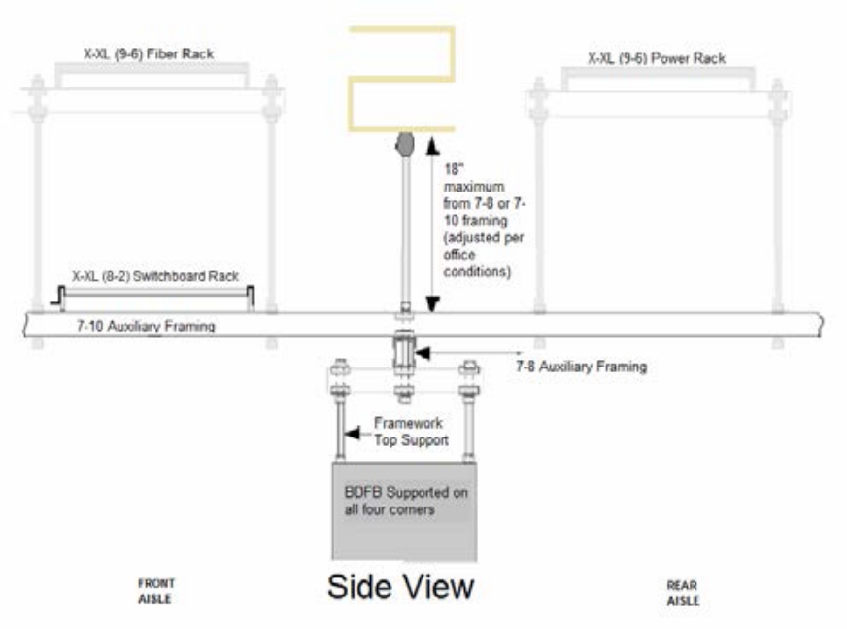
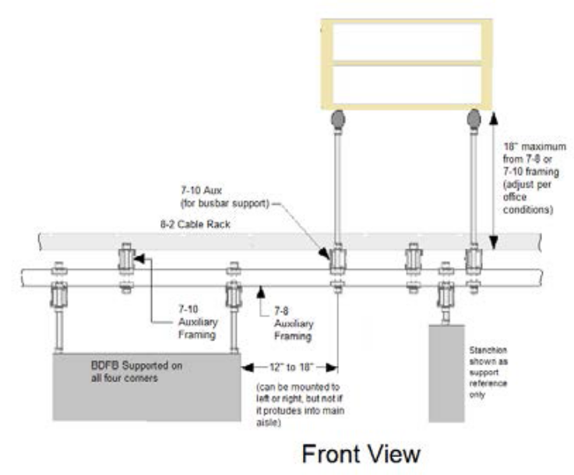
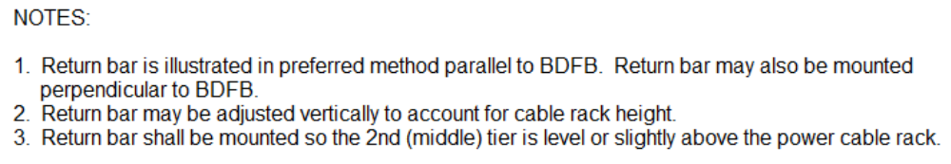
EXHIBIT 2-E2-21
2-E2-21 AUXILIARY FRAMING SUPPORT OF RETURN BUS BARS AT 7FT BDFB
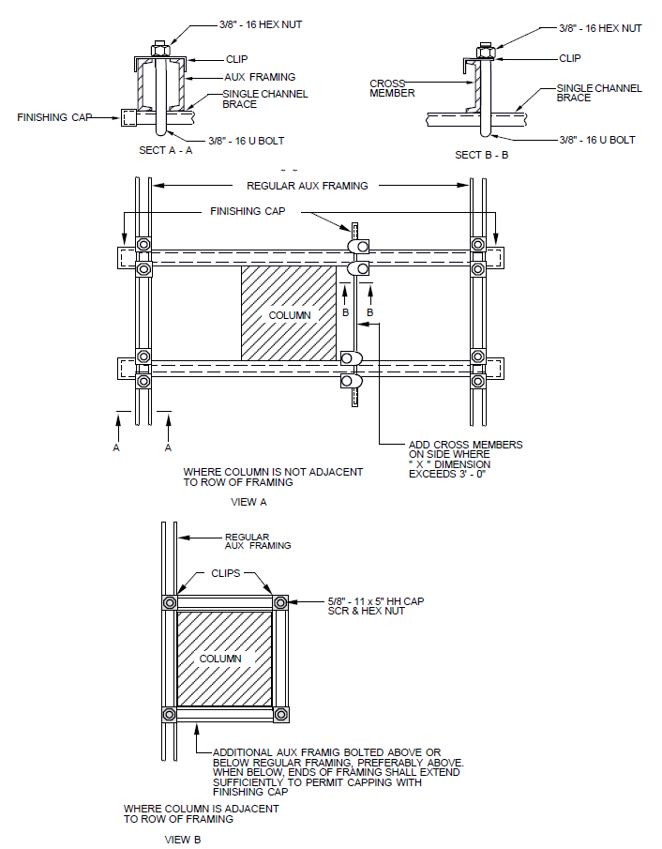
EXHIBIT 2-E2-23 (DISCONTINUED)
2-E2-23 (DISCONTINUED) BRACING AUXILIARY FRAMING TO COLUMNS HISTORICAL ONLY

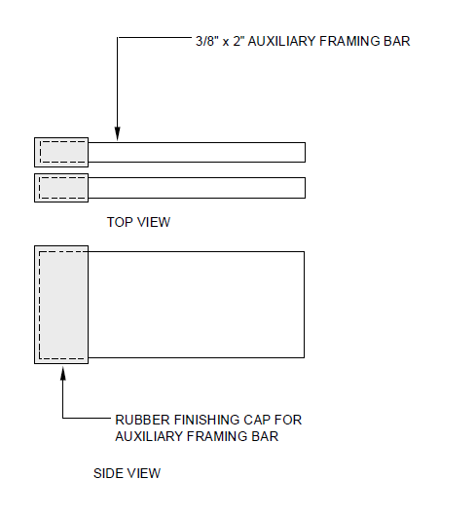

EXHIBIT 2-E2-23C
2-E-23C FINISHING CAPS ON AUXILIARY FRAMING

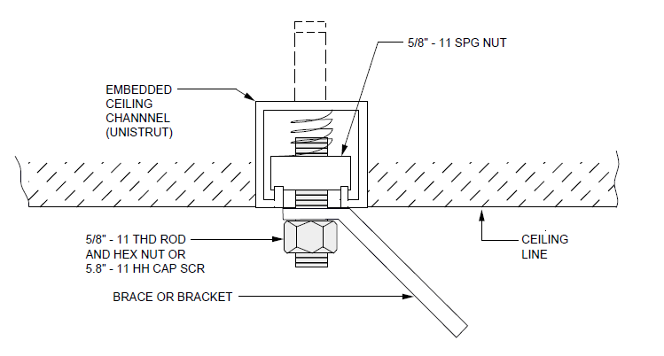

EXHIBIT 2-E2-24
2-E2-24 BRACING OF AUXILIARY FRAMING WITH SINGLE BRACE

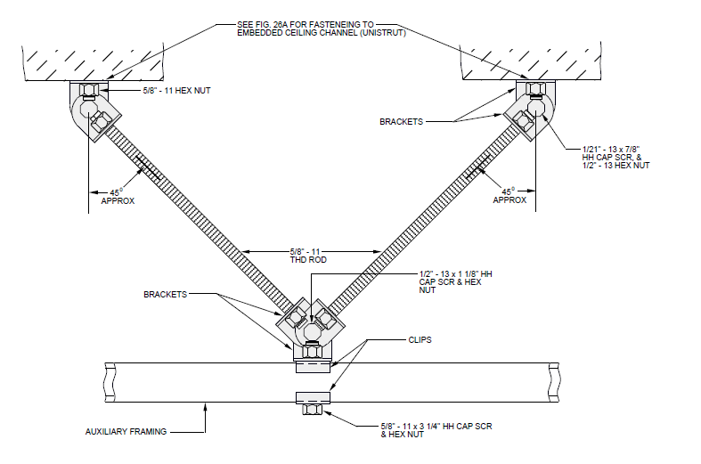

EXHIBIT 2-E2-25
2-E2-25 BRACING OF AUXILIARY FRAMING WITH SINGLE-ROD BRACES

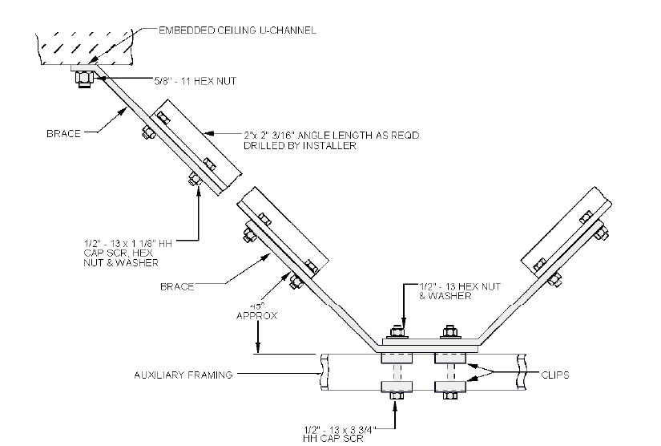

EXHIBIT 2-E2-25A
2-E2-25A BRACING OF AUXILIARY FRAMING WITH DOUBLE - ANGLE BRACES

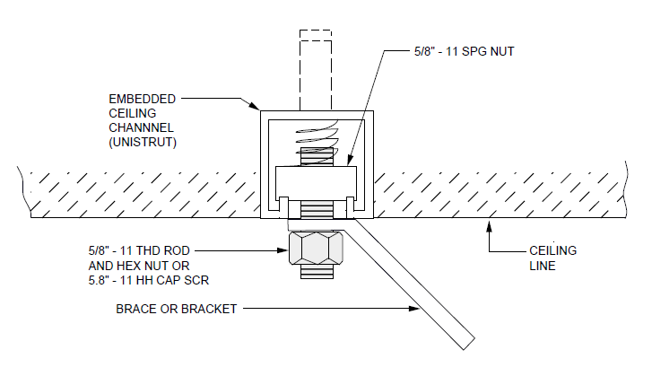

EXHIBIT 2-E2-26A
2-E2-26A FASTENING AUXILIARY FRAMING BRACE TO EMBEDDED CEILING CHANNEL

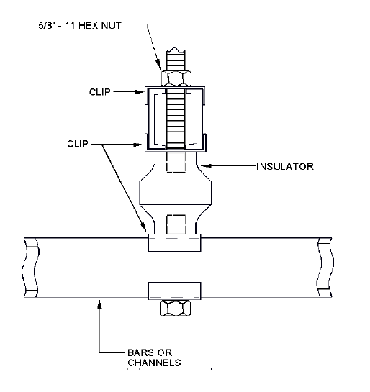

EXHIBIT 2-E2-27
2-E2-27 DOUBLE-LEVEL AUXILIARY FRAMING-ISOLATING TWO LEVELS OF CHANNEL

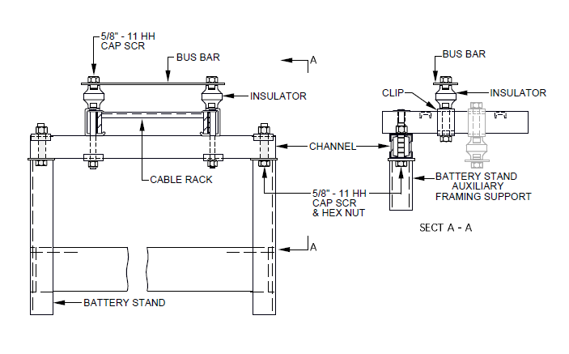

EXHIBIT 2-E2-28
2-E2-28 AUXILIARY FRAMING SUPPORT FOR SHORT BUS BARS ABOVE BATTERY STANDS

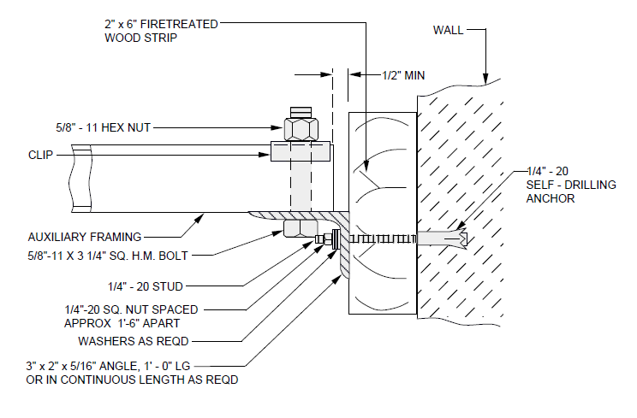

EXHIBIT 2-E2-29
2-E2-29 DOUBLE FRAMING ATTACHED TO WALLS WHERE ANGLE IS DRILLED

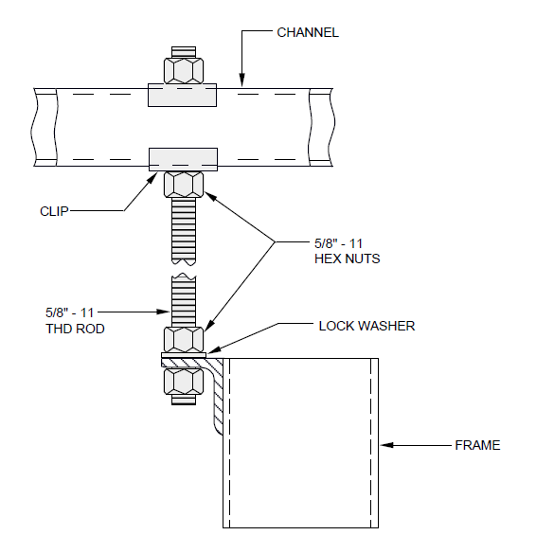

EXHIBIT 2-E2-30
2-E2-30 SUPPORTING FRAME WITH THREADED ROD FROM FRAMING
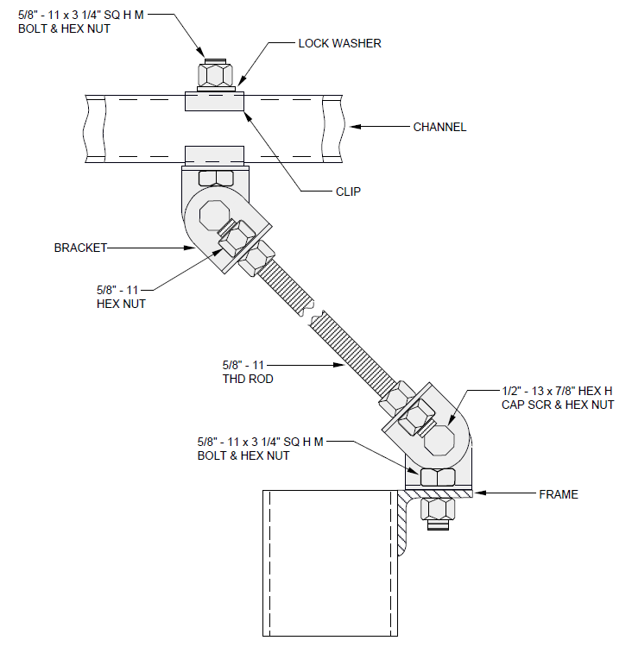

EXHIBIT 2-E2-31
2-E2-31 BRACING FRAMES FROM AUXILIARY FRAMING

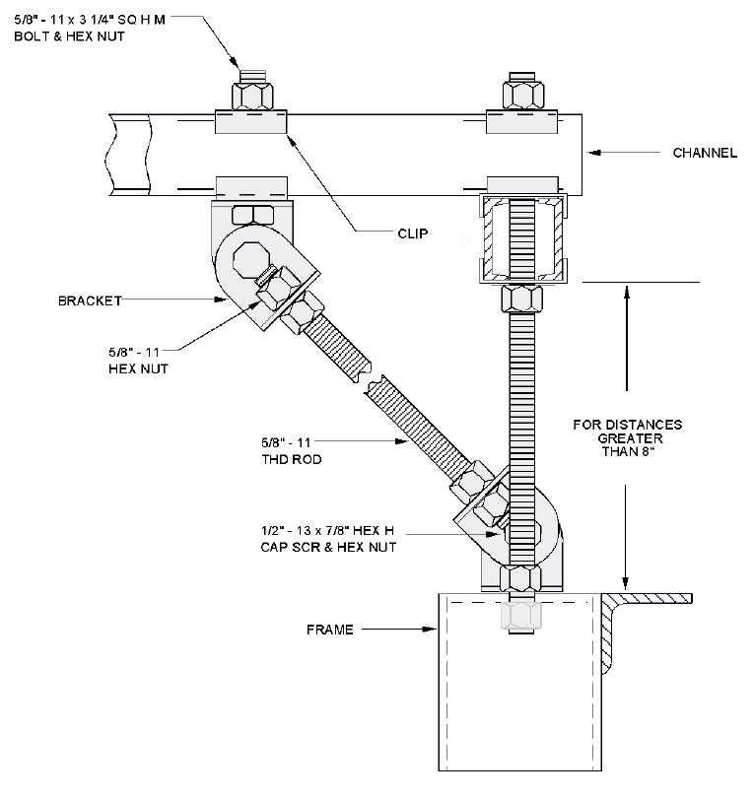

2-E2-31A (DISCONTINUED)
2-E2-31A (DISCONTINUED) BRACING LOW LEVEL ENVIRONMENT FRAMES

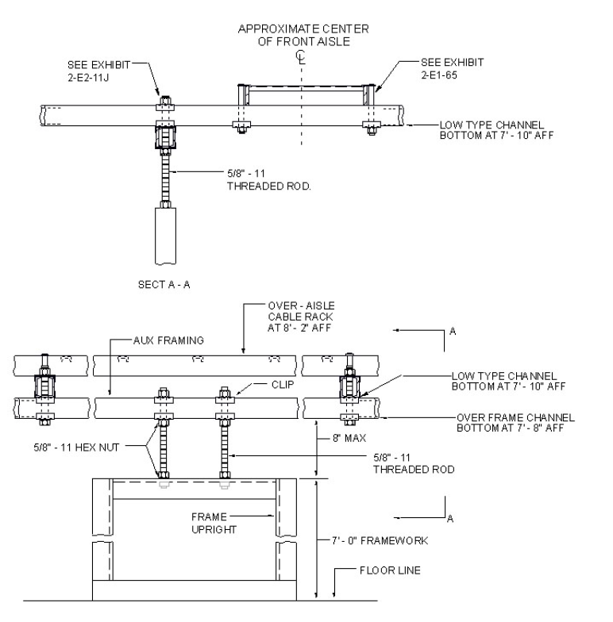

EXHIBIT 2-E2-32
2-E2-32 TYPICAL FRAMEWORK AND IRONWORK ARRANGEMENT FOR A 7’-0” FLOOR SUPPORTED SYSTEM

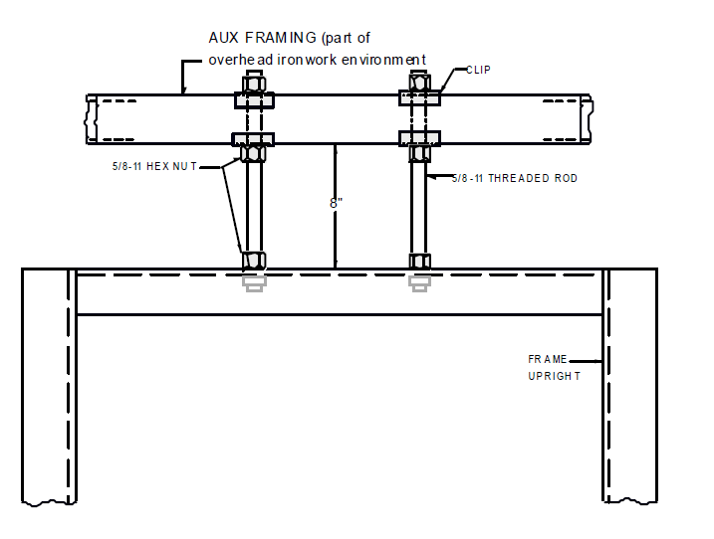

EXHIBIT 2-E2-32A
2-E2-32A TYPICAL ATTACHMENT OF AUXILIARY FRAMING TO UNEQUAL FLANGE CABLE DUCT TYPE FRAMEWORK

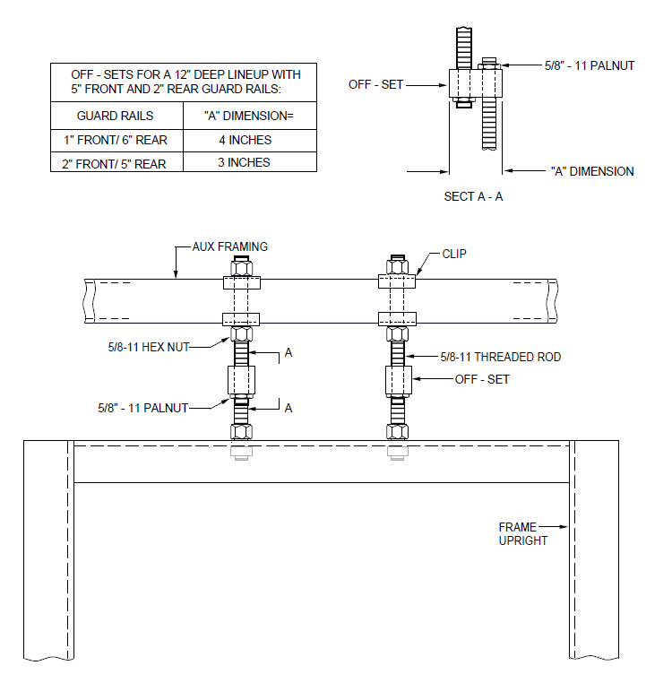

EXHIBIT 2-E2-32B
2-E2-32B TYPICAL METHOD OF INSTALLING HANGER ROD OFF-SET TO MAINTAIN GUARD RAIL ALIGNMENT

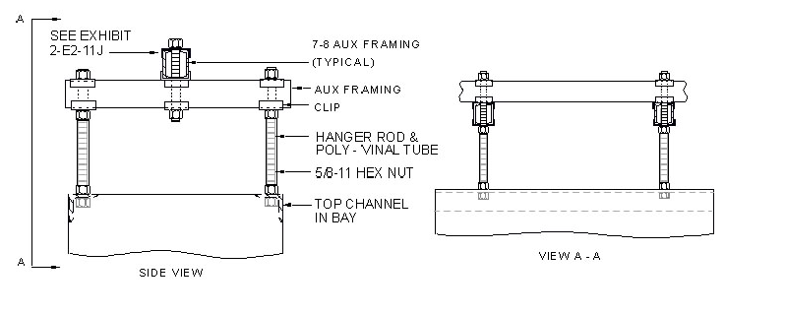
EXHIBIT 2-E2-32C
2-E2-32C TYPICAL METHOD OF SUPPORTING AUXILIARY FRAMING OVER A 7’-0” BDFB

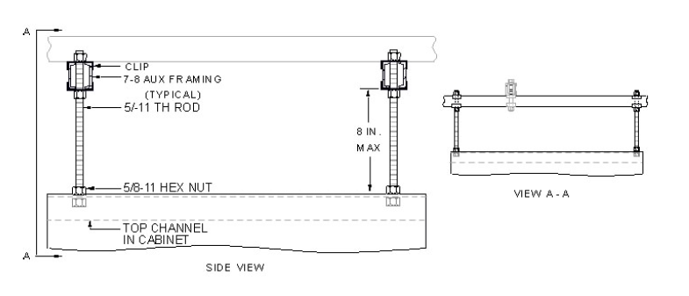
EXHIBIT 2-E2-32D
2-E2-32D TYPICAL METHOD OF SUPPORTING AUXILIARY FRAMING OVER A 7’-0” CABINET

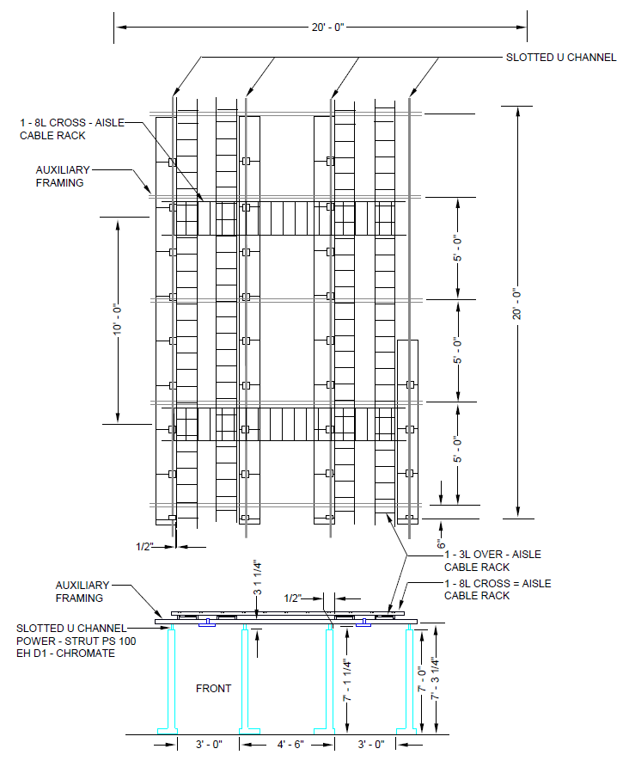
EXHIBIT 2-E2-33 (A&M)
2-E2-33 (A&M) LOW-LEVEL CABLE RACKING (TYPICAL IRONWORK LAYOUT)

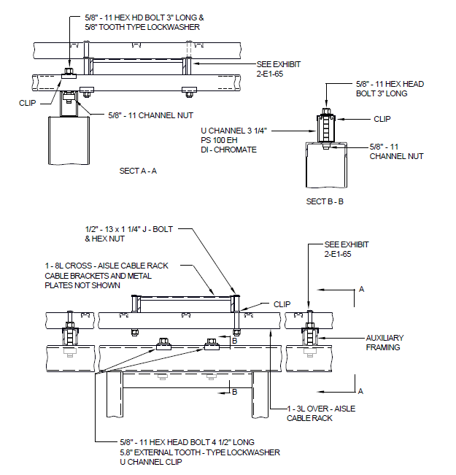

EXHIBIT 2-E2-33A (A&M)
2-E2-33A (A&M) TYPICAL METHOD OF SUPPORTING FRAMEWORK IN A 7’-0” LOW LEVEL ENVIRONMENT

