http://www.monigle.net/email_sig/centurylink/cl_logo.jpg

Customer Test Plan

CenturyLink ASR Consolidation

Date: 1/15/2016

Prepared By:

WSST - Wholesale System Support Team

Document Information

This section identifies information specific to this document.

Document History

All revisions to this document are listed in chronological order.

|  |  |  |
| --- | --- | --- |
| Ver | Date | Description of Changes |
| 1 | 11/2/15 | Initial Draft |
| 2 | 11/23/15 | Removal of “Draft” designation, expanded 2.1 Test Assumption E page 6, added details to the 3.4.1 Data Requirements |
| 3 | 1/15/16 | Updated the Customer Testing Dates, and associated review activities, with the new dates  Updated Section 3.1, page 4 with new schedule reflecting an August 1, 2016 install date  Updated Section 3.3, Exhibits A & B (pages 5 & 6) with new images of the revised Customer Test Plan worksheet, including the addition of a new Column (F) for CLLI(s) (e.g. ACTL, FACTL, SecLoc, (S)MUXLOC, ESP, EVCSP, etc) |
|  |  |  |

Copyright and Trademarks

© CenturyLink, Inc. All rights reserved. The CenturyLink mark, pathways logo and certain CenturyLink product names are the property of CenturyLink, Inc. All other marks are the property of their respective owners.

Table of Contents

1.0 Introduction/Overview 1

1.1 Related Information 1

2.0 Test Planning 2

2.1 Test Assumptions 3

3.0 Test Strategy 4

3.1 Customer Testing Schedule 4

3.2 Test Objectives 5

3.3 Test Approach 5

3.4 Test Dependencies 7

3.4.1 Test Data Requirements 7

3.5 Test Environment 7

3.6 Test Cases 7

3.7 Defects 8

3.7.1 Reporting Defects 9

3.7.2 Defect Severity Definitions 11

3.8 Test Entry and Exit Criteria 12

4.0 Glossary 13

5.0 Customer Testing Resources 14

# Introduction/Overview

As described in the CenturyLink Access Service Ordering and Billing System Consolidation Plan (hereafter the ASR Consolidation Plan; 6/19/15), CenturyLink is consolidating its Access Service ordering and billing systems to streamline processes and systems across CenturyLink’s markets. The approach will be to integrate all Wholesale customers from CORA and EXACT into EASE. These customers will also migrate from IABS to CDG CABS billing.

In accordance with the Change Management Process (CMP), CenturyLink has developed a proposed Draft Test Plan and Potential Test Cases for the wholesale customers to test the new functionality of this project. This document describes the scope, milestones, and testing activities to be carried out during the Customer Test Phases of the ASR Consolidation Plan to ensure common understanding among stakeholders for the testing efforts.

The Draft Test Plan will be reviewed by applicable stakeholders and will serve as a reference document for the testing teams.

## Related Information

The **Project Information Reference** table below provides a single easy reference point for all of the tool identifiers, links, and other reference points associated with this project.

| Reference  Item | Applicable Section(s) of Test Plan | Detail/(URL) |
| --- | --- | --- |
| Draft Test Plan | 2.0 | Draft Test Plan is located at: <http://www.centurylink.com/wholesale/systems/ossconsolid.html> |
| Potential Test Cases | 3.6 | Potential Test cases are located at: <http://www.centurylink.com/wholesale/systems/ossconsolid.html> |
| ASR Consolidation Customer Testing Defect form | 3.71 | The ASR Consolidation Customer Testing Defect form is located at: [http://www.centurylink.com/wholesale/systems/ossconsolid.html](http://www.centurylink.com/wholesale/systems/ossconsolid.html%20) |

# Test Planning

**Test Case Creation**: CenturyLink hosted a joint test planning meeting to review the Draft Test Plan, as well as the Potential Test Cases, with the customers on November 10, 2015. Potential test cases are located at <http://www.centurylink.com/wholesale/systems/ossconsolid.html>.

Individual Customer Testing Review Meetings: If needed, meetings will be scheduled during January-February, 2016 to review and understand the proposed Customer’s test cases.

**Final Test Execution Readiness Meetings:** In March, 2016, individualCustomer Testing meetings will be held to understand and agree upon each Customer’s initial test case priority, testing time(s), review processes, such as Defect entry, initial log in process and any other issues that may impede testing progress.

**Test Case Execution Window**: Test cases will be executed between March 21, 2016 to July 18, 2016 at agreed upon times. See section 3.1 - Customer Testing Schedule for additional details.

**Testing Customer Reporting Test Case Execution Status**: The Testing Customers should report the status of the Test Case Execution using the CenturyLink supplied Excel tracking sheet by COB Central Time (CT) each Thursday to[: asrconsolidationtesting@centurylink.com](mailto::%20asrconsolidationtesting@centurylink.com).

**CenturyLink Test Case Reporting**: A Weekly Update Status will be emailed to each testing by COB CT each Friday. A global Test Status update will also be posted at: <http://www.centurylink.com/wholesale/systems/ossconsolid.html>.

**Testing Success Rate**: Goal for execution and pass rate should be mutually determined during Test Planning**.** See section 3.3 Test Approach for additional details.

**Defect Identification**: Defects should be reported as they are found to [asrconsolidationtesting@centurylink.com](mailto:asrconsolidationtesting@centurylink.com) using the Defect Log Form, located at <http://www.centurylink.com/wholesale/systems/ossconsolid.html>. Severity should be provided as they are received. See section 3.7 Defects for additional details.

**Defect Status Updates**: A Weekly Defects Status update will be emailed to each testing customer by COB CT each Friday. In addition, a global defect status, without company attribution, will be posted to the <http://www.centurylink.com/wholesale/systems/ossconsolid.html> also by COB CT each Friday

**Testing Communications**: Periodically, CenturyLink refreshes the test databases, which may require system downtime . In the event CenturyLink needs to communicate with the customer, the customer’s SPOC will receive notifications via email.

Customers will communicate with CenturyLink via the ASR System Consolidation Testing mailbox: [asrconsolidationtesting@centurylink.com](mailto:asrconsolidationtesting@centurylink.com). CenturyLink will only accept Customer testing communications from the agreed upon SPOC or a designee. If necessary, CenturyLink will contact the Customer SPOC for clarification.

**Testing Resources:** Customer testing resources need to be confirmed prior to the start of testing. It is critical that one customer test resource should be designated as a SPOC. This SPOC should take the lead within the Customer testing company to coordinate the successful completion of the agreed test cases, as well as coordinate communication with CenturyLink. All testing resources should be readily available via phone or email during the testing window or a backup communicated to CenturyLink. This will ensure customer testing stays on schedule and communication regarding a defect resolution incurs no delay. Customers will communicate with CenturyLink via the ASR System Consolidation Testing mailbox: [asrconsolidationtesting@centurylink.com](mailto:asrconsolidationtesting@centurylink.com).

**Testing Timeline**: During planning, the testing timelines should be solidified and mutually agreed for each test set. See section 3.1 Customer Testing Schedule for additional details.

## Test Assumptions

The following assumptions are related to the project/release and its test effort.

1. Customers will have their test environment established and login information available prior to the start of Customer testing.
2. Customers will identify which Test Cases will be executed from the Potential Test Cases spreadsheet. If the customer would like additional test cases which are not in the list of Potential Test Cases, then CenturyLink will have to review and agree.
3. Customers will enter ASRs in EASE Virtual Front Office (VFO) and/or Unified Ordering Model (UOM).
4. Customers will submit orders in ASOG standard format at the time of submittal.
5. This testing will not include Load and Performance (L&P) testing. The L&P test process was described in the CenturyLinkServiceOrderingandBillingSystemConsolidationPlanV3_011516 on page 17 Section 3.3.4.
6. Using converted IABS data, CenturyLink will provide CABS invoice(s) and CSRs in the media format that they have selected in CABS.  These will be available on BANS which contain Specials Access products billed in IABS and selected Switched Access BANS with a limited amount of usage on the BANS.
7. Test Environment Hours/CenturyLink Support Hours will be from 9:00 AM – 4:00 PM Central Time Monday to Friday.
8. Customers will communicate with CenturyLink via the ASR System Consolidation Testing mailbox: [asrconsolidationtesting@centurylink.com](mailto:asrconsolidationtesting@centurylink.com). CenturyLink will only accept Customer testing communications from the agreed upon SPOC or a designee. If necessary, CenturyLink will contact the Customer SPOC for clarification.

# Test Strategy

When planning the project or release, it is important to consider the approach to testing and acceptance. The intent of the test strategy is to establish the framework for testing the system and the work products to be delivered. The strategy should identify the types of testing that are applicable. The strategy should also define the level of participation for the stakeholders and the responsibilities for all participants.

## Customer Testing Schedule

CenturyLink will make available a testing environment at the appropriate time for the Customers to test orders for the ASR Consolidation project.

To ensure all resources are available during the planned testing timeline, test cases will be executed during a defined testing window in the 120 day testing window.

Test Environment Hours/CenturyLink Support Hours

9:00 AM – 4:00 PM Central Time Monday to Friday

| Consolidation Plan Milestone | Date |
| --- | --- |
| Issuance of Draft Tech Specs, including Draft Test Plan and Potential Test Cases | November 2, 2015 |
| Review of Draft Test Plan/Potential Test Cases meeting | November 10 |
| Individual Customer Testing Review Meetings (if needed) | January-February |
| Final Test Execution Readiness Meetings | March, 2016 |
| Customer Testing Begins | March 21 |
| If needed, testing Customers and CenturyLink adjust Customer test cases, based on Revised Tech Specs | March 7-March 21 |
| Customer Testing Ends | July 18 |
| Customer Go/No Go Vote | July 18 |
| Release to Production | August 1 |

## 

## Test Objectives

The objectives for testing this project are :

1. Ensure that CenturyLink customers have tested the new functionality for the ASR Consolidation.
2. Ensure that EASE supports both eBonding and Portal Virtual Front Office (VFO) GUI.
3. Ensure that EASE is in full compliance with ASOG/ASR industry standards and standard ASR configurations.
4. Ensure CDG CABS invoices and CSRs are understood by the Centurylink customers.

## Test Approach

The Testing Customers will select their areas of testing from the Potential Test Cases spreadsheet. If the customer would like additional test cases which are not in the list of Potential Test Cases, then CenturyLink will have to review and agree.

If necessary, individual Customer Testing Review Meetings will be scheduled during January-February, 2016 to review and understand the proposed Customer’s test cases identified from the Potential Test Cases spreadsheet. At this time, the Testing Customers will have completed columns A-M of the Customer Test Plan worksheet. (Exhibit A).



**Exhibit A**: Customer Test Plan worksheet sections (columns A – M) to be completed by the tester and reviewed during the Individual Customer Testing Review Meeting.

Once the Customer Test Cases are identified, the Potential Test Cases spreadsheet will become the customer specific Final Test Plan and the spreadsheet will be named accordingly (e.g. CenturyLink Final Test Plan).

In January-February, 2016, individualCustomer Testing meetings will be held to understand and agree upon Customer’s initial test case priority, testing time(s), review processes, such as Defect entry, initial log in process and any other issues that may impede testing progress**.**

On the customer specific Final Test Plan worksheet the columns N -T (highlighted in orange) is designed to be completed by the tester for each of their executed test cases (Exhibit B). Test cases will be executed between March 21, 2016 to July 18, 2016 at agreed times. See section 3.1 - Customer Testing Schedule for additional details.



Exhibit B: Final Test Plan worksheet section (columns N – T) to be completed by the tester at the time of test execution.

The customer specific Final Test Plan will be used to report testing status and for tracking purposes between CenturyLink and the Testing Customers. The Testing Customers should report their testing status by sending their customer specific Final Test Cases worksheet to [asrconsolidationtesting@centurylink.com](mailto:asrconsolidationtesting@centurylink.com) by COB CT each Thursday.

See section 3.7 Defects for reporting defects during testing.

Below are the Proposed Testing Customer Progress Goals designed to keep the Testing Customers on target to testing completion.

Proposed Testing CustomerProgress Goals**:**

|  |  |
| --- | --- |
| **Customer Test** | **% Complete** |
| 1st 30 days: | 20% |
| 2nd 30 days: | 50% |
| 3rd 30 days: | 80% |
| 4rd 30 days | 100% |

## Test Dependencies

If needed, a review of the Potential Test Cases will be held separately with individual Customer’s Testing during January-February, 2016. The participants will be the CenturyLink Potential Test Case creators and execution contacts identified by the Customers. Customer Test Cases should cover all scenarios that will be executed for the ASR Consolidation project.

### Test Data Requirements

During the preparation of the Customer Test cases, the data needs will be included so that CenturyLink and the Customer can be in agreement on the requirements. CenturyLink can then prepare the necessary data prior to testing commencement. It should be noted that the CenturyLink testing system will have a copy of the appropriate Network data base available for testing. Thus, customers will be able to test with their own customer base.

## Test Environment

The EASE VFO Test Environment URL will be provided before testing begins.

Customers accessing the EASE UOM test environment will have their login information established prior to the start of testing.

If there are access issues with EASE VFO or EASE UOM test environments, please contact the ASR team mailbox [asrconsolidationtesting@centurylink.com](mailto:asrconsolidationtesting@centurylink.com).

## Test Cases

CenturyLink has attached a spreadsheet consisting of Potential Test Cases for the testing Customers. This spreadsheet includes all scenarios that will be available for testing through the VFO and/or UOM EASE interfaces. Customers do not have to test all areas, only those most important to them. If necessary, these Customer identified test cases will be reviewed at the Customer specific test case review meeting in January-February, 2016. At that time, each testing Customer should identify any specific data needs to complete their test cases.

See section 1.1 for the location of the Potential Test Cases spreadsheet.

## Defects

Defects should be reported as soon as possible as they are found and be reported to CenturyLink for triage and resolution. Severity, particularly blocking defects preventing further testing, should be reported as they are discovered.

All defects identified during Customer Testing should be emailed to [asrconsolidationtesting@centurylink.com](mailto:asrconsolidationtesting@centurylink.com?subject=Defect:%20ASR%20System%20Consolidation%20Customer%20Testing)  using the completed ASR Consolidation Customer Testing Defect form (Exhibit **C**).

The ASR Consolidation Customer Testing Defect form can be downloaded from: <http://www.centurylink.com/wholesale/systems/ossconsolid.html.>

In addition, a global defect status, without company attribution, will be posted to the <http://www.centurylink.com/wholesale/systems/ossconsolid.html> also by COB CT each Friday.

### Reporting Defects

To report a defect, the ASR Consolidation Customer Testing Defect form (Exhibit **C**) must be correctly completed and emailed as an attachment to [asrconsolidationtesting@centurylink.com](mailto:asrconsolidationtesting@centurylink.com?subject=Defect:%20ASR%20System%20Consolidation%20Customer%20Testing).

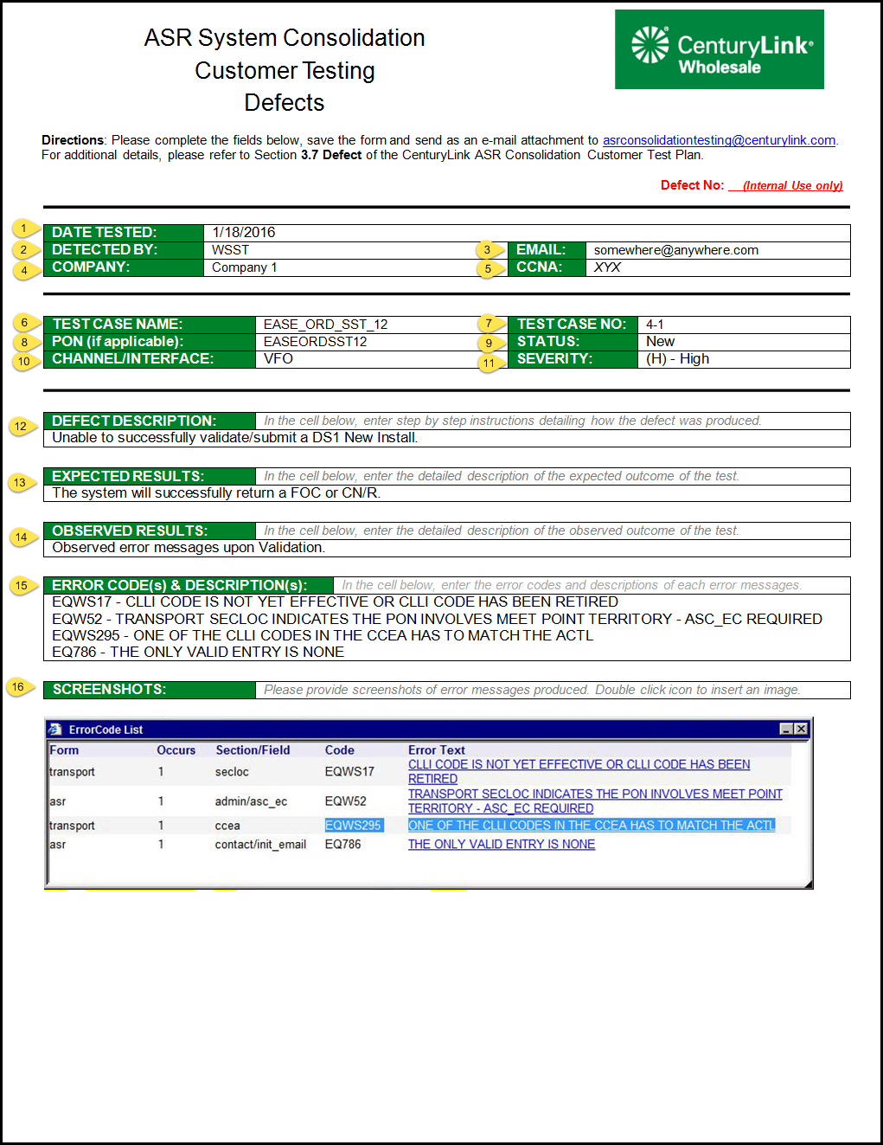

**Exhibit C**: ASR System Consolidation Customer Testing Defect form

To properly fill out the Defect form the following fields must be completed

1. **DATE TESTED** – Date the defect was identified.
2. **DETECTED BY** – Tester’s name.
3. **EMAIL** – Tester’s email address.
4. **COMPANY** – Tester’s company.
5. **CCNA** – Company’s CCNA
6. **TEST CASE NAME** – Indicates the Test Case name that was executed when the defect was encountered. The Test Case name can be found in Column A of theCustomer Test Plan worksheet.
7. **TEST CASE NO** – Indicates the Test Case number that was executed when the defect was encountered. The Test Case number can be found in Column B of theCustomer Test Plan worksheet.
8. **PON (if applicable)** – The PON the tester provided which references the test case.
9. **STATUS**
   1. **New** – New defect
   2. **Existing** – Defect previously reported
   3. **Other**
10. **CHANNEL/INTERFACE** – Indicates which interface was used when the defect was encountered. This can be either EASE VFO or UOM.
11. **SEVERITY** – Please see **Section 3.7.2 Severity** below.
    1. **High -** blocking issue, SLA is 4 business hours
    2. **Medium -** major issue, SLA is 2 business days
    3. **Low -** minor issue, SLA is 5 business days
12. **DEFECT DESCRIPTION** – Detailed step by step instructions of how the defect was produced. These instructions will be used to help determine the root cause of the issue.
13. **EXPECTED RESULTS** – Detailed description of the expected outcome.
14. **OBSERVED RESULTS** – Detailed description of the observed outcome.
15. **ERROR CODES & DESCRIPTIONS** –Error Code and their description generated by the system (e.g. EQ786 - THE ONLY VALID ENTRY IS NONE).
16. **SCREENSHOTS** – Tester to provide screenshots of Error Code(s) and Error Message(s)**.**

### Defect Severity Definitions

The table below references the Severity Level and their description which should be applied when reporting defects.

|  |  |
| --- | --- |
| Defect Severity | |
| Severity | Severity Definition |
| **High** | It is impossible to continue with the testing of the specific functionality because of the severity of the issue. No workaround is available. This may block other test’s completion. Functionality cannot be installed with this defect.  **Response Time:**  4 business hours. |
| **Medium** | Testing can continue however the issue may cause severe disruption to business processes in live operation. Defect results in severely impaired functionality. A workaround may exist but its use is unsatisfactory.  **Response Time:** 2 business days. |
| **Low** | Both testing and live operations may progress. This problem should be corrected, but little or no changes to business processes are envisaged without the fix. Also, cosmetic Issues are considered minor.  **Response Time:**: 5 business days. |

## Test Entry and Exit Criteria

The entrance criteria specified by the Test Plan should be fulfilled before the test can begin. In the event, that any criterion has not been achieved, the test activities may begin if the applicable stakeholders are in full agreement that the risk is manageable.

The exit criteria specified by the Test Plan must be achieved before the software can be recommended for promotion to production.

|  |  |
| --- | --- |
| Customer Testing | |
| Type | Criteria |
| Entrance criteria | * Customer Test Plan and Test Cases have been reviewed and approved. * Test environments have been created and are stable. |
| Exit criteria | * All test cases executed and have been dispositioned as passed, deferred with applicable defects, or descoped with management approval. * A resolution is in place for all severity High and Medium defects. * Per Merger Agreements, CenturyLink will conduct a GO/NO GO vote of CLECs near the conclusion of Customer Testing based on the following criteria: “**Acceptance testing will require a majority vote, no vote to be unreasonably withheld, of the CMP participants in testing, and must reflect two-thirds or more of the transaction volumes.” 1** * Planned activity is documented for unclosed defects. |

See *In the Matter of the Joint Petition for Approval of Indirect Transfer of Control of Qwest Operating Companies to CenturyLink, Minnesota Public Utilities Commission*, Docket No. p-421, et al./PA-10-456, Settlement Agreement between the Joint Petitioners and Joint CLECs, March 4, 2011.

# Glossary

The following list provides a description of any acronyms used within the Test Plan.

| Term | Description |
| --- | --- |
| ASOG | Access Service Ordering Guidelines |
| ASR | Access Service Request |
| BDT | Bill Data Tape |
| BOS | Bill Output Specifications |
| CABS | Carrier Access Billing System |
| CDG | Communications Data Group |
| CDG CABS | The Carrier Access Billing System created and owned by Communication Data Group and is in use at CenturyLink |
| CMP | Change Management Process |
| CSR | Customer Service Record |
| CT | Central Time |
| EASE | Electronic Administration & Service Order Exchange |
| IABS | Integrated Access Billing System |
| SLA | Service Level Agreement |
| SPOC | Single Point Of Contact |
| TRG | Technical Review Group (Ericsson formerly Telecordia) |
| UOM | Unified Ordering Model |
| VFO | Virtual Front Office |
|  |  |

# Customer Testing Resources

* Technical Specifications: <http://www.centurylink.com/wholesale/systems/ossconsolid.html>
* User Guide info, Business Processes and PCATS specific to the Project implementation: <http://www.centurylink.com/wholesale/systems/ossconsolid.html>
* EASE training: <http://www.centurylink.com/wholesale/systems/ossconsolid.html>
* CMP web site: <http://www.centurylink.com/wholesale/cmp/index.html>
* ASOG standards: <http://www.atis.org/obf/download.asp>
* CABS BOS standards: Coordinate with your company representative to the Ericsson Technical Review Group (TRG)