CONTENTS

Chapter and Section Page

5. Cabling, Forming, Running, and Securing 5-1
5.1 General Requirements 5-1
5.2 Cable Mining 5-3
5.3 Bending and Forming 5-5
5.4 Protection and Storage 5-7
5.5 Securing and Supporting 5-8
5.6 Power cables 5-10
5.7 Grounding Conductors 5-11
5.8 Cable Pile-up 5-12
5.9 Coaxial Cables 5-13
5.10 Fiber Optic Cable 5-13
5.11 Ribbon Cable 5-18
5.12 Repair of Damaged Cables 5-18
5.13 Spliced Cables, Splicing Systems, and Mated Connectable Cables 5-18
5.14 Use of Nylon and Plastic Cable Ties 5-19
5.15 Securing Tables 5-20
5.16 Securing Figures 5-22

Figures

5-1 Starting Stitch 5-22

5-2 Kansas City Stitch 5-23

5-3 Sewing First Layer 5-24

5-4 Sewing Second Layer 5-24

5-5 Supporting and Sewing Cables to Supports at Turns 5-25

5-6 Securing Cable to Support with Kansas City Stitch 5-26

5-7 9 Ply Cord splice technique 5-26

5-8 Chicago Stitch Used to Sew Cables Together 5-27

5-9 Banding of Cables with 9 Ply cord 5-28

TOC 5-i

5. Cabling, Forming, Running, and Securing

Note: Additional requirements for power cabling are found in Chapter 9.

5.1 General Requirements
The requirement for cable routing and segregation shall be per job specification and records/drawings, specified in CenturyLink Standard Configuration documents or technical publications.

Cables shall be run directly from point to point with only a “maintenance loop” of cable (not to exceed 4 feet) stored on the cable rack. All “maintenance loop” cabling must remain within the confines of the cable rack or designated cable support system.

5.1.1 All cables (other than grounding cables and alarm wires) shall be run within the confines of the cable rack stringers and shall not be run so as to block access to entrance to a bay. Do not run cables on existing cable racks where cable pileup exceeds cable pileup limits or the top of cable horns. Cable horns are limited to a maximum usable length of twelve inches. Routing of cables between relay racks and frames without using the overhead cable support systems is prohibited (Unless specified in the Standard Configuration document). Placement of vertical splices, adapters on or in the relay rack uprights and cable ways and or horizontal/vertical cable support systems is prohibited. Unless specified in the Planning & Engineering Guidelines (PEG) the use of connectors in the frame/relay rack uprights is also prohibited

Note: If the PEG grants the Service Supplier a Letter of Deviation on running their cable in offices that have excessive build-up then that supplier shall document and place a copy of that waiver in the job package.

5.1.2 Supporting or securing of any cable to AC conduit is prohibited.

5.1.3 Remove all cable running tags and binder grouping material after the completion of testing. Exception: When requested by the B&C personnel and the CenturyLink Design Engineer concurs with a letter of deviation, on a per job basis, the tags may be left in place if those tags are made of a fire resistant material and will not inhibit the installation of future cable or restrict equipment maintenance. A copy of that waiver shall be placed in the job package. Refer also to Chapter 6, Par. 6.5.

5.1.4 Cable and cable management systems shall be at a distance sufficient to maintain a maximum cable/enclosure temperature of 115° F. At a minimum, the distance shall be no less than 6 inches of clearance from engine exhaust pipes, steam pipes, or other similar hazards.

5.1.5 Cable spanning horizontal planes shall not exceed 9 inches without additional support. Interim support points (auxiliary framing, conduit, etc.) must be installed so as not to interfere with future cross aisle cable racks or cable access to bays, cabinets, BDFB return bars, etc.

5.1.6 Where cables transition off a cable rack, they shall be routed over the side stringers or off the end of a cable rack that will not be extended at some future date. Cables shall not be routed through the cable rack with the exception of “un-protected” battery cables where cable bending radius requirements can be maintained (refer to Par. 9.2.8).

For additional cable routing and transition requirements, refer to TP 77351 Chapter 6, Par. 6A.4.6. All cables dropping into a frame from a horizontal cable rack or duct system must be routed to align as directly above the frame upright or vertical duct system as possible. At no time will cable of any type make a horizontal transition greater than nine inches across the top of the bay to access the opposite bay upright or vertical duct arrangement. Overhead horizontal cable rack or duct systems must be extended beyond the location below where the cable will enter the bay upright or vertical duct.

5.1.7 All cable connections within a bay shall be supported within 24 inches of a point of termination.

5.1.8 Cables larger than 14 AWG must not be routed through a frame’s uprights. Cables smaller than 14 AWG, must not pass from the front of the bay to the rear (unless specified in CenturyLink Standard Configuration documents).

5.2 Cable Mining

5.2.1 Cable mining conducted above working equipment shall only be done after precautions are taken to protect the equipment below. A protective barrier shall be constructed between the cable rack and the equipment. Before any cables are removed, the cable racks shall be vacuumed with a High Efficiency Particulate Arrester (HEPA) vacuum.

5.2.1.1 The B&C personnel will identify the critical equipment over which any cable mining activity must be performed in the Maintenance Window. The Service Supplier or contract agent will add this information to the Detailed MOP using the following format:

“List of Equipment on the Mining Route. Activity above this equipment must be performed in the Maintenance Window.”

Relay Rack and Equipment Description

RR# (s)
(DCS, Optical Terminal equipment, power plant rectifiers, BDFB, synchronization, alarming, etc.)

This information must be entered into the Detailed MOP before any actual work steps or requirements are added. This is to recognize which equipment is considered “Critical Equipment” and where cable mining activities will be performed in the maintenance window.

NOTE: All other cable mining activities, assigned by this job, can be performed during normal business hours (including the restitching of cable racks after cables selected for removal are mined).

5.2.2 Ring or loop type cutters, which require the free end of the cable to be inserted through a ring or loop, shall be required for the removal of cable. Removal of cables shall have an authorized "Detailed" MOP written before any cable is removed.

5.2.3 A current probe or clamp on ammeter capable of reading both AC and DC currents shall be used to check for a zero current condition prior to the cutting of power/power return and grounding cables. The installer shall be required to designate the far-end termination on both sides of the power / grounding cable prior to the initial cut. This shall be documented in the "Detailed" MOP and a copy placed in the job package.

Note: Any power/power return and ground cable found without zero current flow shall be referred to CenturyLink B&C for de-energizing. If a grounding conductor is inadvertently energized, ensure that there is an adequate alternate current path prior to cutting it. Power cables (either the “hot” lead or the grounded return) that are going to be cut/removed and are still energized must be defused (or circuit breaker disabled) prior to the cut/removal.

5.2.4 All cables earmarked for removal/mining should be removed, where practical, to maintain cable pileup limits and safe loads. Where cabling cannot be removed without causing a service interruption, those cables shall be mined / removed to a minimum of the top of the cable rack where removal is not possible and the ends of all remaining cables shall be individually taped and tagged with far end information for future removal.

All removals shall be in compliance with all applicable codes including NEC Article 800.2:
Abandoned Communications Cable is defined as: Installed communication cable that is not terminated at both ends at a connector or other equipment and not identified for future use with a tag. (This definition has been added to the 2002 Code for use with 800.52(B), which now requires removal of accessible abandoned communications cable. Abandoned cable increases fire loading unnecessarily, and, where installed in plenums, it can affect airflow. Similar requirements can be found in Article 640, 645, 725, 760,820, and 830.)

5.3 Bending and Forming

5.3.1 Cables shall not be run or formed in a manner that violates the minimum bend radius.

Minimum Bending Radius for Cable and Wire Table

Power Cables
 | Wire Size |  | Max. Amps |  | Circular Mils |  | Weight/Ft. |  | Diameter* |  | Min. Bend Radius
 | 30 |  | 0.3A |  | 100 |  | - |  | - |  | 0.09”
 | 28 |  | 0.5A |  | 160 |  | - |  | - |  | 0.11"
 | 26 |  | 0.9A |  | 254 |  | - |  | - |  | 0.14"
 | 24 |  | 1.3A |  | 404 |  | - |  | -
 | 22 |  | 2.3A |  | 642 |  | - |  | -
 | 20 |  | 3A |  | 1,021 |  | - |  | -
 | 18 |  | 7A |  | 1,624 |  | - |  | -
 | 16 |  | 10A |  | 2,582 |  | - |  | -
 | 14 |  | 15A |  | 4,110 |  | 0.026# |  | 0.19" |  | 1.71"
 | 12 |  | 20A |  | 6,530 |  | 0.035# |  | 0.21" |  | 1.89"
 | 10 |  | 30A |  | 10,380 |  | 0.049# |  | 0.24" |  | 2.16"
 | 8 |  | 50A |  | 16,510 |  | 0.084# |  | 0.31" |  | 2.79"
6 |  | 65A |  | 26,240 |  | 0.126# |  | 0.40" |  | 3.60"
4 |  | 85A |  | 41,740 |  | 0.190# |  | 0.45" |  | 4.05"
2 |  | 115A |  | 66,360 |  | 0.275# |  | 0.51" |  | 4.59"
1/0 |  | 150 |  | 105,600 |  | 0.443# |  | 0.63" |  | 5.67"
1/0 Flex |  | 150 |  | 111,100 |  | 0.510# |  | 0.66" |  | 5.94"
2/0 |  | 175 |  | 133,100 |  | 0.540# |  | 0.68" |  | 6.12"
2/0 Flex |  | 175 |  | 131,300 |  | 0.630# |  | 0.72" |  | 6.48"
4/0 |  | 230 |  | 211,600 |  | 0.814# |  | 0.75" |  | 6.75"
4/0 Flex |  | 230 |  | 222,200 |  | 0.890# |  | 0.84" |  | 7.56"
350 |  | 310 |  | 350,000 |  | 1.310# |  | 0.98" |  | 8.82"
350 Flex |  | 310 |  | 373,700 |  | 1.490# |  | 1.07" |  | 9.63"
 | 500 |  | 380 |  | 500,000 |  | 1.815# |  | 1.12" |  | 10.08"
 | 500 Flex |  | 380 |  | 535,300 |  | 2.000# |  | 1.24" |  | 11.16"
 | 750 |  | 475 |  | 750,000 |  | 2.700# |  | 1.34" |  | 12.06"
 | 750 Flex |  | 475 |  | 777,700 |  | 2.900# |  | 1.54" |  | 13.86"

Fiber Optic Cables
Cable Type | Sub-Units/Cable | Fibers/Sub- Unit Assembly | Sub-Unit Diameter | Cable Diameter* | Min. Bend  Radius
Single | N/A | N/A | N/A | 2mm | 1.5 inches
Dual | N/A | N/A | N/A | 2mm | 1.5 inches
Quad | 4 | 1 | 1.6mm | 5.4mm | 2.1 inches
12 Strand | 12 | 1 | 900 µm | 0.278 inches | 2.8 inches
24 Strand | 4 | 6 | 0.184 inches | 0.541 inches | 5.41 inches
48 Strand | 4 | 12 | 0.206 inches | 0.590 inches | 5.9 inches
72 Stranded | 6 | 12 | 0.206 inches | 0.722 inches | 7.2 inches
72 Ribbon | 6 | 12 | Ribbon | Ribbon | Ribbon

General Rules for Non-Specific Cable Types
Cable Type | Bending Radius
Switchboard/ABAM | 3 Times Cable Diameter
Shielded/Coaxial, Twin Conductor | 10 Times Cable Diameter
Power Cable | 9 Time Cable Diameter (Refer to Par. 9.11)
Armored Cable (BX), Flexible Steel  X) | 5 Times Cable Diameter
Grounding Conductor | 1 Ft. Min. (12 in.)

Note: General Bending Rule, (for cable types not specified above) bending radius equals 10 times the diameter.

5.3.2 Earthquake Considerations
Cabling between equipment elements that are secured to different earthquake planes (i.e. floor and ceiling) shall require additional slack between the cable break off and the equipment frame. Typically an additional 9 inch slack loop shall be provided.

5.4 Protection and Storage
Protect all cables and wires against damage at all locations where they come in contact with sharp edges or threaded rod, using sheet fiber paper, plastic edge guard, and/or protective tubing as appropriate.

5.4.1 All cables stored for future use shall be identified at the point of termination with both far and near end location information. All cables shall be stored in a manner that allows for future access.

5.4.2 Cables run (extended), but not yet connected, shall be coiled, banded, and stored in a manner that shall not damage equipment or cause a safety hazard. Under no circumstances shall unconnected cables be stored in the cable rack system, in frame uprights, or vertical duct systems. Unconnected cables in cable support systems must be removed.

5.4.3 Plastic electrical tape or heat shrinkable tubing shall be used to wrap/protect the butt location of ABAM and shielded cables.

5.4.4 All cables shall have their exposed ends covered (taped) during the running process to protect existing equipment. The tape shall be left on until the cables are terminated. All cable running activities that have been determined to have the potential of damaging equipment or causing a safety hazard to personnel shall have a "Detailed” MOP written and authorized describing the hazards of how the supplier will handle the emergency situation.

5.4.5 Specific Locations Requiring Protection
All types of cable rack that have threaded rod(s) within 3 inches of the cable rack shall have the threaded rod(s) protected with protective tubing. All tubing shall be installed prior to the start of cable running operations.

5.4.5.1 Provide protection using sheet fiber paper on inverted ladder-type cable rack in a horizontal or vertical plane where the wire and cable is in contact with the flange side of the cross straps.

5.4.5.2 Power wires fastened to the underside of channel type cable rack straps shall be protected.

5.4.5.3 Cables on distributing frames that are butted at the transverse arm require fiber protection or fanning rings.

5.4.5.4 Fanning rings shall be required when wires are fanned under transverse arms

(i.e. when wires from one cable are terminated on multiple blocks).

5.4.6 Specific Cabling Requiring Protection
All soft rubber insulated cables require protection when secured with 9 ply cord, or equivalent. Cable insulation that will not cold flow is exempt from this requirement. Cold flow is a condition where insulation thins or flows away from an impingement point.

5.4.6.1 All exposed ends of power/ground cables shall be protected with rubber insulating tape and plastic electrical tape or heat shrinkable end caps. The added insulating and protective covering shall be equivalent to the insulation and protective cover of the involved cable. This requirement applies specifically to common feeders serving multiple bays or cables that have been dead-ended.

5.5 Securing and Supporting
5.5.1 All switchboard cables and wires not in screened or panned and bracketed (with cable horns) are to be sewn with. 9 ply cord (twine, waxed polyester, 9 ply) or equivalent. Horizontal runs are to be sewn every sixth strap and when necessary to keep cable in the cable rack or from sagging through the cable rack. Vertical runs and all waterfall type cable racks are to be sewn on alternate straps (typically beginning at least 2 straps prior to and ending 2 straps after the waterfall distance to maintain a smooth transition). To the extent possible and prudent, cables shall be sewn in complete layers the approximate width of the cable rack before starting additional layers. Installer may leave securing cord provided that an ending stitch is made and the cord is properly stored (secured back so that it doesn’t provide a safety hazard for equipment or personnel) for future use. No more than two square inches of cable shall be secured under a single stitch. Band between cable rack break-off and first frame support is exempt from the two square inch requirement.

Note: Securing cables at the shelf or point of termination shall be per Planning & Engineering Guidelines or manufacturer’s recommendation, whichever is more stringent.

5.5.2 All cables shall be tied with 9 ply cord, or equivalent, at cable rack break-off points, banded or tied between the cable rack and first support (where this distance exceeds eighteen inches), and tied at the first available support (cable support bracket) on a frame, bay, vertical fiber duct or cabinet. Where no cable support bracket exists, the Service Supplier may secure cabling through rear relay rack upright mounting holes or rear vertical fiber duct mounting holes to meet the eighteen-inch requirement provided that cable bending radius tolerances are maintained (refer also to par. 5.3). At the point of break-off the cable rack stringer (side of the cable rack) cables shall be bundled together and protected with sheet fiber paper or equivalent. When cable rack pileup prevents the installer from securing cables at the cable rack break-off, they shall be secured to the existing cables.

5.5.3 All cables and wires shall be secured at intervals not to exceed three sheath feet in protected ducts or eighteen inches in open ducts and at all turns or junctions within the frame, bay, or cabinet.

5.5.4 Secure all cables at turns, before and after all turns and junctions of horizontal runs in other than pan, basket, and horned racks.

5.5.5 Cable shall not be unsupported for a distance greater than three sheath feet, measured from the last support on the cable rack or waterfall to the first support on the frame, bay, or relay rack, or vertical fiber duct except where otherwise specified in Planning & Engineering Guidelines, specifications or drawings.

5.5.6 Distributing frame cabling requires the securing of all cables on first and every alternate transverse arm, at break-off points, turns, and at the terminal strip location. Cables secured to horizontal transverse arm shall be secured according to the following table. Transverse arms on the horizontal side of the distribution frame shall have their cabling equally distributed across the served area. Cables are butted on the transverse arm at the point of break-off. Cable Ties shall not be used to secure cables on Distributing Frames. Cables shall be secured using 9 ply waxed cord or equivalent.

5.5.7. All cables shall be secured in a manner that affords access to the equipment.

Distribution Frames Cable and Wire Securing

How To Identify Need | Securing Guidelines
On transverse arms 5” or less | Secure cable sheath within one-half inch of butt.
On transverse arms 5” to 12” in length | Secure cable sheaths within one-half inch of butt.
On transverse arms greater than 12” | 1. Secure at cable turn  2. Secure at cable butt location  3. Secure midway between butt and turn
Frame vertical side | Sew cables at alternate transverse arms
Unsupported drop at bottom or top of frame | Maximum cable distance 3 sheath feet
Distribution of fanning rings | No additional support required
Wires that cross under a transverse arm at cable butt | Requires a fanning ring instead of butt fiber

5.6 Power Cables

The use of segregated cable racks for power is the first choice of installation in central offices. Where placement of a separate segregated power cable rack is not physically possible (some embedded 9’ or 11’6” environments) the following may apply with the approval of the Representative responsible for Common Systems engineering standards and the Design Engineer.

Power cables with protection devices 70 amps or lessand using cables 4/0 AWG or smaller may be run on cable racks utilized for switchboard cabling if no alternative exists. any power cables larger than 4/0 regardless of size shall be run on dedicated FUSED POWER CABLE ONLY cable racks (per TP 77385). The placement of any type of cable used for anything other than power on FUSED POWER CABLE ONLY racks is strictly prohibited. New floor supported area build-outs will require segregated cable racking for power cable. The issuance of Letters of Deviation waving any of these requirements shall be considered invalid. Refer also to Chapter 9 Par. 9.2.4.

5.6.1 Dedicated FUSED POWER CABLE ONLY cables racks shall not be equipped with screens, pans or cable horns. T-intersections and / or 90 degree turns in the racks require corner brackets in order to maintain the minimum-bending radius of larger size cables. All cabling on these racks shall be secured per Table 5.15.

5.6.2 Power cables (Battery and Battery Return) on unsecured cable racks shall be closely coupled/paired and secured together at 24-inch intervals. Refer also to Par. 9.2.3 and 9.3.2.1.

5.6.3 Cables from the rectifiers to the battery, charge/discharge bus, between the battery stands and from the batteries to the distribution panels shall be on a separate cable rack from all other cables. These cables shall be referred to as UNPROTECTED POWER CABLES.

5.6.4 Vertical runs of power cable, which extend more than three floors, shall be provided with twenty feet of horizontal cable run out every third floor to alleviate weight buildup.

5.6.5 Power (battery and battery return) cables shall be supported within 24 inches of a point of termination.

5.6.6 Power alarm and monitoring leads run within power room locations only may be secured directly to cable rack stringers with 9 ply cord. Use of metal securing clips on cable rack stringers or auxiliary framing and/or nylon (or other) tie wraps for securing these leads is prohibited. Alarm and monitoring leads run outside of the power room environment shall be run on a dedicated switchboard cable rack where such switchboard cable rack exists.

5.7 Grounding Conductors
5.7.1 Grounding conductors 1/0 and smaller may be secured directly to the side of cable racks with cord or ties. See 5.14, “Use of Nylon and Plastic Cable Ties ”.

5.7.2 Grounding conductors larger than 1/0 shall be suspended on and secured to cable hangers. Cable hangers shall be placed at eighteen-inch intervals.

5.7.3 Grounding cables shall be supported within 24 inches from the point of termination.

5.8 Cable Pile-up

5.8.1 All cables shall be run within the confines of the cable rack stringers and shall not be run so as to block access to the entrance of a bay. Do not run cables on existing cable racks where cable pileup exceeds cable pileup limits or the top of cable horns. Cable horns are limited to a maximum usable length of twelve inches

Note: Detailed cable pile-up information is documented in Technical Publication 77351, Chapter 6, 6A.4.1. Safe load limits is documented in Technical Publication 77351 Chapter 6A.3.

Switchboard/ABAM Cable
Horizontal Cable Rack

Width of Cable Rack | Supports on 5’1” Centers | Supports on 6’0” Centers
5” to 12” | See 5.8.1.1 | See 5.8.1
15” to 25” | 12” | 10”
30” | 10” | 7”

5.8.1 The maximum pile-up of switchboard, coax, ABAM, etc. allowed on cable rack 12 inches wide or less shall be no greater than the width of the cable rack.

Vertical Cable Rack
5.8.2 Vertical runs of Switchboard/ABAM type cables are is limited to 12 inches of pile up for cable racks 12 inches and larger.

Power Cable Rack
5.8.3 The maximum pile-up on vertical or horizontal “Power Only” cable rack shall not exceed 7 inches.

Power Cable Pile-up (Horizontal and Vertical)

Width of Ladder  Cable Rack | Maximum Depth of Cable Allowed (Supports on 5’1” Centers | Maximum Depth of Cable Allowed (Supports on 6’ Centers
12-20 Inches  (Solid Stringer Only) | 7 Inches | 7 Inches
25-30 Inches  (Reinforced Only) | 7 Inches | 7 Inches
5.8.4 The maximum width of horizontal and vertical dedicated power cable rack shall not exceed 20 inches before converting to a reinforced cable rack. Any dedicated power cable rack 25 inches in width or larger shall be a reinforced cable rack. All power cable rack shall be solid stringer type only.

5.8.5 The maximum pile-up on cable hangers or “T” bars or brackets shall be limited to 2 1/2 inches. One-inch cable minimum clearance shall be maintained between hanger and supporting cable rack stringer. The maximum pile-up on cable brackets or hangers shall not exceed the manufacturers recommended weight restriction or the width of the bracket, whichever is more stringent.

5.8.6 Fiber Optic Riser Type Cable Pile-up (Horizontal and Vertical)

Width of Ladder  Fiber Cable Rack | Maximum Depth of Cable Allowed (Supports on 5’1” Centers) | Maximum Depth of Cable Allowed (Supports on 6’ Centers)
5 Inches | 5 Inches | 5 Inches
12-20 Inches | 7 Inches | 7 Inches

5.9 Coaxial Cables

5.9.1 Coaxial cables may be commingled with other types of switchboard cables and wire. Coaxial cables shall not be run on “Fiber Optic Only” or “Power Only” cable rack.

5.9.2 Care shall be taken, when sewing or banding, not to indent or collapse cables.

5.10 Fiber Optic Cable
5.10.1 Upon receipt of fiber optic cables for installation, the Service Supplier shall conduct a walk-through of the cable route. The Service Supplier shall inform the CenturyLink Design Engineer of any fiber cable that exceeds acceptable slack limits referenced in Paragraph 5.10.4.

5.10.2 Wherever fiber cables may come in contact with any sharp or metal edge, the cable shall be protected with sheet fiber paper or equivalent. Fiber jumpers and cables shall be protected from lacing twine by wrapping those in one layer of sheet fiber paper.

5.10.3 Fiber Optic Intra-office Riser cables and jumpers shall not be pulled or twisted during installation. Fiber cable (12 fiber and smaller) must be bundled together and loosely secured every 6’ along horizontal cable support systems to prevent coiling or snagging. Manufacturers' guidelines regarding bend radius shall be followed at all times where these requirements are more stringent than those listed in this chapter.

5.10.4 Fiber Optic Cable slack storage within dedicated, segregated fiber-only cable racks or fiber duct-type protection systems is strictly prohibited. Fiber optic cable slack shall be stored in approved slack storage panels and facilities only. The looping of fiber cables (within any dedicated fiber duct or cable rack system) is strictly prohibited. Fiber jumper slack shall be stored on reels or trays, specifically designed for that purpose. Only CenturyLink-approved fiber cable support systems and slack storage units may be used within Central Office environments. Slack lengths stored in the horizontal trough system or on the “Fiber Optic Cable Only” Cable” rack shall not be looped and will adhere to the following examples:

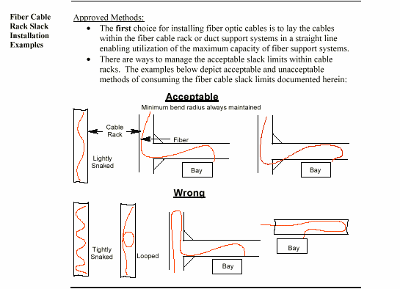

Note: Acceptable fiber cable slack limits within horizontal sections of “Fiber Only Cable” rack or trough systems will be equal to or less than those stated in the following tables.

Maximum Fiber Cable Slack Lengths per Fiber Cable
(Within “Fiber-Only” Cable Racks):
Run Length in Meters | Run Length In  Feet | Maximum Slack  In Feet (Meters)
1-15 | ∼3.3’ to ∼50’ | 2’ (∼.6m)
16-25 | ∼53’ to ∼ 82’ | 3’ (∼.9m)
26-50 | ∼85’ to ∼164’ | 5’ (∼1.5m)
51-75 | ∼167’ to ∼246’ | 7’ (∼2.1m)
> 76 | >∼250’ | 10’ (∼3m)

Maximum Fiber Cable Slack Lengths per Fiber Cable
(Within “Fiber Duct-Type” Cable Racks):
Run Length in Meters | Run Length In  Feet | Maximum Slack  In Feet (Meters)
1-15 | ∼3.3’ to ∼50’ | 1’ (∼.3m)
16-25 | ∼53’ to ∼82’ | 2’ (∼.6m)
26-50 | ∼85’ to ∼164’ | 3’ (∼.9m)
> 51 | >∼167’ | 5’ (∼1.5m)

5.10.5 Cable ties shall not be used for banding or securing fiber optic cables/jumpers.

5.10.6 Metallic type fiber optic cables shall be grounded. Components include protective cable covering, cable sheath and/or any metallic inner strength members.

5.10.7 All 90-degree corners used to route and support fiber cables on “FIBER OPTIC CABLE ONLY” cable racks must be equipped with corner brackets. Fiber cables are routed around the corners using the approved corner brackets.

5.10.8 New cable racks installed to support fiber optic cables must be dedicated for that purpose. Placing intra-office fiber optic cables with copper cables on the same cable rack is strictly prohibited. All new fiber cable racks will be dedicated, segregated orange ladder type (solid stringer only) equipped with orange plastic kydex pan and cable horns. The standard size cable rack for fiber optic cables in 7’ floor-supported systems is 20” (unless specific office conditions, CenturyLink capacity decisions, or CenturyLink Standard Configuration documents dictate otherwise). Fiber optic cables run horizontally on these racks are not secured except where the cable breaks onto or off of the cable rack. At these points, the fiber cable will be wrapped with a layer of sheet fiber paper and secured to the cable rack stringers, or transition bracket while maintaining the minimum bend radius.

5.10.9 Vertical fiber cable rack will be installed using the orange ladder cable rack without the plastic pan and brackets. The vertical fiber cable itself must be manually wrapped with sheet fiber paper and securely tied with 9 ply cord to every cable rack cross strap to secure the cable on vertical runs. Fiber optic inter-office “MIC” type cable will be laid in the orange cable rack unsecured. Existing gray fiber cable rack will not be removed to add the new standard fiber orange cable rack. Adding orange pan to other colors of fiber cable rack is not acceptable. New fiber cables placed on existing gray fiber cable rack will continue to be wrapped with sheet fiber paper and secured to
every fourth cross strap. Orange panned and bracketed fiber cable rack will be used for all new additions. Gray cable rack is not acceptable for new fiber cable rack installations, only for extending existing systems. For additional fiber optic cable requirements, refer to par. 8.17.2 and TP 77351, Chapter 6, Unit G or the CenturyLink Fiber Optic Cable Requirements and Slack Limits Policy document.

5.10.10 Fiber cables transitioning from a horizontal cable rack system must be loosely bundled and secured as close to the top of the vertical 2”X2” multi-slotted fiber duct as possible using the holes on the back of the duct.

5.10.11 End caps are required on the end of all horizontal or vertical sections

5.10.12 Fiber jumpers and cables will be run in either an approved fiber protection system or on dedicated, segregated cable rack per the following guidelines:

Fiber Optic Cable / Jumper Type | Shall be run in a Fiber Protection System | Shall be run on Fiber  Cable Rack
OFN type Fiber Jumpers | Yes | No (Note 1)
OFNR / OFNP Type Fiber Cable: 1 fiber | Yes | Yes (Note 3)
OFNR / OFNP Type Fiber Cable: 2 to12 fibers | Yes  (Note 2) | Yes (Note 3)
OFNR / OFNP Type Fiber Cable: over 12 fibers | No | Yes

Notes:
1. It is recommended that fiber patch cords/jumpers shall not be run commingled with larger type fiber optic cables. The weight of the larger cables has the potential to cause service-disrupting micro bends in the smaller patch cords/jumpers.
2. Small quantities of fiber optic cables (10 cables or less total) containing between 4 – 8 fibers/cable may be run in the fiber duct where existing office conditions prevent the installation of a cable rack system (or where the maximum quantity of 10 cables would not be exceeded).
3. Multiple groups of single or dual OFNR fiber cables may be run on dedicated, segregated panned and bracketed orange fiber-only cable rack when the following criteria is met:
• The small fiber cables are to be bundled together every 5’ to 6’ within the ladder [panned and bracketed] orange cable rack.
• The fiber cables are bundled together by wrapping the fiber cable group with sheet fiber paper and loosely securing with 9 ply cord.
• Care must be taken to ensure that small fiber cable bundles remain undamaged on the cable rack. Where possible, segregate the fiber cable bundles from larger cables within the cable rack and limit instances where large cables cross over smaller cable bundles.

5.10.13 Outside Plant (OSP)-rated fiber cable must be spliced and converted to OFNP or OFNR fiber cable at the cable vault or cable entrance into the CO environment. The OSP-rated fiber cable must be transitioned to low smoke indoor OFNR rated cable within 50 sheathed feet from the OSP cable entering into the network facility from an outside wall to conform to current applicable National Electric Code (NEC) limits and CenturyLink network policy requirements. To support this OSP cable length limitation, an approved FSF device must be placed within the 50 sheathed feet of the OSP cable’s entrance into the network facility through an outside wall. This length limitation includes all rise and run measurements along the cable route to the FSF, including inside the cable vault. Only the use of OSP OFNR or OFNP indoor/outdoor rated transition cable will allow extension beyond the 50 foot rule.

5.10.14

Fiber optic cable trough capacity pileup estimates are as follows (by duct size):

2” x 2” FiberGuide
Duct Pileup in  Inches | Quantity 1.7 mm  Cables | Quantity 2.0 mm  Cables | Quantity 3.0 mm Cables
2 | 480 | 360 | 160

4” x 4” FiberGuide
Duct Pileup in  Inches | Quantity 1.7 mm  Cables | Quantity 2.0 mm  Cables | Quantity 3.0 mm Cables
2 | 960 | 720 | 320
3 | 1440 | 1080 | 480
4 | 1920 | 1440 | 640

4” x 6” FiberGuide
Duct Pileup in  Inches | Quantity 1.7 mm  Cables | Quantity 2.0 mm  Cables | Quantity 3.0 mm Cables
2 | 1440 | 1080 | 480
3 | 2160 | 1620 | 720
4 | 2880 | 2160 | 960

4” x 12” FiberGuide
Duct Pileup in  Inches | Quantity 1.7 mm  Cables | Quantity 2.0 mm  Cables | Quantity 3.0 mm Cables
2 | 2880 | 2160 | 960
3 | 4320 | 3240 | 1440
4 | 5760 | 4320 | 1920

Note: The pileup estimates above are based on the following assumptions:
• Fiber cable quantities listed above are laid straight within the duct to obtain the maximum capacity available.
• Fiber cables are singles or small “duals” only.
• These estimates apply only to horizontal sections of fiber duct.
• All fiber cables placed in the trough are the size indicated.

5.11 Ribbon Cable
Some Fiber Optic Ribbon type cables can be run on dedicated fiber cable rack. For detailed specifications on fiber optic cable approved for use within central offices and buildings, contact the CenturyLink representative for fiber cable standards or technology selection. All other fiber ribbon cables shall be placed in dedicated cableways and labeled for fiber optic ribbon cables only.

5.12 Repair of Damaged Cables
5.12.1 Damaged outer jackets of Polyvinyl Chloride (PVC) covered cables shall be repaired with electrical tape. The tape shall be applied in two half-lapped layers with the final two wraps applied without tension and overlapping. The tape shall extend a minimum of two inches past the damaged section.

5.12.2 Seriously damaged sections of outer jackets of PVC covered cables shall be repaired by removing the damaged section and replacing it with the covering from a similar cable. Apply a single half-lapped layer of electrical tape over the new section, extending two inches either side of the repaired section, to secure it in place.

5.12.3 Damaged outer jackets of power cable shall be repaired with an insulation equivalent to that of the original insulation or with an insulating device identified for the purpose. Heat shrink tubing and/or electrical tape are approved for this use.

5.12.4 A run of cable shall be replaced if the number of damaged conductors exceeds five percent of total conductors. For fiber cables the maximum number of damaged conductors cannot exceed 12 fibers out of a 72-fiber cable.

5.12.5 Repair of damaged fiber cables must be evaluated (for loss characteristics) and approved by the PEG Representative responsible for fiber cable standards prior to installation.

5.13 Spliced Cables, Splicing Systems, and Mated Connectable Cables
5.13.1 Multi-conductor cable shall be rerun if the number of spliced conductors exceeds five percent of the conductors in the cable. Under certain conditions, this requirement may be deviated from with permission of the CenturyLink Design Engineer or the use of an approved cable splicing system. A LOD shall be required and the reason for not rerunning the cable shall be documented in the job log.

5.13.2 Splicing of any type of cables shall be kept to a minimum and, if required, shall be done at the equipment shelf or approved splice shelf. All splices shall be protected.

5.13.3 Mating of connectable cables shall be kept to a minimum and if required shall be done at the equipment shelf. Connectors shall only appear in the vertical upright. Connectors shall only appear in the vertical upright of frames, bays or cabinets when specified in the PEG Standard Configuration.

5.13.4 Mated connectable cables shall be mated and secured by using twine, tie wraps, hook and loop systems, screws, spring clips, clear heat shrink, etc.

5.13.5 Spliced or mated cables shall be protected, designated (location, type, functionality), and be accessible for maintenance. Splices or mated cables that are stored in cableways, or dispersed throughout the equipment facility shall require a “Master Location List” (RG47-0156). The “Master Location List”, shall show all splice number, splice locations, splice type, and functionality of the spliced circuit. The “Master Location List” shall reside at the same facility and be available to those with a need for the information. Splice locations shall also be designated to show exact location of the splice. Designations shall be visible from the floor, and are require a minimum designation of a Master Location List reference number. Splice connections shall have sufficient slack at the splice point for maintenance. Splicing fiber optic cables are only permitted within approved splice shelves.

5.13.6 Protective covers or caps shall be installed on unused connectors to protect contacts from mechanical or ESD damage.

5.14 Use of Nylon and Plastic Cable Ties
5.14.1 Cable ties are not approved for securing or banding of cables in cable racks or securing fiber optic cables and jumpers.

5.14.2 Cable ties used for banding and securing of cable, PVC protection etc. shall be of an adequate size, type, strength, etc. for the particular application. Tightening cable ties to the point of damaging the cable is strictly prohibited.

5.14.3 Cable ties shall be trimmed at the locking head with a flush cutting device that provides automatic tensioning.

5.14.4 Under no circumstances shall cable ties have sharp or jagged cut ends protruding from the locking head. A cable tie is considered to have sharp or jagged ends when it is sharp to the touch.

5.14.5 The locking head of reusable cable ties shall be positioned so as not to interfere with the installation or removal of apparatus or equipment

5.14.6 Reusable cable tie tails shall be positioned so as not to present a personnel hazard.

5.14.7 When superimposing additional cable or wire to forms, existing cable ties shall be removed where the heads of tie wraps interfere with additional cable or wires.

5.14.8 Where cable or wire forms are secured to cable securing brackets, the locking head of the cable tie shall be positioned on the side of the bracket opposite the side on which the cables or wires are run.

5.14.9 Nylon ties shall not be used at any location on the MDF, CDF SDDF, COSMIC or any other type of Distribution Frame.

5.14.11 Approved Cable Tie Applications

5.14.11.1 Banding together of cables after the cables break off the cable rack or other similar banding operations.

5.14.11.2 Banding together of cables or power wire including flexible cordage and soft rubber cables with the use of protection.

5.14.12.3 For power cable strain relief ties.

5.14.13.4 For banding together armored cables.

5.14.14.5 The securing of power, ground, and armored cable to cable brackets and other similar-type wire supporting details in power equipment bays.

5.14.15.6 The securing of ground cable to the stringers of cable rack and auxiliary framing bars.

5.15 Securing Tables

Sewing Horizontal Resting Runs On
Dedicated Power and Switchboard Cable Racks

Size of Wire | Sew at Strap | No. of Twine  Strands | Ultimate No. of Layers | Cables per  Stitch
400 kcmil or  Larger | Every 4th | 4 | Any Number  Note 1 | 2
250-374 kcmil | Every 4th | 2 | Any Number  Note 1 | 2
4/0 and Smaller | Every 4th | 2 | Any Number  Note 1 | 4
Switchboard  Cable | Every 6th | 2 | Any Number  Note 1 | 6  Note 2
Fiber Optic  Cable  (OFNR) | Every 4th | 2 | Any Number  Note 1 | Note 3  (Refer also to  Par. 5.10.13)

Sewing Vertical Or Inverted Horizontal Runs
On Dedicated Power and Switchboard Cable Racks

Size of Wire | Sew at Strap | Number of  Twine Strands | Ultimate  Number of  Layers | Cables per  Stitch
250 kcmil or  Larger | Every Strap | 4 | Note 1 | 1
4/0 - #4 | Every Strap | 2 | Note 1 | 2
#6 and Smaller | Every Strap | 2 | Note 1 | Note 2
Switchboard  Cable | Alternate Strap | 2 | Note 1 | 4  Note 2
Fiber Optic  Cable (Refer to Note 1 below) | Every Strap | 2 | Any Number  Note 1 | Note 3  (Refer also to Par. 5.10.9)

Note: The following types of fiber optic cable ratings are included in these securing requirements:
- OFNP
- OFNR
- I/O OFNP
- I/O OFNR
- OSP-rated (where permitted to be run on cable rack).

Sewing on Horizontal Runs of Cable Hangers
Cable Hangers Spaced at 18” Intervals

Size of Wire | Sew at Strap | Number of  Twine Strands | Ultimate  Number of  Layers | Cables per  Stitch
250 kcmil or larger | Every Hanger | 2 | Note 1 | 1
4/0 and smaller | Every Hanger | 2 | Note 1 | 2  Note 2

Notes:

1. Limited by Par. 5.8.6, “Cable Pile-up,” requirements.

2. Cables under a single stitch shall not exceed two square inches.

3. Quantities of single fibers (1 - 12) can be loosely secured together provided they do not exceed 1 square inch per stitch. Fiber optic cables containing between 24 – 72 fibers will be secured at 2 cables per stitch.

5.16 Cable Securing Figures

DOUBLE A LENGTH
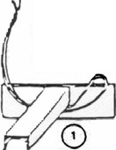

OF TWINE.
EVEN UP ENOS AND PASS LOOP UNDER THE STRAP.
PLACE FREE ENOS
THROUGH LOOP.

Figure 5-1 Starting Stitch
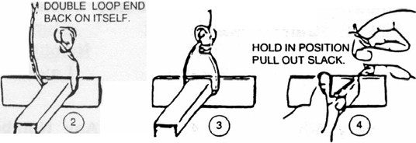

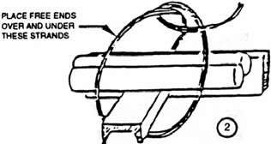

PlACE I'AU ENOS
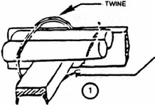

UNDEASTIW'

COMPLETED STI TCH
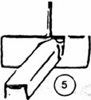

TIGHTEN STITCH BY PUWNG TO THE RIGHT & DRAWING LOOP TO TOP
FRONT EDGE OF CABLE. REMOVE SLACK & TIGHTEN STITCH WITH A STEADY EVEN PULL.
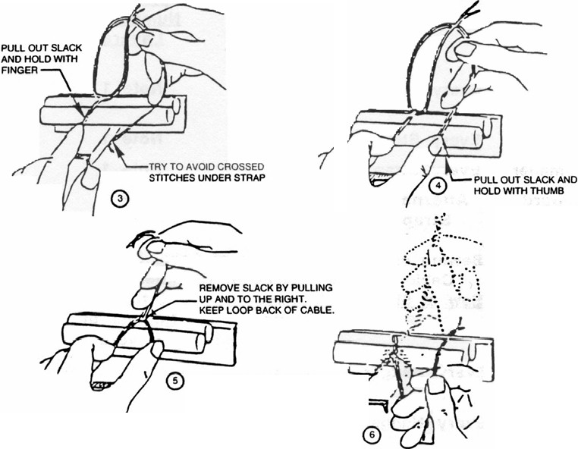

Figure 5-2 Kansas City Stitch

KEEP STrTCHES STRAIGHT
'-·
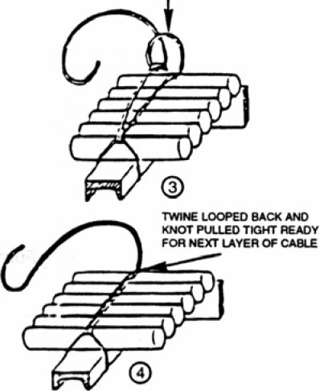

WrTH I<NOT 11EADY
TO BE PUu.ED TlGHT.

//
\
,
:
i

l
'\,9.01 1

Figure 5-3 Sewing First Layer
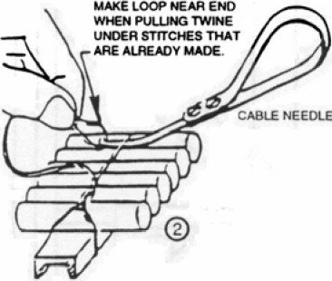

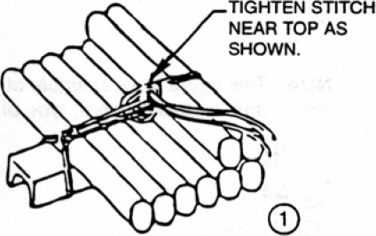
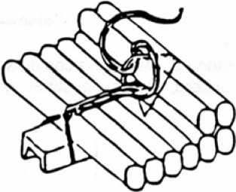

Figure 5-4 Sewing Second Layer

1/8" x 1" Steel Bar, Ends Roundeo--+-+-- -,. and Deburred.

Furnished by Installer.

Simple Stitching For Securing Bar to Cable Rack

Cable--

Note: This figure is an example of one method of preventing cable sag. Thickness of bar is
"minimum". Location of bar, type of twine or cord, and type of stitching is discretionary.
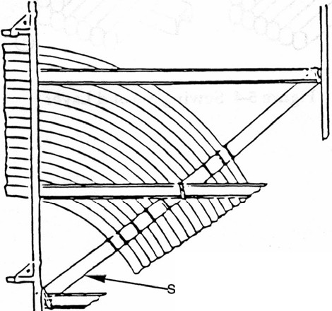

trap Iron Support 1/8" X 1"

Figure 5-5 Supporting and Sewing Cables to Supports at Turns

LOCK ON "KANSAS CITY" STITICH
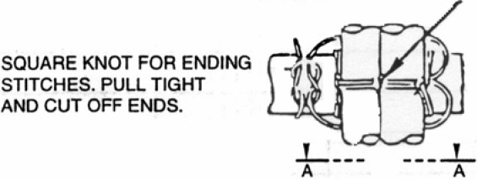

STARTING LOOP PLACED AROUND FORM 7 BRACKET. SIMILAR TO THE STARTING LOOP FOR A REGULAR CHICAGO STITCH

SECT AA
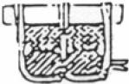

STARTING HAWTHORNE KNOT FOR STITCH ENDING STITCHES.PULL
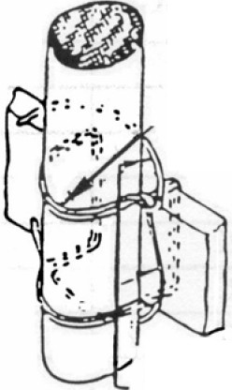

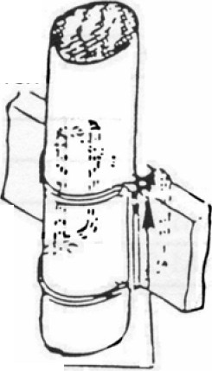

PASS EACH END COMPLETELY
AROUND IN OPPOSITE
DIRECTIONS AND END

TIGHT AND CUT OFF ENDS.

SECURING CABLE TO SUPPORT WITH KANSAS CITY STITCH
WITH A SQUARE KNOT

SECURING CABLE TO SUPPORT WITH CHICAGO STITCH

'

Figure 5-6 Securing Cable to Support with Kansas City Stitch

LOCATE SPLICE SO IT WILL NOT INTERFERE WITH THE MAKING OF STITCHES

. ...-NEW TWINE LOOPED
1

PASS ENDS OF OLD TWINE THRU LOOP OF NEW TWINE

CUT OFF ENDS . \
CLOSE TO KNOT '. 4
&i

Figure 5-7 Splice

WHEN PASSING lWlNE BETWEEN CASLES lEAVE ENOUGH SLACK
ON BOnt SIDES SO AS TO MAKE ITLONG ENOUGH TO GRASP THE lWlNE WHILE TIGHTENING THE STITCH
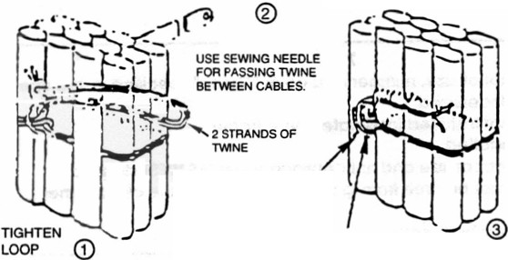

®
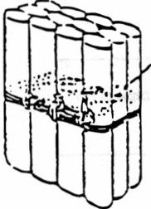

TIE WITH DOUBLE KNOT AND CVT OFF ENOS TO 1/4"

IN EACH CASE PULL OUT SLACK BEFORE STARTING NEXT STITCH
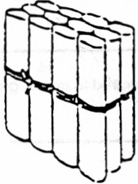



SECOND STITCH
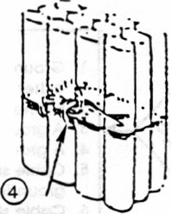

VIEW OF COMPLETED CHICAGO STITCH
STITCH CABLES

Figure 5-8: Chicago Stitch Used to Sew Cables Together

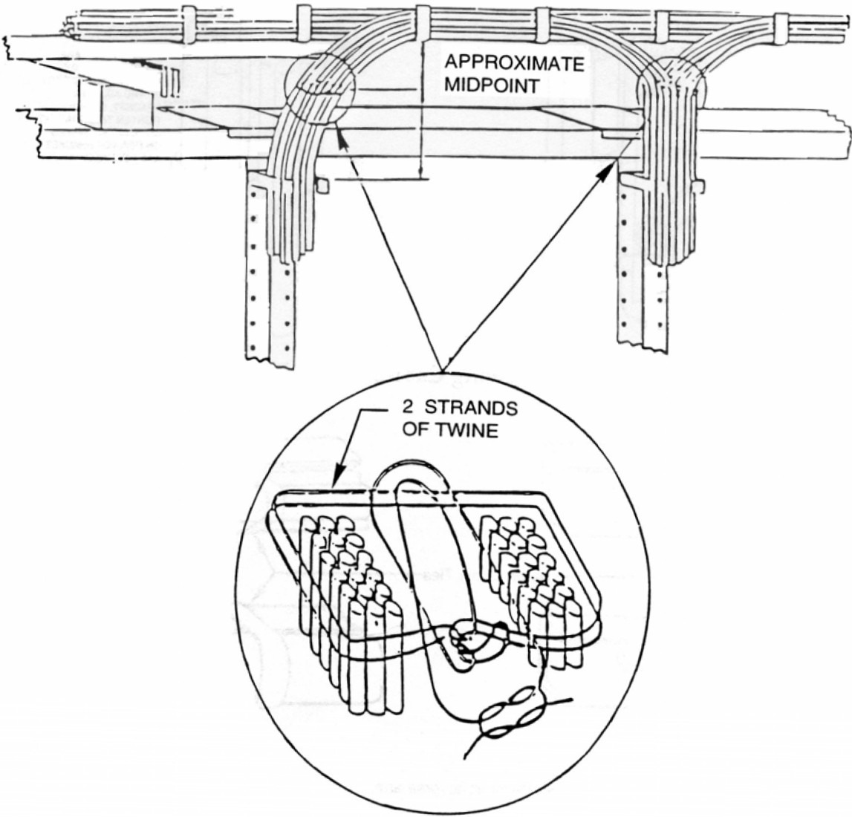

Figure 5-9: Banding of Cables with Twine

