

**CenturyLink EASE ASR**

**Pre-Order**

Version notice

History

All versions of this document are listed in chronological order.

|  |  |  |
| --- | --- | --- |
| Version | Date | Description |
| 0.1 | February 2016 | Initial Document Creation |
| 1.0 | March 7, 2016 | Final |
| 2.0 | January 6, 2017 | Draft |
|  |  |  |
|  |  |  |
|  |  |  |
|  |  |  |
|  |  |  |
|  |  |  |
|  |  |  |
|  |  |  |
|  |  |  |

Important: This document has been through a formal review process. To the best of our knowledge, it is accurate. CenturyLink Communications, Inc. reserves the right to make further modifications when necessary.

Table of Contents

ASR Pre-Order 3

Log In 3

EASE CFA Inquiry 4

EASE CLLI Inquiry 7

EASE Location Inquiry 10

Search Function 14

NC NCI Inquiry Guideline External App 15

Purpose 15

External App Data NC / NCI Inquiry 15

Acronyms 17

# ASR Pre-Order

### Log In

To access the Pre-Order tool, log into EASE using your established credentials. The URL for EASE is: <http://ease.centurylink.com/ease.jsp>

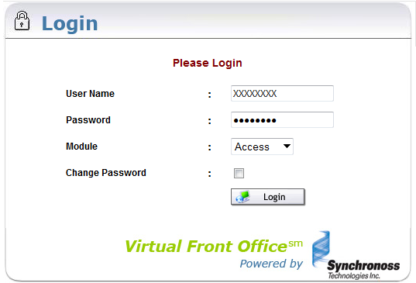

Upon successful log in, select the Pre-Order Tab from the menu bar. The options available are New and Search.

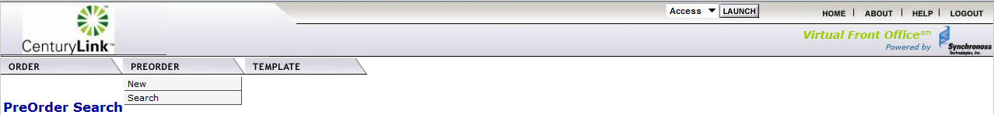

# EASE CFA Inquiry

CFA Inquiry can be executed within EASE for Pre-Order.

1. Select New from the Pre-Order Tab

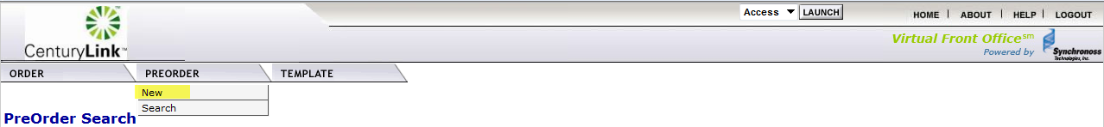

1. A new page will display. To execute a CFA inquiry, complete the following fields:
   1. Message ID – The system will pre-populate this field with a numeric value. The user can override this information to better track their inquiries. Example: TEST001
   2. Receiver Code – Select the ICSC region associated with where the CFA is located
   3. Service Type – Select CFA Inquiry
   4. Initiate

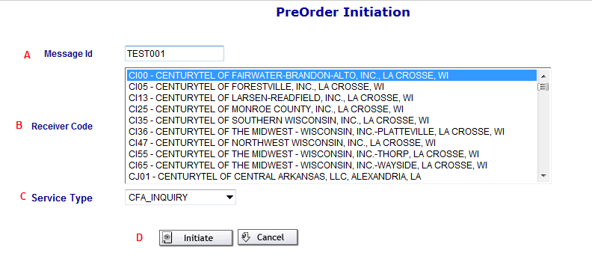

1. A new page will display with the fields of ASR Inquiry Additonal Header and Channel Facility Assignment. All fields on this screen are mandatory
   1. ASR Inquiry Additional Header
      1. Message ID will pre-populate from the initiation screen
      2. CCNA – Enter the CCNA in all CAPS
      3. ICSC will be pre-populated from the initiation screen
      4. State – Enter the 2 digit state abbreviation
   2. LOAI
      1. Select “Y” if you have an LOA (optional)
      2. Enter the LOA CCNA (mandatory if “Y” is selected
   3. Channel Facility Assignment
      1. FACDESG identifies the facility designator
      2. FACTYPE identifies the facility type
      3. CHANNEL identifies the channel and may be populated with the entire range of facility such as 1-24 for a T1 or 1-28 for a T3
      4. LOCA identifies the A location of the CFA
      5. LOCZ identifies the Z location of the CFA
   4. Submit

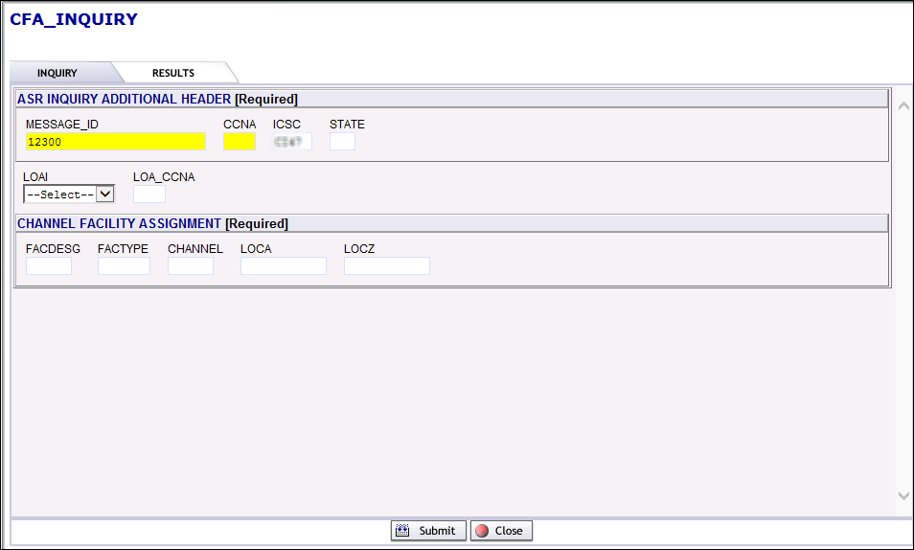

1. Based on the information entered on the CFA Inquiry tab, the system will execute the request and provide a response upon submission
   1. The CFA response results will display in the IRM field
      1. Busy – The CFA informtion entered has been executed and the slot is busy
         1. When the CFA channel is busy, the system will return the circuit information for the channel being validated. You will either see the ECCKT ID of the circuit, or “Viewing Restricted to Facility Owner” if the CFA belongs to another customer
      2. Vacant – The CFA information entered has been executed and the slot is vacant and available for reservation
      3. Requested Information not found – The CFA information is not found using the information provided
      4. CFA Validation Error – the CFA information entered is not valid
2. User is able to Save / Print / Close / Change the Response page.

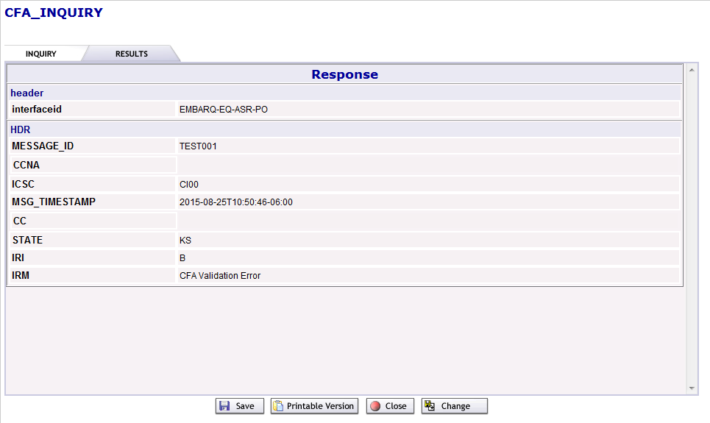

# EASE CLLI Inquiry

CLLI Inquiry can be executed within EASE for Pre-Order.

1. Select New from the Pre-Order Tab



1. A new page will display. To execute a CLLI inquiry, complete the following fields:
   1. Message ID – The system will pre-populate this field with a numeric value. The user can override this information to better track their inquiries. Example: TEST001
   2. Receiver Code – Select a Receiver Code, which will generate the ICSC on the inquiry screen
   3. Service Type – Select CLLI_SCAN_INQUIRY
   4. Initiate

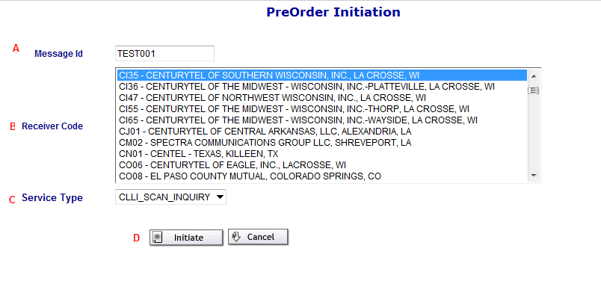

1. A new page will display with the fields of ASR Inquiry Additonal Header and CLLI.
   1. ASR Inquiry Additional Header
      1. Message ID will pre-populate from the initiation screen
      2. CCNA – Enter the CCNA in all CAPS
      3. ICSC will be pre-populated from the initiation screen
      4. State – Enter the 2 digit state abbreviation; not required to initiate search
   2. CLLI
      1. LOCA – Enter the CLLI for Location A
      2. LOCZ – Enter the CLLI for Location Z
   3. Submit

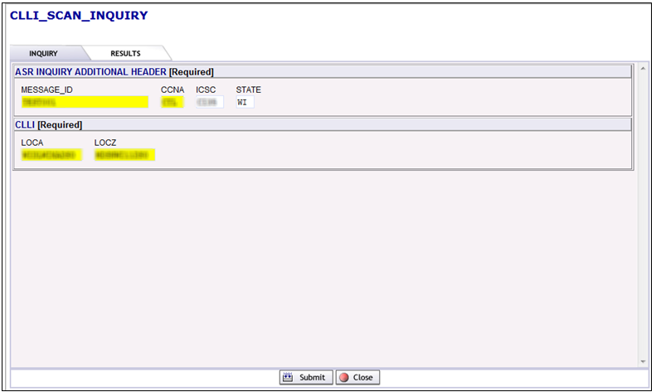

1. Based on the information entered on the CLLI Inquiry tab, the system will execute the request and provide a response upon submission
   1. The CLLI response results will display in the IRM field
      1. Validated – the CLLI information will list the circuits using those two CLLIs
      2. Available – The CLLI information will result in a response within the IRM field stating Channel Available
      3. Requested Information Not Found – The CLLI information will result in a response within the IRM field stating: Result: The input is not valid or CLLI belongs to a different company.
      4. Service Not Available – The CLLI informtion will result in a response within the IRM field stating: Service is not available for this Receiver Code.
2. User is able to Save / Close / Change the Response page.

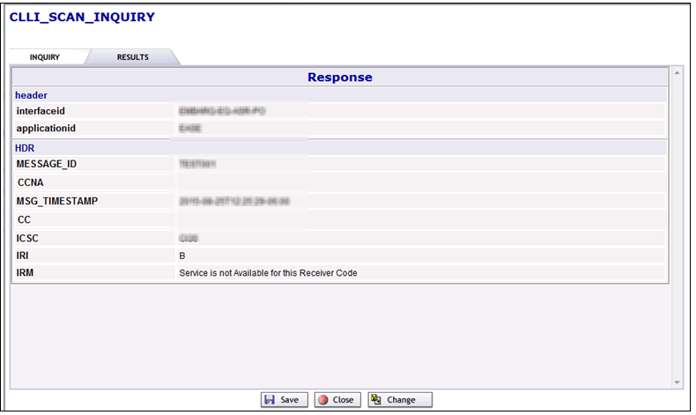

# EASE Location Inquiry

Address validation can be executed within EASE for Pre-Order and also within EASE for ASR on the Transport, or EUSA page.

1. Select New from the Pre-Order Tab



1. A new page will display. To execute a Location inquiry, complete the following fields:
   1. Message ID – The system will pre-populate this field with a numeric value. The user can override this information to better track their inquiries. Example: TEST001
   2. Receiver Code – Select the ICSC region associated with where the address is located
   3. Service Type – Select Location_Inquiry
   4. Initiate

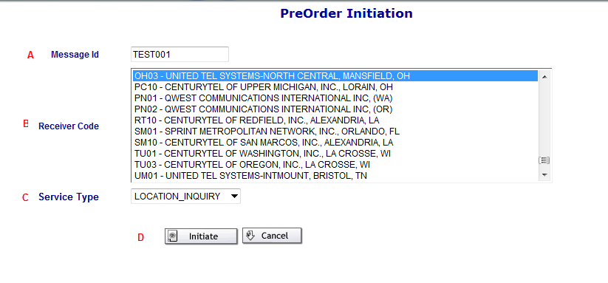

1. A new page will display with the required fields of ASR Inquiry Additonal Header, Address Detail, Working Telephone Inquiry, Working Circuit Inquiry
2. ASR Inquiry Additional Header
   * 1. Message ID will pre-populate from the initiation screen
     2. CCNA must be entered in all CAPS
     3. ICSC will be pre-populated from the initiation screen
     4. State - Enter the 2 digit state abbreviation
3. Address Detail (Required)
4. AFT identifies the format of the address being supplied. Valid entries:
   * + 1. A = Rural Route and/or box number
       2. B = Unnumbered
       3. C = Provider Assigned house number
       4. D = Descriptive
       5. E = Provisioning Adddress
5. SAPR identifies the prefix for the address number of the service address
6. SANO identifies the number of the service address
7. SASF identifies the suffix for the address number of the service address
8. SASD identifies the street directional prefix for the service address. Valid entries:
   1. E = East
   2. W= West
   3. N = North
   4. S = South
   5. NE = Northest
   6. NW = Northwest
   7. SE = Southeast
   8. SW = Southwest
9. SASN identifies the street name of the service address
10. SATH identifies the thoroughfare portion of the service address, such as LN (lane) or BLVD (boulevard)
11. SASS identifies the street directional suffix for the service address. Valid entries are shown below. NOTE: This is not the same as DIR and the two cannot be used interchangeably in the address validation for ASR.
    1. E = East
    2. W= West
    3. N = North
    4. S = South
    5. NE = Northest
    6. NW = Northwest
    7. SE = Southeast
    8. SW = Southwest
12. LD1, LD2, LD3 identifies additional specific information related to the address. Valid entries:
    1. UNIT
    2. ROOM
    3. APT
    4. RM
    5. STE
    6. FL
    7. FLR
    8. BLDG
    9. COMP
13. LV1, LV2, LV3 identifies the value associated with the location designator
14. City identifies the city, village, or township
15. State identifies the abbreviation for the state or province
16. Zip identifies the ZIP or postal code
17. Working Telephone Number Inquiry is currently not available
18. Working Circuit Inquiry
    1. WKCID identifies the working circuit ID in a serialized formt associatd with the request and is 27 alpha/numeric characters. The WKCID must been paired with SWC or the NPANXX to return results
    2. SWC identifies the service wire center CLLI Code associated with this request and is 8 or 11 alpha/numeric characters
    3. NPA/NXX is associated with the location inquiry and is 6 numeric characters

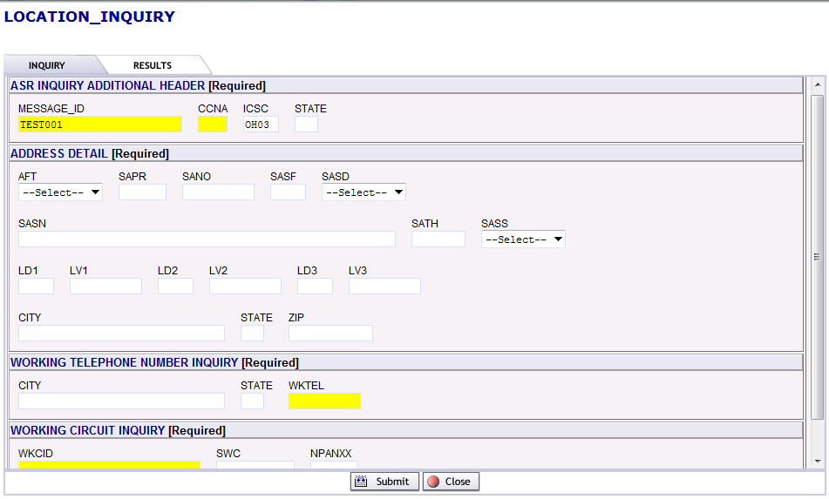

1. Based on the information entered on the Location Inquiry tab, the system will execute the request and provide a response upon submission
   1. The Location response results will display in the IRM field
      1. Exact match – the address information entered was executed successfully
      2. Alternatives exist – there are multiple addresses that meet the criteria entered. User shall review for the correct address, change the criteria and revalidate.
      3. No CenturyLink address found for this address

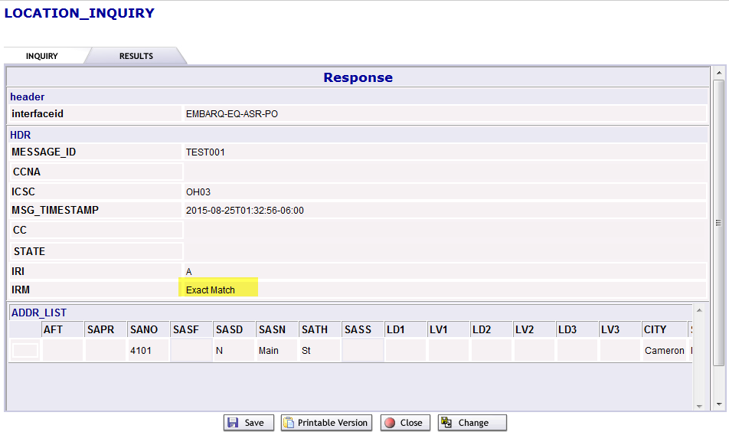

1. User is able to Save / Print / Close / Change the Response page.

Note: Complex Address inquires may be entered using the location designator fields.

# Search Function

To search for previous pre-order inquiries, populate the fields with the search criteria and select the Go button. It will return all pre-order inquiries matching the search criteria entered.

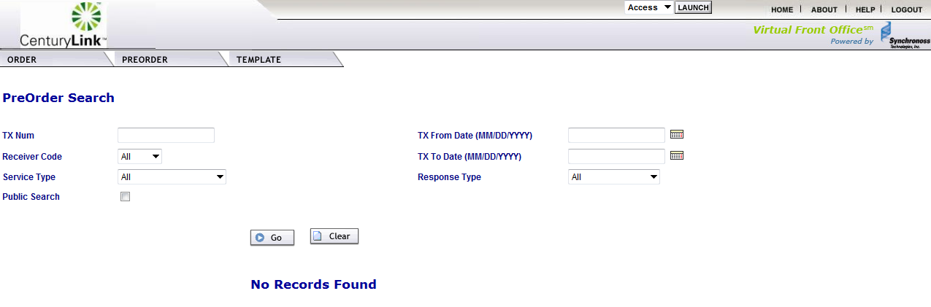

* TX Num – enter the Message ID that initial Inquiry & Response saved. Wildcard searches can be performed using the % symbol
* Receiver Code – Select the ICSC code from the drop down menu
* Service Type – Select location inquiry from the drop down menu
* Public Search – If checked, it will search for all the pre-orders, not limited to the user ID. If not checked, it will limit the search to only the user ID.
* TX From Date (MM/DD/YYYY) – Enter the begin date or click the calendar to select the begin date for the date range search
* TX To Date (MM/DD/YYYY) – Enter the end date or click the calendar to select the end date for the date range search
* Response Type – select the response required from the drop down menu

Note: Clicking the Clear button will erase al the search criteria entered and returns the fields to the original state with the default values displayed as applicable.

# NC NCI Inquiry Guideline External App

### Purpose

External App Data provides a method to validate key information to enter accurate information for an Access Service Request (ASR) within VFO. This is a connection from within EASE VFO to the external Reference Table Maintenance Utility.

### External App Data NC / NCI Inquiry

To validate CenturyLink ***specific*** NC/NCI codes, access the External App Data menu item from the ORDER drop down menu and select NcNciInquiry.

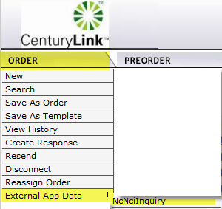

You will be presented with a new page “Welcome to Reference Table Maintenance Utility”.

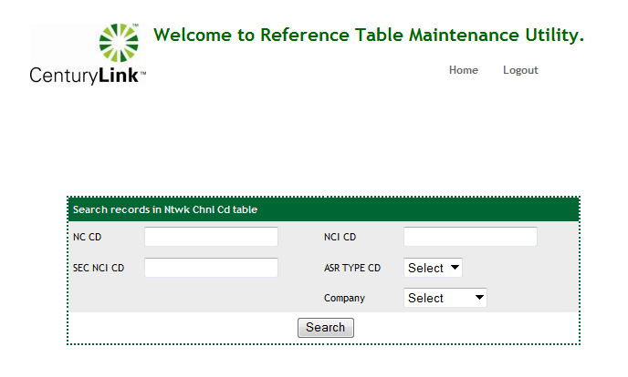

1. NC CD: Identifies Network Channel (NC) code
   1. Enter the NC code to search:
      * Valid entries: Full NC code,
      * System will display list of valid NC codes with associated NCI CD, SEC NCI ID, and ASR Type for entry into VFO order.
2. NCI CD: Identifies Network Channel Interface code
   1. Enter the NCI code to search:
      * Valid entries: Full NCI code
      * System will display list of valid NCI codes with associated NC CD, SEC NCI CD, and ASR Type for entry into VFO order.
3. SEC NCI CD: Identifies secondary NCI code
   1. Enter the NCI and SEC NCI code to search:
      * Valid entries: SEC NCI Codes; for best results enter NC/NCI/SEC NCI fields
      * System will display list of valid NC/NCI/SEC NCI codes with associated criteria
4. ASR Type CD: Identifies associated ASR Reqtype for NC/NCI code
   1. Enter the ASR type code to search:
      * Valid entries: ASR Reqtype code; example: Reqtype SD
      * System will display list of valid ASR Types for associated NC CD, NCI CD and SEC NCI CD for entry into VFO order
5. Company: Identifies associated NC/NCI/SEC NCI Company
   1. Enter the company name to search:
      * Valid entries: CenturyLink or Qwest
6. Click the search button to intiate the request.

# Acronyms

|  |  |
| --- | --- |
| Acronym | Definition |
| AFT | Address Format Type |
| ASR | Access Service Request |
| CCNA | Customer Carrier Name Abbreviation |
| CFA | Connecting/Channel Facility Assignment |
| CLLI | Common Language Location Identifier |
| EASE | Electronic Administration & Service Order Exchange |
| ECCKT | Exchange Company Circuit |
| FACTYPE | Facility Type |
| FACDESG | Facility Designator |
| ICSC | Interexchange Customer Service Center |
| IRM | Information Request Message |
| LD1 | Location Designator 1 |
| LD2 | Location Designator 2 |
| LD3 | Location Designator 3 |
| LV1 | Location Value 1 |
| LV2 | Location Value 2 |
| LV3 | Location Value 3 |
| LOCA | Location A |
| LOCZ | Location Z |
| SANO | Service Address Number |
| SAPR | Service Address Number Prefix |
| SASD | Street Directional Prefix |
| SASN | Service Address Street Name |
| SATH | Street Type |
| SASS | Street Directional Suffix |
| SWC | Serving Wire Center |
| WKCID | Working Circuit ID |