EASE VFO ASR
Training

February 3, 2017

The information provided herein is for training purposes only. The information
provided does not create or modify any legal obligations between CenturyLink and a
Customer. The parties’ relationship is governed by existing legal obligations.

Table of Contents
Course Description 5
Prerequisites 5
Course Objectives 5
EASE Overview 6
What is EASE? 6
EASE Virtual Front Office (VFO) 6
EASE Virtual Front Office (VFO) Continued 7
VFO Log In 7
EASE Navigation 8
Access 8
Order List 9
Default Screen 9
Order Status ICONs 11
Status Column 12
VFO Function ICONs 13
VFO Tabs 14
Order Tab 15
PreOrder Tab 16
Template Tab 16
VFO Data Search 17
Order Tab Search 17
Order History 18
PreOrder Search 19
Template Search 19
VFO PreOrder 21
VFO PreOrder New 22
Location Inquiry 23
CFA Inquiry 25
CLLI SCAN Inquiry 26
PreOrder Success 28
PreOrder is not Successful 28
VFO PreOrder Search 29
VFO Ordering 31
VFO Order Template Creation 32
VFO Order Template Search, Modify, Delete 34
VFO Order Replication 36
VFO Order Entry 38
Ordering Options – Resend 42
Ordering Options – View 43
VFO Order Validation 43
VFO Error Identification and Correction 44
VFO Order Submission 46
VFO Order Submission D/N Related Orders 47
Supplementing Orders 47
Supplemental Order - Cancel 48
Supplemental Order – Change Due Date 48
Supplemental Order – Other 49
Acronyms 50
Appendix 1 - EASE VFO ICON List 51
Appendix 2 - EASE VFO Order Status List 52
Appendix 3 – IRM Responses for Addresses 59
Appendix 4 – IRM Responses for CFA 60
Appendix 5 – Address Details 61
Appendix 6 – EASE VFO Order Types 62
Appendix 7 – EASE Helpful Hints for CORA Users 65

Course Description
This instructor facilitated web-based course is designed to provide an overview of ASR ordering in CenturyLink’s Electronic Administration & Service Order Exchange (EASE) Virtual Front Office. In addition, it provides a review of pre-order functions, the EASE external application, and the EASE Maintenance Utility Guideline. This guide is meant for a generic order representation only. The ASOG and custom business rules should be referenced for specific guidelines in the population of fields for specific order submission.

Prerequisites
The attendee should have a working knowledge of the ASR ordering process.

Course Objectives
Upon completion of this course, you will be able to:
- Log on
- Navigate
- PreOrder CenturyLink addresses and Connecting Facility Assignments (CFAs) for ASR
- Initiate and submit ASRs
- Initiate supplement orders
- Create order templates
- Track pending and completed orders
- View pertinent ASR information such as Firm Order Confirmations (FOCs), Clarification Notifications, Jeopardies, Completions, and Design Layout Requests (DLRs)

EASE Overview

What is EASE?
Electronic Administration & Service Order Exchange (EASE) is used for order initiation, submission, and tracking. It is a Web-based application that is made to enhance the overall process of ordering Wholesale services from CenturyLink.
EASE is the order entry application that is used by CenturyLink Wholesale customers to initiate, submit, and track Access Service Requests (ASRs) for Switched Access, Special Access, CLEC Interconnection, and Wireless Interconnection services.

EASE Virtual Front Office (VFO)

Virtual Front Office (VFO) is the Web-based EASE application that provides a gateway for external CenturyLink Wholesale customers to submit Access Service Requests (ASRs) to CenturyLink. VFO provides easy access to all of the industry standard ASR forms and allows the user to initiate, submit, and track Access Service Requests (ASRs).
Orders submitted to CenturyLink can be tracked in VFO.
ASRs can be submitted to CenturyLink:
- Directly via online access to VFO
- By batch—customers can continue to submit batch orders just as they do today and those batch orders are tracked in VFO
- By UOM (Universal Ordering Module)
- By paper—all paper orders received by CenturyLink are entered into VFO

EASE Virtual Front Office (VFO) Continued
EASE Virtual Front Office (VFO) provides you with:
- Online ASR ordering
- Industry standard ASR forms and fields
- PreOrder of CenturyLink addresses
- PreOrder of Connecting Facility Assignments (CFA)
- Up front order editing
- Easy to understand error messages
- Simplified order status indicators
- Search functionality
- Order replication and template creation

VFO Log In

EASE VFO users must obtain a Log In ID and password in order to access EASE VFO. CenturyLink Wholesale customers may contact their CenturyLink Account manager for additional information regarding VFO access and pre-coordination of orders.
Use the following URL to access EASE VFO: http://ease.centurylink.com/vfo_asr.jsp

EASE Navigation

Access
Once logged in to EASE VFO there are tabs, menus, ICONs and status indicators to assist with managing and initiating orders. External CenturyLink customers who need online access to submit ASRs must obtain a VFO ID and password in order to submit and track orders. Any customer with online access can submit and track orders in VFO once an ID and password are obtained.
Click the EASE VFO link provided. Enter the user name and password, then click the login button.
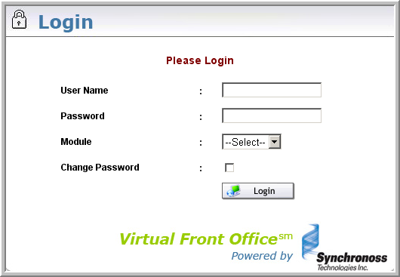
Upon successful log in, select the VFO tab, then the ASR tab
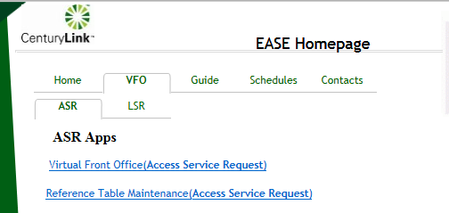

The user is presented with the Order List screen upon selecting the Virtual Front Office (Access Service Request) link.
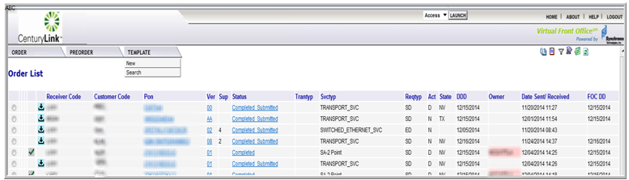

Order List

Once logged on to EASE VFO, the Order List displays and there are three tabs—Order, PreOrder, and Template—that contain drop-down menus. In EASE VFO, there are also picture ICONs at the top right that perform specific functions. The Order List displays how many orders are in the list and how many pages there are.
External Wholesale customers only see orders belonging to them.

Default Screen

Below is the Order List default screen that displays for ASR once logged on to EASE VFO. The user can return to this screen at any time by clicking the Home link at the top right of the screen.
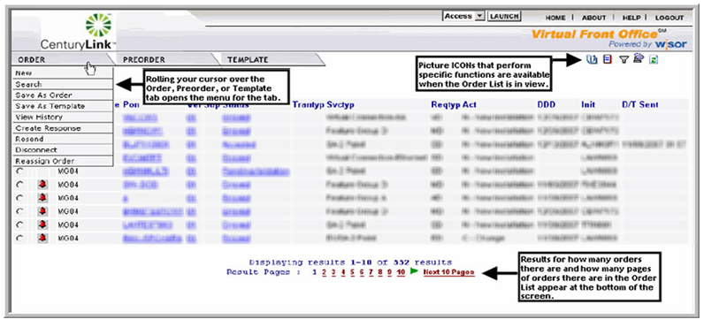
Rolling the cursor over the Order, PreOrder or Template tab opens the menu for that tab.
ICONs that perform specific functions are available when the order list is in view.
Results for how many orders there are and how many pages of orders there are in the Order List appear at the bottom of the screen.
The EASE VFO Order List presents orders with the most recent updates at the top of the list. Each column may be sorted by clicking the column header. Search functionality is also available to help sort through orders and is discussed later in this training.

Order Status ICONs

The column to the right of the PON displays order status ICONs that assist with identifying the current status of an order.
For a list of all order status ICONs that may display, please view the EASE VFO ICONs List in Appendix 1.
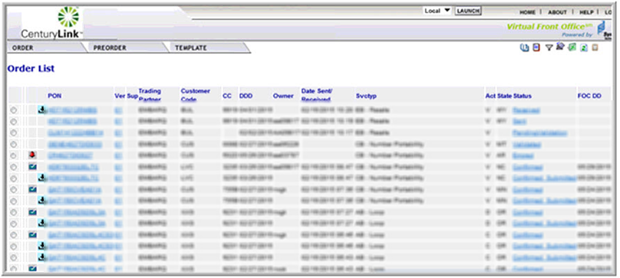

Status Column

The Status column on the VFO Order List of EASE shows the current status of an order from the Order List—for example, Errored, Accepted, or Confirmed. The user can view the current status of the order by clicking the status listed in the Status column; however, only the current status can be viewed this way—for example, if the order is in Confirmed status, clicking Confirmed in the Status column displays the Confirmation information.
Jeopardies, Confirmations, and other statuses can also be viewed by looking at the history of the order. Looking at order history is discussed in greater detail later in this training.
For a list of all available statuses and necessary actions, please view the EASE VFO Order Status List in Appendix 2.
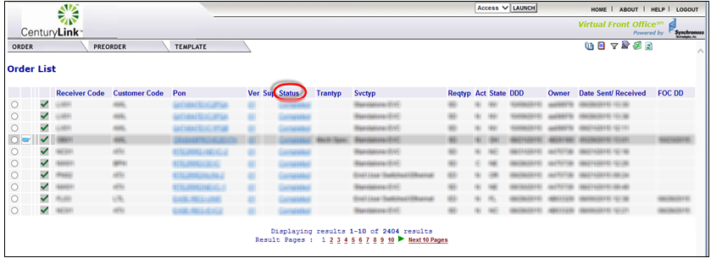

VFO Function ICONs
There are picture ICONs that perform specific functions at the top right of the screen when the Order List is in view: History, Create Response, Filter, Return to Default Sort, Export to Excel and Refresh. Each of these ICONS performs a specific function. Some of these ICONs require an order to be selected from the Order List in order for the function to be performed.

The History ICON provides a detailed history of an order selected from the Order List. This is where the history of an order can be viewed including Errored, Confirmed, Clarification, Jeopardy, DLR/Design, Completed, etc.

The Create Response ICON allows the user to create a manual response such as a Jeopardy or Clarification for an order selected from the Order List. This function is performed by internal CenturyLink employees to notify external customers of order issues. Once a manual response is created, it can be viewed by looking at the history of an order.

The Filter ICON provides a way to filter orders from the Order List. Clicking this ICON prompts another screen to come up and allows the user to add filter criteria. Once the Order List is filtered, it must be cleared to return the Order List to the default view.

The Return to Default Sort ICON allows the user to return the Order List to the default sort order after it has been sorted by a column in the Order List. Filtering and sorting are different. The Return to Default Sort ICON is not to be used to clear a filter. Clearing a filter requires clicking the Filter ICON again, clicking Clear, and clicking OK as shown in the filtering simulation.

The Export to Excel ICON exports an order selected from the Order List into an Excel document.

The Refresh ICON refreshes the Order List to show the latest order activities including new orders and updates to existing orders. The Refresh ICON is not used to clear a filter or a sort, but only to update the Order List to show the most recently updated orders.

VFO Tabs
The Order, PreOrder, and Template tabs all have menus that are accessible by rolling the cursor over the tab heading. Some of the drop-down menu options require that the Radio button in the first column on the Order List be selected and other drop-down menu options do not. If an order has not been selected order from the Order List and a menu option is chosen that requires an order be selected, a box displays prompting the user to select an order from the Order List.
Important: When accessing menus, to get the menu to display the cursor must be rolled over the tab instead of clicking it. Once the menu is visible, the user can click the menu selection. If the tab is clicked instead of rolling the cursor over it, the menu disappears and the user must move the cursor away and then back over it to see the menu.

Order Tab
The Order tab has several menu options that each provide different functions—for example, new order initiation and searching for existing orders. When rolling the cursor over the Order tab, a list of menu options appears.
- New - initiate a new order.
- Search - search existing orders.
- Save As Order - replicate an existing order selected from the Order List.

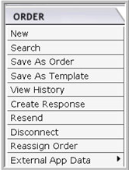
- Save As Template - create a template from an order selected from the Order List.
- View History - view the history of an order selected from the Order List—this menu option provides the same functionality as the History ICON in the top right hand corner.
- Create Response (Internal functionality only) - create a manual response for an order selected from the Order List—for example, manually create a Clarification or Jeopardy.
- Resend - resend an order selected from the Order List
- Disconnect - select an existing, completed order from the Order List to create a Disconnect order for the services installed on that existing order.
- Reassign Order - reassign an order selected from the Order List to someone else. Reassign Order is available based on manager rights assigned with the User ID.
- External App Data
  - NC/NCI Inquiry - search for valid NCNCI combinations.

PreOrder Tab
The PreOrder tab provides the option to initiate a PreOrder. When rolling the cursor over the PreOrder tab, a list of menu options appears.
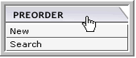
- New – perform the following:
  - PreOrder on CenturyLink addresses
  - PreOrder on CFAs
- Search – search for a PreOrder that was previously saved

Template Tab
The Template tab can be accessed in order to create a new order template or to search for an existing order template. When rolling the cursor over the template tab, a list of menu options appears. Templates can also be initiated while viewing an existing order by selecting Save as Template menu option from the Order tab while in an order.
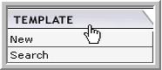
- New - create an order template
- Search – search for an existing order template

VFO Data Search
EASE VFO houses CenturyLink Access Service Requests (ASRs). There are many ways to search for existing ASR order information.

Order Tab Search
A search can be performed in EASE VFO by selecting Search from the Order tab menu. Rolling the cursor over the Order tab displays the menu. When selecting the Search menu option, an Order Search Page box displays with Purchase Order Number (PON) highlighted as the default search option.
The user can choose to search by PON or select another search option. Once a search option is selected, type the exact search criteria in the Search For: box to begin the query.
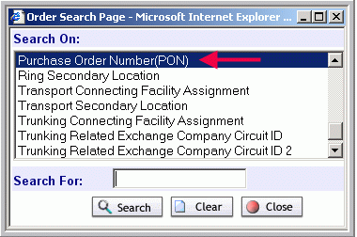

The following are some other search options:
- ACI Connecting Facility Assignment
- ASR Circuit Reference Number
- ASR Project ID
- ASR Two Six Code
- EUSA Secondary Location
- Initiator
- Multi-EC Order
- Ring Secondary Location
- Transport Connecting Facility Assignment
- Transport Secondary Location
- Trunking Connecting Facility Assignment
- Trunking Secondary Location
A partial search can be performed by entering part of the search criteria followed by a %. This is considered a wildcard or partial search.
Order updates such as confirmations and jeopardies can all be viewed online in EASE VFO by performing a PON search and then viewing the PON history.
If the search is successful, orders matching the search criteria are displayed in the Order List.
If the search is not successful, “No Records Found” displays. From the Order Search Page box, click the Clear button to search again, or click the Close button to discontinue the search function.

Order History
Once a PON is retrieved by performing a search from the Order tab search menu, the History ICON can be used to view the history of the order.
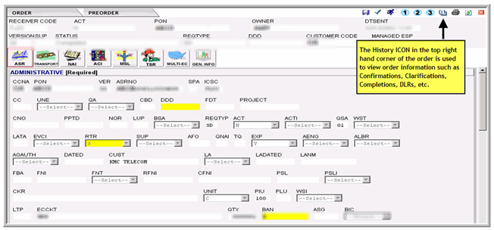
Once the History ICON is clicked, an Order History window opens and displays the history of the order. To view any of the details of a status, click the PON to the far left. Remember, Jeopardies, DLRs, and Completions can be viewed via the Order History screen.
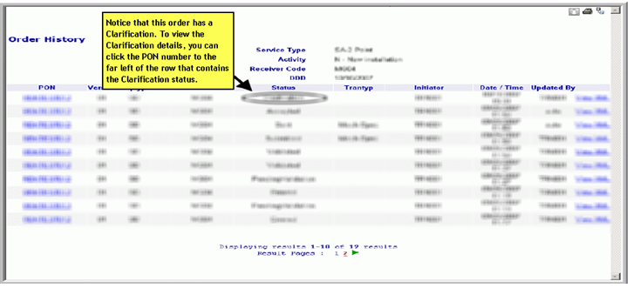

PreOrder Search
An existing PreOrder can be searched in EASE VFO by selecting Search from the PreOrder Tab menu. Rolling the cursor over the PreOrder Tab displays the menu. When selecting the search option, the screen changes from Order List to PreOrder Search screen. This functionality is discussed later in this training.

Template Search
An existing template can be searched in EASE VFO by selecting Search from the Template tab menu. Rolling the cursor over the Template tab displays the menu. When selecting the Search menu option, the screen changes from the Order List to the Template List screen. Once the Template List screen displays, the user can select a template from the list or use the Template List screen fields to search for a template that does not appear in the list.
The Template List screen displays a list of existing templates. You can search for a template by populating one or more of the search fields and then clicking the Go button.
The red X can be used to delete an existing template from the list. Selecting the radio button the left of the template name and then clicking the red X deletes the template.
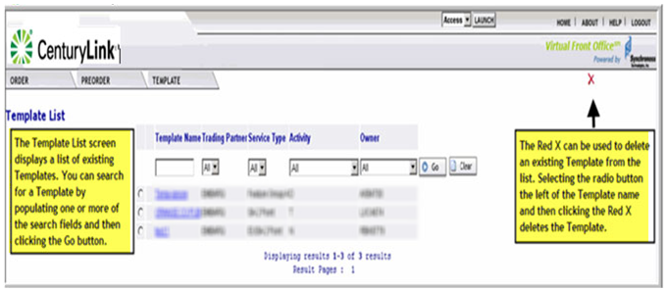
You cannot apply a template to a new order by searching for it. Applying a template takes place when an order is initiated and is discussed later in this training.
The following are the fields that appear on the Template List screen:
- Template Name - the name of the existing template.
- Trading Partner - the Trading Partner who created the template.
- Service Type - the template service type.
- Activity - the order activity of the template—for example, Change, New, or Move.
- Owner - the user ID of the template creator.
- Red X - the ICON used to delete a template selected from the Template List.

VFO PreOrder
Prior to submitting an online order in VFO, a PreOrder can be done on:
- CenturyLink addresses for ASR
- Connecting Facility Assignments (CFAs)
If a CenturyLink address PreOrder is not done by using the PreOrder tab menu, an address PreOrder can be performed during order initiation. This functionality is covered later in the training.
Using PreOrder functionality ensures that good data is present on the order before it is submitted to CenturyLink. This eliminates rejections and delays in customer orders.
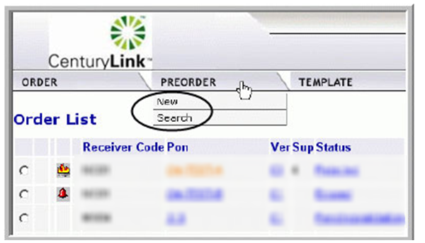
- Selecting New from the PreOrder menu allows to the user initiate a new PreOrder
- Selecting Search from the PreOrder menu allows the user to search for an existing PreOrder.

VFO PreOrder New
CenturyLink addresses and CFAs can be validated prior to order submission by doing a preorder. Preordering from the Preorder tab is convenient when wanting to perform the preorder first without submitting the order. Selecting New from the Preorder tab drop-down menu enables the user to initiate a new preorder. Once New is selected, a PreOrder Initiation screen opens.
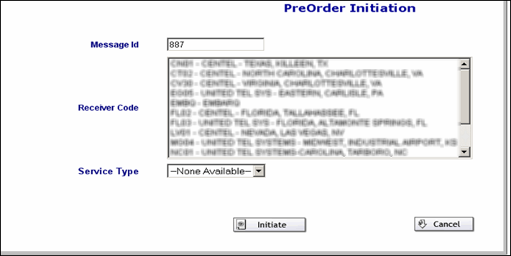
Following are the fields that appear on the PreOrder Initiation screen:
- Message Id - tracks the preorder—it can be the Purchase Order Number (PON) or any other alpha, numeric, or alpha-numeric combination up to twenty-five characters in length.
- Receiver Code - drop-down that contains the CenturyLink ICSC for the region where the address or CFA is located.
- Service Type - contains three values—CFA_INQUIRY, CLLI_SCAN_INQUIRY and LOCATION_INQUIRY.
- Initiate - initiates the preorder.
- Cancel - discontinues the preorder.
Once a new ASR preorder is initiated, one of three screens display:
- LOCATION_INQUIRY displays when doing a preorder on a CenturyLink address
- CFA_INQUIRY displays when doing a preorder on a CFA
- CLLI_SCAN_INQUIRY displays when doing a preorder on a CLLI

Location Inquiry
When doing an address inquiry, type in the EXACT address including City, State, and Zip Code.
- Type the CCNA in the CCNA field.
- Type the state abbreviation in the State field.
- Type the address including city, state, and zip code in the Address Detail section.
- Click the Submit button.
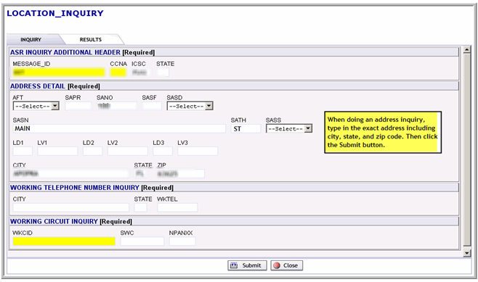

The query is initiated and the results display on the Results tab. The IRM fields shows whether or not the preorder was successful. See Appendix 3 for all IRM Address responses.
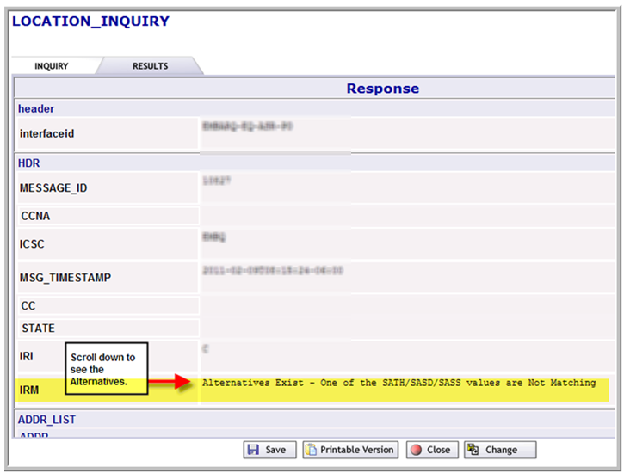
There are certain fields required in the address details section of any order that contains an address. The minimum entries in the address details section are:
- SANO = House Number
- SASN = Street Name
- CITY
- STATE (must be in all capital letters)
- ZIP CODE
See Appendix 5 Address Details for additional fields that could possibly be required in the address details section of the order depending on the addresses.

CFA Inquiry
When doing a CFA Inquiry, type the EXACT CFA including the channel or channel range; for example 1-28. If you enter a channel range, the results show you all channel availability.
- Type the CCNA in the CCNA field.
- Type the state abbreviation in the State field.
- LOAI – If you have LOA enter “Y” (optional)
- If you enter “Y”, the LOA_CCNA field is mandatory
- Type the facility designation for the CFA—for example, C101 in the FACDESG field.
- Type the type of facility—for example, T3 in the FACTYPE field.
- Type the channel in the CHANNEL field.
- Type the ACTL and MUX in the LOCA and LOCZ fields.
- Click the Submit button.
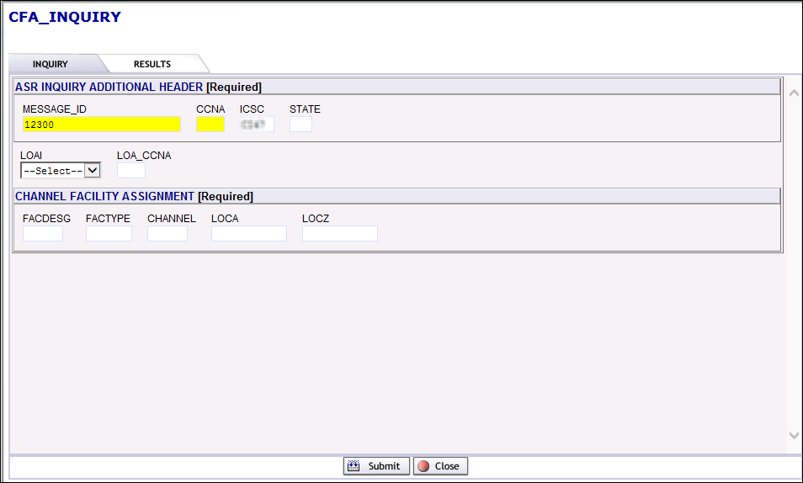

The query is initiated and the results display on the Results tab. The IRM fields shows whether or not the preorder was successful. See Appendix 4 for all IRM CFA responses.

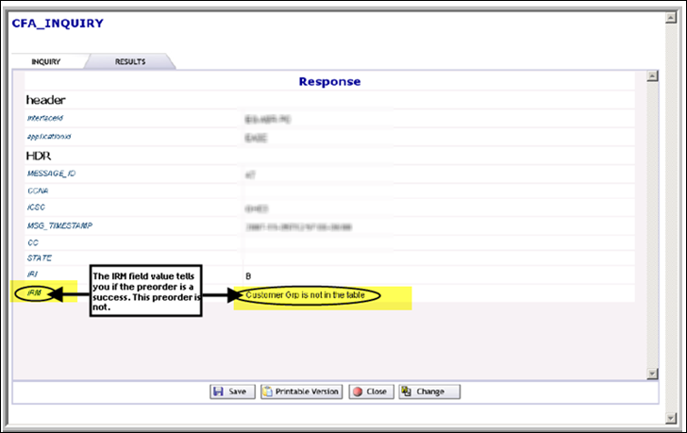

CLLI SCAN Inquiry
When doing a CLLI SCAN Inquiry, complete the mandatory fields:
- Type the CCNA in the CCNA field
- Type Location A CLLI in the LOCA field
- Type Location Z CLLI in the LOCZ field
- Click the Submit button.
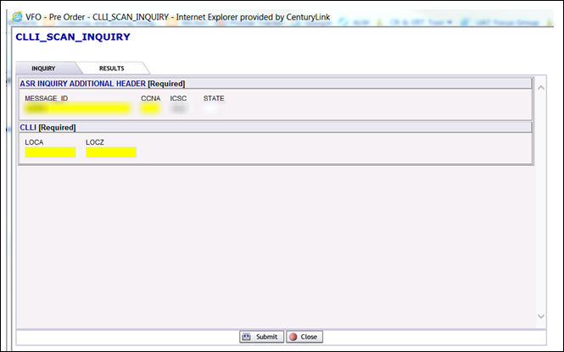

The query is initiated and the results display on the Results tab. The IRM fields shows whether or not the preorder was successful.
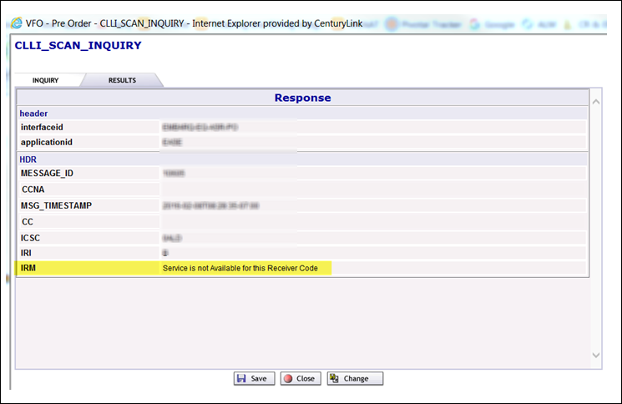

PreOrder Success
If the PreOrder is a success the user can:
- Use the Save button to save the PreOrder
- Click the Printable Version button to view and print the PreOrder
- Click the Close button to exit

The PreOrder record is not saved if closing without saving first. Once a CenturyLink address or CFA is validated via the PreOrder tab and is determined to be valid, the user can to proceed to order initiation.

PreOrder is not Successful
If the PreOrder is not a success the user can:
- Click the change button to try to preorder again
- Click the save button to save the preorder
- Click the printable version button to view and print the preorder
- Click the close button to exit.

VFO PreOrder Search
Selecting Search from the Preorder tab drop-down menu enables a search for an existing preorder. If a preorder has been previously done, there is a PON or other ID attached to that preorder based on what was placed in the Message ID or TX NUM field at the time of the initial preorder. The user can also search for other more general information. If wanting to search for all previously saved preorders, the user must check the Public Search box; otherwise the search only returns preorders that have previously been entered.
Once Search is selected from the Preorder tab drop-down menu, the screen changes to the PreOrder Search screen.
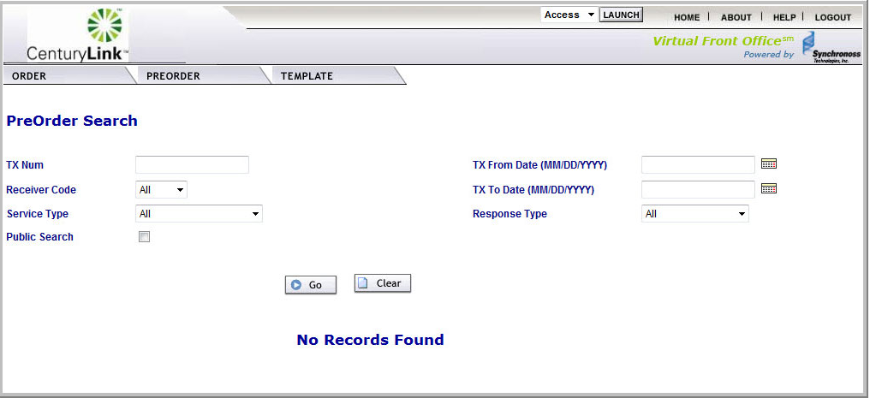

Following are the PreOrder Search screen fields for ASR:
- TX Num - search for the Message ID that is attached to a preorder when it is initially done from the Preorder tab—the TX NUM and Message ID are the same thing and it may be the PON number.
- Receiver Code - search for preorders done in a certain CenturyLink region.
- Service Type - search for existing address or CFA preorders.
- Public Search - check this to initiate a public search rather than only searching for your previous preorders.
- TX From Date and TX To Date - search for a previous preorder that was initiated in a certain time frame.
- Response Type - search for existing preorders that returned a certain response—Alternatives Exist, Found, Not Found, or Restricted.
- Go initiates the preorder search.
- Clear clears the search criteria.

VFO Ordering
When initiating and submitting ASRs to CenturyLink via EASE VFO, the user can either initiate a brand new order or replicate an existing order. Order replication allows the user to make a copy of an order, modify it, and send it one time. Template creation allows the use of an order shell repeatedly.
VFO Ordering allows the user to:
- Create an order template
- Replicate an existing order
- Initiate and validate a new order
- Identify and correct order errors
- Submit an order
- Supplement an order
- Perform other miscellaneous order functions

VFO Order Template Creation
Order templates can be initiated in three ways:
- Choose Save As Template from the Order Tab menu on the order list
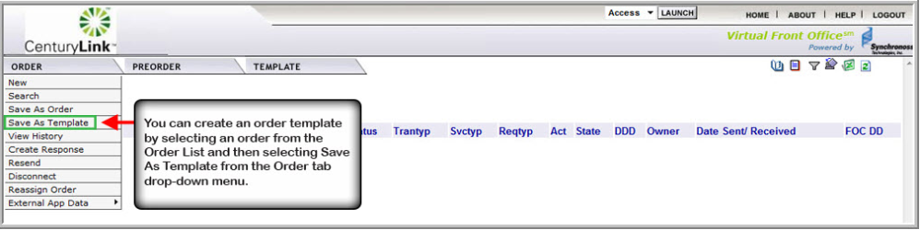
- Choose Save As Template from the Action sub-tab menu while viewing an order
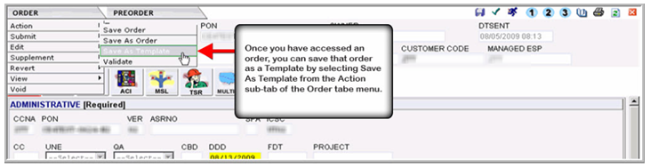
- Choose New from the Template tab menu on the Order List screen
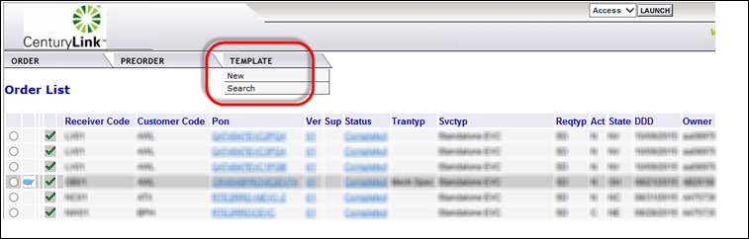
Information in templates should be basic so that additional orders of the same type can be created using the template.

The Template Initiation screen appears.
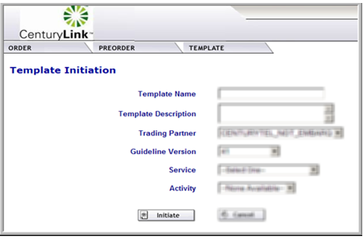

VFO Order Template Search, Modify, Delete
EASE VFO allows the user to search for, modify, or delete templates. With the order list in view, select search from the template tab menu.

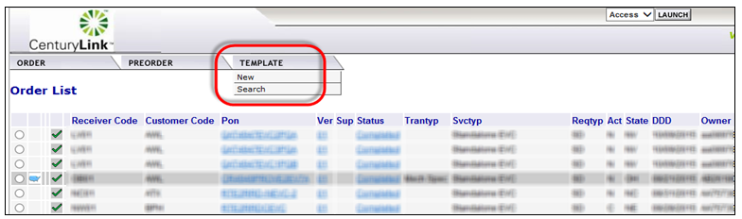

The template list screen appears.
If a template needs deleted, click the radio button the left of the template name, then click the red X in the top right corner of the screen. A pop up box displays asking the user if they are sure the template should be deleted. Click OK to delete the template. Note: Only an order template owner can delete a template.
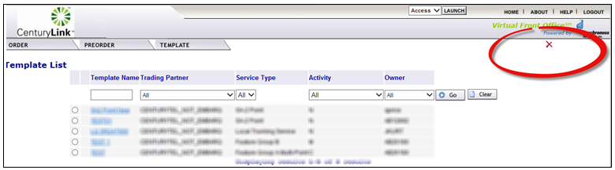

To change or modify the template, click the template name from the list. The template appears, allowing changes to be made to the template. Click the Save ICON or select save from the template tab menu.
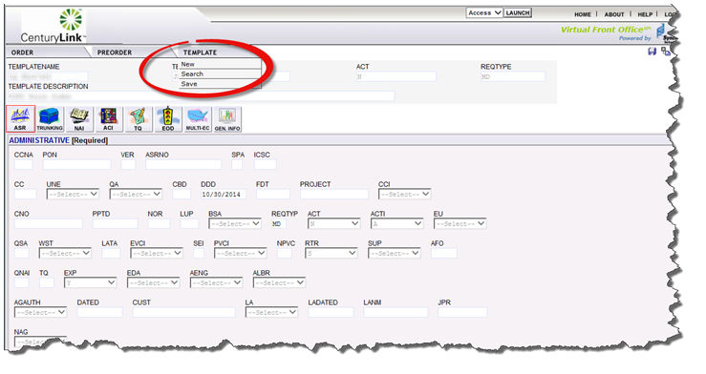

VFO Order Replication
Once an order has been submitted to CenturyLink in EASE VFO, the user can choose to replicate (copy) an existing order to use as a model for a new order. The replication function requires changing the existing PON number and only copies the order for one use. To make a shell order, create a template and don’t replicate the existing order.
Search for an order that is the same type of service as the order needed. The order replication function can be initiated two ways as follows:
Choosing Save as Order from the Order tab drop down menu to Replicate an order selected from the Order List.
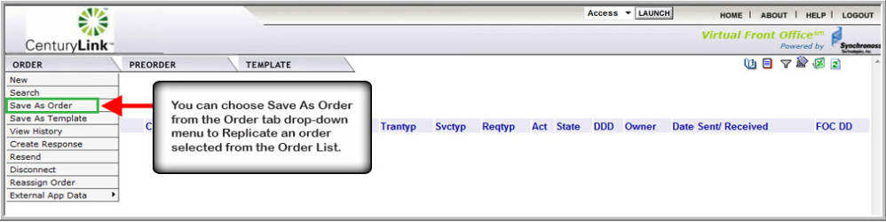
Selecting Save As Order from the Action sub-tab of the Order tab menu initiates Replication of the order you are in.
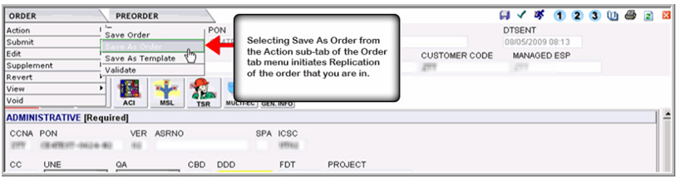

The screen changes to the Save As New Order screen.
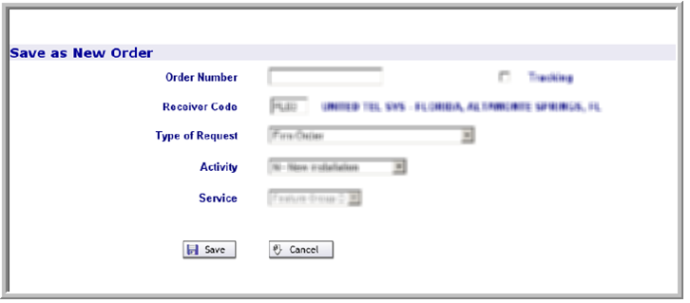
Type a new PON in the Order Number field; the PON can be up to sixteen alpha, numeric, or alpha-numeric characters.
If the new order is for tracking purposes only, click the Tracking box. Caution: Tracking only orders are not dispatched for provisioning.
The Receiver Code field is pre-populated; however, it can be changed
The Type of Request field is pre-populated; leave it as it returned.
The Activity field is pre-populated; however, it can be changed
When ready to create the order, click the save button, enter all pertinent fields, and submit the order.
If not ready to create the order, click the cancel button. The order is replicated and the screen will return to the previous view.

VFO Order Entry
From the Order List screen, select New from the order tab drop down menu.
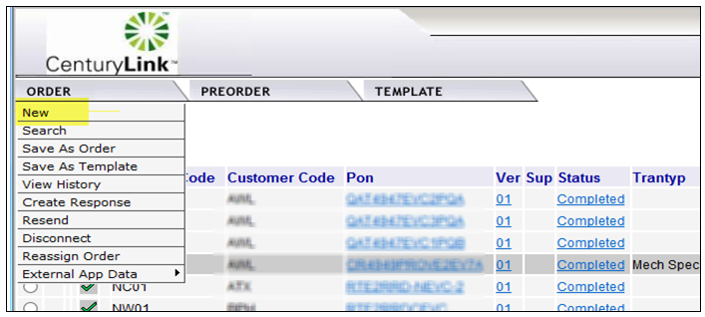
This initiates a new order. It is important to use the proper naming convention when in the NEAC, OMG, ECIO, or COS groups. These naming conventions ensure order tasks route to the proper work group.
When entering an order, select the type of service for the order. For a list of order types, please view the EASE VFO Order Types List in Appendix 6.
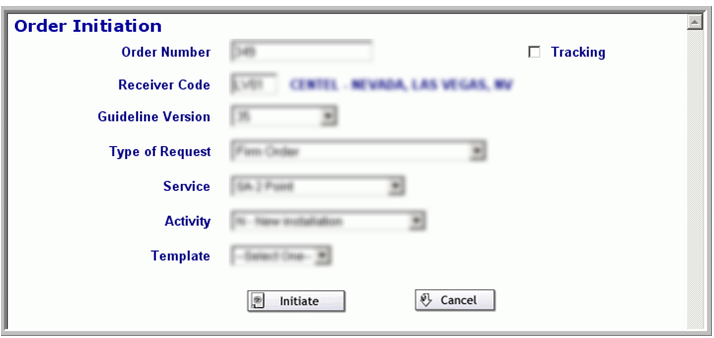
The following are the Order Initiation window fields:
- Order Number - Purchase Order Number (PON). The PON can be up to sixteen alpha, numeric, or alpha-numeric characters. A PON number can only be used once per ICSC/Receive Code and customer. EASE VFO automatically populates the Order Number field with the next available number, the number that EASE VFO assigns can be changed.
- Tracking - the Tracking button is used to indicate that the order is for tracking purposes only.
- Receiver Code - the ICSC of the region of the order—for example, MG04 or LV01. If the order is meet-point with two or more Local Exchange Carriers (LEC), the Receiver Code field must be the ICSC code of the LEC that is in control of the order. Once typing in this field begins, a list of codes appears in a drop-down list and the correct ICSC can be selected
- Guideline Version - the version of the industry standard guideline that applies to the order. This field prepopulates once the Receiver Code is added.
- Type of Request - Firm Order is the default value and is the only valid value for this field.
- Service - the types of services are available in the Service field drop-down menu—for example, EUSA-2 Point or SA-2 Point.
- Activity - the order activities are available in the Activity field drop-down menu—for example, New, Change, or Disconnect.
- Template - previously created templates are in the Template field drop-down menu. A template can be chosen if one is available.
- Initiate - initiates the order.
- Cancel - discontinues the order entry process.
Once the order initiation screen is populated with the basic order information, the user is redirected to the order. EASE VFO provides all industry standard forms and fields. When clicking an EASE VFO field, help text displays across the bottom of the screen that assists with choosing valid field values an formats.
All orders entered in EASE VFO must be in all capital letters, so setting the CAPS LOCK button on the keyboard is a good idea before entering an order.
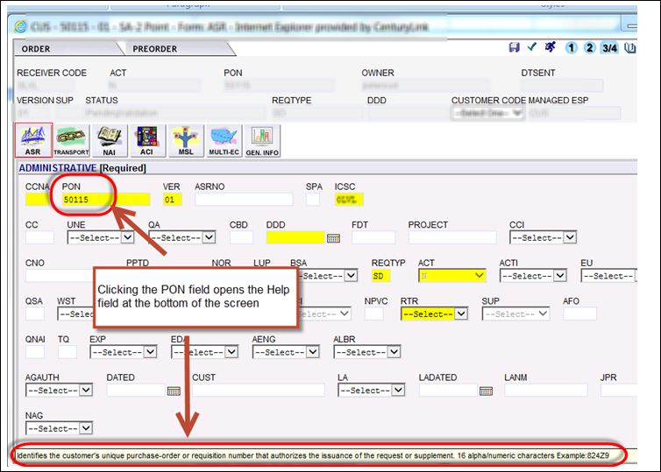
The default form is the ASR form. The red outline tells on the current form. Forms can be changed by clicking the form boxes.

General information, such as receiver code, activity, and PON are pre-populated based on what was entered on the order initiation screen. The order stays in pending validation status until it is validated.
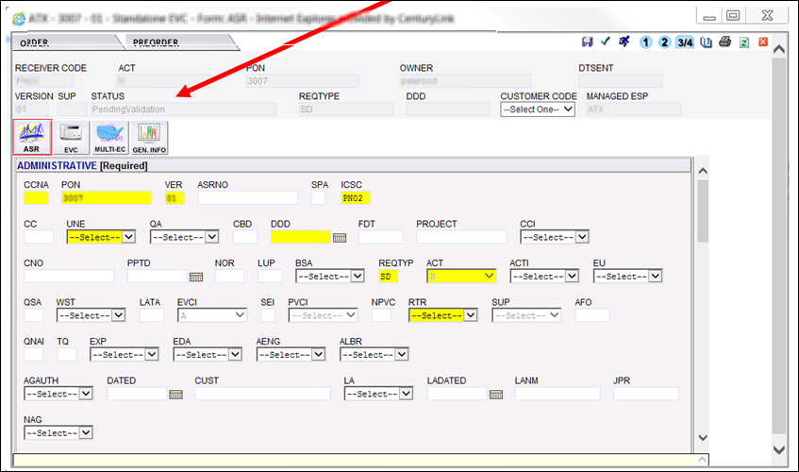
More or less fields may be required depending on what type of order is being entered.

Ordering Options – Resend
If the order gets stuck in Sent or Resent status and it is not a meet-point order where CenturyLink is not in control, the order can be resent to try to get it to go to Accepted status. The order stays in Sent status initially on meet-point orders where CenturyLink is not in control, so do not resend the order in that scenario. There are two ways to resend an order (other than meet-point orders where CenturyLink is not in control) as follows:
Choose Resend from the Order tab Edit sub-menu when within an order.
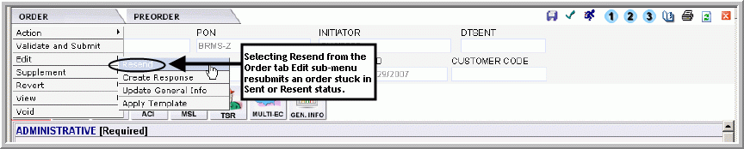
Choose Resend from the Order tab when an order is selected from the order list.
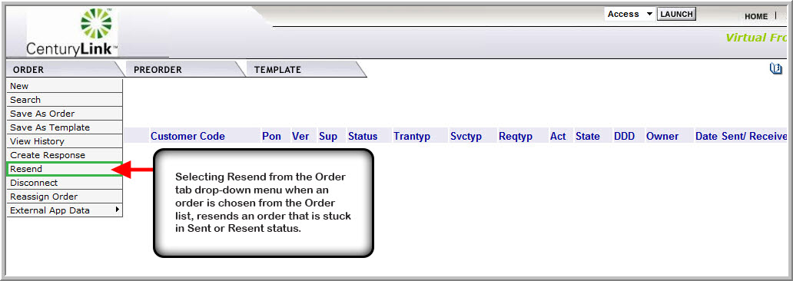

Ordering Options – View
The user can view a printable version of an order by selecting View from the Order menu, then View Printable Version from the sub-menu.
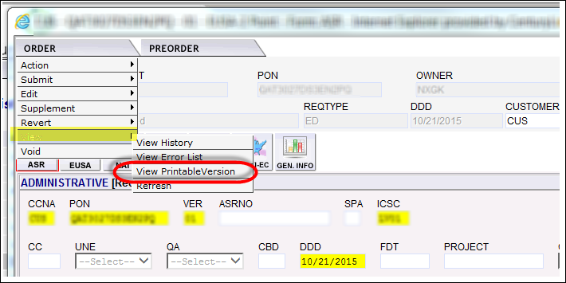

VFO Order Validation
Once the required forms and fields have been completed, the order must be validated prior to submitting to CenturyLink. There are three ways to validate an order.
Click the to validate the order upon completing the fields.
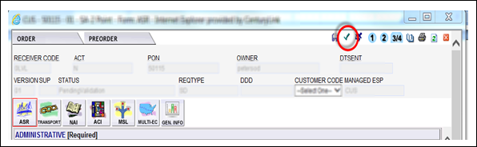
Select Validate from the Action sub menu of the Order tab menu while in an order.
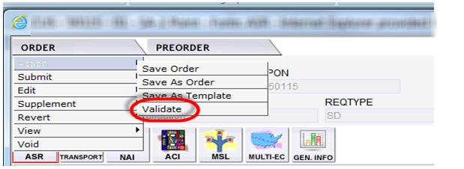
Select Validate and Submit from the Order tab menu while in an order.
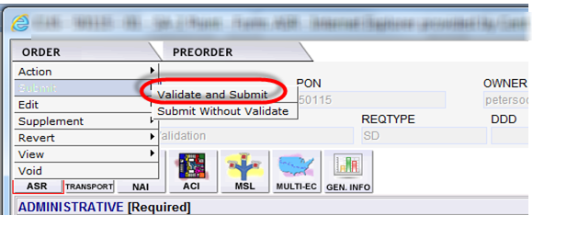
Selecting Validate and Submit from the order tab menu while in an order also submits the order to CenturyLink if there are no validation errors.

VFO Error Identification and Correction
After clicking the Validate ICON, EASE performs a systematic check on all of the order fields and values. If the order has errors, an Error Code List displays:
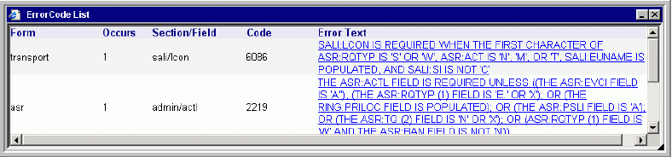
Read the description of the error and click the blue hyperlinked Error Text to be taken to the field with the error.
The following are the Error Code List columns:
- Form - On which ASR form the error occurs.
- Occurs - How many occurrences of the error.
- Section/Field - In which section and field the error occurs.
- Code - Internal code connected to the error.
- Error Text - Description of the error.
Once the errors have been cleared, the order is ready to be submitted to CenturyLink.

VFO Order Submission
Once order validation is performed and the order is error free, the Status field changes to Validated and the order is ready to be submitted to CenturyLink. There are two ways to submit an order:
Click the Submit ICON in the top right corner of the order.
The user can select Validate and Submit from the Order tab drop down menu.
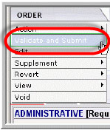
After validating and submitting, wait a few seconds and check the Status field.
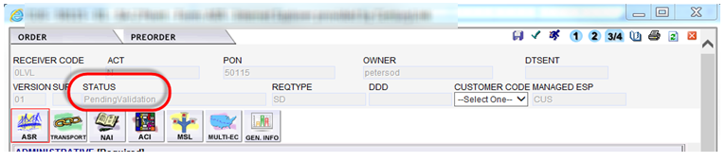
If the Status field says ‘Accepted’ the order has been submitted and order entry is done unless a supplement is required.
If the Status field says “Sent” or “Resent” and is a meet point order where CenturyLink is NOT in control, this status stops at the Sent status. This is ok, and there is no need to resend the order.

VFO Order Submission D/N Related Orders
Disconnect /New related orders require the RPON fields of both are populated with the related PON. The Coordinated Conversion (CCVN) field on the Disconnect order must be populated with the CCNA when the same circuit ID is to be used on the install. If the CCNA & ACNA are different, both can be entered in the CCVN field.

Supplementing Orders
An order can be supplemented once it is in “Accepted” status up to the point that it reaches “Completed” status. If a SUP is required, first search for the order.
Once the order has been located, there are two ways so initiate the SUP; click one of the three Supplemental ICONs .
- 1 = Cancel
- 2 = Due Date Change (DDD Change)
- Others
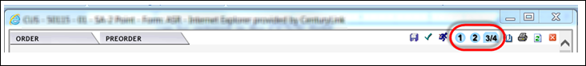
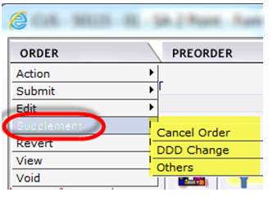

The user can also select one of the options from the Supplement Tab sub menu

Supplemental Order - Cancel
If a supplement is issued to cancel an order (SUP 1) a pop-up is received box asking “Do you want to proceed with the Cancel”? Clicking OK proceeds with the order cancellation; Clicking the Cancel button discontinues the cancel request.
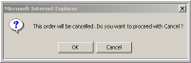
If OK is selected, a second pop-up appears that remarks to be entered. The user can enter remarks and then click OK to continue with the order cancellation.
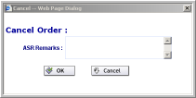

Supplemental Order – Change Due Date
If a supplement is issued to change the due date on the order (SUP 2) a Desired Due Date Change pop-up box displays. Select the new due date, add remarks if necessary, and click the Change button. If the Cancel button is selected, the due date change is discontinued.

Supplemental Order – Other
If a supplement is initiated to change anything other than the due date (SUP 3 / 4), the status changes to Pending Validation. Make the necessary changes to the order and click the Submit ICON .

Acronyms

Acronym | Description
ACNA | Access Customer Name Abbreviation
ASR | Access Service Request
CCNA | Customer Carrier Name Abbreviation
CCVN | Coordinated Conversion
CFA | Connecting Facility Assignments
DLR | Design Layout Request
EASE | Electronic Administration & Service Order Exchange
NC | Network Channel
NCI | Network Channel Interface
RPON | Related Purchase Order Number
SECNCI | Secondary Network Channel Interface
VFO | Virtual Front Office

Appendix 1 - EASE VFO ICON List

Status ICON | Definition
 | Cancelled
 | Confirmed
 | Completed
 | Errored
 | Jeopardized
 | Pending (FOC or DLR)
 | Rejected
 | Tracking Only (This means that the order was placed outside of VFO and it is in VFO for tracking only)
 | Multi-EC

Appendix 2 - EASE VFO Order Status List

Status | Definition |  | Send/Rcv or Rcv | User Action
Accepted | The Access Provider (Trading Partner) has received the order and sent a positive acknowledgement for the order. Exchange Path has updated the status, stored the message in the Exchange Path database, and sent a notification message to VFO to update the status. The ASR has passed fatal validations. |  | Send/Rcv | Wait for FOC
Accepted | The Access Provider (Trading Partner) has received the order and it has passed fatal validations. |  | Receive | The response goes to  Accept Submitted, so it can be transmitted to the order originator.
Accepted Submitted | The Accepted response is sitting in queue waiting to be transmitted to the ASR  Originator. |  | Receive | Once the Accepted status has been transmitted, the  status is changed to  Accepted Sent.
Accepted System Errored | The Accepted response could  not be transmitted to the  ASR originator. |  | Receive | Once the system errors have been resolved, the Accept response can be  Submitted again.
Accepted Sent | The Accepted response has  been transmitted to the ASR originator. |  | Receive | The user can create and submit.
Cancel Accepted |  | The AP has returned a positive acknowledgement of canceling an ASR. Exchange Path has updated the  status, stored the message in the Exchange  Path Database, and sent a notification  message to VFO. | Send/Rcv | No Action
Cancel Received |  | The Cancel request has been received by the AP. | Send/Rcv | No Action
Cancel Rejected |  | The AP has returned a negative rejection acknowledgment for a cancellation. | Send/Rcv | View the reject reason and take the recommended action.
Cancel Resent |  | The Cancel request has been resent. | Send/Rcv | No Action
Cancel Sent |  | A Cancel request has been sent to the AP. | Send/Rcv | No Action
Cancel Submitted |  | The Cancel request has been sent to Exchange Path (behind the scenes EASE interface) for validation and subsequent processing. | Send/Rcv | No Action
Cancel Tracked |  | An order that is for tracking only has been cancelled. | Send/Rcv | No Action
Cancelled |  | The order has been supplemented with a cancel request. | Send/Rcv | No Action

Status | Definition | Send/Rcv or Rcv | User Action
Clarification | The AP has initiated a Clarification message. Exchange Path has updated the status, stored the message in the Exchange Path Database, and sent a message to VFO to update the status. | Send/Rcv | Review the Clarification and take the recommended action.
Clarification Invalidated | The AP has initiated a Clarification message for the order, but the clarification was not validated. | Send/Rcv | Review the Clarification and take the recommended action.
Clarification Cleared | The Trading Partner has returned a  Clarification Cleared message for the  Access Order and Exchange Path has sent a notification message to VFO to update the status. | Send/Rcv | No Action
Clarification Cleared Invalidated | The AP has initiated a Clarification Cleared message for the order, but the Clarification was not validated. | Send/Rcv | No Action
Clarification Cleared Saved | The Clarification Cleared has been cancelled and a response notification has  been created and saved by the user in VFO. | Receive | A Clarification Cleared response is submitted by the user.
Clarification Cleared Submitted | The Clarification Cleared response is sitting in queue, waiting to be  Transmitted to the ASR originator. | Receive | Once the  Clarification Cleared  response has been  transmitted, the status  is changed to  Clarification Cleared  Sent.
Clarification Saved | There are issues/questions about an ASR and a Clarification response has been created and saved by the user in VFO. | Receive | The Clarification  response is submitted  by the user. Review the Clarification and take the recommended action.
Clarification Sent | The Clarification response has been transmitted to the ASR originator. | Receive | Review the Clarification and take the recommended action.
Clarification Cleared Sent | The Clarification Cleared response has been transmitted to the ASR originator. | Receive | The user can create and submit any of the  Subsequent statuses.
Clarification Cleared System Errored | The Clarification Cleared response could not be transmitted to the ASR originator. | Receive | Once the system errors have been resolved, the Clarification Cleared response can be submitted again.
Clarification System Errored | The Clarification response could not be transmitted to the ASR originator. | Receive | Once the system errors have been resolved, the Clarification cleared response can be submitted again.

Status | Definition | Send/Rcv or Rcv | User Action
Clarification Submitted | The Clarification response is sitting in queue, waiting to be transmitted to the  ASR originator. | Receive | Once the Clarification  response has been  transmitted, the status  is changed to  Clarification Sent.
Clarification Validated | The Clarification has been initiated and validated, but not sent or submitted. (It’s viewable online, but won’t be sent back via e-mail, fax, or batch.) | Receive | Submit the Clarification.
Completed | The VFO user has manually updated the ASR status to Completed or the AP has initiated a Completed message. | Send/Rcv | Review Response
Completed Invalidated | The AP has initiated a completion message, but the completion was not validated by the internal EP system. | Receive | No Action
Completed Saved | The ASR has been Completed and a response has been created and  Saved by the user in VFO. | Receive | The Completed response is submitted by the user.
Completed System Errored | The Completed response could not be transmitted to the ASR originator. | Receive | Once the system errors have been resolved, the Completion response can be submitted again.
Completed Sent | The Completed response has been transmitted to the ASR originator. | Receive | No further updates are  allowed once the order is in a Completed Sent status.
Completed Submitted | The Completed response is sitting in queue, waiting to be transmitted to the ASR originator. | Receive | Once the Completed  response has been  transmitted, the status  is changed to Completed Sent.
Confirmed | The AP has returned a Confirmation message for the order. Exchange Path has updated the status, stored the message in the EP database, and sent a notification message to VFO to update the status. | Send/Rcv | Review Response
Confirmed Sent | Indicates that the Confirmed response has been transmitted to the  ASR originator. | Receive | User can create and  submit any of the  subsequent statuses.
Confirmed Submitted | The Confirmed response is sitting in queue, waiting to be transmitted to the ASR originator. | Receive | Once the Confirmed  response has been  transmitted, the status  is changed to Confirmed Sent.
Confirmed Saved | The Confirmation response has been created and saved by the user in VFO. | Receive | The Confirmed response is submitted by the user.
Confirmed System Errored | The Confirmation response could not be transmitted to the ASR originator. | Receive | Once the system errors have been resolved, the Confirmed response can be submitted again.
DLR Saved | The DLR response has been created and saved by the user in VFO. | Receive | The DLR response is submitted by the user.
Status | Definition | Send/Send-Receive | User Action
DLR Sent | The DLR response has been transmitted to the ASR originator. |  | The user can create and submit any of the  Subsequent statuses.
DLR System Errored | The DLR response could not be transmitted to the ASR originator. | Receive | Once the system errors have been resolved, the DLR response can be  submitted again.
DLR Submitted | The DLR response is sitting in queue, waiting to be transmitted to the ASR  Originator. | Receive | Review Response
Design Order Confirmed Saved | The DOC response has been created and saved by the user in VFO. | Receive | The DOC response is submitted by the user.
Design Order Confirmed Submitted | The DOC response is sitting in queue waiting to be transmitted to the ASR originator. | Receive | Once the DOC response has been transmitted, the status is changed to Design Order Confirmed Sent.
Design Order Confirmed System Errored | The DOC response could not be transmitted to the ASR originator. | Receive | Once the system errors have been resolved, the DOC response can be submitted again.
Design Order Confirmed Sent | The DOC response has been transmitted to the ASR originator. | Receive | The user can create and submit any of the subsequent statuses.
Design Order Confirmed | The AP has returned a Design Order Confirmation message for the order. Exchange Path has sent a notification message to VFO to update the status. | Send/Rcv | Review Response
DLR/Design | The AP has returned a DLR for the order. Exchange Path has updated the status, stored the message in the EP database, and sent a notification message to VFO to update the status. | Send/Rcv | Review Response
Jeopardy with Errors Invalidated | The Jeopardy was initiated, not validated, and contains errors. | Send/Rcv | Validate and submit the Jeopardy response.
Jeopardy with Errors Submitted | The Jeopardy with Errors response is sitting in queue waiting to be  Transmitted to the ASR originator. | Receive | Once the Jeopardy with Errors response has been transmitted, the status is changed to Jeopardy with Errors Sent.
Jeopardy with Errors Saved | The FOC date is in Jeopardy due to errors on the ASR and a response has been created and saved by the user in VFO. | Receive | The Jeopardy with  Errors response is submitted by the user.
Jeopardy with Errors System Errored | The Jeopardy with Errors  Response could not be transmitted to the ASR originator. | Receive | Once the system errors have been resolved, the Jeopardy with Errors response can be submitted again.

Status | Definition | Send/Send-Receive | User Action
Jeopardy with Errors Sent | The Jeopardy with Errors response has been transmitted to the ASR originator. | Receive | The user can create and submit any of the  Subsequent statuses.
Jeopardy Invalidated | The Jeopardy was initiated and not validated. (It is viewable online, but won’t be sent back via e-mail, fax, or batch. | Receive | Validate and submit the Jeopardy response.
Jeopardy Saved | The FOC date is in jeopardy and a response has been created and saved by the user in VFO. | Receive | The Jeopardy response is submitted by the user. Review the Jeopardy and take the recommended action.
Jeopardy Sent | The Jeopardy response has been transmitted to the ASR originator. | Receive | The user can create and submit any of the subsequent statuses.
Jeopardy Submitted | The Jeopardy response is sitting in queue waiting to be transmitted to the ASR originator. | Receive | Once the Jeopardy  response has been  transmitted, the status  is changed to Jeopardy Sent.
Jeopardy System Errored | The Jeopardy response could not be transmitted to the ASR originator. | Receive | Once the system errors have been resolved, the Jeopardy response can be submitted again.
Jeopardy Saved | The FOC date is in Jeopardy and a response has been created and saved by the user in VFO. | Receive | The Jeopardy response is submitted by the user.
Errored | The ASR has failed the validation process. Exchange Path has updated the Request Status, stored the ASR, and sent an Error Notification to VFO. | Receive | Correct the error and validate again.
Jeopardy | Jeopardy status indicates that there are situations that may jeopardize critical dates of the ASR. | Send/Rcv | Review the Jeopardy and take the recommended action.
Jeopardy with Errors | Indicates there are situations that may jeopardize critical dates of the ASR and there are errors with the request. | Send/Rcv | Review the Jeopardy and take the recommended action.
Pending Completion | The Exchange Path Monitor process  determines that a Completion notice has  Not been received in the time allotted and issues a notification message to VFO to update the status. | Send/Rcv | Contact the AP to find out the cause of the delay in response.
Pending Design | The Exchange Path Monitor process determines the DLR or Design information has not been received in the time allotted and a notification message is sent to VFO to update the status. | Send/Rcv | Contact the AP to find out the cause of the delay in response.
Pending Confirmation | The Exchange Path Monitor process determines that the Firm Order Confirmation (FOC) has not been received in the time allotted and issues a notification message to VFO to update the status. | Send/Rcv | Contact the AP to find out the cause of the delay in response.
Pending Response | The Exchange Path Monitor process determines a Response has not been received in the time allotted and a notification message is sent to VFO to update the status. | Send/Rcv | Contact the AP to find out the cause of the delay in response.

Status | Definition | Send/Send-Receive | User Action
Pending Validation | An initial request or a change to a request (other than Cancel) has been created, but the request has not been sent to Exchange Path for validation or submission to the AP. After selecting Submit or Validate, the resulting response from Exchange Path will be Validated or Errored. | Send/Rcv | Finish entering the order and submit.
Received | This status appears when service requests are sent to VFO for processing. This indicates the customer’s request has been received. | Send/Rcv | The Accept response is generated by the system if fatal validations are passed.
Rejected | The AP has returned a negative (rejection) acknowledgment. Exchange Path has updated the status, stored the message in the Exchange Path  Database, and sent a notification message to VFO to update the status. | Send/Rcv | Review the response and take the recommended action.
Resent | Another copy of the last submitted version of the ASR is sent to the AP. | Send/Rcv | No Action
Sent | The order is sent to the AP, the status is updated, and a notification message is sent to VFO to update the status. | Send/Rcv | No Action
Sent Failed | An attempt to send the order to the AP fails. | Receive | Try to send the order again.
Submitted | This status indicates that an initial request or a change to a request has been sent to the AP for validation and subsequent processing—status does not apply to a cancel request. | Send/Rcv | No Action
Supplemented | The order has been supplemented. | Receive | No Action
Supplement Received | The customer has sent a supplement to the previously received service request. | Send/Rcv | The Accept response is generated by the system if fatal validations are passed.
System Errored | VFO has received a system error message from Exchange Path. | Send/Rcv | Read the error message, correct it, and submit the order again.
TP Cancelled | The Access Provider has cancelled the customer’s order due to no response to a Clarification/Notification Request. | Send/Rcv | Create a new order if one is still needed.
TP Cancelled Invalidated | The AP (also known as the Trading Partner (TP)) has cancelled the customer’s ASR due to no response to a Clarification/Notification Request (internal EP did not validate cancellation). | Receive | Create a new order if one is still needed.
TP Cancelled Submitted | The TP Cancelled response is sitting in queue waiting to be transmitted to the ASR originator. | Receive | Once the TP Cancelled has been transmitted, the status is changed to TP Cancelled Sent.

Status | Definition | Send/Send-Receive | User Action
TP Cancelled Saved | The ASR is being cancelled by the Access Provider because Clarifications have not been resolved and a response has been created  and saved by the user in  VFO. | Receive | The TP Cancelled response is submitted by the user.
TP Cancelled Submitted | The TP Cancelled response is sitting in queue waiting to be transmitted to the ASR originator. | Receive | Once the TP Cancelled  response has been  transmitted, the status  is changed to TP Cancelled _Sent.
TP  Cancelled System Errored | The TP Cancelled response could not be transmitted to the ASR originator. | Receive | Once the system errors have been resolved, the TP Cancelled response  can be submitted again.
TP Cancelled Sent | The TP Cancelled response has been transmitted to the ASR originator. | Receive | The user can create and submit any of the subsequent statuses.
TP Errored | The Trading Partner has returned one or  More error messages for the order.  Exchange Path has updated the status,  stored the message in the Exchange Path  Database, and sent a notification message to VFO to update the status. | Send/Rcv | Review the response and take the recommended action.
TP Errored Saved | The ASR has validation errors and a response has been created and saved by the user in VFO. | Receive | The TP Errored response is submitted by the user.
TP Errored Submitted | The TP Errored response is sitting in queue waiting to be transmitted to the ASR originator. | Receive | Once the TP Errored response has been transmitted, the status changes to TP Errored Sent.
TP Errored System Errored | The TP Errored response could not be transmitted to the ASR originator. | Receive | Once the system errors have been resolved, the  TP Errored response  can be submitted again.
TP Errored Sent | The TP Errored response has been transmitted to the ASR Originator. | Receive | The user can create and submit any of the subsequent statuses.
Tracked | The order was initiated as a “Tracking Only” request and is not be transmitted to the AP. This is used when the order was sent manually outside of VFO and you want to track the order progress manually in VFO. | Send/Rcv | No Action
Validated | This indicates that an order has been successfully validated and there are no errors. | Send/Rcv | No Action
Voided | An order that was never submitted can be voided to indicate that the order should not be transmitted to the AP. | Send/Rcv | No Action

Appendix 3 – IRM Responses for Addresses

IRM Field Response | Definition
Exact match | The CenturyLink address is valid according to CenturyLink records.
Alternatives exist | The CenturyLink address is not an exact match of what CenturyLink records show. Alternative addresses are provided.
Zip code was not found. Request not executed : -2109 | The zip code entered is not in CenturyLink territory.
State Code is invalid for this Zip Code. Request not executed : -2110 | The state and zip code combination is invalid.
Facilities not found : -2131 | The address is valid in CenturyLink territory, but no facilities exist.
No EMBARQ addresses found for this address : -2130 | The address is not valid.

Appendix 4 – IRM Responses for CFA

IRM Field Response | Definition
Channel Vacant - Available for Assignment | The CFA is valid and the channel specified is available for assignment.
Channel Busy - Not Available for Assignment | The CFA is valid, but the channel specified is not available for assignment.
Requested Information Not Found | The CFA cannot be found in our records.

Appendix 5 – Address Details
Address Field | Definition
AFT (Address Format Type) | Identifies the format of the address being supplied  Valid Entries:  A = Rural route and/or box number  B = Unnumbered  C = Provider Assigned house number  D = Descriptive  E = Provisioning Address
SAPR (Service Address Number Prefix) | Identifies the prefix for the address number of the service address
SASF (Service Address Number Suffix) | Identifies the suffix for the address number of the service address
SASD (Service Address Street Directional Prefix) | Identifies the street directional prefix for the service address—for example, N = North, S = South, E = East, W = West, etc
SATH (Service Address Street Type) | Identifies the thoroughfare portion of the street name of the service address—for example, LN = Lane, BLVD = Boulevard, ST = Street, etc
SASS (Service Address Street Directional Suffix) | Identifies the street directional suffix for the service address—for example, N = North, S = South, E = East, W = West, etc  Note: The SASS is different than the SASD. The SASS is when the directional comes after the street name—for example, Main St West.
LD1 (Location Designator 1) | Identifies additional specific information related to the address—for example, building, floor, unit, or room
LV1 (Location Value 1) | Identifies the value associated with the LD1 of the address
LD2 (Location Designator 2) | Identifies additional specific information related to the address—for example, building, floor, unit, or room
LV2 (Location Value 2) | Identifies the value associated with the LD2 of the address
LD3 (Location Designator 3) | Identifies additional specific information related to the address—for example, building, floor, unit, or room
LV3 (Location Value 3) | Identifies the value associated with the LD3 of the address
Complex Addresses | Complex address inquiries can be entered using the Location Designator fields. You can populate the minimum required address inquiry fields plus the location designators if applicable as follows:  - LD1 – Enter description types—for example, UNIT, APT, ROOM, RM, FL, FLR, BLDG, or STE  - LV1 – Enter the value associated with the description type—for example, 100, 1, or 36  The LD description type can be placed in any Location Designator field: LD1, LD2, or LD3 and the associated value is placed in the corresponding LV1, LV2, or LV3 fields.

Appendix 6 – EASE VFO Order Types

Service Type | CenturyLink Product | Request/Order Type | EASE VFO Forms | Notes
CCS Links | SS7 Links | LD/Switched | TQ  Trunking
EUSA-2 Point | - DS0  - DS1  - DS3  - Program Audio  - Program Video  - LC EVPL UNI | ED/Specials/PLT | EUSA  SES (EVPL) | End-user address to End-user address (only one address with EVPL)
EUSA-Multi-Point | - DS0  - DS1  - DS3 | ED/Specials/PLT | EUSA  MSL
End User EVC | UNI/EVC Combo | ED/LC EVPL | SES  EVC | LC EVPL Combo order with address
End User Switched Ethernet EVC | UNI/EVC Combo | ED/LQ MOE | SES  EVC | Combo order with address
End User Switched Ethernet | UNI | ED/LQ MOE | SES | UNI with one address
Feature Group A-Multi-Point | N/A | N/A | N/A | Per Tariff - CenturyLink offering is point-to-point only
Feature Group A | - Trunks  - Combos | AD/Switched | FGA
Feature Group B | - Trunks  - Combos | MD/Switched | Trunking  TQ  EOD
Feature Group C | - Trunks  - Combos | MD/Switched | Trunking  TQ  EOD | Not used by CenturyLink
Feature Group D | - Trunks  - Combos | MD/Switched | Trunking  TQ  EOD

Service Type | CenturyLink Product | Request/Order Type | EASE VFO Forms | Notes
Local Trunking Service | - Trunks  - Combos  - LIS and WIS Trunks  - LIS and WIS Combos  - LIS and WIS 911 Trunks  - LIS and WIS 911 Combo  - Paging  - Type 1 | MD/Switched | Trunking  TQ  EOD
Ring Service | - LC SONET  - LC SOCR | RD/LC Rings | Ring | Not offered as meet-point
SA-2 Point | - DS0  - DS1  - DS3  - LC MASC  - Collocation scenarios  - LC NetPoint  - Program Audio  - Program Video  - LC OptiPoint  - LQ OWS  - LQ German  - LQ SHNS  - Ethernet Transport  - LC EVPL UNI | SD/Specials/PLT | Transport  NAI (Daisy Chain) | • ACTL to end-user or ACTL to central office  • LC EVPL UNI has not SECLOC
SA-Multi-Point | - DS0  - DS1  - DS3 | SD/Specials | Transport  MSL

Service Type | CenturyLink Product | Request/Order Type | EASE VFO Forms | Notes
SACNXX | 500, 900 Service | MD/Switched | Trunking  TQ  EOD
Standalone EVC | EVC | SD/LC EVPL and LQ MOE | EVC
TQ | Translations Only | MD/Switched | TQ
Transport EVC | UNI/EVC Combo | SD/LC EVPL | Transport  EVC | ACTL and no SECLOC
Transport Switched Ethernet EVC | UNI/EVC Combo | SD/LQ MOE | SES  EVC | ACTL and no SECLOC
Transport Switched Ethernet | UNI | SD/LQ MOE | SES | ACTL and no SELOC
Virtual Connection EUSA | - Frame Relay  - ATM  - DSL over ATM  - Resale Frame Relay | XD/Broadband | EUSA  VC
Virtual Connection-SA | - Frame Relay  - ATM  - DSL over ATM | VD/Broadband | Transport  VC
WAL | WATS | WD/WATS | WAL

Appendix 7 – EASE Helpful Hints for CORA Users

- Use CAPS LOCK on the keyboard when entering orders
- Dashes and spaces are not needed when entering telephone numbers
- User will enter “N” for New BAN, “E” for Existing BAN, or the BAN itself.
- Using Order Template for repetitive information such as Design / Engineering, Maintenance, and Implementation contact information builds an order more efficiently
- The SALI information can be found at the bottom of the product specific form
- The user will manually enter information into the PI field on the SALI Form
- The user will indicate the number of SALIs by entering the value into the QSA field
- State code is a manually entered on the SALI form
- The user will manually enter the EVCNUM field on the EVC form
- The user will manually populate the number of UREFs into the NUT field on the EVC form
- The LREF field will be manually populated by the user based on the number of level of service mapping configurations being requested
- On the ACI form, the REFNUM field will begin with 0002 and increment sequentially for each additional ACI needed
- On the ASR form, the user will manually enter Y in the correct position in the AFO field to obtain specific forms:
  - 1st position = ACI form
  - 3rd position = NAI form
  - 4th position = EOD form
  - 5th position = VCAT form

- On the ASR form, the user will manually enter the number of NAI forms into the QNAI field
- The user will manually enter the values into the TQ field on the ASR form.

