

EASE LSR VFO
User’s Guide

Table of Contents
Document Information 4
Version Notice 4
Change Log 4
Document Location 4
Records Retention Policy 4
Introduction 5
Browser Guidelines 5
Navigating EASE 7
EASE VFO System Requirements 9
Whom to Call and When 9
Overview 10
EASE VFO Overview 10
Password Rules 10
EASE Access 11
Login 13
EASE Home Page ICONs 15
EASE Home Page Tabs 16
Order Status List 18
Order Status ICONs 18
Order Tab 19
LSR Order Entry 19
Order Validation 22
Error Code List 23
Order Submission 25
Address Details 26
Complex Addresses 26
Data Search 27
Order Replicate 29
Order Supplements 31
Ordering Options 32
View 32
Save Order 33
Revert 33
Void 34
Order History 34
View Status from the Order List 35
PreOrder Tab 36
TX Type……………………………………………………………………………………………………38
Save and Search 40
EASE Help 41
Appendix 1 - Order List Status 42
Appendix 2 - Order Types 44
Appendix 3 – PreOrder IRM Responses 45
Appendix 4 – Address Fields and Definitions 46

Document Information

Version Notice
Document Date | Software Release | Document Version
August 2018 |  | Version 1.0

Change Log
Revision Date | Document Version & Software Release | Description

Document Location
You can obtain the latest version of this document at http://www.centurylink.com/wholesale/systems/ossconsolid_lsr.html

Records Retention Policy
LSRs that have been submitted to CenturyLink and processed will be retained in the database for a period of 2 years. CenturyLink will perform a purge of these records twice annually in January and July. The purge date will be based on the date of the last activity transmitted on the SR. For example, if the completion or cancellation date of the LSR is November 2015, the deletion of this record would occur in January 2018 and once purged will no longer be accessible to you.

Requests that have been created but not submitted to CenturyLink will not be purged from the database regardless of the date created. However, unsubmitted LSRs that have not been modified for more than 2 years whose "Last Edited User" is no longer a valid user in the system may be purged at CenturyLink's discretion.

Introduction

This User guide provides the user with instruction to create, modify, cancel, and submit Local Service Requests (LSRs). This guide is meant for a generic order representation only. The LSOG and custom business rules should be referenced for specific guidelines in the population of fields for specific order submission.

Browser Guidelines
EASE VFO will support Internet Explorer version 11 and Google. Earlier versions of Internet Explorer will not work with VFO.
Your browser may ask whether you want passwords and information to be saved for future use. If you see a message asking you to save your password or other information, do not do so. Saving your password may create security problems. Saving other information may not work as intended within the system.

Web Site: https://ease.centurylink.com/

Select VFO (Virtual Front Office)
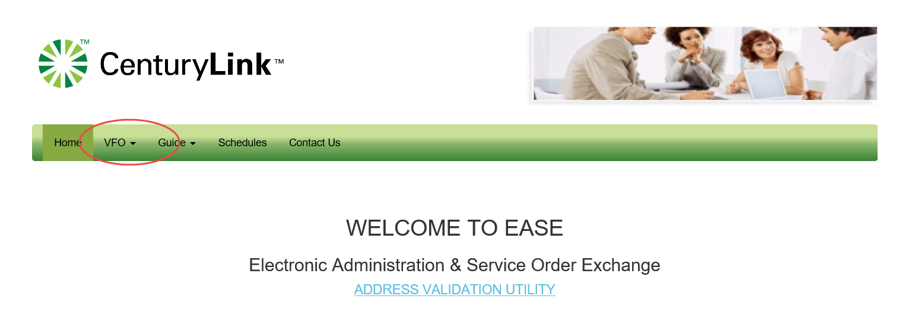
In drop down for LSR (Local Service
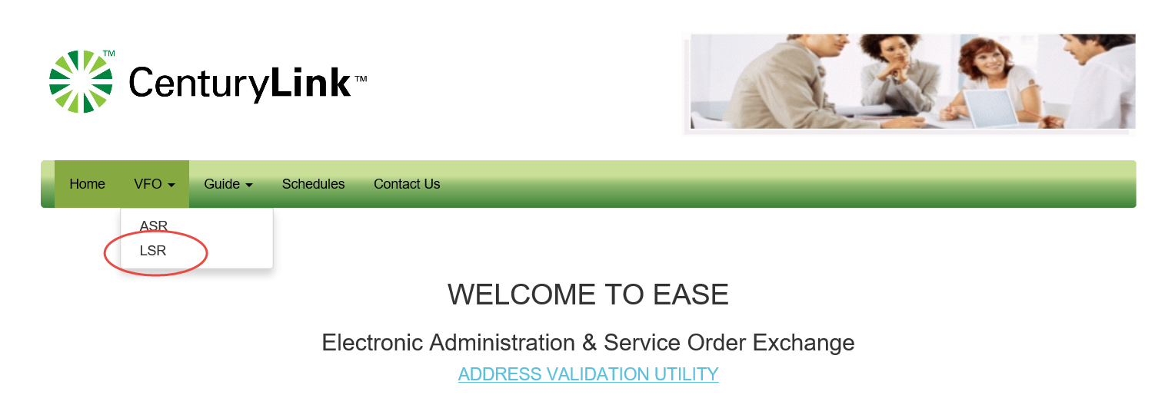
Then select Virtual From Office (LSR)

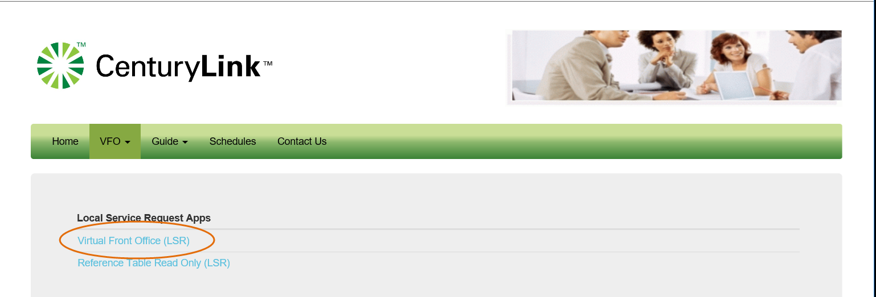

The Login Page prompts you for User Name and Password and is already populated with Local as the Module (you can also change your password from this location) Once info is entered you may either click the Login button  or the Enter key from your keyboard.

Navigating EASE –

To navigate in EASE, use the top row of buttons that are on the Right and slightly below the CenturyLink logo:

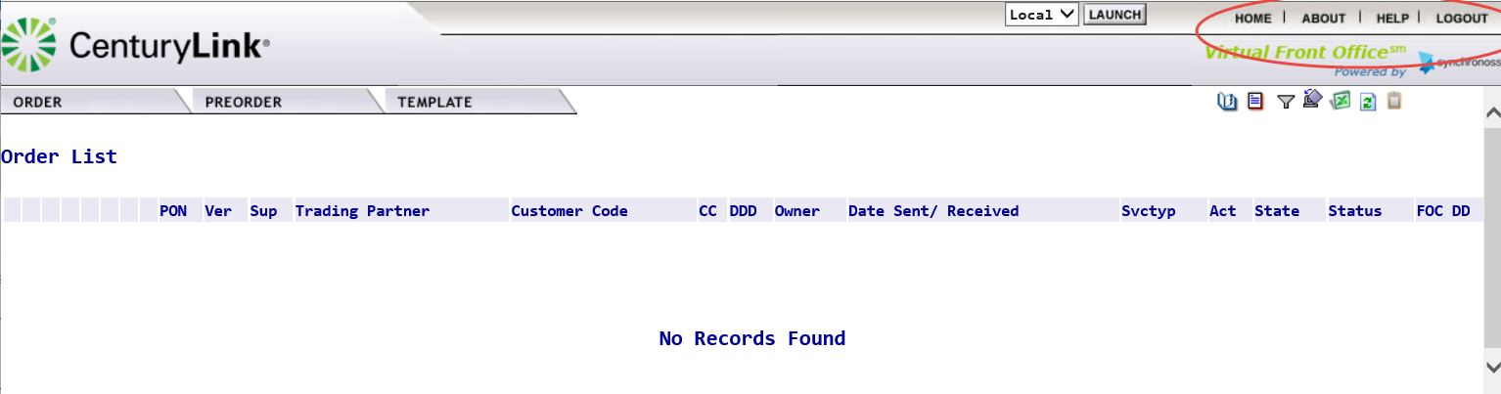

To do this... | Click this button / tab...
Return to the Order List page | Home
Open a pop-up window that lists login name of current user, current user’s full name, date and time the current version of the application was installed, VFO copyright information | About
Provides options to access VFO Admin Guide, VFO User Guide and VFO LSOG Guide | Help
Logout of VFO and return to the login page | Logout

The tabs in the Upper Left
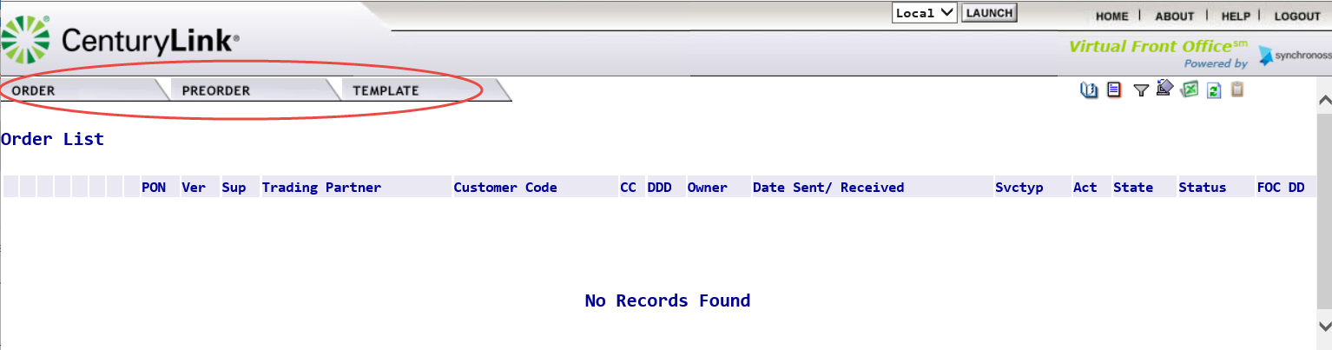
To do this... | Click this button / tab...
Access functionality to create or search for an order | Order
Initiate, search, and / or submit pre-order transactions | PreOrder
Access functionality to create or search for a template | Template
Access User Profiles and other security related information. This tab will only be visible if you have sufficient permissions | Administration

Following are standard guidelines to follow when working in EASE VFO

- A user can edit all fields unless they are dimmed. Fields that are automatically filled in cannot be edited.

- Avoid copying/pasting text from other applications (Word, Excel, PDF, and so on) into fields. Doing so may introduce "garbage characters" (carriage returns, tabs, line feeds, unsupported non-ASCII characters, spaces, and so on) that cannot be interpreted or translated properly when the data is transferred. Once a situation like this occurs, the only workaround is to perform a copy-to-new function and fix the offending field prior to requesting a validation, which forces the user to submit the LSR under a different PON. The workaround is cumbersome, and data could be unrecoverable if the situation occurs on a SUP.
EASE VFO System Requirements

Browser: VFO will support Internet Explorer version 11 and Google. Earlier versions of Internet Explorer will not work with VFO.

Whom to Call and When

If you need an account created or changes to your OCN/CC/CCNA permissions or personal information (name, email address, etc.), contact your EASE system administrator at Helpdesk.EASE@CenturyLink.com.
For LSR Ordering Systems Information, go to http://ease.centurylink.com/.

Requirement updates and additional questions and answers can be found at the CenturyLink LSR Ordering Systems web site at http://ease.centurylink.com/.

For all other problems, call the Wholesale Systems Help Desk:

Monday-Friday 6:00 a.m. to 7:00 p.m. (Mountain Time) Saturday 7:00 a.m. to 2:00 p.m. (Mountain Time)
Overview

EASE VFO Overview

Virtual Front Office (VFO) is the Web-based EASE application that provides a gateway for external CenturyLink Wholesale customers to submit Local Service Requests (LSRs) to CenturyLink. Internal CenturyLink employees also have access to VFO for order submission and tracking. VFO provides easy access to all industry standard LSR forms and allows the user to initiate, submit, and track Local Service Requests (LSRs).
Orders submitted to CenturyLink can be tracked in VFO.
LSRs can be submitted to CenturyLink:
Directly via online access to VFO
By UOM (Universal Ordering Module)

Password Rules

Customer users can change their own passwords using the following rules:

Passwords chosen must: verify this is still current
Be at least 8 characters in length but not more than 16 characters
Contain at least one character from any three of the following four categories
Uppercase alphabets (A-Z)
Lowercase alphabets (a-z)
Numbers (0-9)
Special characters (~ ` ! @ # $ % ^ & * ( ) - _ = + { } [ ] \ | ; : ‘ “ , . < > / ?)

Passwords chosen must not:
Contain a space
Be “password” itself
Be the same as the login user name
Be the same as the old password that is being changed

EASE Access

EASE is accessed via the following URL: https://ease.centurylink.com/

The home page of EASE will present with several tabs: VFO, Guide, Schedules, Contacts, as well as access to the Address Validation Utility Tool. Insert new screen print

The VFO > LSR Tab provides access to the Virtual Front Office (Local Service Request Apps) and the Reference Table Read Only (LSR). New screen print

The Guide > LSR > General and CenturyLink 2Q14 Files Tabs provide access to several helpful links as shown below.

GENERAL tab

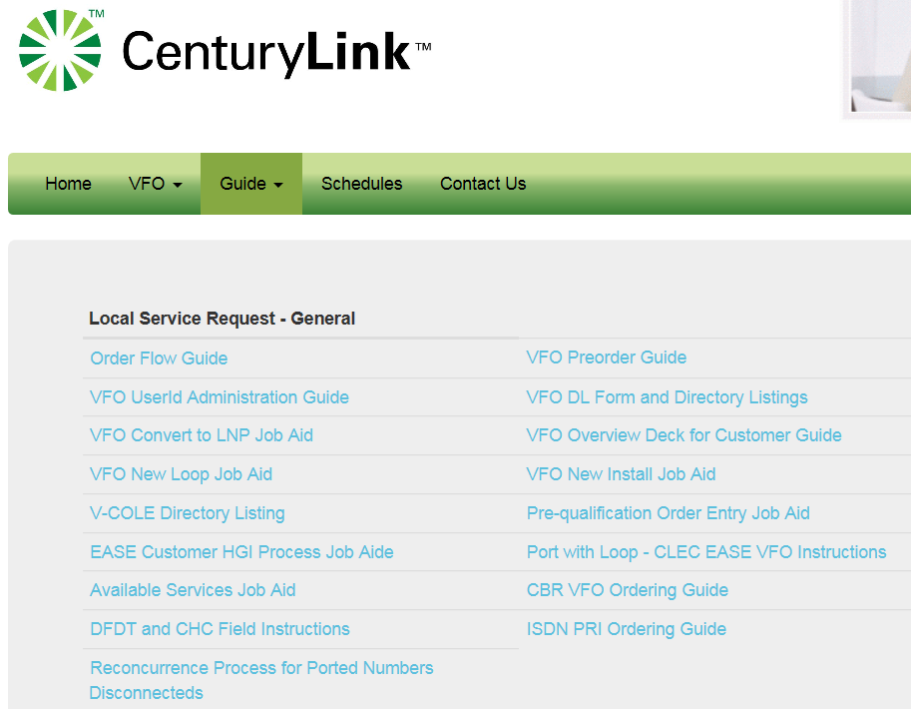
CenturyLink 2Q14 Files tab
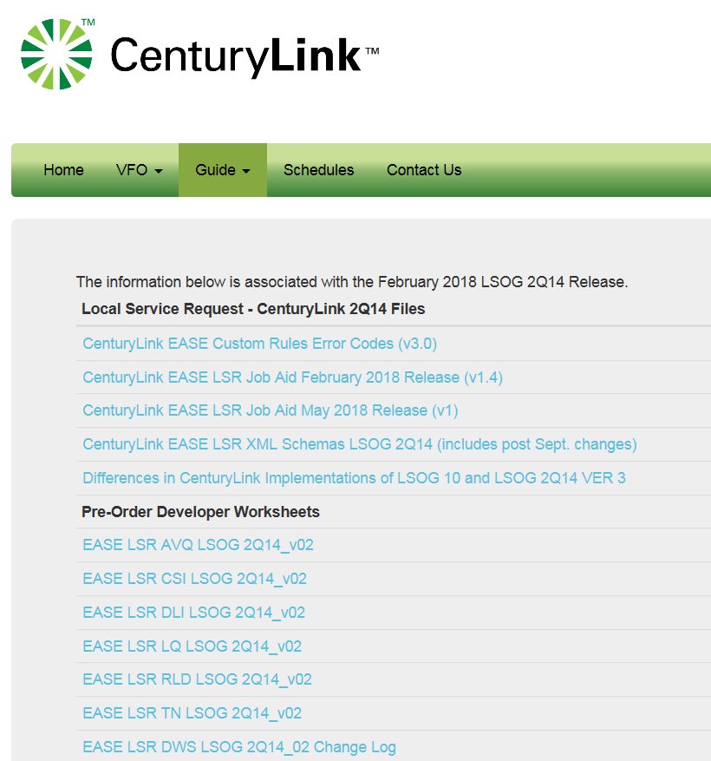
The Schedules Tab provides a list of Release Schedules.

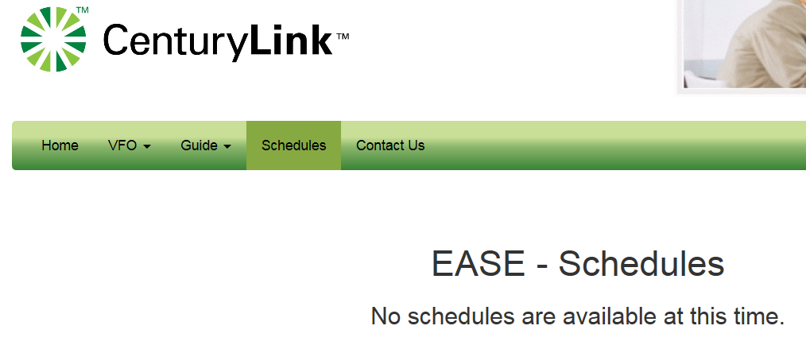

Contact Us Tab provides the phone number to the EASE Help Desk as well as the email address(es). 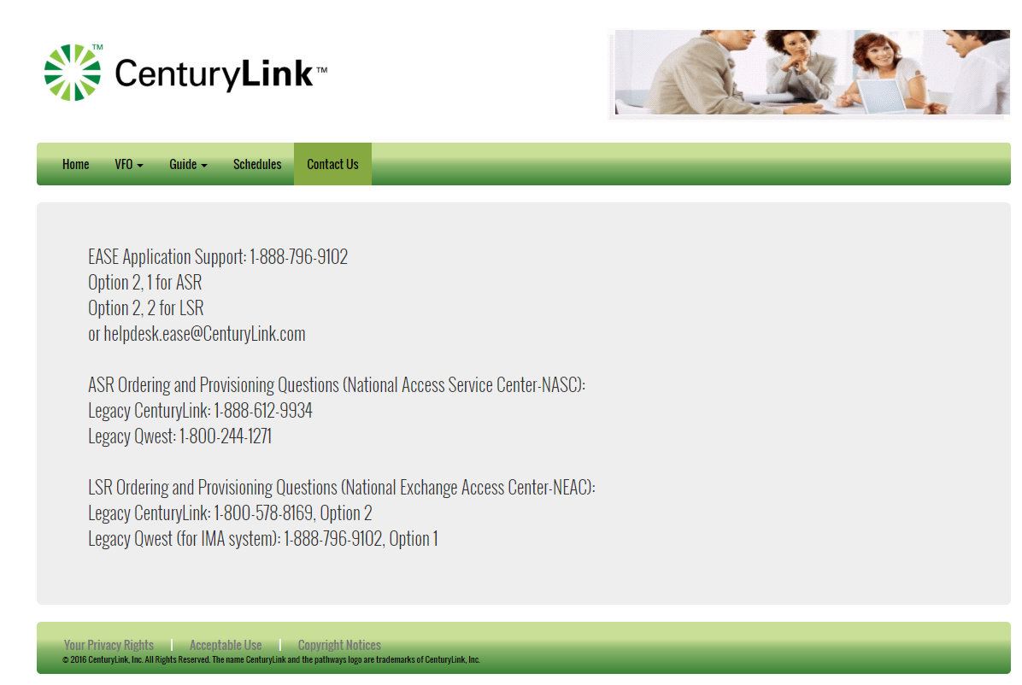

Login

EASE VFO users must log in with established credentials

Enter: Username and Password
Module: Local
Click the Login button

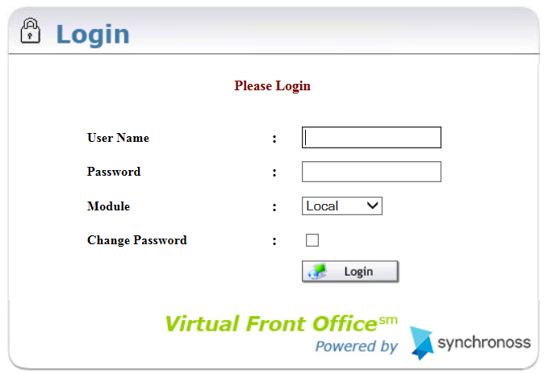

Upon successful login the user will be presented with the EASE Homepage.

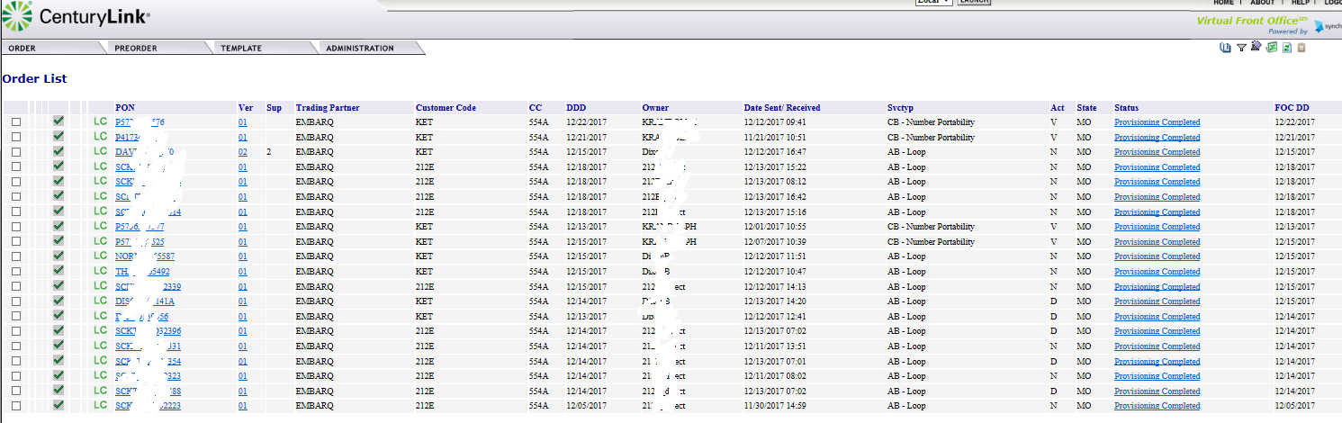

EASE Home Page ICONs – ensure same as updated Page ICON file

The upper righthand corner of the VFO Home Page has 7 action icons to select.


ICON | DEFINITION
 | History – provides a detailed history of an order, including Errored, Confirmed, Clarification, Jeopardy, DLR/Design, Completed, etc.
 | Create Response – allows user to create a manual response such as a Jeopardy or Clarification for a selected order
 | Filter – provides a way to filter orders from the order list. Clicking this ICON prompts another screen to open and requires the user to filter the criteria. Once filtered, user must clear the filter to return the order list to default view.
 | Return to Default Sort – allows user to return the order list to the default sort order
 | Export to Excel – exports an order selected from the Order List into an excel document
 | Refresh – Refreshes the Order List to show the latest order activities including new orders and updates to existing orders. This is NOT used to clear a filter or a sort, but only to update the Order List
 | Response Summary Report – provides abbreviated info, ie. Desired Due Date, Desired Time Frame, ILEC Order number

EASE Home Page Tabs

The top menu bar offers three options: Order, Pre-Order, and Template. Each of these tabs contain drop down menus. The user can return to this screen at any time by clicking the Home link in the top right of the screen.

Tab | Function
Order | New – Initiate a new order
 | Search – Search existing orders
 | Save as Order – Replicate an existing order
 | Save as Template – Create a template from an existing order
 | View History – View the history of an existing order
 | Create Response - Create a manual response for a selected order
 | Reassign Order – Reassign an order to someone else
 | External App Data 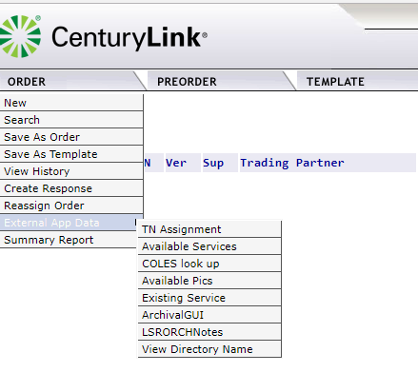
 | Summary Report
PreOrder | New – Perform the following:  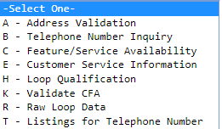
 | Search – Search for a preorder that was previously saved
Template | New – Create an order template
 | Search – Search for an existing order template

Order Status List

There is a Status column in EASE VFO that shows the user current status of orders in the Order List. These statuses also show when viewing the history of an order. Appendix 1 – Order Status List provides a definition, action, and user action for each status.

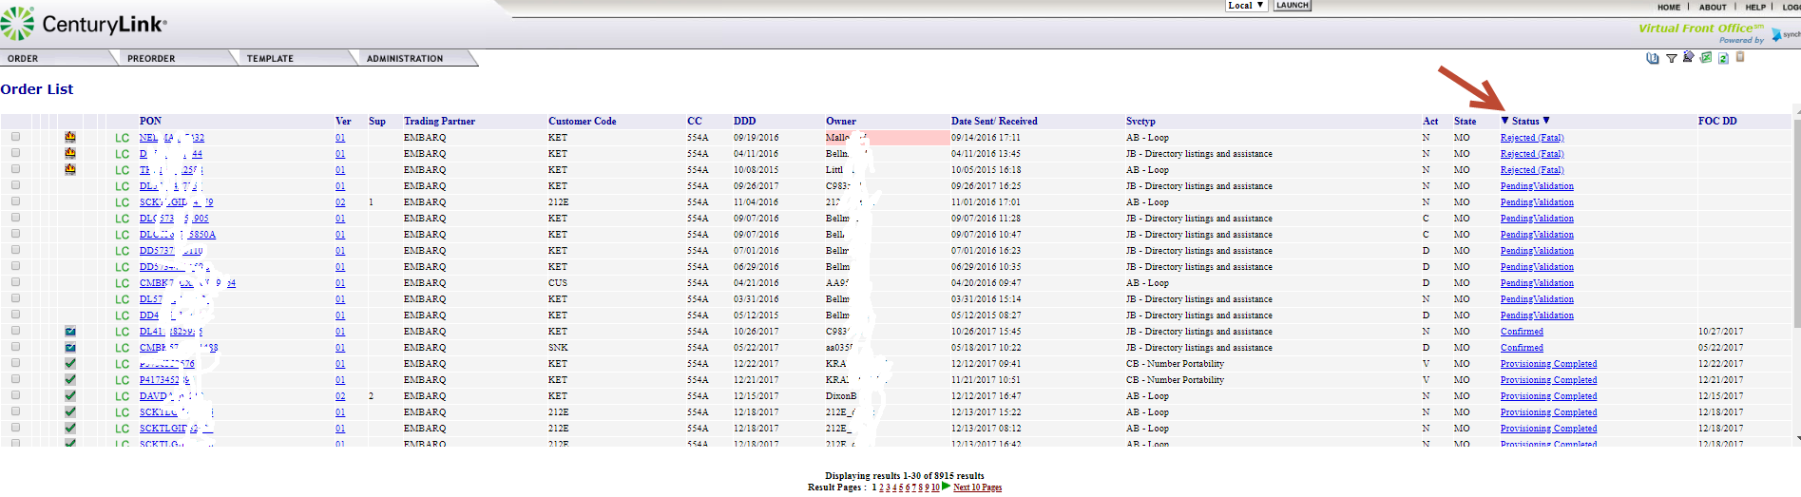

Order Status ICONs

Status ICONs may display to the left of the PON column on the Order List. These status ICONs are designed to assist with identifying the current status of orders in the Order List. Below is a list of all available status ICONs that may display on the Order List in EASE VFO.

Status ICON | Definition
 | Confirmed
 | Completed
 | Errored
 | Jeopardized
 | Rejected
 | RPON Present

Order Tab

LSR Order Entry

EASE VFO contains all of the industry standard forms and fields that are required to enter a Local Service Request (LSR). This document only includes the fields that are necessary for new installations of most order types; however, keep in mind that more fields or less fields may be required depending on what type of order being entered.

There is help text available for each field in an order in EASE VFO. The help text may assist the user with correcting errors or choosing valid field values. The help text for each field displays at the bottom of the screen after clicking into the field.

Note: All orders entered in EASE VFO must be in all capital letters. Set Caps Lock button on the keyboard before entering an order.

The user will select New from the Order Tab.

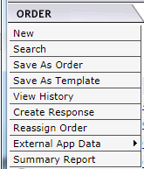

Once New has been selected, the Order Initiation window displays, and the user will enter basic ordering criteria.

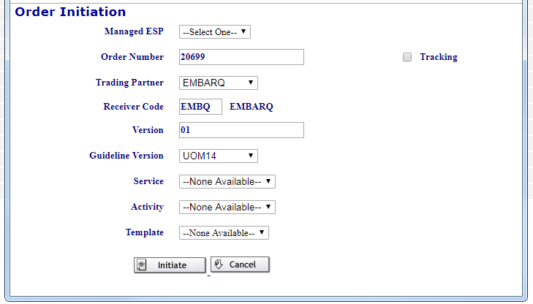

Managed ESP –this is the OCN for Order
Order Number – Purchase Order Number (PON). The PON can be up to sixteen alpha, numeric, or alpha-numeric characters. A user can only use a PON once. EASE VFO automatically populates the Order Number field with the next available number, but a user can override the number that EASE VFO assigns.
Trading Partner – Please enter EMBARQ
Receiver Code – Defaults to EMBQ.
Version – the version of the order
Guideline Version – the version of the industry standard guideline that applies to the order. OCN – may display if multiple OCN available for selection for specified Managed ESP
Service – the types of services are available in the Service field drop-down menu—for example, REQ AB - Loop.
Activity – the order activities are available in the Activity field drop-down menu—for example, New, Change, or Disconnect.
Template – previously created templates are in the Template field drop-down menu. User can choose to apply a template to an order if one is available.
Initiate – initiates the order.

Cancel – discontinues the order entry process. Upon initiating the order, the user will be navigated to the order. All information populated on the Order Initiation Page will populate onto the order. The default form is the LSR form as shown below. The red outline will indicate what form the user is creating.
Upon initiating the order, the user will be navigated to the order. All information populated on the Order Initiation Page will populate onto the order. The default form is the LSR form as shown below. The red outline will indicate what form the user is creating depending upon Activity and ReqType.

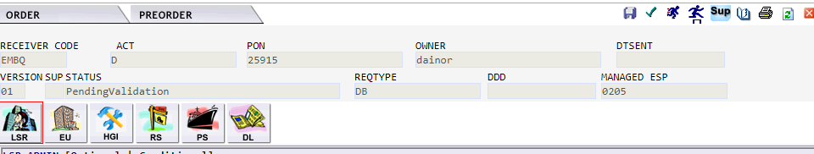

Select the valid Managed ESP for the order from the CUSTOMER CODE field drop-down menu.
Select the valid OCN in a drop down – required field

Populate the Service from drop down.

Populate Activity from drop down.

Click the Initiate button

In the Contact section of the LSR form, type the name of the customer employee who originated the request in the INIT field if not already populated

Populate the INITIATOR_TEL field with the phone number of the person who initiated the order. This field can be up to fourteen numeric characters and there should be no hyphens.

Type the name of the person to contact for design, engineering, or translations questions in the DSGCON field depending upon product

Populate the DSGCON_TEL field with the phone number of the person to contact for design, engineering, or translations questions if needed

Type the name of the person responsible for control of installation and completion in the IMPCON field.

Populate the IMPCON_TEL field with the phone number of the person to contact for installation and completion issues.

Order Validation

Once the required forms and fields have been completed, the order must be validated prior to being submitted. There are three ways to perform order validation.

Click the Validation ICON  in the upper righthand corner of the screen while in an order.

Select Validate from the Action sub-menu of the Order tab menu while in an order.

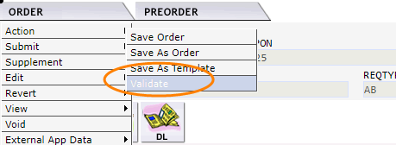

Selecting Validate and Submit from the Order tab menu while in an order.

Selecting Validate and Submit instigates order validation and submits the order to CenturyLink if there are no validation errors.

Error Code List

After an order is validated, if there are errors, an Error Code List box will display. The status of the order changes to “Errored” if the order is validated and there are errors. The user needs to correct the items shown in the Error Code List before the order can be successfully submitted.
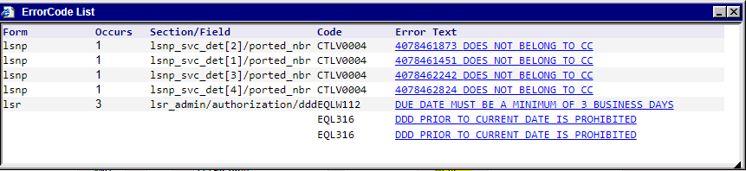

These are the Error Code List columns:
Form – On which LSR from the error occurs
Occurs – How many occurrences of the error
Section/Field – In which section and field the error occurs
Code – Internal code connected to the error
Error Text – Description of the error – Errored fields are highlighted in red.

Click the blue underlined Error Text to be taken to the location of the error within the order. The field will be highlighted in red and the user can make the correction and move on to the next error for correction. The user can validate at any time during this process to check progress. It is recommended a user validate after each error correction as correcting one error may eliminate other errors or may generate new errors.

Occasionally, clicking the blue underlined error text does not take the user to the error. If this happens, the user will be presented with a Manual Error Search Box. Click OK to close the box. The user must manually look for the error.

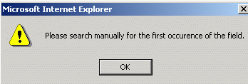

A user may view the Error Code List by selecting View Error List from the View sub-menu on the Order Tab.
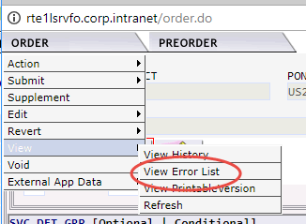

Help text is available for each field once in an order in EASE VFO. The help text may assist with correcting errors or choosing valid field values. The help text for each field displays at the bottom of the screen after clicking in the field.

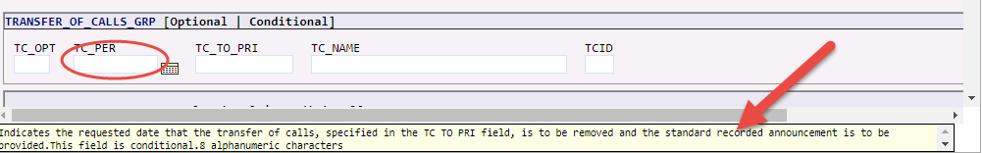
Order Submission

Once order validation is performed and the order is error free, the Status field will change to Validated and the order is ready to be submitted. There are two ways to submit an order.

Click the Submit ICON  in the top righthand corner of the order.

Select Validate and Submit from the Order Tab drop-down menu.
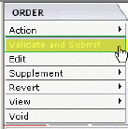

Upon successful submission, the Status field in the order will change to ‘Sent’. If a customer does not receive an Sent or “error” status within their normal processing time, the customer may contact CenturyLink to determine if the order is stuck before resending.

Use the following matrix to determine the next step:

If | Then
The Status field at the top of the order says Sent or Resent  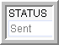  Exception: Meet-point orders where CenturyLink is not in control stop at Sent status. This is okay and the user does not have to resend when this happens. | Roll the cursor over the Order tab and choose Resend from the Edit sub-tab menu.

Address Details

Certain fields are required in the Address Details section for any order that contains an address. The minimum entries in the Address Details section are:
SANO = House Number
SASN = Street Name
CITY
STATE
ZIP CODE
For a complete list of the available fields in the Address Details see Appendix 4 – Address Field and Definitions.

Complex Addresses

Complex address inquiries can be entered using the Location Designator fields. User must populate the minimum required address inquiry fields plus the location designators if applicable as follows.

LD1 – Enter description types—for example, UNIT, APT, ROOM, RM, FL, FLR, BLDG, or STE
LV1 – Enter the value associated with the description type—for example, 100, 1, or 36
AAI - describe
The LD description type can be placed in any Location Designator field, LD1, LD2, or LD3 and the associated value is placed in the corresponding LV1, LV2, or LV3 fields.

Data Search

A user can access the Order tab Search menu option to find different search criteria, view the history of an order including Confirmation, Jeopardies, Completions, etc., and search for and modify existing templates. Note: A partial search can be performed by entering part of the search criteria followed by a %. This is considered a wildcard or partial search.

With the Order List in view, select the Order Tab > Search option.

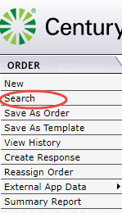

The Order Search Page appears with Purchase Order Number (PON) as the default search option.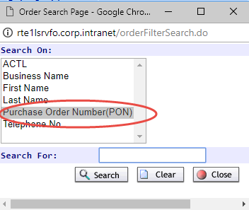

Select a search option; for example Purchase Order Number (PON), Business name, Last Name etc. Type the exact information in the Search For field, then click the Search button. The query will be initiated.

Use the following matrix to determine the next step:

If | Then
The search is successful and orders matching the search criteria are displayed in the Order List | Click the Close button in the Order Search Page box.
The search is not successful and “No Records Found” displays below the Order List | From the Order Search Page box, click the Clear button to search again or click the Close button to discontinue the search function.

Order Replicate

A user can replicate an existing order to use for new order creation in EASE VFO. The order that a user replicates (copies) is for one-time use. If a user wants to create a shell order for use on a go forward basis, a user would create a template and not replicate an existing order. Replication requires the user to change the existing PON. There are two methods to replicate an order.

From the Order tab when the Order List is in view, select an order from the Order List, then select the Save As Order menu option from the Order Tab to initiate the order replication function.
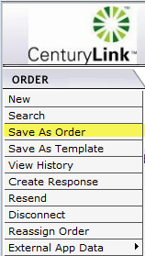

From the Order tab when in an existing order—when viewing an existing order, the Save As Order menu option can be selected from the Action sub-menu of the Order tab to initiate the order replication function.

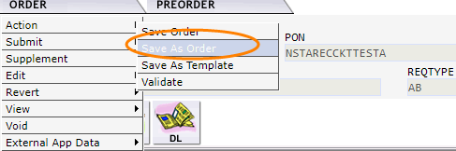

Once the user proceeds, the screen will populate with the Save As New Order page.
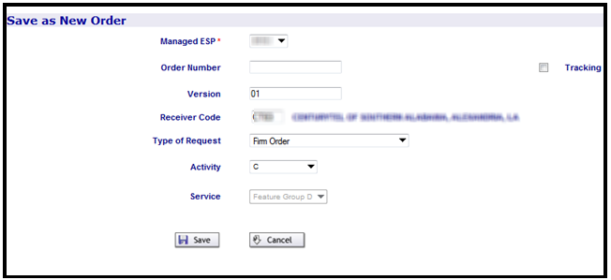

Use the following matrix to determine the next step:

If | Then
User is ready to create the order | Click the Save button and proceed  Result: The order is replicated and the new order displays.
User is not ready to create the order | Click the Cancel button and do not proceed.  Result: The order is not replicated, and the screen returns to the previous screen of either the Order List or the order.

Enter all pertinent fields and submit the order to CenturyLink.

Order Supplements

Once an order is submitted and the status changes to Accepted (or Sent), the user must issue a supplement order to make changes or cancel. The user can make changes or cancel all the way up to the point at which the order changes to Completed status. There are two ways to supplement an order:

Select the Sup Icon 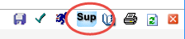 in the top right of the order to initiate the supplement. 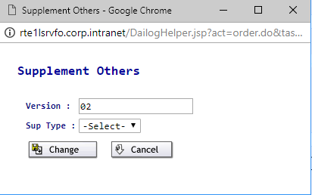

1 = Supplement Cancel
2 = Supplement DDD Change (Due Date Change)
3 / 4 = Supplement Others
Add values 4-7 and description

You can also do a Sup from the Order Drop
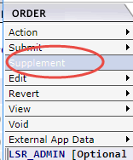

Ordering Options

There are two Order Tabs as follows:

The Order Tab that displays when the default Order List screen is in view.
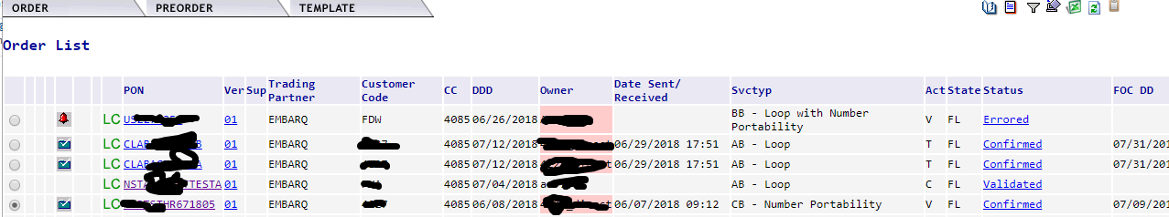

Order Not Accepted or Error

If the order gets stuck in Sent and does not receive an “accept” or “error” status within their normal processing time, the customer may contact CenturyLink to determine if the order is stuck.

View

A user can view a printable version of an order by selecting the View Printable Version from the View sub-menu of the Order tab menu while in an order.

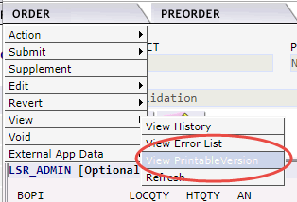

Save Order

The Action menu option from the Order tab drop-down menu within an order contains a Save Order sub-menu option. When working with an order, a user can save work any time by selecting Save Order from the Action menu option of the Order tab. An order will be saved every time it is validated.

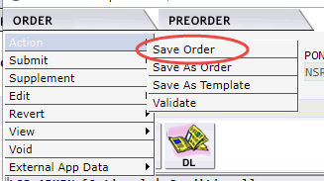

Revert

The Revert menu option from the Order tab has two sub-menu items as follows:

Revert to Last Save - Reverts the order back to the last time it was saved or validated.
Revert to Last Submitted - Reverts the order back to the last time it was submitted.

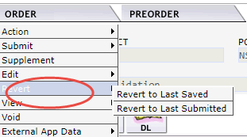

Void

The Void menu option from the Order tab within an order allows the user to void an order that has not been submitted and accepted. Once an order has been submitted and accepted, the user will have to supplement the order to cancel if it is not needed. If an order is voided, the PON associated with that order cannot be used again until the voided PON is purged from the database. There is not a timeframe established for purging voided orders at this time.

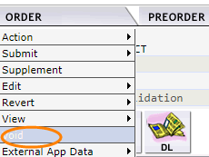

Order History

There are several ways to view the history of an order in EASE VFO as follows:
Click the History ICON  when an order is selected from the Order List
Clicking the History ICON while viewing an order
Selecting View History from History sub-menu of the Order tab while viewing an order

Use the following matrix to determine the next step:

If | Then
User wants to see the history of an order from the Order List | - Click the radio button next to the left of the order.  - Click the History ICON in the upper righthand corner of the screen.
User wants to see the history of an order that user is viewing | - Click the History ICON in the upper righthand corner of the screen.  - Select View History from the History sub-menu of the Order tab.

Use the following matrix to determine the next step:

If | Then
User wants to see errors associated with the order | - Click the PON that has a Status column that says Errored.  Result: The order displays with Error Code List box that shows you what errored at that point in the order lifecycle.  - Click the Close button at the top right of the screen to exit that piece of the order history.
User wants to view a Jeopardy, Confirmation, or Completion | - Click the PON that has a Status column that says, Jeopardy, Completion, or Confirmation.  Result: The appropriate form is displayed.  - Click the X in the top righthand corner of the window to exit the form.  Note: User can select the Print button at the top right to print the form data.

Use the following matrix to determine the next step:

If | Then
User wants to return to the order of which you were viewing the history | Click the Back to Order ICON  in the top righthand corner of the screen.
User wants to close the order | Click the X in the top righthand corner of the window.

View Status from the Order List

Looking at the Order History screen is not the only way to view, Confirmations, Jeopardies, and Completions. When the PON is in view on the Order List, a user can click the Status column of that PON and view these items.

PreOrder Tab

Using preorder functionality ensures good data is present on the order before it is submitted to CenturyLink. This eliminates multiple rejections and delays in customer orders. There are two submenus under the PreOrder Tab in EASE VFO.

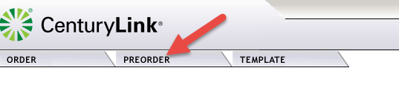

- Selecting New from the PreOrder menu allows the user to initiate a new preorder.
- Selecting Search from the PreOrder menu allows user to search for an existing preorder.

If a CenturyLink address preorder is not done by using the PreOrder tab menu, the user can perform an address or search preorder during order initiation. Instructions on how to perform the CenturyLink address preorders while entering an order are in the EASE VFO Order Module.

With the Order List in view, place the cursor over the PreOrder Tab and select New. The PreOrder Initiation screen appears.

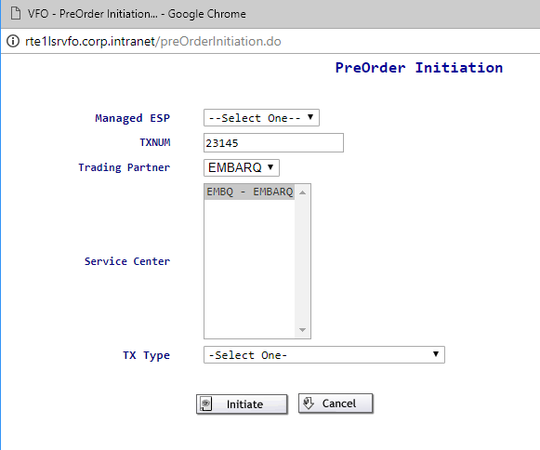

- Managed ESP has a drop-down that needs selected.
- TXNUM – tracks the preorder—it can be the Purchase Order Number (PON) or any other alpha, numeric, or alphanumeric combination up to twenty-five characters in length or default to auto populated number.
TX Type
There is a drop down for the type of PreOrder Initiation that you desire to do.
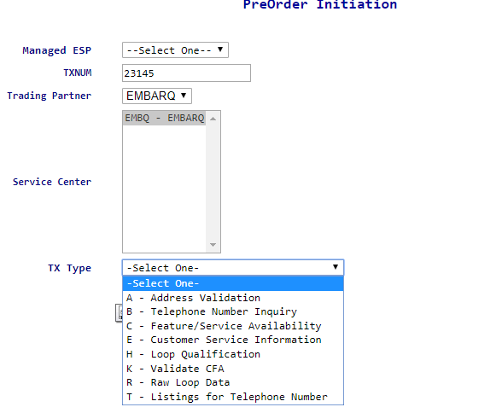
Move cursor over one (A,B,C,E,H,K,R, or T) and click the Initiate button.
Then enter info requested on the page that next appears. Please use CAPITALS on all entries:

A – Address Validation
STATE (in top)
Address Info
The MINIMUM entries on this screen include:
House Number (SANO), Street Name (SASN), City, State and ZIP code.
E – Customer Service Information
AGAUTH – must be Y (to confirm you have customer’s authorization to look up info)
DATED
WTN
CSR_DATE
H – Loop Qualification
MS
Address Info (same fields as appropriate in an order)
T – Telephone Number Inquiry
CC
STATE
LTN
STATE

Important Notes:
Abbreviations:
Address Validation uses 911 addressing. Therefore, addresses in the database are reflective of the manner in which each individual city, state or community entered them. This will result in variances in abbreviations. For example, Avenue may be found as AVE or AV.

Highways:
When validating addresses which are highways, you may want to try the following variations:
  - US XX (where XX = the highway number)
  - US Hwy XX
  - HWY XX

Numbered streets are normally in the database using the numeral but they may also be spelled out. For example, Second Street may be 2, 2nd or Second. It is recommended that you first try your validation using just the number. For example: 2.

Address Validation Results Screen | Based on the information entered on the Address Validation screen, the system will execute the request and provide a response. The response results will display in the IRM field. For example: Exact Match, Alternatives Exist, Facilities Not Found, etc.
  Response | Response Definition
  Exact Match | The address information entered has been executed successfully.
  Alternatives Exist | Multiple addresses met the criteria entered. The user will need to review available addresses displayed for the correct address, change the criteria, and re-validate.
  Facilities Not Found | The address is valid in SIG. WILSERV cannot verify the address.
  No EMBARQ Address Found for This Address | The address is not in EMBARQ’s location.

Save and Search

After the Pre-Order result is displayed, the user can save the result for future use by clicking on the Save button at the bottom of the Address Validation Results Tab. The message, “Request and Response saved successfully” will appear at the top of the screen. Click the Close button.

To initiate a search, return to the Pre-Order screen and select Search. The screen displays the search criteria at the top and underneath a list of all the pre-order results that have been saved. At the bottom of the screen, it displays the total number of saved results. Click on the number next to the Results Page or arrow to display the next ten results.

Note: The preorder record is not saved if user closes without saving first.

If the preorder is not a success, the user can:

Click the Change button to try the preorder again.
Click the Save button to save the preorder.
Click the Printable Version button to view and print the preorder.
Click the Close button to exit

Once a CenturyLink address or is validated via the Preorder tab and is determined to be valid, user can proceed to order initiation.

EASE Help

Help text is available for each field once in an order in EASE VFO. The help text may assist the user with correcting errors or choosing valid field values. The help text for each field displays at the bottom of the screen after clicking into the field.

The LSR Order Page – https://ease.centurylink.com/
EASE Training - http://training.centurylink.com/ease
Address Validation utility, Virtual Front Office and Reference Table Maintenance - http://ease.centurylink.com/
The LSOG Document if available from the OBF Document Catalog at ATIS.org.

Contact Information

For additional assistance with LSR Inquiries:
Via Phone: 800-578-8169
Via Phone: Helpdesk.Ease@centurylink.com

Appendix 1 - Order List Status

The Order List status matrix below provides definition and user action for each status on the Order List.

Status ICONs | Status ICONs may display to the left of the Receiver Code column on the Order List. These status ICONs are designed to further assist you with identifying the current status of orders in the Order List.  Below is a list of all available status ICONs that may display on the Order List in EASE VFO.

Status ICON | Definition
 | Confirmed
 | Completed
 | Errored
 | Jeopardized
 | Rejected
 | RPON Present

Status | Definition | Send/Rcv or Receive | User Action
Completed | The VFO user has manually updated the LSR status to Completed or the AP has initiated a Completed message. | Send/Rcv | Review Response
Confirmed | The AP has returned a Confirmation message for the order. Exchange Path has updated the status, stored the message in the EP database, and sent a notification message to VFO to update the status. | Send/Rcv | Review Response
Errored | The LSR has failed the validation process. Exchange Path has updated the Request Status, stored the LSR, and sent an Error Notification to VFO. | Receive | Correct the error and validate again.
Jeopardy | Jeopardy status indicates that there are situations that may jeopardize critical dates of the LSR. | Send/Rcv | Review the Jeopardy and take the recommended action.
Rejected | The AP has returned a negative (rejection) acknowledgment. Exchange Path has updated the status, stored the message in the Exchange Path  Database, and sent a notification message to VFO to update the status. | Send/Rcv | Review the response and take the recommended action.

Appendix 2 - Order Types and Request Types

ReqType Description
A Loop
B Loop w Number Portabliity
C Number Portability
D Retail/Bundled
E Resale
F Unbundled Local Switching (Port)
J Directory Listings & Assistance
K Resale Private Line
L Resale Frame Relay
M Combined Loop & Unbundled Local Switching (Port)
N DID/DOD/PBX
P CENTREX Resale
Q ISDN

Activity Type (not all activities are available for every ReqType)
B Restore
C Change an existing account, e.g., rearrangement, partial
D Disconnection
L Seasonal Disconnection
N New installation and/or account
S Suspend
T Outside move of end user location
V Conversion of service to new LSP as specified
W Conversion as is

Appendix 3 – PreOrder Responses –

Address Validation Results Screen | Based on the information entered on the Address Validation screen, the system will execute the request and provide a response. The response results will display in the IRM field. For example: Exact Match, Alternatives Exist, Facilities Not Found, etc.
  Response | Response Definition
  Exact Match | The address information entered has been executed successfully.
  Alternatives Exist | Multiple addresses met the criteria entered. The user will need to review available addresses displayed for the correct address, change the criteria, and re-validate.
  Facilities Not Found | The address is valid in SIG. WILSERV cannot verify the address.
  No EMBARQ Address Found for This Address | The address is not in EMBARQ’s location.

Pre-order Error Message

Error Message | The following error messages are related to Pre-order activities:  AGAUTH Value should be populated for CSI Inquiry – Please verify the AGAUTH field is populated.  CC/State Missing in CSI Inquiry - Please verify the CC/State fields are populated.  Change button - Allows the user to make changes to the fields on the Inquiry Tab.

Appendix 4 – Address Fields and Definitions

The below matrix provides the address fields and definitions for the Address Details section of an order. (The End User information) 

Address Field | Definition
AFT (Address Format Type) | Valid Entries:  A = Rural route and/or box number  B = Unnumbered  C = Provider Assigned house number  D = Descriptive  E = Provisioning Address
SAPR (Service Address Number Prefix) | Identifies the prefix for the address number of the service address
SASF (Service Address Number Suffix) | Identifies the suffix for the address number of the service address
SASD (Service Address Street Directional Prefix) | Identifies the street directional prefix for the service address—for example, N = North, S = South, E = East, W = West, etc
SATH (Service Address Street Type) | Identifies the thoroughfare portion of the street name of the service address—for example, LN = Lane, BLVD = Boulevard, ST = Street, etc
SASS (Service Address Street Directional Suffix) | Identifies the street directional suffix for the service address—for example, N = North, S = South, E = East, W = West, etc  Note: The SASS is different than the SASD. The SASS is when the directional comes after the street name—for example, Main St West.
LD1 (Location Designator 1) | Identifies additional specific information related to the address—for example, building, floor, unit, or room
Address Field | Definition
LV1 (Location Value 1) | Identifies the value associated with the LD1 of the address
LD2 (Location Designator 2) | Identifies additional specific information related to the address—for example, building, floor, unit, or room
LV2 (Location Value 2) | Identifies the value associated with the LD2 of the address
LD3 (Location Designator 3) | Identifies additional specific information related to the address—for example, building, floor, unit, or room
LV3 (Location Value 3) | Identifies the value associated with the LD3 of the address

