|  |  |  |
| --- | --- | --- |
| **Announcement Date:** | **August 24, 2021** | |
| **Effective Date:** | **November 22, 2021** | |
| **Notification Number:** | **CMPR.CMPP.08.16.21.F.18252.BVMS_WEBSITE_DECOMMISSED** | |
| **Notification Category:** | | Systems |
| **Target Audience:** | CLEC-C & CLEC-Q | |
| **Subject:** | **Level 2 – BVMS Website Being Decommissioned** | |
|  |  | |
|  |  | |

**Summary of Change:**

Due too little to no usage, the BVMS website (<https://bvms.centurylink.com/>) is scheduled to be decommissioned on November 22, 2021.

Below is a screen shot of the current website.

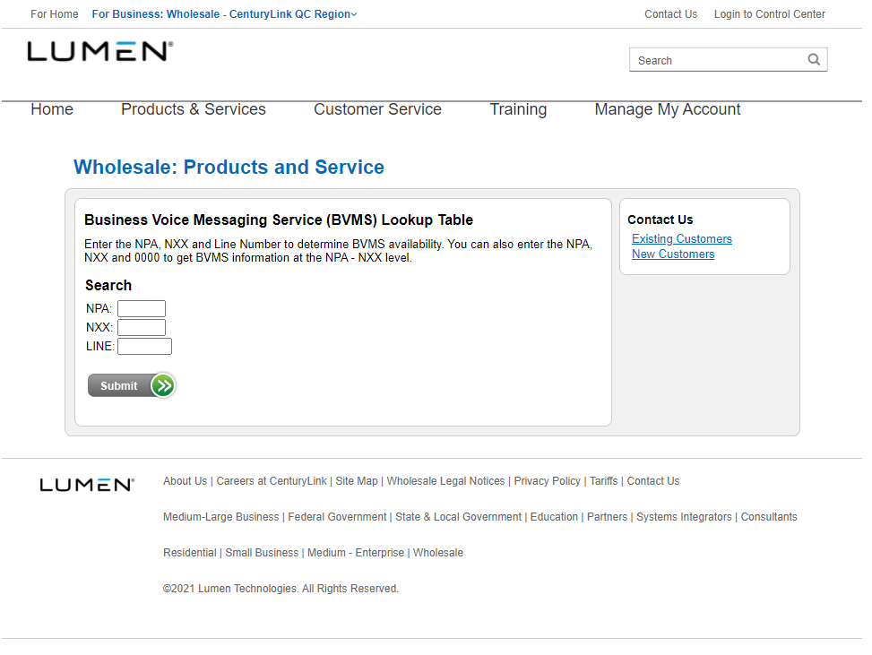

**Comment Cycle:**

CenturyLink encourages you to review and submit questions or comments at any time during the comment cycle as listed in the table below.

You may e-mail questions or comments to [cmpcomm@centurylink.com](mailto:cmpcomm@centurylink.com).  Be sure to reference the Notification Number listed above.

**Timeline:**

|  |  |
| --- | --- |
| Website available | August 24, 2021 |
| CLEC Comment Cycle begins | August 25, 2021 |
| CLEC Comment Cycle ends | 5:00 PM MT, September 1, 2021 |
| CenturyLink response to CLEC Comments (if applicable) | September 2, 2021 |
| Proposed Website Decommissioned Date | November 22, 2021 |

If you have any questions concerning this change, please contact Customer Service for CenturyLink Wholesale: <http://www.centurylink.com/wholesale/CS_profile.html>.