WBSA EASE VFO LSR LC Region (Eastern States) Pre-Ordering and Ordering Job Aid

Contents
EASE LSR Login 2
LSR Preorder 3
LSR New Install PON 6
EASE LSR Logout 15

DISCLAIMER: It is the customer’s responsibility to ensure they are using the most updated document. LUMEN is not responsible for updating or notifying the customer of industry change. Lumen updates to the document will be posted in the Wholesale Broadband product catalog at https://www.centurylink.com/wholesale/pcat/wbsaresale.html.

EASE LSR Login
Follow the steps below to login to EASE VFO LSR.
Step | Action
1 | To access EASE VFO, copy/paste or ctrl click https://ease-lsr.centurylink.com/ . (Note: Use Chrome for browser)  - User Name: Enter User Name  - Password: Enter Password  - Module: select Local from the dropdown  - Click Login  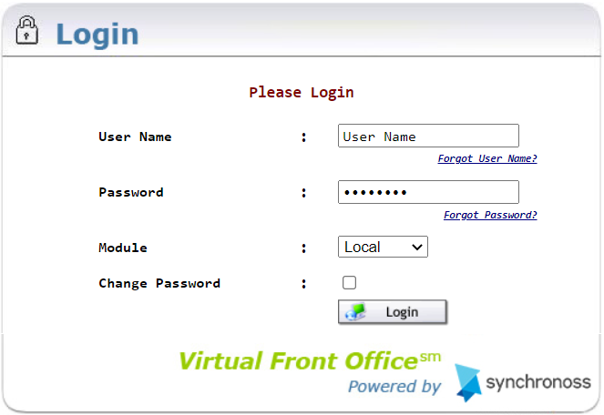  Result: Home Page/Status Screen Displays.  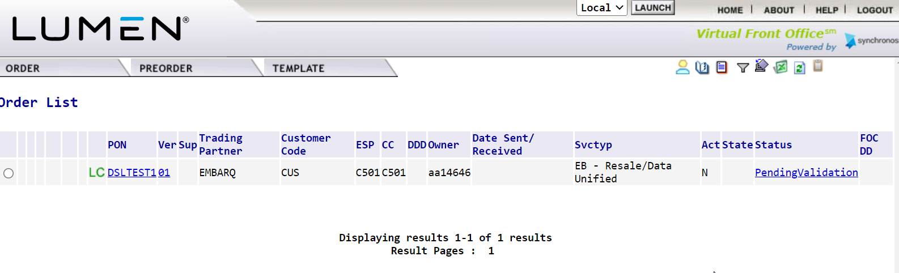

LSR Preorder
Preorder is an option that provides address validation and speed qualification. The information can be saved and retrieved later into an LSR. Follow the steps below to perform a Preorder.
NOTE: Entries should be in ALL CAPS.

Step | Action
1 | Hover over PREORDER and click New.  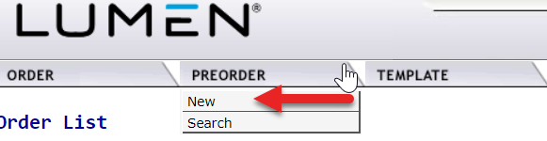
2 | - Enter the Managed ESP in Managed ESP field, if necessary. It will be the ESP that includes access to the CenturyLink region OCN.  - Enter a Tracking ID in the TXNUM Field (Note: This will be used to search for any saved Preorder queries.)  ALERT! Please make note of the TXNUM populated as it will be used to retrieve preorder information on later steps.

LSR Preorder (Continued)
Step | Action
3 | - Select the OCN in OCN field.  Select A=Address Validation from the TX Type field.  Utilize Values of:  - Click Initiate  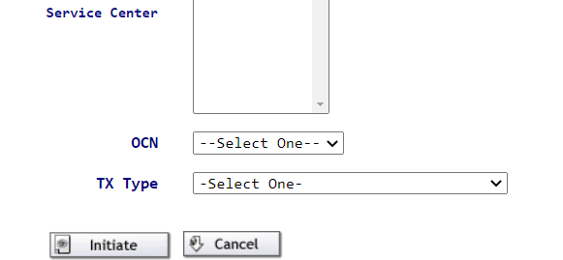
4 | Enter the following fields as required:  - CCNA – CenturyLink region OCN/Company Code  - STATE – Two Alpha characters  - Within the SVC-ADDR-GRP:  - SANO – Svc Address Number (required)  - SASD – Svc Address St Direction Prefix (required if part of address)  - SASN – Svc Address Street Name (required)  - SATH – Svc Address Street Type (required)  - SASS – Svc Address St Dir Suffix (required if part of address)  - CITY – Required  - STATE – Two Alpha characters (required)  - ZIP (required)  - LD/LV – Supplemental information such as unit, bldg., etc. (required if part of address)

LSR Preorder (Continued)
Step | Action
4  cont | - Click Submit  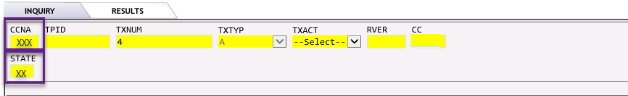
5 | Example of Exact Address Match Found. NOTE: use scroll bar for down and up and left and right  - If Exact Address Match Found, click Save.  Or  - If Near Match returned:  - Review the alternatives.  - Click on Change  - Return to step 4.

LSR New Install PON
Follow the steps below to create and submit an LSR.
Step | Action
1 | Hover over ORDER and click New.  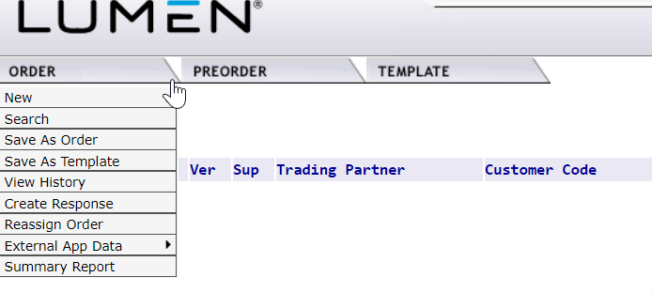
2 | - Select the Managed ESP, if necessary. It will be the ESP that includes access to CenturyLink region OCN.  - Enter the order number in Order Number field. NOTE: Must start with DSL. (Example: DSL12345).  - Select the OCN.  - Select EB-Resale in Service Field.  - Select N-New Installation in Activity field.  - Click Initiate.

LSR New Install PON (Continued)
Step | Action
3 | LSR Form Entry  LSR Admin Section:  - Enter 1 in LOCQTY field.  - Enter the Project ID in PROJECT field. It will always begin with CWS and end in BSA (example: CWSxxxxBSA)  - Select B in PROJINDR.  - Select E in RTR.  - Enter CCNA – CCNA = ACNA  Authorization section:  - Enter (1BF- for Business, 2BF- for Residence) in TOS field. Note: The dash is part of the TOS.  - Select DDD (Desired Due Date)
LSR New Install PON (Continued)
Step | Action
3 cont. | LSR Form Entry (continued)  Contact section:  - Enter name of person creating LSR in IMPCON field (to the right of the screen)  - Enter TN of person creating the LSR in IMPCON TEL NO field.  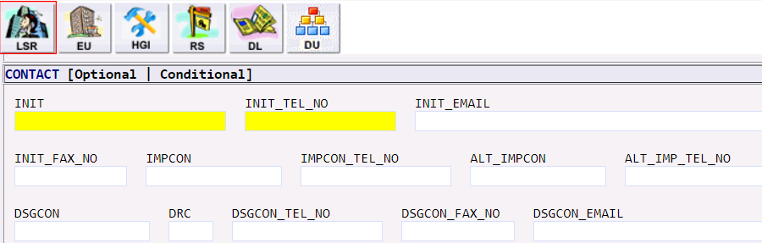  Remarks Info section:  - Enter remarks pertinent to the request in REMARKS1. (Example: install pure broadband, speed 10.0)
4 | Click on EU Form  LOC ACCESS section:  - Enter 1 in LOCNUM field.  - Enter name of the end-user in NAME field, must be 2 words, ex: McDonald’s Restaurant.
LSR New Install PON (Continued)
Step | Action
4 cont | EU Form Entry (continued)  LOC ACCESS INFO section:  - Enter local contact person in LCON.  - Enter local contact person telephone number in TEL NO.  SVC ADDR GRP section:  - Click Search Pre-Order.  - Select the saved Preorder TXNUM related to this request and click on it.

LSR New Install PON (Continued)
Step | Action
4 cont | EU Form Entry (continued)  Result: Preorder opens.  - Click PrePopulate.  Result: EU SVC ADDR GRP pre-populates with valid address.
5 | Click on RS Form  RS ADMIN section:  - Enter 0001 in RSQTY field.  RS SVC DET section:  - Enter N in the TNS field.

LSR New Install PON (Continued)
Step | Action
5 cont | RS Form Entry (continued)  SVC DET GRP section:  - Enter 01 in LOCNUM field.  - Enter 01 in LNUM field.  - Enter N in LNA field.  LINE RESTRICT 2 GRP:  - Enter NONE in PIC field.  - Enter NONE in LPIC field.  FEATURE GRP Section:  - Enter 5 in section(s).  - Click Add.  Result: There are now 6 Feature fields available to be populated.

LSR New Install PON (Continued)
Step | Action
5 cont | RS Form Entry (continued)  Utilizing the WBSA External Comm Feature Code Spreadsheet, Eastern States Tab, enter FEATURE GRP [1] through [6] with valid Feature Codes for the speed/technology to be ordered. Note: Not all FEATURE fields may be populated; entries may vary depending on whether Static IPs are requested.  https://www.centurylink.com/wholesale/pcat/wbsaresale.html  RS FEATURE GRP [1] Section:  - Enter N in FA field.  - Enter NDT Line Feature Code in FEATURE Field.  RS FEATURE GRP [2] Section:  - Enter N in FA field.  - Enter the speed Feature Code in FEATURE Field.  RS FEATURE GRP [3] Section:  - Enter N in FA field.  - Enter the install Feature Code in FEATURE Field.  RS FEATURE GRP [4] Section:  - Enter N in FA field.  - Enter the Gateway/Modem Feature Code related to the install choice in FEATURE Field.  NOTE: FEATURE GRP [5] and [6] can be used for ordering Static IP. If not ordering Static IP, leave them blank and go to next step.  RS FEATURE GRP [5] Section:  - Enter N in FA field.  - Enter Static IP Address Feature Code FEATURE Field.  RS FEATURE GRP [6] Section:  - Enter N in FA field.  - Enter Static IP Feature Code for the number of IPs requested in FEATURE Field.

LSR New Install PON (Continued)
Step | Action
7 | In top right corner of LSR, click on Save ICON.  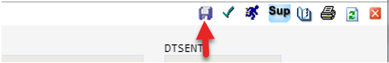
8 | In top right corner of LSR, Click on Validate ICON.  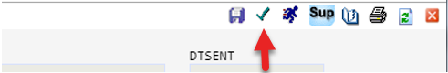
9 | If Error Code list returns, correct those errors. Errors must be corrected before PON can be submitted.  Example of Error Code List:  If no errors were received or once PON is error free, click on Submit ICON.  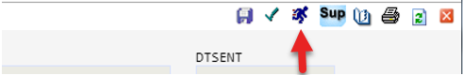  Result: STATUS will show Submitted.

LSR New Install PON (Continued)
Step | Action
10 | Click on Red X in top right hand corner to exit out of PON.  Result: Home Page/Status Screen will display.
11 | End of process.

EASE LSR Logout
Follow the steps below to Logout of EASE VFO LSR.

Step | Action
1 | Click LOGOUT in the top right-hand corner.  Result: Login screen displays.

