EASE VFO Preorder

New Preorder | CenturyLink addresses and Connecting Facility Assignments (CFAs) can be validated prior to order submission by doing a preorder. There are two ways to do a preorder as follows:  - By selecting New from the Preorder tab drop-down menu  - By clicking the Validate button in the Address Detail section while entering an order or next to the CFA field while entering an order

Preorder—Preorder Tab
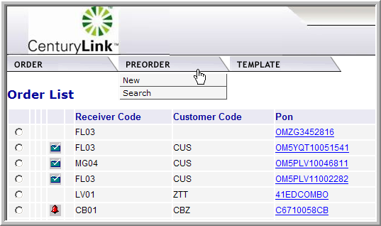
Roll your cursor over the PreOrder tab and click New to initiate a new preorder on a CenturyLink address or CFA in EASE VFO.

Preorder—Validate Button within the Order
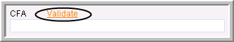
Continued on next page
EASE VFO Preorder, Continued

Preorder—Preorder Tab | Take the following steps to do a preorder from the Preorder tab in EASE VFO.

Step | Action
1 | With the Order List in view, roll your cursor over the Preorder tab and select New from the drop-down menu.  Result: The PreOrder Initiation screen appears.  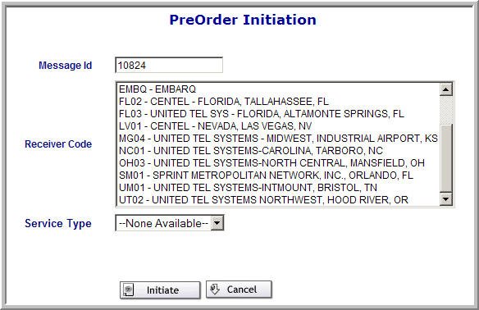
2 | Type a tracking ID in the Message ID field.  Note: This can be up to twenty-five alpha, numeric, or alpha-numeric characters. You can use the PON if you have one.
3 | Choose the region of the CenturyLink address from the Receiver Code box. You can select EMBQ for any state.
4 | Select CFA_INQUIRY or LOCATION_INQUIRY from the Service Type field drop-down.
5 | Click the Initiate button.  Result: The CFA_INQUIRY or LOCATION_INQUIRY screen appears with the Inquiry tab as the default.
Continued on next page
EASE VFO Preorder, Continued

Exhibit 1—LOCATION_INQUIRY Screen
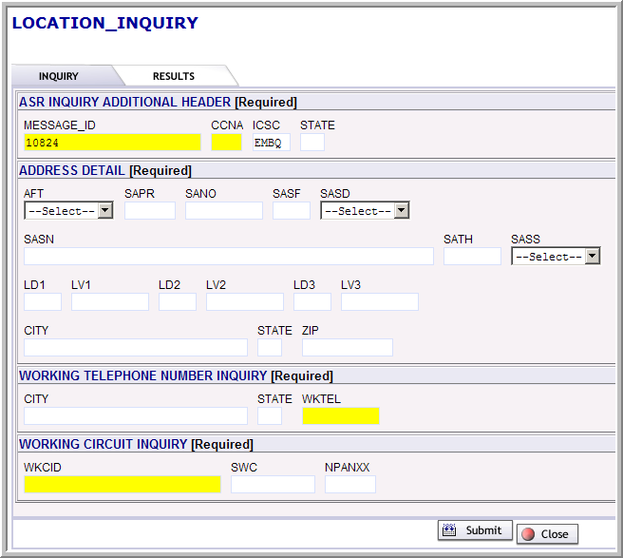
Continued on next page
EASE VFO Preorder, Continued

Exhibit 2—CFA_INQUIRY Screen
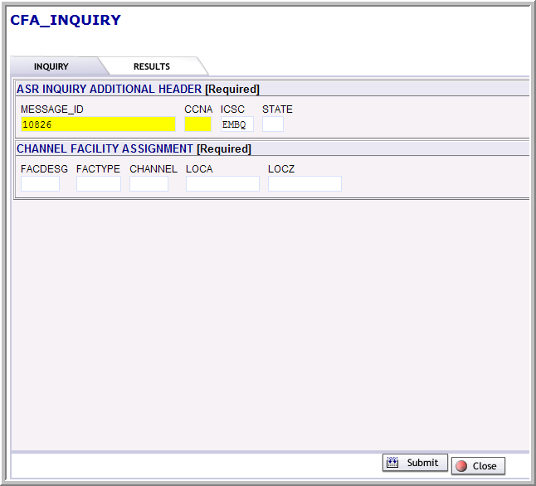
Continued on next page
EASE VFO Preorder, Continued

Preorder—Preorder Tab Steps (Continued)

Step | Action
6 | Use the following table to determine the next step.  Results: The query is initiated and the results display on the Results tab. The IRM fields shows whether or not the preorder was successful.
  If | Then
  Doing a preorder on a CenturyLink address and you are on the LOCATION_INQUIRY screen | - Type the CCNA in the CCNA field.  - Type the state abbreviation in the State field.  - Type the address including city, state, and zip code in the Address Detail section.  - Click the Submit button.  Note: There is a Glossary on the last page of this document that provides the Address Detail section field names and definitions.
  Doing a preorder on a CFA that contains at least one CenturyLink location and you are on the CFA_INQUIRY screen | - Type the CCNA in the CCNA field.  - Type the state abbreviation in the State field.  - Type the facility designation for the CFA—for example, C101 in the FACDESG field.  - Type the type of facility—for example, T3 in the FACTYPE field.  - Type the channel in the CHANNEL field.  - Type the ACTL and MUX in the LOCA and LOCZ fields.  - Click the Submit button.
Continued on next page
EASE VFO Preorder, Continued

Exhibit 3—Preorder Results for Location
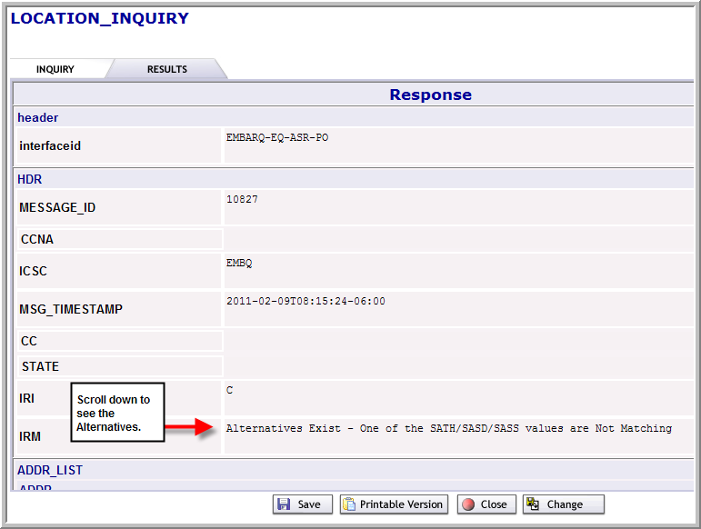
Continued on next page
EASE VFO Preorder, Continued

IRM Responses for Address | Following are the possible IRM field responses that may be seen when doing a preorder on a CenturyLink address.
  IRM Field Response | Definition
  Exact match | The CenturyLink address is valid according to CenturyLink records.
  Alternatives exist | The CenturyLink address is not an exact match of what CenturyLink records show. Alternative addresses are provided.
  Zip code was not found. Request not executed : -2109 | The zip code entered is not in CenturyLink territory.
  State Code is invalid for this Zip Code. Request not executed : -2110 | The state and zip code combination is invalid.
  Facilities not found : -2131 | The address is valid in CenturyLink territory, but no facilities exist.
  No EMBARQ addresses found for this address : -2130 | The address is not valid.
Continued on next page
EASE VFO Preorder, Continued

Exhibit 4—Preorder Results for CFA
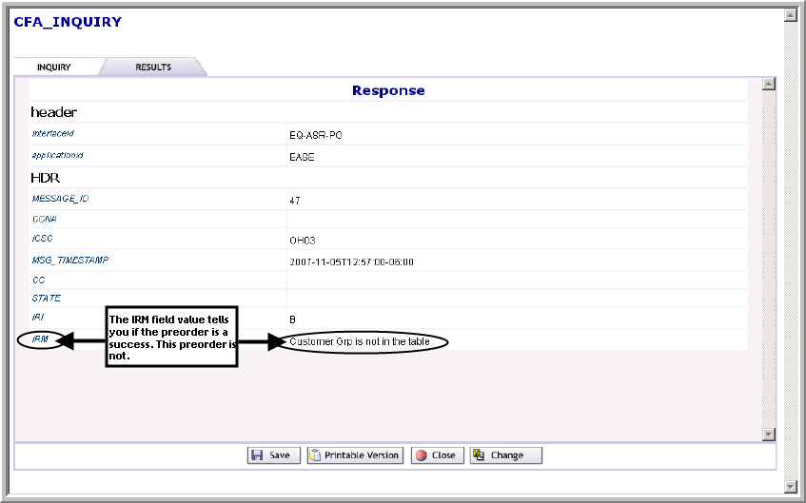

IRM Responses for CFA | Following are the possible IRM field responses that may be seen when doing a preorder on an CenturyLink address.
  IRM Field Response | Definition
  Channel Vacant - Available for Assignment | The CFA is valid and the channel specified is available for assignment.
  Channel Busy - Not Available for Assignment | The CFA is valid, but the channel specified is not available for assignment.
  Requested Information Not Found | The CFA cannot be found in our records.
Continued on next page
EASE VFO Preorder, Continued
Preorder—Preorder Tab Steps (Continued)

Step | Action
7 | Use the following table to determine the next step.
  If | Then
  The preorder is a success | You can:  - Click the Save button to save the preorder.  - Click the Printable Version button to view and print the preorder.  - Click the Close button to exit.  Note: The preorder record is not saved if you close without saving first.
  The preorder is not a success | You can:  - Click the Change button to try the preorder again.  - Click the Save button to save the preorder.  - Click the Printable Version button to view and print the preorder.  - Click the Close button to exit.

Successful Preorder | Once a CenturyLink address or CFA is validated via the Preorder tab and is determined to be valid, you can proceed to order initiation.
Continued on next page
EASE VFO Preorder, Continued

Preorder—Validate Button | While entering an order, preorder validation of a CenturyLink address or CFA can be initiated by clicking the Validate button next to the CFA field or the Address Detail section. When this happens, the Inquiry tab of the LOCATION_INQUIRY or CFA_INQUIRY screen is bypassed and you are taken directly to the Results tab. The IRM field of the Results tab is where you can identify whether or not the CenturyLink address or CFA is valid—see Exhibit 3 or Exhibit 4.

Glossary

Address Details section | There are certain fields required in the Address Details section for any order that contains an address. The minimum entries in the Address Details section are:  - SANO = House Number  - SASN = Street Name  - CITY  - STATE (must be in all capital letters)  - ZIP CODE  Following are the other fields that could possibly be required in the Address Details section of the order depending on the address.

Address Field | Definition
AFT (Address Format Type) | Identifies the format of the address being supplied  Valid Entries:  A = Rural route and/or box number  B = Unnumbered  C = Provider Assigned house number  D = Descriptive  E = Provisioning Address
SAPR (Service Address Number Prefix) | Identifies the prefix for the address number of the service address
SASF (Service Address Number Suffix) | Identifies the suffix for the address number of the service address
SASD (Service Address Street Directional Prefix) | Identifies the street directional prefix for the service address—for example, N = North, S = South, E = East, W = West, etc
SATH (Service Address Street Type) | Identifies the thoroughfare portion of the street name of the service address—for example, LN = Lane, BLVD = Boulevard, ST = Street, etc
Continued on next page
Glossary, Continued

Address Details section (continued)

Address Field | Definition
SASS (Service Address Street Directional Suffix) | Identifies the street directional suffix for the service address—for example, N = North, S = South, E = East, W = West, etc  Note: The SASS is different than the SASD. The SASS is when the directional comes after the street name—for example, Main St West.
LD1 (Location Designator 1) | Identifies additional specific information related to the address—for example, building, floor, unit, or room
LV1 (Location Value 1) | Identifies the value associated with the LD1 of the address
LD2 (Location Designator 2) | Identifies additional specific information related to the address—for example, building, floor, unit, or room
LV2 (Location Value 2) | Identifies the value associated with the LD2 of the address
LD3 (Location Designator 3) | Identifies additional specific information related to the address—for example, building, floor, unit, or room
LV3 (Location Value 3) | Identifies the value associated with the LD3 of the address

Complex Addresses | Complex address inquiries can be entered using the Location Designator fields. You must populate the minimum required address inquiry fields plus the location designators if applicable as follows:  - LD1 – Enter description types—for example, UNIT, APT, ROOM, RM, FL, FLR, BLDG, or STE  - LV1 – Enter the value associated with the description type—for example, 100, 1, or 36  The LD description type can be placed in any Location Designator field—  LD1, LD2, or LD3 and the associated value is placed in the corresponding  LV1, LV2, or LV3 fields.

