EASE VFO Log On

EASE VFO Access | Take the following steps to log on to EASE VFO.

Step | Action
1 | Click the EASE VFO link provided by your Supervisor or located on the Local Wholesale Web site.  Result: The EASE VFO Homepage appears.
2 | Click the VFO tab.
3 | Click the Virtual Front Office link.
4 | Type the Username and Password provided to you and click the Sign On button.  Result: The Virtual Front Office Login window appears.  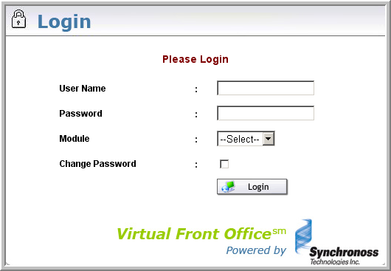
5 | Type your user name in the User Name field and press Tab.
6 | Type your password in the Password field and press Tab.
Continued on next page
EASE VFO Log On, Continued

EASE VFO Access (continued)

Step | Action
7 | Use the following table to determine the next step.
  If | Then
  Accessing EASE VFO for ASRs | Select Access from the Module drop-down menu.
  Accessing EASE VFO for LSRs | Select Local from the Module drop-down menu.
8 | Use the following table to determine the next step.  Note: You are required to change your EASE VFO password every 90 days. You will be systematically prompted to change the password when it is time.
  If | Then
  You want to change your password. | Click the Change Password box.  Result: A screen displays prompting you to change your VFO password.
  You do not want to change your password. | Click the Login button.  Result: You are logged on to EASE VFO with the Order List in view.
Continued on next page
EASE VFO Log On, Continued

Exhibit 1—Default ASR Order List Screen
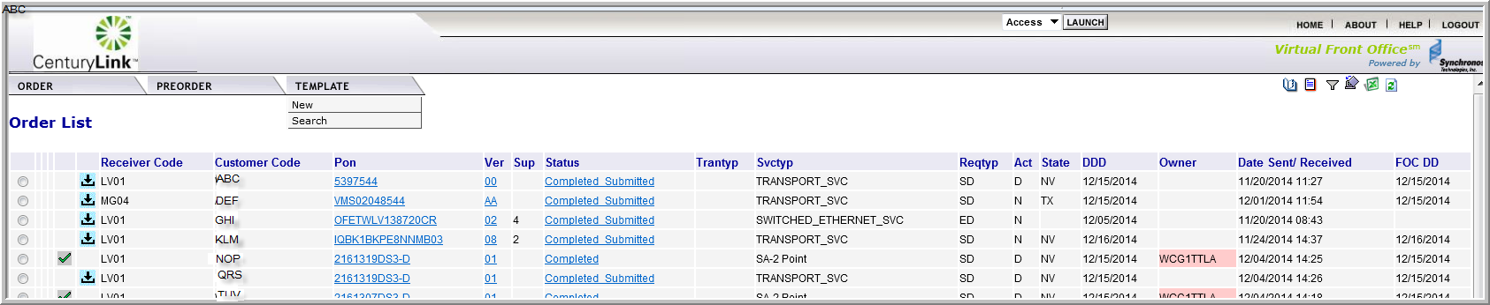

Exhibit 2—Default LSR Order List Screen
