Requesting Access to CenturyLink Systems User’s Guide
There are two ways to access CenturyLink systems via the Web: through CPID (CenturyLink Protected Internet Delivery) and using a digital certificate.

Several CenturyLink systems use CPID to control access, including ECR, FAM-SAGA, and DLIS (which also requires a digital certificate). To access these systems you need a CPID user ID and password, which you request using the same process as for requesting a digital certificate (detailed in this document). When you receive access, CenturyLink e-mails you your CPID user ID and password. For more information about CPID, go to http://qpid01.qwest.com/.

Several CenturyLink systems require a digital certificate, including CEMR, FLI, IMA, CORA, and RLD. A digital certificate (or digital ID) is used to validate your identity on the Internet. It is considered an identity card for cyberspace and/or your electronic credentials for the Internet. The main reason for using a digital certificate is security. The certificate enables our server to establish a secure connection to your browser. Additionally, the certificate allows CenturyLink to associate your browser to your record in our user database, which then identifies you to the application. In our E-Commerce (ECOM) environment, we use both server certificates and client certificates. While certificates do require a few more steps to gain initial access to our systems, it allows CenturyLink to offer safely customer information over the Internet. To learn more about digital certificates, go to “Frequently Asked Questions” located at this URL: http://ecom.qwest.com/ecomhelp/, this page contains important information regarding digital certificates and helpful links regarding the technical aspects of digital certificates.

To request a digital certificate or access to CPID, follow the instruction listed under “Requesting access for individual users.”

Information needed to download a digital certificate
Directions to follow when downloading your digital certificate are located at these URLs:
Instructions for Netscape: http://ecom.qwest.com/ecomhelp/netscape.html#obtain
Instructions for Internet Explorer: http://ecom.qwest.com/ecomhelp/ie.html

Based on applications to be accessed, CenturyLink recommends that you choose which browser that will be used for digital certificate access. The browser that supports CenturyLink’s applications is Netscape 4.51. Based on the browser choice, you should follow the appropriate set of digital certificate download instructions and should avoid switching between browsers. Once a digital certificate is downloaded, it only applies to the browser in which it was downloaded. Additionally, the following disclaimer can be found on the ECOM help site located at: http://ecom.qwest.com/ecomhelp/. Digital certificate access is used for multiple applications. The VeriSign/CenturyLink or RSA/CenturyLink supported browser and versions are listed above. Results cannot be guaranteed if other versions or browsers are used.” To download your certificate, go to this URL: http://ecom.qwest.com/. For assistance with downloading your certificate, please contact the CenturyLink Information Technologies Wholesale Systems Help Desk at 888-796-9102 use option 2.

General information
A digital certificate request must contain specific information. The request is used not only to request a digital certificate ID and PIN, but also to build you and your company’s information into the specific system database. For this reason, a request must be submitted for each system that the user wants to access because each system’s security requires specific information. This allows for a faster electronic processing time and that the appropriate security information has been submitted.

Digital certificates take a minimum of 48 hours to process, which begins at the time Wholesale Service Support Team receives the request. However, processing times for the assignment of digital certificates will vary with the volume of requests.

Company-level requirements
A digital certificate allows you access through CenturyLink’s firewall and displays a list of system choices you have been established to access. Once the user clicks on the system name, the certificate will direct them to the requested application or system. Many of CenturyLink’s systems have additional security requirements. These requirements are driven by the ACNAs, CCNAs and/or RSIDs associated with the company name. Access Customer Name Abbreviation (ACNA) is a three digit alpha code assigned to identify carriers for billing and other identification purposes. These are assigned by Telcordia. Customer’s Carrier Name Abbreviation (CCNA) is a three digit alpha code that identifies the common language code. Reseller Identification (RSID) is a three digit alphanumeric code assigned by CenturyLink. These ACNAs and RSIDs are part of the system’s security; it allows users to view only the information associated with their company. ACNAs, CCNAs, and RSIDs are NOT interchangeable.

Designated points of contact (DPOC)
Wholesale Companies may establish designated points of contact (DPOC) for their company. The DPOCs are responsible for requesting system access on behalf of their company’s employees and must adhere to CenturyLink’s security policy by only providing the digital certificate information to the appropriate user. If the Wholesale company chooses to establish a DPOC, they must email the following information to their CenturyLink service manager or to wholesale.servicesupportteam@centurylink.com for each DPOC: company name, name, email address, telephone number. The Wholesale company is responsible for providing current information. Once the Wholesale company establishes DPOCs with CenturyLink, CenturyLink will accept digital certificate request only from the DPOC. Any requests submitted from individuals other than the DPOC will be emailed back to the submitter and to the DPOC established for that company.

Initial setup (Process to establish your company within CenturyLink’s systems)
A Wholesale company wanting to access CenturyLink’s systems must provide a list of all ACNAs and RSIDs that they own by email to their CenturyLink service manager and to the Wholesale Service Support Team (WSST) at wholesale.servicesupportteam@centurylink.com. From this list, the company must determine which one will be the primary. The primary may be either an ACNA or RSID; the choice is yours. Most CenturyLink systems or applications will only accept one ACNA or RSID on the request form that is used to process the digital certificate request and set up the user in the application. There are a few systems or applications where you must list all ACNAs, CCNAs, or RSIDs when requesting access. The service manager or WSST will notify the security managers of the applications to have the company access properly established.

Subsequent setup (When a company buys or merges with another company)
The purchasing company must contact their CenturyLink service manager and to WSST by email to notify CenturyLink of the new ACNAs CCNAs, and RSIDs they own. The service manager or WSST send this information to each of the system’s security managers. This information is needed so CenturyLink’s security tables may be updated. If these tables are not updated then users will not be able to access the information they need.

Systems accessed by digital certificate or through CPID
System name | Company-level requirements to process access request
CEMR (Customer Electronic Maintenance & Repair ) | Primary ACNA or primary RSID and company name
ECR (Electronic Customer Reporting) | Company name and all RSIDs needing access
FAM (Facility Availability Matrix) | Company name
FLI (Fiber Loop Inventory) | Company name
IMA (Interconnect Mediated Access) | Primary RSID and company name
CORA (CenturyLink Online Request Application) | Company name
CPID-DLIS (Directory Listing Inquiry System) | CCNA and company name
RLD (Raw Loop Data) | Company name
SAGA (Street Address Guide Area) | Company name

Digital certificate process flow

Example
Sam Jones of ABC Telephones needs access to CEMR. Sam visits the website http://www.centurylink.com/wholesale/clecs/electronicaccess.html and clicks on “CEMR Digital Certificate Request”. Sam then completes the spreadsheet with the required information and emails it as an attachment to his CenturyLink service manager and wholesale.servicesupportteam@centurylink.com. The service manager or/and WSST reviews the request to make sure that the appropriate information has been supplied and it is in the correct format, then email the request to ECOM. ECOM is the group who assigns the certificate and pin information. This information is emailed back to WSST. When the certificate information is sent back to WSST, the same information is also emailed to the CEMR group. This group builds Sam into the CEMR application so that he will be able to access CEMR after he has downloaded his certificate. WSST then forwards it to Sam and CenturyLink service manager.

Sam now needs access to another system, IMA; he must follow the same process as before to request access. Sam completes the “IMA Digital Certificate Request” by providing EXACTLY the same user information as in the original request, and with the appropriate company information. He emails it as an attachment to his CenturyLink service manager and to wholesale.servicesupportteam@centurylink.com. The service manager or/and WSST reviews and emails the request to ECOM and sends the information that Sam’s digital certificate now can access IMA. WSST notifies Sam and CenturyLink service manager that IMA access is added to his certificate. Sam goes to his certificate, and now can access either CEMR or IMA.

Peter Wilson and Kim Blake are new employees of ABC Telephones. They both require access to CEMR and IM. Their supervisor, Sam Jones, who is also the DPOC for ABC Telephones, goes to the website http://www.centurylink.com/wholesale/clecs/electronicaccess.html to complete a new “CEMR Digital Certificate Request” form and a new “IMA Digital Certificate Request” form. Sam lists the appropriate information for both Peter and Kim in each spreadsheet and emails both spreadsheets as an attachment to his CenturyLink service manager and to wholesale.servicesupportteam@centurylink.com. The same process is followed as when Sam requested his digital certificate.

Flow chart
Wholesale Customer (WC) completes Digital Certificate (DC) Request form for specific system access and emails it to the service manager (SM) and Wholesale Service Support Team (WSST)
WC verifies that requested access has been received. Then downloads DC into the appropriate browser to access the ECOM Gateway
The WC uses the assigned DC; ECOM gateway authenticates the DC user and allows the WC through the gateway

WSST reviews information to ensure that requested system access has been processed. And then forwards DC information letter to WC and CenturyLink service manager

The SM or/and WSST reviews system access request and sends the request for specific system access via DC to ECOM

WC selects the specific system and is able to access the requested CenturyLink System

ECOM sends email to WSST with DC information; WSST with the URL for WC instructions for training manual and downloading process

ECOM electronically processes requests, sends DC information to WSST and to the specific system’s security group

ECOM sends email to System Administrator (SA) with the information required to build the individual WC in the specific system
SA builds the WC into the system, granting access

Security policy
CenturyLink assigns one digital certificate per individual user. Once a digital certificate has been assigned, additional system access may be requested to add to the user’s certificate. This user is not allowed to share information regarding the digital certificate with any other person. If a user is found to be sharing a digital certificate, this violation will result in the termination of access to CenturyLink’s systems.

Individual user-level requirements
One digital certificate is issued per person, their personal computer (PC), and may only be downloaded once. Note: Contact the Wholesale Systems Help Desk at 888-796-9102; use option 2 for assistance in the download process.
Your PC must have the appropriate browser that is required for accessing required applications. Please see the appropriate User’s Guide for specific information. This information may be found at http://www.centurylink.com/wholesale/training/coursecatalog.html. A completed request form (spreadsheet) is required for each system needing access. For example, if you need access to CEMR and RLD, you must complete both CEMR Digital Certificate Request spreadsheet and RLD Digital Certificate Request spreadsheet. CEMR and RLD require different security information so that the user may be built into the database correctly.

Requesting access for individual users
- Log on to http://www.centurylink.com/wholesale/clecs/electronicaccess.html. Read the information provided at this website.
- Click on the Digital Certificate Request application for the system you need to access.
- Complete the spreadsheet with all of these required fields
- user’s last name
- user’s first name
- user’s email address—if the company does not assign email address then fill in the field with the following standard “First Name.Last Name.Company Name” example: Jane.Doe.NewTelephoneCompany
- ten-digit telephone number (with dashes)
- the appropriate company information
- user’s email address or the designated point of contact (DPOC) email address
Note: Please do not change any of the formatting of the spreadsheets; this will delay processing your request.
- Email the completed spreadsheet to your CenturyLink service manager and to wholesale.servicesupportteam@centurylink.com as an attachment.
- Read the User Guide for the system that you will be accessing. User guides and training may be found at http://www.centurylink.com/wholesale/training/coursecatalog.html.
- Upon receipt of digital certificate number and pin, verify access to systems requested has been processed. If a system has been requested but you have not received confirmation, please contact your CenturyLink service manager and wholesale.servicesupportteam@centurylink.com.
- Then go to http://ecom.qwest.com/ecomhelp/netscape.html#obtain for instructions on downloading your certificate into Netscape. For Internet Explorer, instructions for downloading your certificate go to http://ecom.qwest.com/ecomhelp/ie.html. For assistance in the digital certificate download process contact the Wholesale Systems Help Desk at 888-796-9102, use option 2.
- Wholesale customers must download their digital certificate within 30 days of receipt; digital certificates that are not downloaded within this time will be removed from the system. If your digital certificate has been removed from the system, you will be required to order a new digital certificate by following the steps listed above.
- Please send an e-mail to your CenturyLink service manager and wholesale.servicesupportteam@centurylink.com if you need to reorder your digital certificate.
- For any questions please contact the Wholesale Systems Help Desk at 888-796-9102, use option 2.

What happens after your request is emailed to your CenturyLink service manager and wholesale.servicesupportteam@centurylink.com?
Wholesale companies with established DPOC:
- The CenturyLink service manager or/and WSST will validate the request has been submitted by the DPOC.
- If the request has been submitted by the DPOC, then the CenturyLink service manager or WSST will validate that.
- If the request has been submitted by an individual other than the DPOC, the CenturyLink service manager and WSST will email the request to back to the submitter and to the DPOC established for that Wholesale company.
Wholesale companies without established DPOC:
- The CenturyLink service manager or/and WSST will validate that the request is accurate and complete, and then email it to ECOM for processing.

If the form is incomplete or the format is changed, WSST will send the application back to the CenturyLink service manager and the Wholesale customer for completion. This will delay the processing of your request. WSSA will coordinate with the appropriate groups to have security and system access established. This process requires a minimum of 48 hours to complete. However, processing times for assignment of digital certificates will vary with the volume of requests.
A completed spreadsheet is required for each system needing access. For example, if you need access to CEMR and RLD, you must complete both CEMR Digital Certificate Request spreadsheet and RLD Digital Certificate Request spreadsheet. For this reason, a request must be submitted for each system that the user wants to access because each system’s security requires different information (ACNAs, CCNAs, or RSIDs). This allows for a faster electronic processing time and that the appropriate security information has been submitted. Once your request has been processed, your CenturyLink service manager or and WSST will verify that all requested system access has been granted. They will then email your certificate information to you.

Requesting additional access
Additional application or system access can be added to your CenturyLink digital certificate at anytime. If you have already been issued a CenturyLink digital certificate for system access and need access to another system, you must complete the appropriate digital certificate request spreadsheet. That system access will be added to your current digital certificate. Access to additional systems will take a minimum of 48 hours to process. However, processing times for assignment of digital certificates will vary with the volume of requests

Note: When completing additional access requests you must provide exactly the same user information as you did on your original request. This is to ensure that the access is added to your original certificate and a new one is not issued.

Renewing digital certificates
Digital certificates expire 5 years from the date the user downloads the certificate. A notification email is automatically generated 1 week before the expiration of your current certificate. It will be sent to the email address you supplied during your original enrollment for a certificate. A user has one month from the expiration date to renew their certificate. If the expiration date is 8/14/2008, the user would have until 9/13/2008 to renew their certificate. One month is generally 30 calendar days. After the one month, the certificate is no longer valid and the user would need to email their CenturyLink service manager and WSST at wholesale.servicesupportteam@centurylink.com to order a new certificate. If you have any questions regarding the renewal process, visit http://ecom.qwest.com/ecomhelp/ and scroll to the “digital certificate Renewal” section for additional information. For additional assistance with renewing your digital certificate, please contact the Wholesale Systems Help Desk at 888-796-9102, use option 2.

Deleting digital certificates
When a company no longer employs an individual who has been issued a digital certificate by CenturyLink, that company is required to send an email to their CenturyLink service manager and WSST at wholesale.servicesupportteam@centurylink.com with all of the following information of the terminated employee:

EXAMPLE:
First and Last Name Mary Jones
Telephone Number 303-896-1234
Company Name ABC Telephone Company
ACNA, CCNA and RSID Codes ABT, TRC, T99
System Access IMA, CEMR
Email address Mjones@abctelco.com
Digital certificate number (9 digits) 369852147

The service manager or/and WSST will review and WSST will notify the appropriate groups to have user access and the certificate deleted.

Examples
The following pages are examples of the digital certificate request spreadsheets for each system using the Digital Certificate Security Access method.

CEMR—Information requirements to request access
To request access to CEMR please complete the “CEMR Digital Certificate Request” spreadsheet with the following information: User’s Last Name, User’s First Name, User’s Email Address or Unique Identifier (First Name.Last Name.Company Name), Ten Digit Telephone Number (with dashes), Primary ACNA-Company Name, OR Primary RSID-Company Name and User’s Email Address or Designate Point of Contact Email Address. There are four lines of examples in the spreadsheet for you to follow.
Note: Please confirm that you are completing the correct spreadsheet for the required system access.

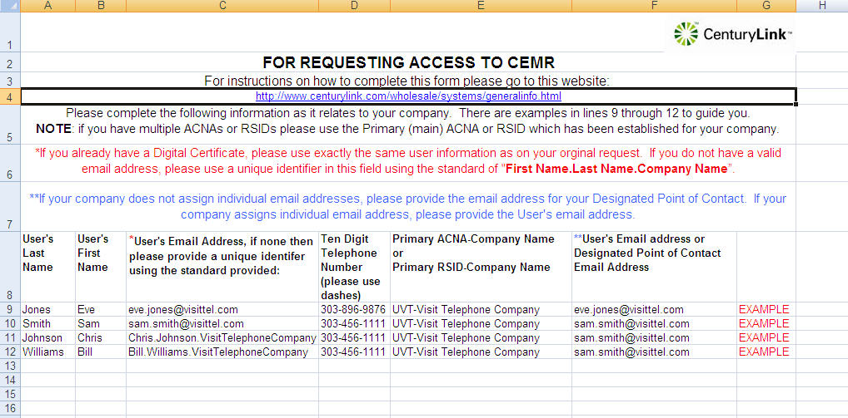

ECR—Information requirements to request access
To request access to ECR please complete the “ECR Access Request“ spreadsheet with the following information: User’s Last Name, User’s First Name, User’s Email Address or Unique Identifier (First Name.Last Name.Company Name), Ten Digit Telephone Number (with dashes), Company Name (RSID) and User’s Email Address or Designated Point of Contact Email Address. Please list all RSIDs needing to be accessed. There are four lines of examples in the spreadsheet for you to follow.
Note: Please confirm that you are completing the correct spreadsheet for the required system access.

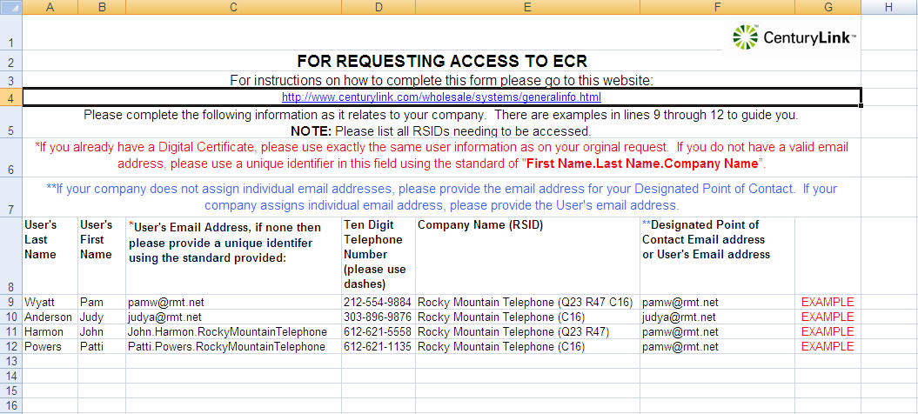

FAM/SAGA—Information requirements to request access
To request access to FAM or SAGA please complete the “FAM-SAGA Access Request” spreadsheet with the following information: User’s Last Name, User’s First Name, User’s Email Address or Unique Identifier (First Name.Last Name.Company Name), Ten Digit Telephone Number (with dashes), Primary RSID-Company Name and User’s Email Address or Designated Point of Contact Email Address. There are four lines of examples in the spreadsheet for you to follow.
Note: Please confirm that you are completing the correct spreadsheet for the required system access.

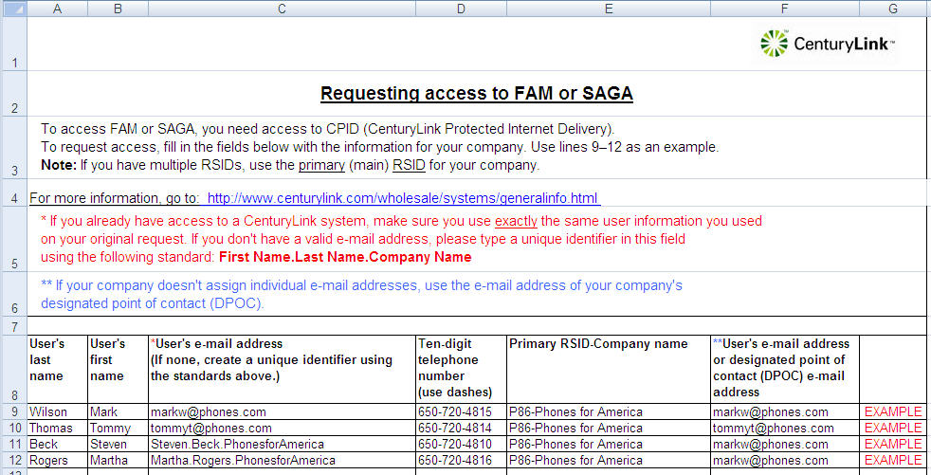

FLI—Information requirements to request access
To request access to FLI please complete the “FLI Digital Certificate Request” spreadsheet with the following information: User’s Last Name, User’s First Name, User’s Email Address or Unique Identifier (First Name.Last Name.Company Name), Ten Digit Telephone Number (with dashes), Company Name and User’s Email Address or Designated Point of Contact Email Address. There are four lines of examples in the spreadsheet for you to follow. Note: Please confirm that you are completing the correct spreadsheet for the required system access.

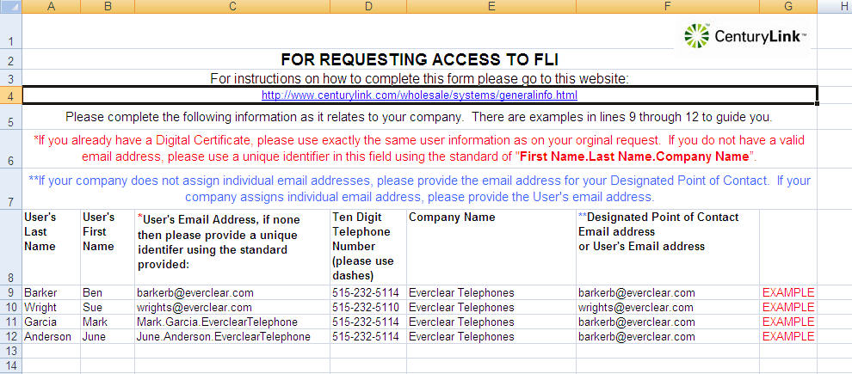

IMA—Information requirements to request access
To request access to IMA please complete the “IMA Digital Certificate Request” spreadsheet with the following information: User’s Last Name, User’s First Name, User’s Email Address or Unique Identifier (First Name.Last Name.Company Name), Ten Digit Telephone Number (with dashes), Primary RSID-Company Name and User’s Email Address or Designated Point of Contact Email Address. There are four lines of examples in the spreadsheet for you to follow. Note: This is only to request a digital certificate. Each company must have an IMA System Administrator who establishes the users into IMA. To request access as an IMA System Administration, please go to http://www.centurylink.com/wholesale/clecs/electronicaccess.html. Then click “Request for Interconnect Mediated Access (IMA) System Administrator” to complete this form.
Note: Please confirm that you are completing the correct spreadsheet for the required system access.

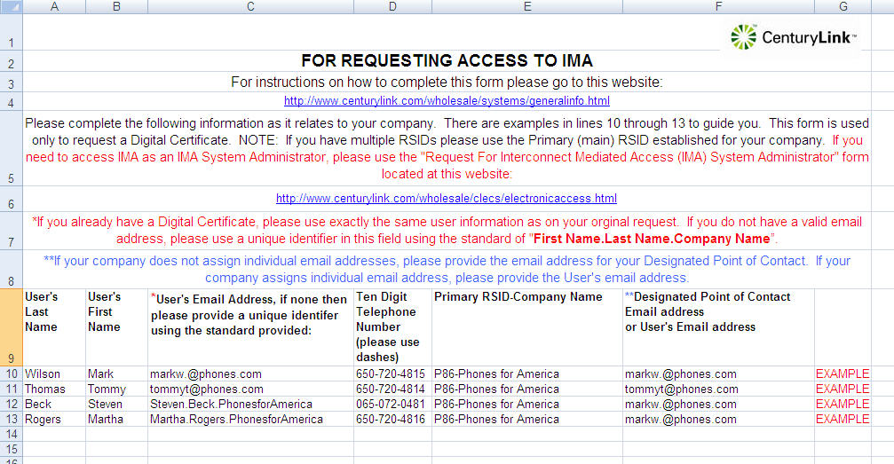

CORA—Information requirements to request access
To request access to CORA please complete the “CORA Digital Certificate Request” spreadsheet with the following information: User’s Last Name, User’s First Name, User’s Email Address or Unique Identifier (First Name.Last Name.Company Name), Ten Digit Telephone Number (with dashes), Company Name and User’s Email Address or Designated Point of Contact Email Address. There are four lines of examples in the spreadsheet for you to follow. Note: This is only to request a digital certificate. Each company must have a CORA System Administrator who establishes the users into CORA. To request access as a CORA System Administration, please go to http://www.centurylink.com/wholesale/clecs/electronicaccess.html. Then, click "Request for CenturyLink Online Request Application (CORA) System Administrator" to complete this form.
Note: Please confirm that you are completing the correct spreadsheet for the required system access.

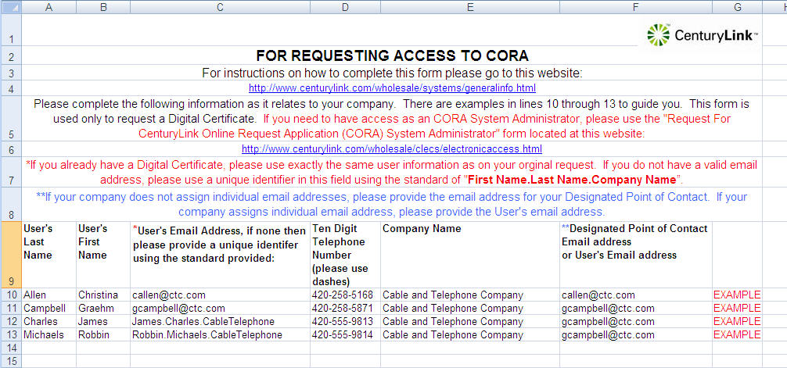

CPID-DLIS—Information requirements to request access
To access DLIS, you need a digital certificate and access to CPID (CenturyLink Protected Internet Delivery).
To request access to CPID-DLIS please complete the “CPID-DLIS Digital Certificate Request” spreadsheet with the following information: User’s Last Name, User’s First Name, User’s Email Address or Unique Identifier (First Name.Last Name.Company Name), Ten Digit Telephone Number (with dashes), CCNA-Company Name, and User’s Email Address or Designated Point of Contact Email Address. There are four lines of examples in the spreadsheet for you to follow.
Note: Please confirm that you are completing the correct spreadsheet for the required system access.

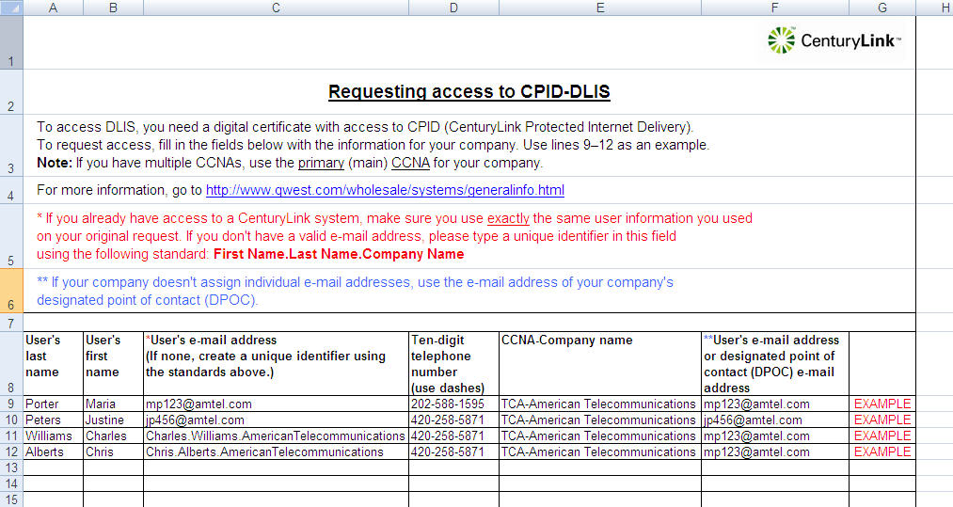

RLD—Information requirements to request access
To request access to RLD please complete the “RLD Digital Certificate Request “spreadsheet with the following information: User’s Last Name, User’s First Name, User’s Email Address or Unique Identifier (First Name.Last Name.Company Name), Ten Digit Telephone Number (with dashes), Company Name and User’s Email Address or Designated Point of Contact Email Address. There are four lines of examples in the spreadsheet for you to follow.
Note: Please confirm that you are completing the correct spreadsheet for the required system access.



