Wholesale HSI Process Team
Abstract
This document is intended to aid with the submission of WBSA material and has been extended to include new scenarios involving Pair Bonding and GPON efforts. This document is not intended to be an all-inclusive source base as the nature of conversion and change orders is dependent upon content from the customer account.
IMA Pre-Ordering and Ordering Job Aid
WBSA Expansion

Contents
Pre-Ordering 2
Address Validation 5
Loop Qual 8
Appointment Scheduling 13
TN Reservation 22
IMA Ordering 26
Local Service Request Form: 31
End User Form: 34
Resale Form: 37
Directory Listing form 46
APPENDIX A – HSI Technologies 51
APPENDIX B – Appointment USOCs 52
APPENDIX C – Order Scenario Summary Notes 53
Single Line Scenarios 53
Pair Bond Scenarios 54
Pair Bond Scenarios continued 56

Pre-Ordering
Open the IMA GUI URL of https://ima.centurylink.com/ima and sign in using the following fields:
- Corporate ID (RSID assigned by CenturyLink (format is case sensitive e.g. Z99)
- Username (created with your IMA Admin person)
- Password:
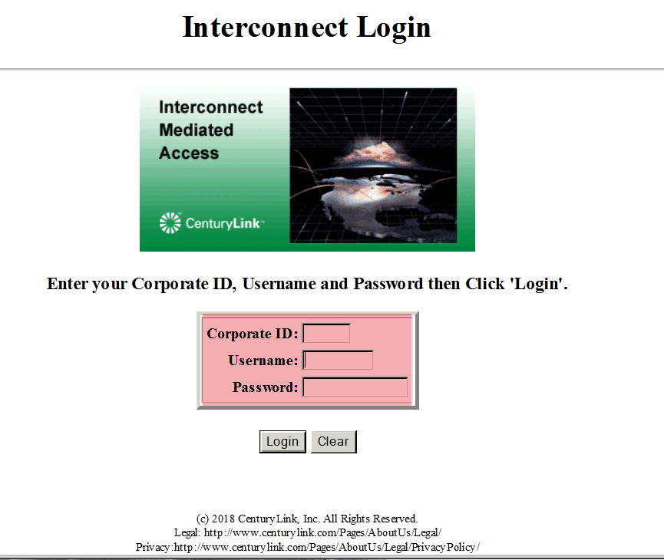

Once you are logged in, then you will see the following screen titled Interconnect Functions. Select the PreOrder/Order/PostOrder option. This activity will open another IE browser window.
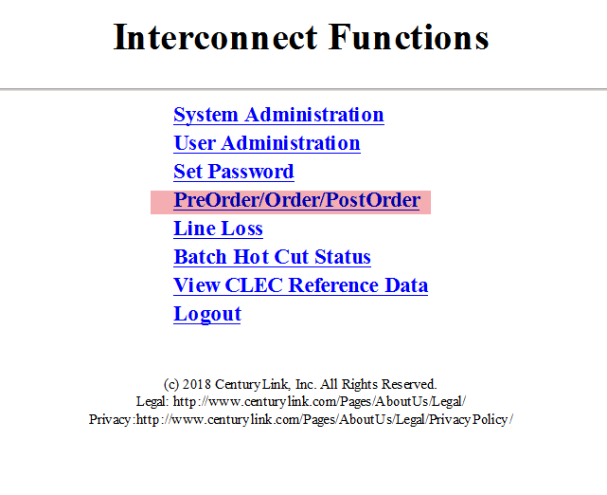

This is the next screen you will see. Select PreOrder and then select the Pre-Order Function by highlighting the name of the function on the PreOrder pulldown.
The most common Pre-Order options are:
- Validate Address
- Review CSR
- Schedule Appointment
- Reserve Telephone Numbers
- Loop Qualification
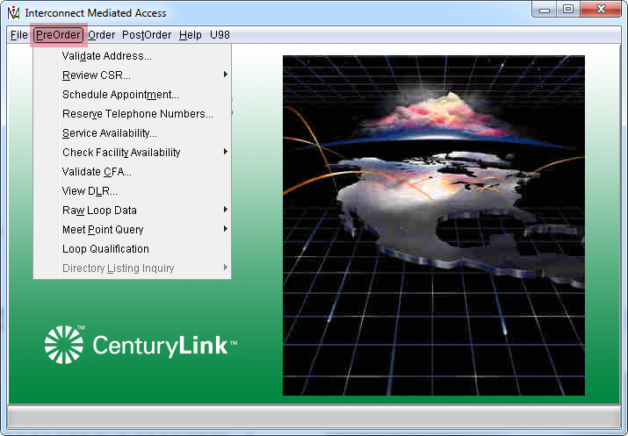

Address Validation

After selecting Validate Address from the PreOrder pulldown, the Select Address Validation Type screen will appear. It allows for validation by Street Address or Telephone Number. Select Validate by Street Address.
Note:
As long as you don’t close your browser, IMA saves the last 10 addresses you validated. When you prepare the request forms, you can select any of those addresses and IMA will automatically fill in the validated address for your customer.
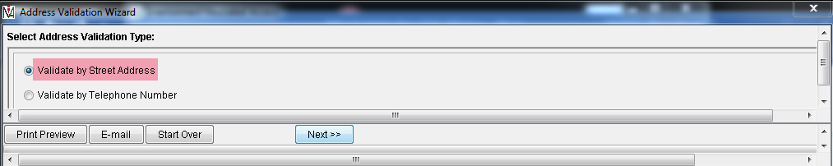The Address Validation by Street Address Screen will appear. Populate all pertinent fields and select Next.
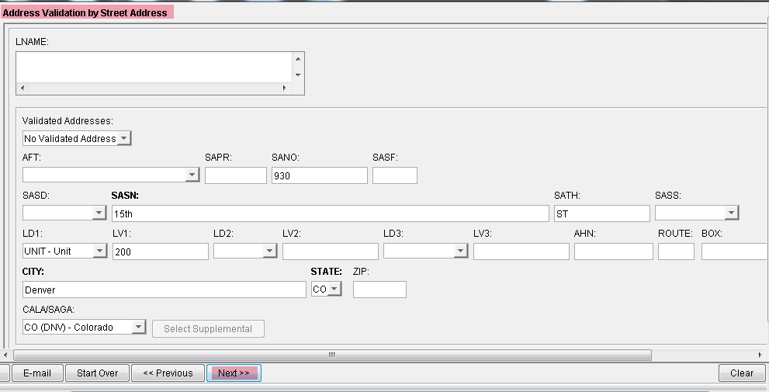

The validated address will display in the Validated Addresses pulldown. In this case there is working service but due to it being Non-Published a WTN (Working TN) or LNAME (Listed Name) does not display. Also, the LD1 field was input as UNIT but was corrected to show ROOM which should be used for other Pre-Order or LSR input.
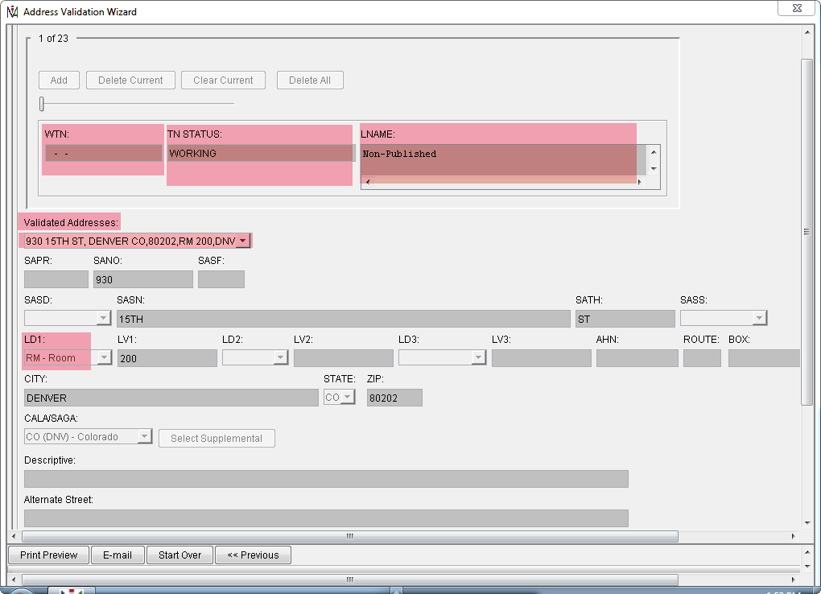

The output indicates a Validated Address and saves it for additional pre-order and order transactions. Switch Information is also provided.
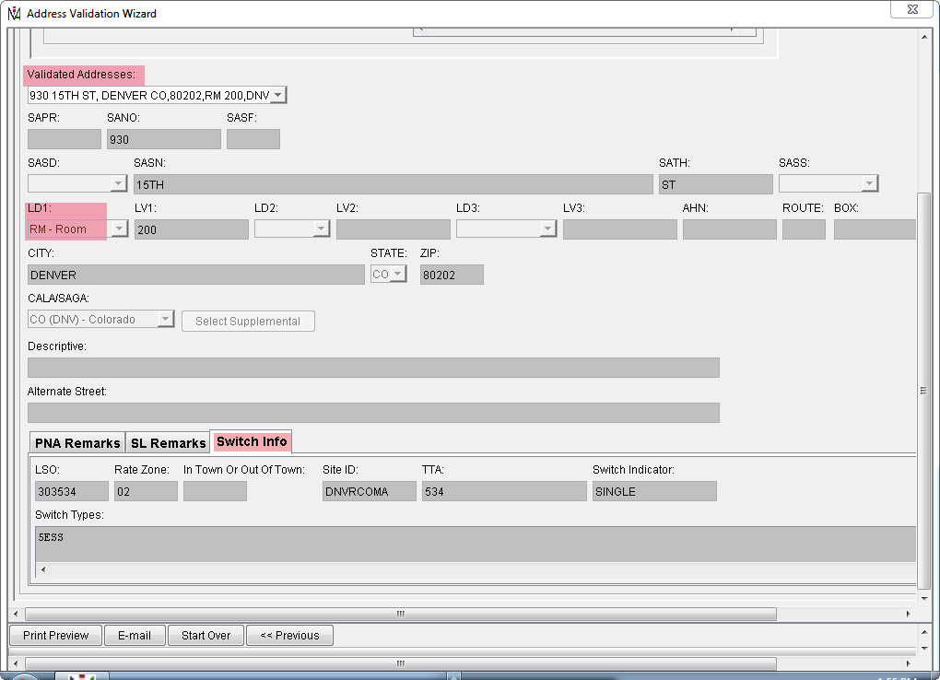
Select Finish at the far right.

Loop Qual

Select Loop Qualification from the Pre-Order pulldown
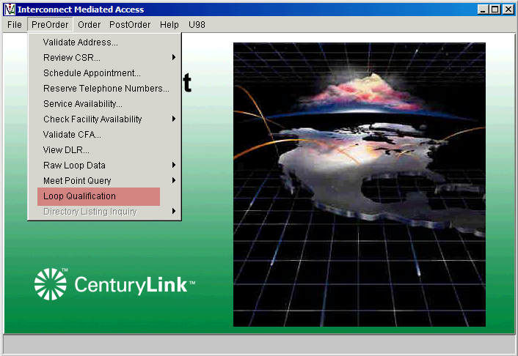

The Loop Qualification Request screen will appear.
Select an MS (Market Segment) of A – Resale. Search Validated Addresses and highlight the one that you want to use for the Loop Qualification.
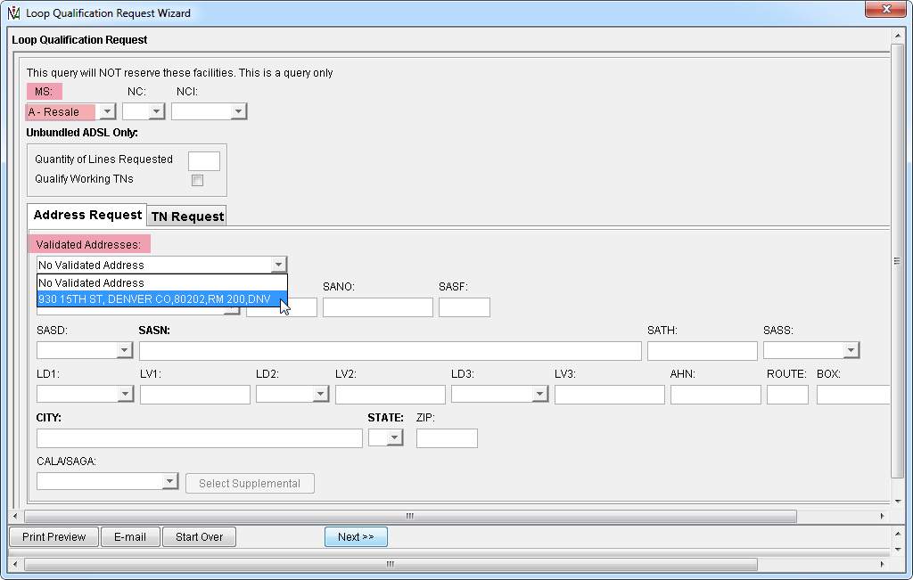

Once the address is selected, the previously validated address elements will be populated in the appropriate address fields.
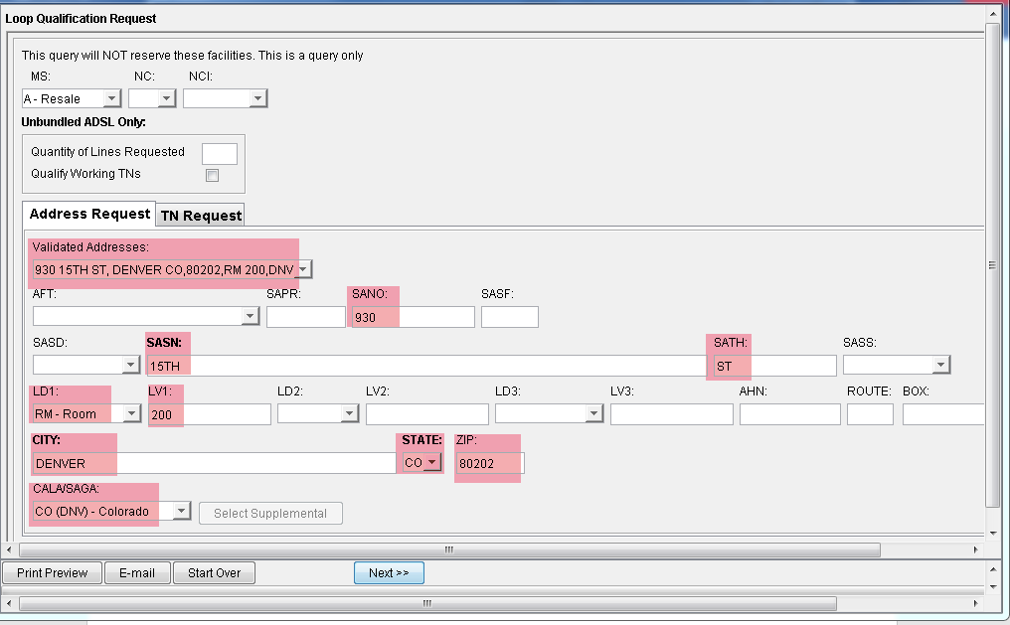
Select Next.

The Loop Qualification and Loop Data tabs will display below the address information. Note for the Loop Qualification tab that it indicates there are 1 of 2 results. This result is for ATM technology.
APPENDIX A lists the current technologies returned for CenturyLink.
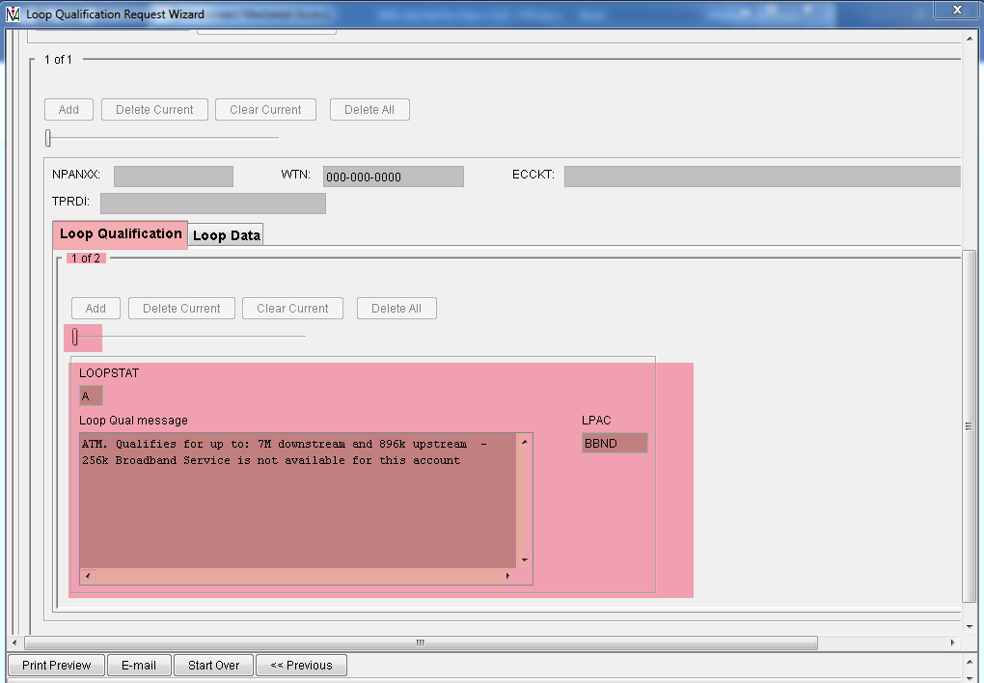

When you select the Slider button below the Add button and move it to the right, it will display the second result. Notice the screenshot now shows 2 of 2 and the slider is midway. This result is for VDSL2 technology.
NOTE: Be sure to note the technology type and speed for use in the selection of the proper USOCs during ordering process. Technology information is useful for providing the correct tech install USOC when reserving an appointment. See page 13.
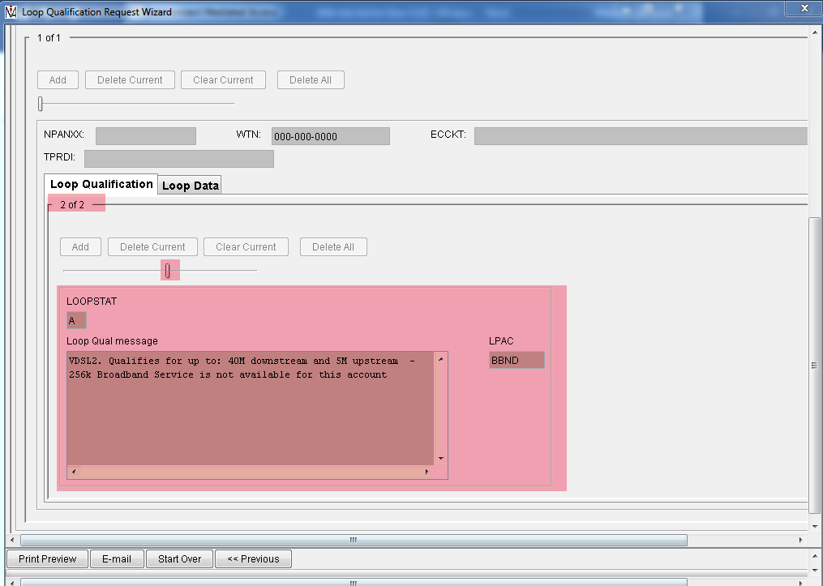
NOTE: Additional speeds may be higher if grooming is authorized during order submission. The conditional qualification message will append the value COND to the associated technology. You may see the base speed, two speeds with the base and the conditional qualification, or single conditional speed. To use the higher conditional speed the LSR Form SCA field must be Y for submission.
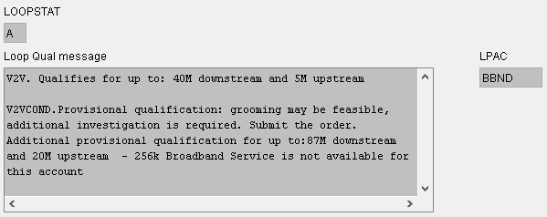

Appointment Scheduling

The Appointment Scheduling screen will appear once Schedule Appointment is selected on the Pre-Order pulldown. The tech install USOCs will need to be added separately in the Other work Required USOCs field. Once the USOC is added in the field, select the Add button so the USOC will be retained on the query.
Create PON to be used in your Pre-Order & Order activity.
Rules for PON - The PON must be a minimum of 4 characters and a maximum of 13 characters. Special characters (anything that is not a letter or a number) are not allowed, except hyphen.
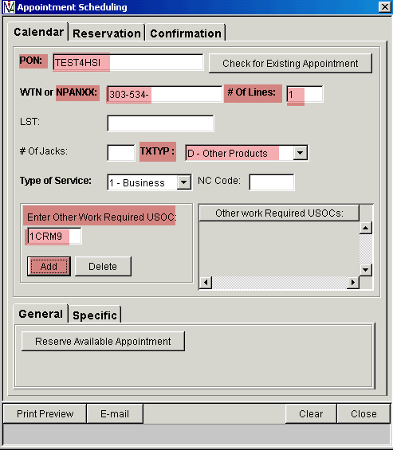

Tech install USOCs (Multiple USOCs are required to reserve enough tech time for the type of installation):
- Business USOCs:
- VDSL2 technology = 1CRM9 and 1CRA3
- ADSL2+ or ATM technology = 1CRMC and 1CRA3
- Along with the USOCs above, these are required USOCs depending on technology:
  - GPON = 1CROC and 1CRGN
  - Pair Bonding Install
    - VDSL2 technology (Vectored)= 1CRGC
    - VDSL2 technology (Non-Vectored) = 1CRGF
    - ADSL2+ technology = 1CRGA
- Residential USOCs:
- VDSL2 technology = 1CRM9 and 1CRA1
- ADSL2+ or ATM technology = 1CRMC and 1CRA1
- Along with the USOCs above, these are required USOCs depending on technology:
  - GPON = 1CROC and 1CRGN
  - Pair Bonding Install
    - VDSL2 technology (Vectored)= 1CRGC
    - VDSL2 technology (Non-Vectored) = 1CRGF
    - ADSL2+ technology = 1CRGA
If you are changing the broadband technology for an end user at a later date, use the VT6RT USOC to reserve technician time for dispatch to the x-box. If you are changing from a single line speed to a pair bonded speed, a full tech install will be necessary.
APPENDIX B has a summary table of appointment USOCs.

Once added, the USOC will display in the Other Work Required USOC field.
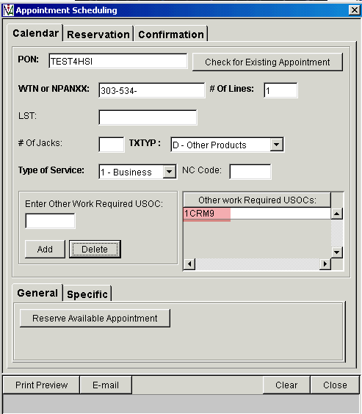

You may then enter additional USOCs, if needed. Click the Add button to move the USOCs to the list
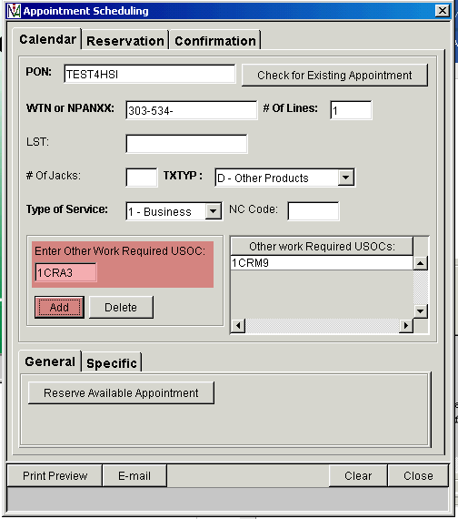

Once you select Add, any additional USOCs will be added to the Other Work Required USOC field.
Continue adding USOCs to reserve the correct amount of tech time
Once all of the USOCs have been added, then select Reserve Available Appointment.

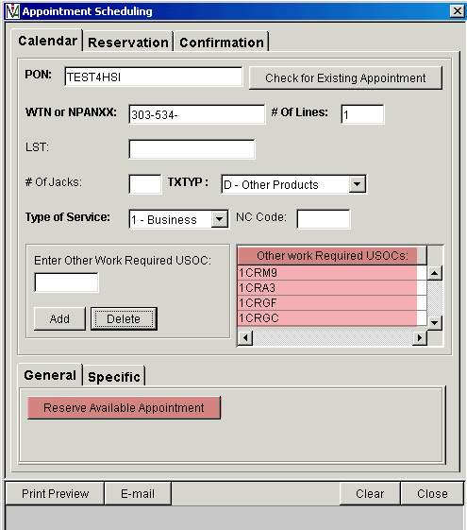

Note: If you desire a specific due date you may select the Specific Date tab and input a preferred date. The Appointment Scheduling service will retrieve the next available appointment for the requested date.
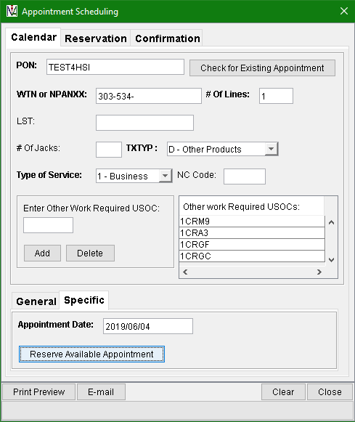

The next available appointment based on your original input will be displayed as the Completion Date.
Other data provided is:
- The PON that was input which will match the Pre-Order to the LSR.
- A Confirmation Number that will be entered on the Service Order.
- After, Before, and Completion times.
If the appointment is not satisfactory, you may select a different appointment by selecting the Reservation tab.
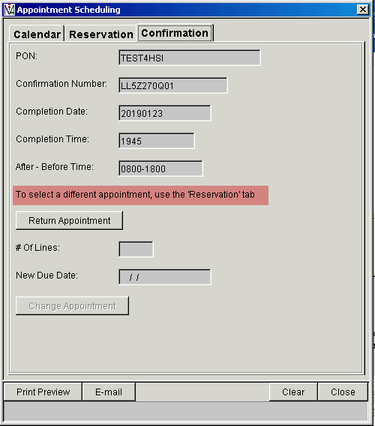

The Reservation screen will provide a list of Available Appointments. Select a row that matches the date and timeframe wanted. Then select Reserve Highlighted Appointment.
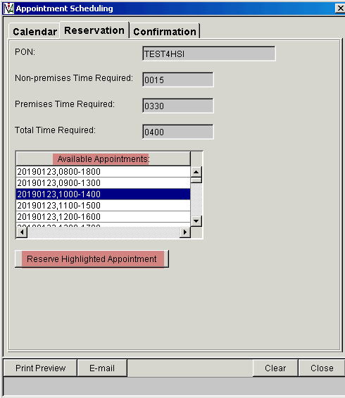

The Confirmation screen will then display. You will notice that the Confirmation Number and After – Before Time now display the changes made on the Reservation screen.
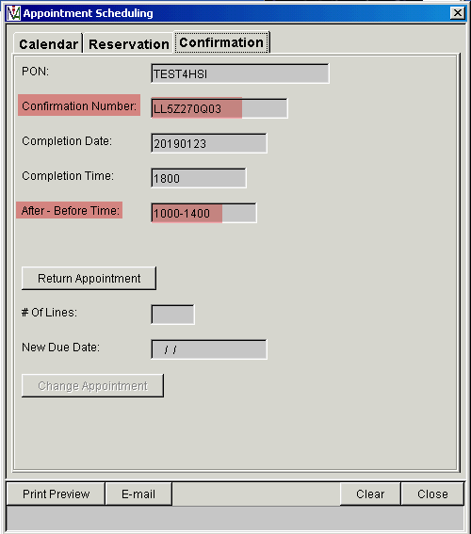

Select Close.

TN Reservation
Select Reserve Telephone Numbers from the PreOrder pulldown. The TN Availability Screen will appear in a new window.
NOTE: IMA will return your reserved TN and provide a Data TN on your FOC. Please note the new Data TN for your records.

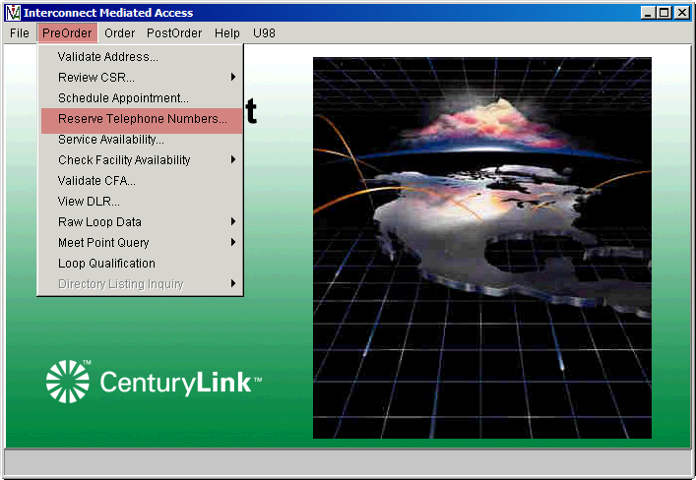

This is the screen when you first open the TN Availability screen. See next step to begin populating the entries. (Note: If the new broadband speed will be provided by Pair Bonded technology, then change the Number of TNs from 1 to 2)
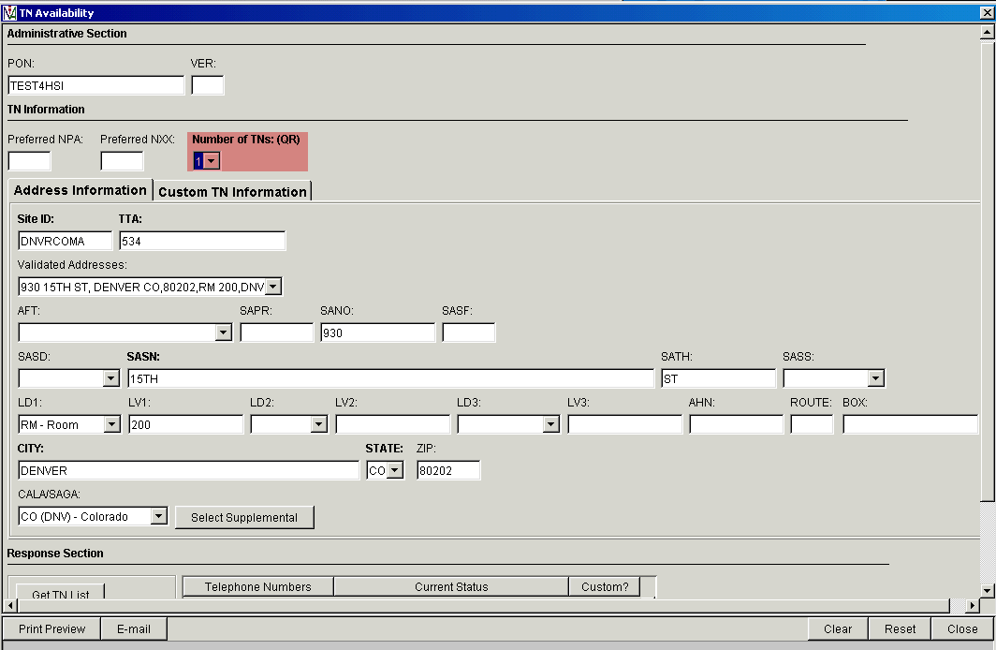

Locate the address under the Validated Address dropdown and populate the PON used in the Appointment Scheduling step. Then select the GET TN List button.
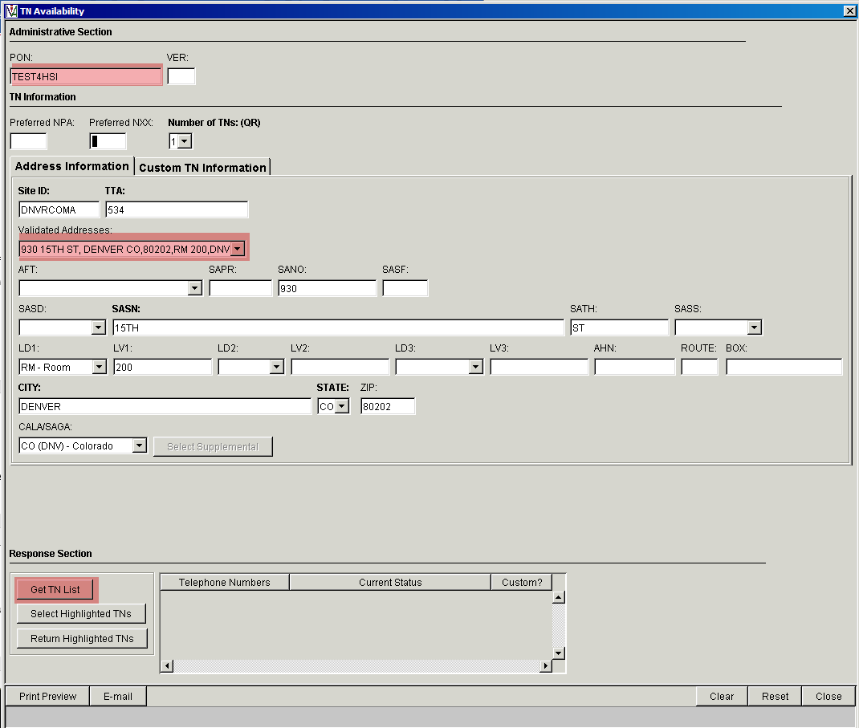

A Telephone Number will be returned. Click on the blue highlighted row and then click on the Select Highlighted TN button.

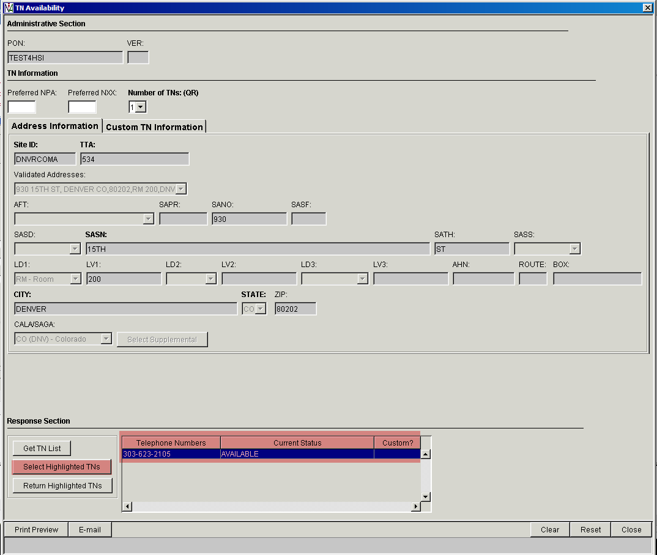

If Pair Bonded, then highlight both TNs and click on Select Highlighted TNs
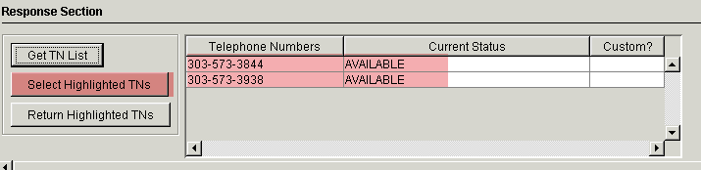
Once selected, the TN Status will change from Available to Selected. Click the Close button to complete the transaction.
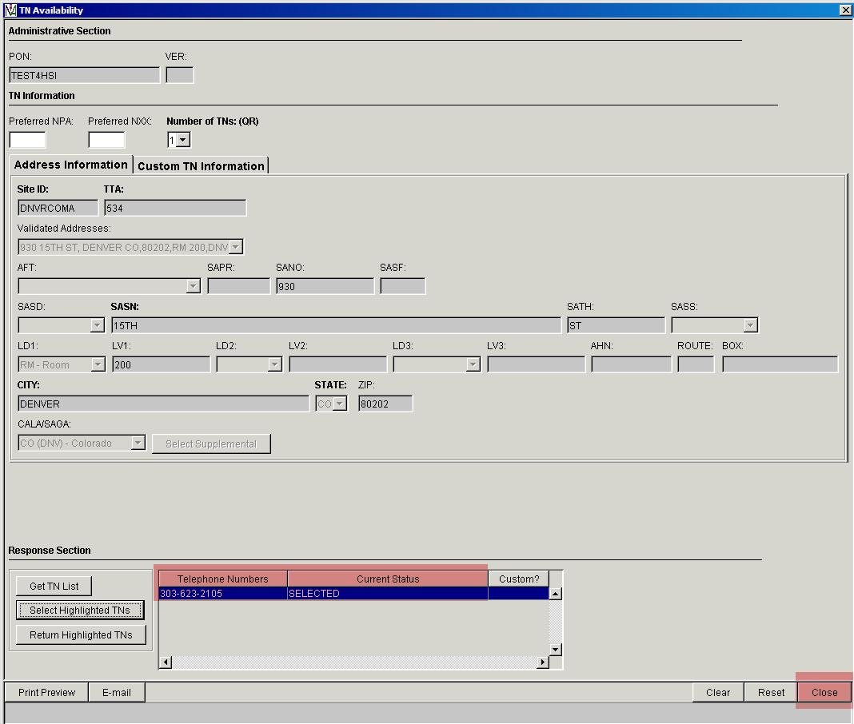

IMA Ordering
Open the IMA GUI URL of https://ima.centurylink.com/ima and sign in using the following fields:
- Corporate ID (RSID assigned by CenturyLink (format is case sensitive e.g. Z99)
- Username (created with your IMA Admin person)
- Password:

Once you are logged in, then you will see the following screen titled Internet Functions. Select the PreOrder/Order/PostOrder option. This activity will open another IE browser window.

This is the next screen you will see. Select Order and then option New LSR/BRC.

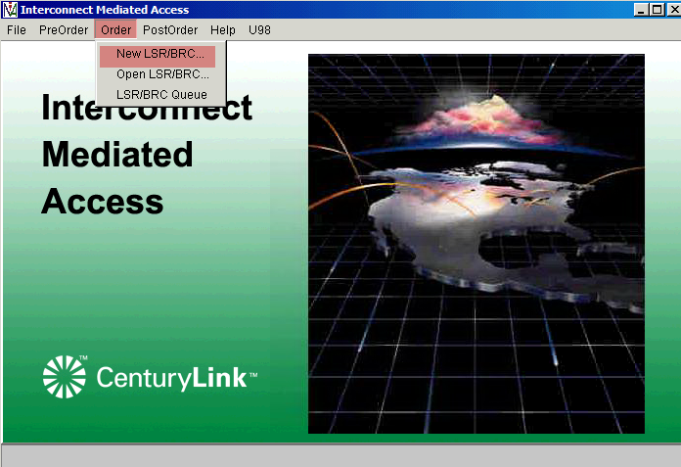

Pre-Ordering is always required in order to simplify and improve accuracy of the ordering activity.
Enter the PON that was created during Pre-Order steps
Select the REQTYP of E- Resale (POTS, PAL, PBX, ISDN, and DSL).
Select the Activity of N – New Installation and/or Account.
Select the Type of Service TOS of 1BF – Business, Single-Line, Flat Rate or (Residential service = 2BF).
- Multi-line Business would use TOS of 1AF – Business, Multi-Line, Flat Rate

Four forms are returned under the Form Name column:
- Local Service Request (LSR)
- End User (EU)
- Resale Form (RS)
- Listing Forms (DL)
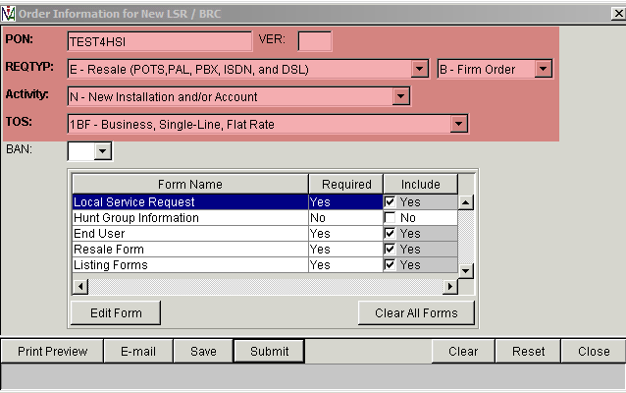
Note: The required flag will vary based on the activity of your order. For example disconnects will not require Listings Forms while new connects will.

Local Service Request Form:

Start with the Local Service Request form. Double Click on the form to open or highlight the form and select the Edit Form button. A new window will open with the LSR form.
These fields are automatically populated due to the options selected earlier:
Desired Due date (DDD), Appointment Time (APPTIME) and Appointment Confirmation number (APTCON) Information were populated due to the IMA Pre-Order Appointment scheduler option
Also populate the RTR (Response Type Requested) field with C. This entry indicates you want a Confirmation sent.
Authorization (AGAUTH) and date of authorization date (DATED) are required fields.
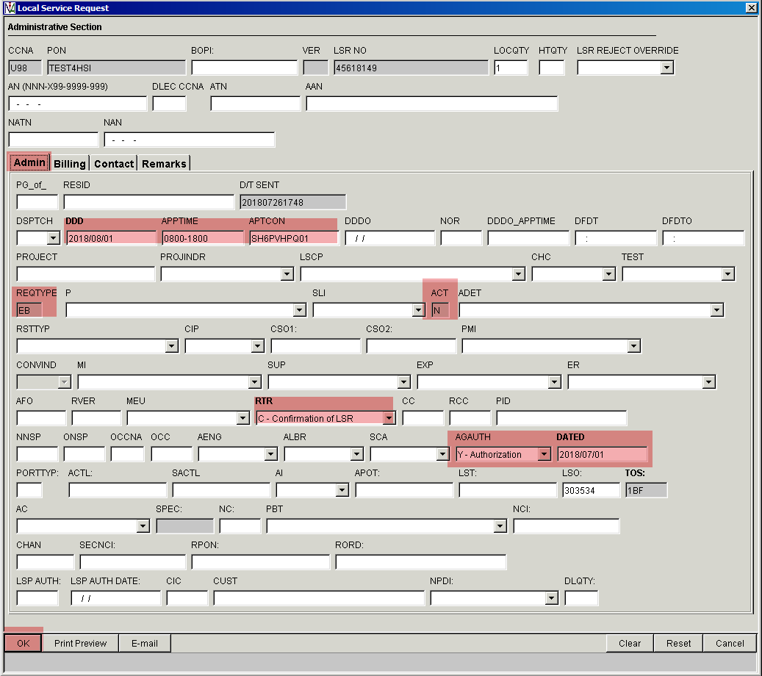
If any unique remarks are needed, click on the Remarks tab and populate the field.
The remarks information will be viewed by the LSR Processing Center.
Example remark: Change Local Contact information
Remarks tab: The Manual Indicator (Manual Ind) option default is N. If you need your request reviewed by the Center, change the option to Y and enter Remarks.
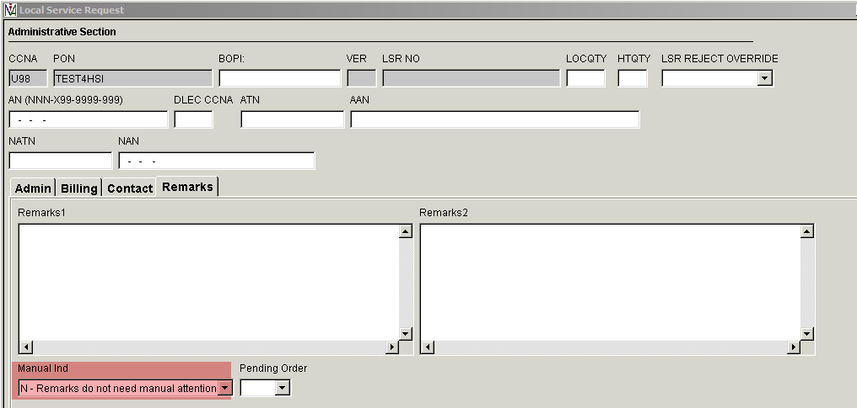

LSR with manual Handling: Change the Manual Ind to Y, Add a Remark then click OK button
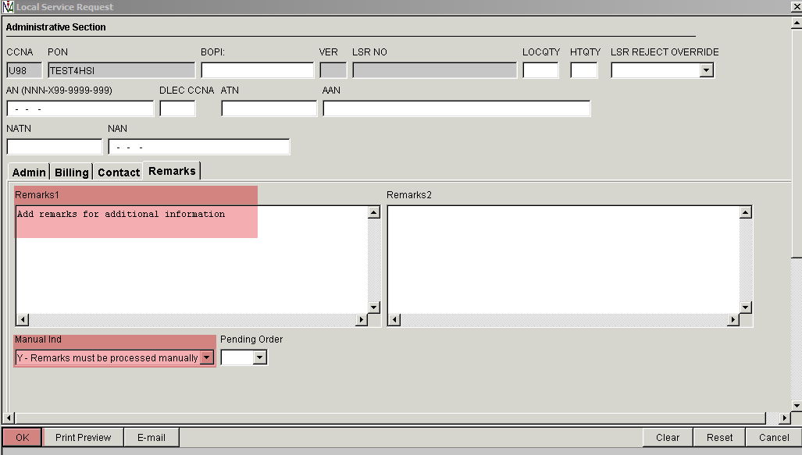

End User Form:
Double Click on the End User form to open or highlight the form and select the Edit Form button. A new window will open with the End user form.
The end user name and address are added on this form, along with the modem shipping address.
Add the end user name in the Name field.
Select the specific address in the Validated Address drop down box. This data is available if pre-order address validations were made prior to creating the LSR order.
Add a Local Contact and telephone number in the LCON and TEL NO field. This is a person at the end user address who is aware of this installation in case the tech has a question while on the premises.
If there is additional information that would be helpful to the tech, add information in the ACC field (tag at dmarc, install broadband service in telco room, etc.).
IMA edits require shipping information even though you may have selected a Full tech install option.
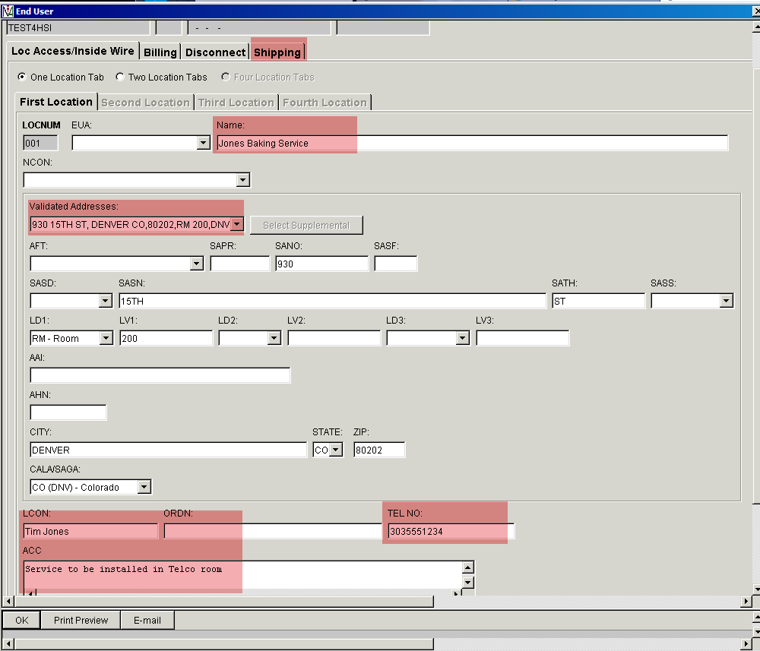

In the Shipping tab, you may either select the Use service address option, which will populate the end user information, or you may enter an alternate address if you would like the modem shipped elsewhere.
We do not recommend the use of the alternate shipping address option, we prefer you use the service address option and always require a modem.
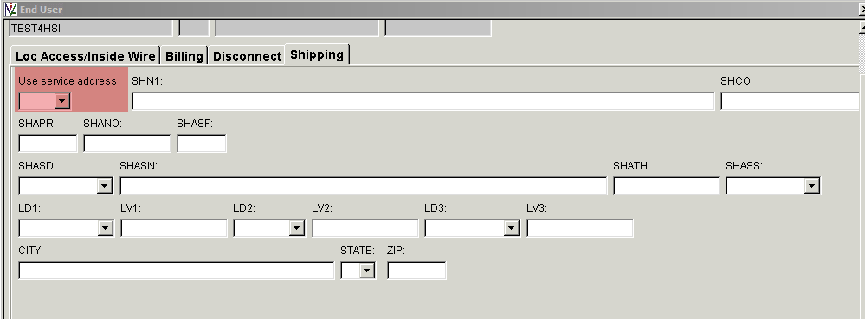
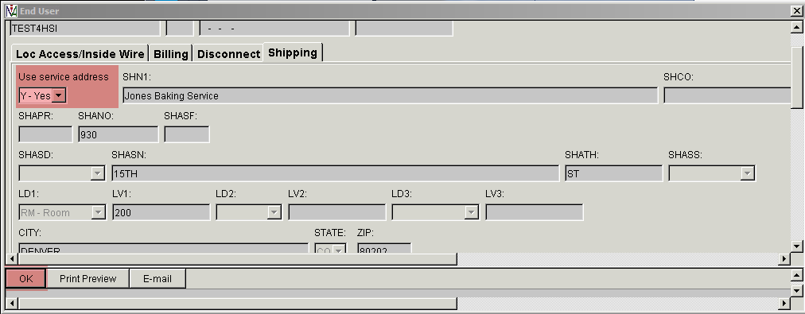

Resale Form:
Next, edit the Resale Form. You must click the Add button before you may enter data on this form.
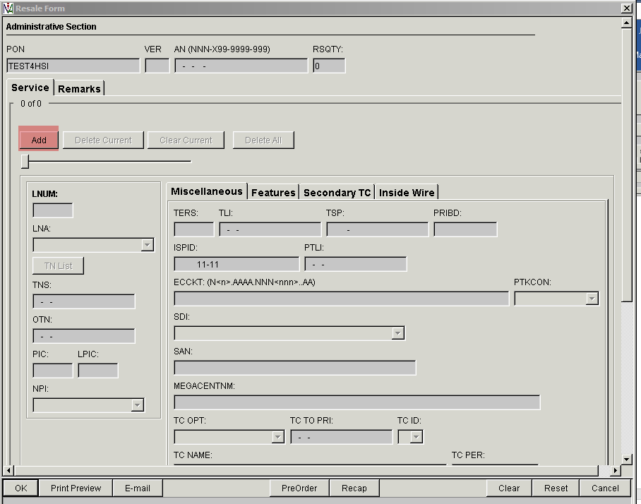

Once you click the Add button, it will allow entries on the form.
Note: When ordering a pair bonded broadband speed, then two service forms will be needed. Fill out the first form. Then activate the form for the second line by clicking on the Add button again.
On a new connect order, the LNA is N – New. PIC and LPIC fields will need to contain the data NONE.
In the MEGACENTNM field, populate USWNET. IMA will retrieve the full CenturyLink ISP name.
Click on the TN List button to view the TN you previously reserved and saved for this PON. A new window will open.

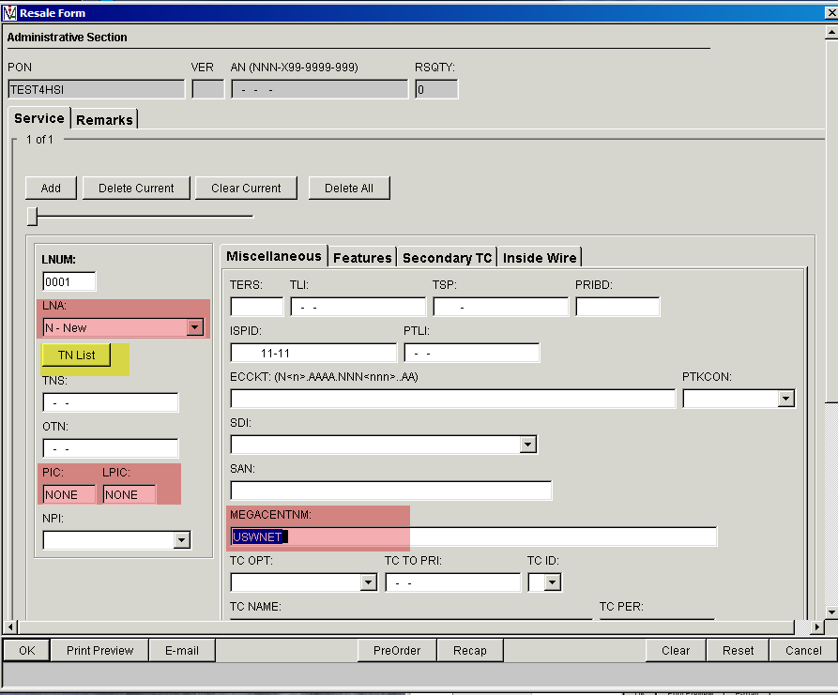

Click on the telephone number that is appropriate for the PON and then click OK to close this window.
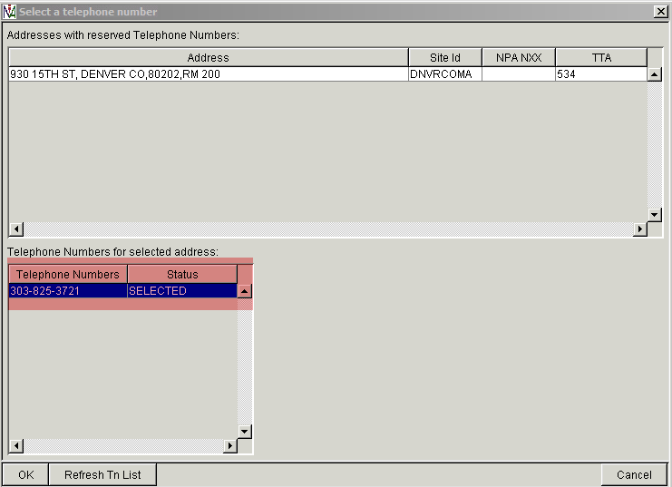

Next, add Features (USOCs) to this PON. Select the Features tab and click the Add button.
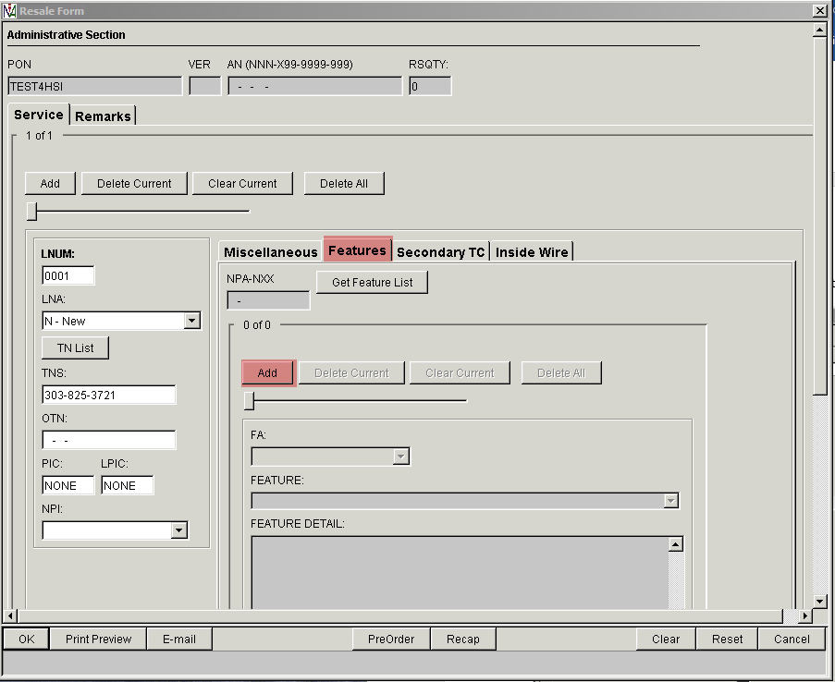

Now the form is ready for USOCs to be added. USOCs are added one at a time in the FEATURE field. Click the Add button to add another feature USOC instance. In this example, the GFB USOC has been added. Then click Add.
USOCs can be found in the CenturyLink™ Wholesale Broadband Service Agreement (WBSA) PCAT (Product Catalog) section below, just click “here” below
Available WBSA Products
Please click here to see the available services.

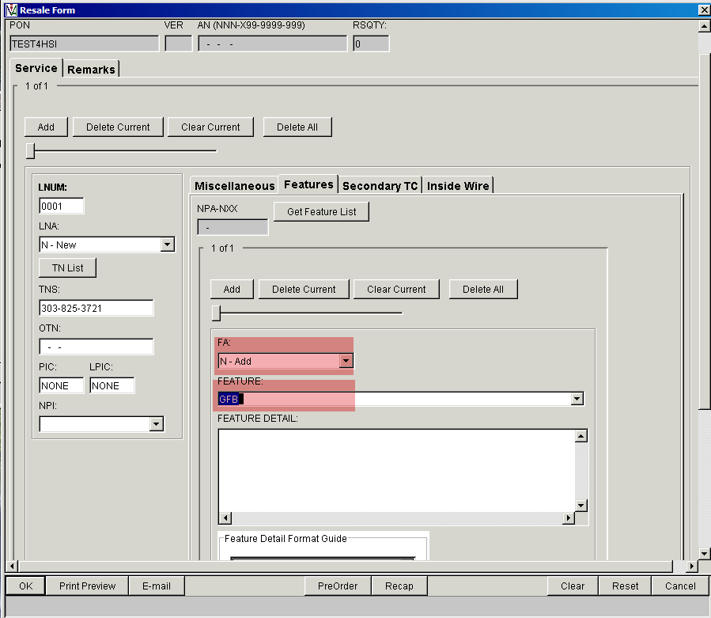

Pair Bonded: In the Feature Detail section for the Feature GFR or GFB, then add a reference to the second reserved TN. Here is how it would appear: /BCCR 303-555-1234
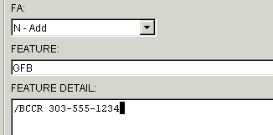
The BCCR is a cross reference between the two lines required for ordering Pair Bonded service. The 1st line’s TNS field becomes the BCCR value on the 2nd line and the 2nd line’s TNS becomes the 1st line’s BCCR.
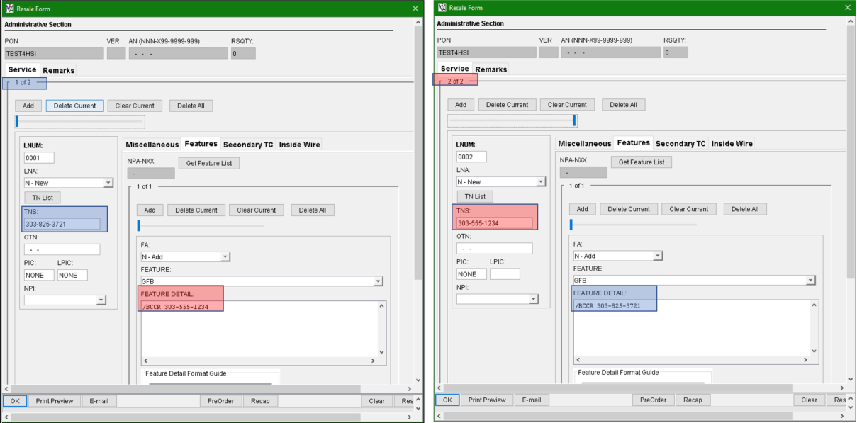

The 2nd feature added is the broadband speed USOC of EHXHC. It is helpful if the technology is added in the FEATURE DETAIL field as shown below. This address is supported by the VDSL2 technology so we added the information /NTI VDSL2. If the technology was ADSL2+, then the FEATURE DETAIL field would contain an entry of /NTI ADSL2+. See chart below for additional /NTI values.

The Broadband technology was found during the Pre-Order Loop Qualification step. Use that information to populate the correct USOCs and Feature Detail on the LSR.
Some examples may include:
Loop qual results indicate ADSL2+ or VDSL2, then select a speed USOC that begins with “E” (e.g EHXAB). If the loop qual results indicate ATM, then select a GRL++.
Continue adding features/USOCs until all specific ones for the request are added:
- Line USOC = GFR (Residential) or GFB (Business)
- Broadband Speed USOC = EHX++ or GRL++
Technology | NTI value
VDSL2 | VDSL2
VDSL2 Vectored | V2V
VDSL2 Pair Bonded | V2-PB
VDSL2 Vectored Pair Bonded | V2V-PB
ADSL2+ Pair Bonded | ADSL2+
ADSL2+ Pair Bonded | A2P-PB
Pair Bonded | PB
GPON | GPON
  - In Feature Detail, add data /NTI VDSL2 or /NTI ADSL2+ (see chart below for additional values)

- ISP USOC = NMO77 for Business or NMO4T for Residential
- Modem USOC s
  - DXLY6 – Single line under 40M speed
  - DXLYG – 40M and over, GPON or Pair Bonded
- Tech install USOCs:
- Business
- VDSL2 technology = 1CRM9 and 1CRA3
- ADSL2+ or ATM technology = 1CRMC and 1CRA3
- Residential
- VDSL2 technology = 1CRM9 and 1CRA1
- ADSL2+ or ATM technology = 1CRMC and 1CRA1
Note: The additional USOCs for GPON or pair bonding will be added systematically to the service order and won’t need to be entered on the Resale form. (e. g. 1CROC, 1CRGN, 1CRGC, 1CRGF or 1CRGA)
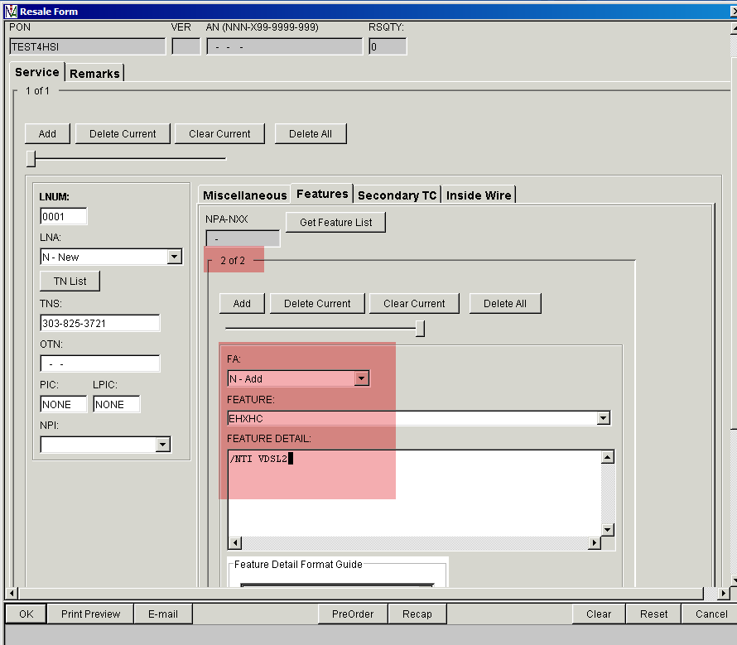

In the example below, you will note that six features have been added to this request. Use the slider bar to view the USOC instances. Once all the features have been added, click OK.
Note: If a feature was added in error, you may use the Delete Current or Clear Current button to remove one feature/USOC or the Delete All button to remove all the previously entered features/USOCs. Then, they will need to be re-added.
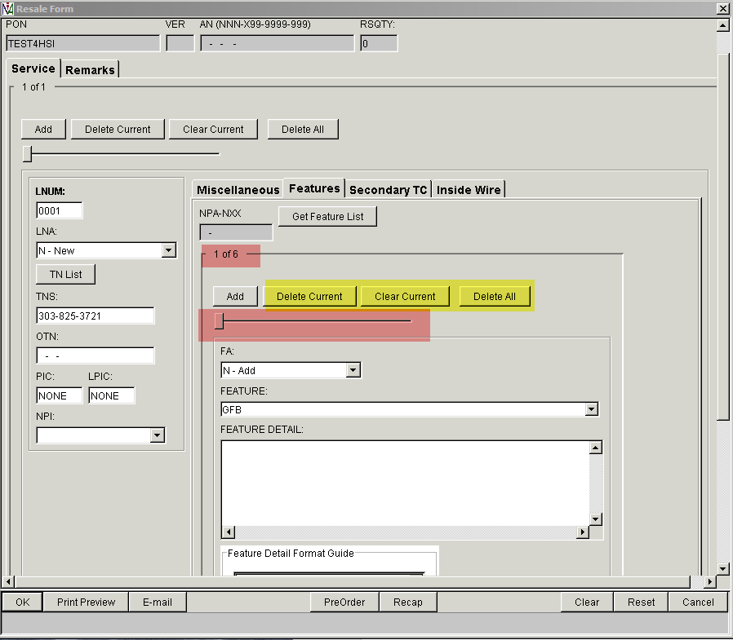

Directory Listing form (Listing Form)
Next, edit the Listings Form.
Click on the Add button to add data.
Note: The DL form is required in IMA even though there isn’t a Listing associated to a Standalone Broadband account.
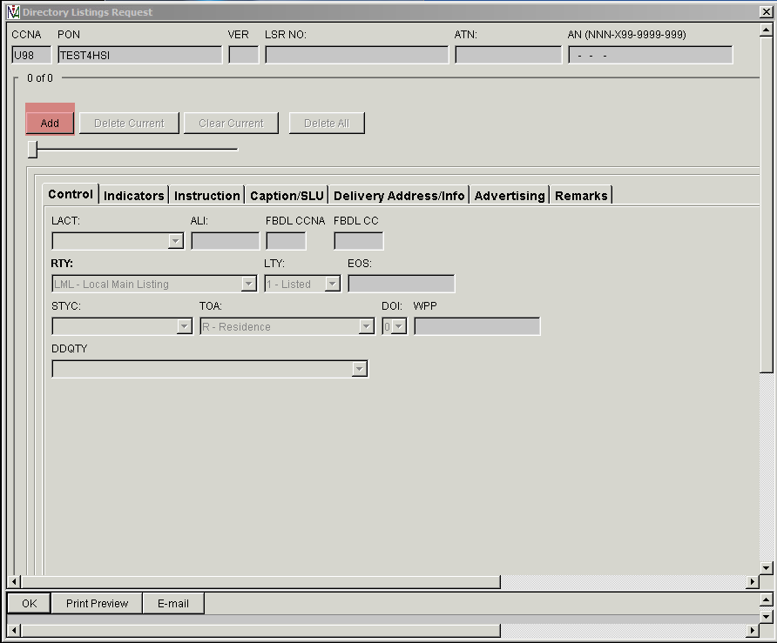

Populate these fields:
- LACT = N- New Listing
- RTY = LML – Local Main Listing
- LTY = 3- Non-Pub
- STYC = SL- Straight Line
- TOA = B - Business or R - Residence
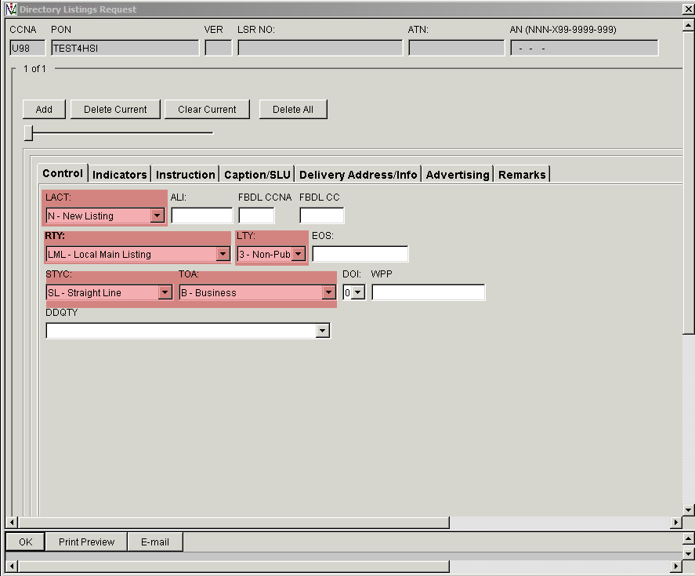

Then, click on the Instruction tab. Populate the LNLN (Listed Name Last Name) field and LNFN (Listed Name First Name) fields and populate with the end user information.
Click OK when finished.
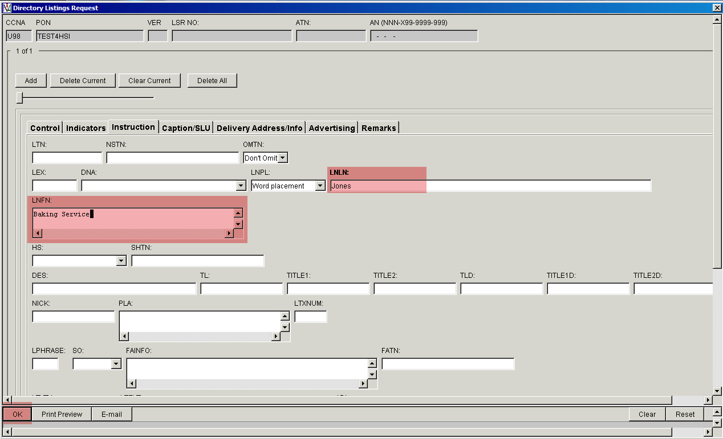

Now that all the forms have been populated, click Save for IMA to begin validating the fields on the LSR forms.
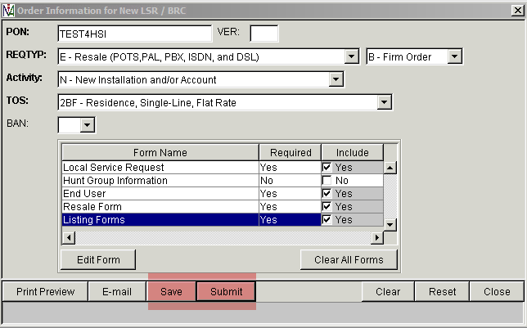
IMA will open a new window with Messages from your Save.
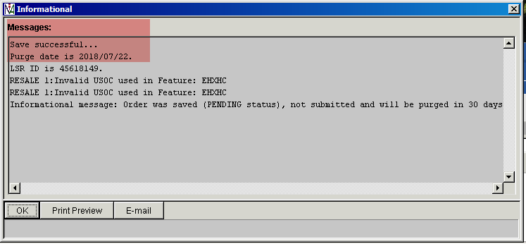

Once all displayed errors have been corrected, select Save or Submit to begin the processing of the request.
Screen below is the view to click Submit:
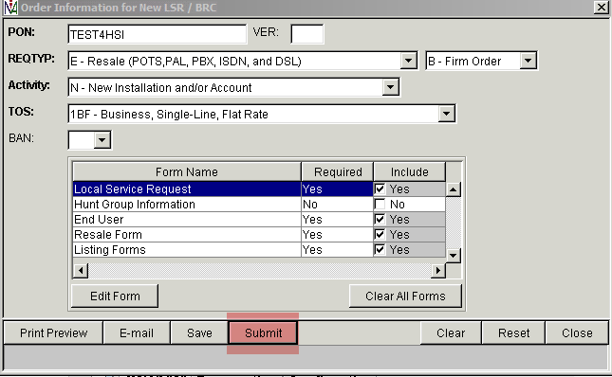
After clicking Submit, then Click Commit to complete the LSR submission transaction
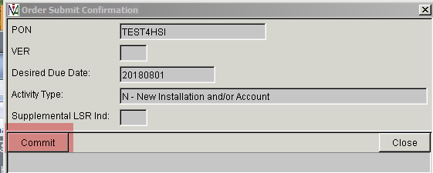

APPENDIX A – HSI Technologies
Technologies Available | Description
ATM | ADSL – Associated with GRL++ USOCs
ADSL2+ | ADSL2+
ADSL2+COND | ADSL2+ - Needs further evaluation
VDSL2 | VDSL2
VDSL2COND | VDSL2 – Needs further evaluation
V2V | VDSL2 Vectored
V2V COND | VDSL2 Vectored - Needs further evaluation
PB | Pair Bonded
PBCOND | Pair bonded – Needs further evaluation
GPON | GPON
GPONCOND | GPON – Needs further evaluation

APPENDIX B – Appointment USOCs
Type of Service | Technology | USOCs
1 (Business) | ADSL2+ | 1CRMC  1CRA3
 | VDSL2 | 1CRM9  1CRA3
 | GPON | 1CRMC  1CRA3  1CROC  1CRGN
 | Pair Bonding (ADLS2+) | 1CRMC  1CRA3  1CRGA
 | Pair Bonding (VDSL2) | 1CRM9  1CRA3  1CRGF
 | Pair Bonding (Vectored) | 1CRM9  1CRA3  1CRGC
2 (Residential) | ADSL2+ | 1CRMC  1CRA1
 | VDSL2 | 1CRM9  1CRA1
 | GPON | 1CRMC  1CRA1  1CROC  1CRGN
 | Pair Bonding (ADLS2+) | 1CRMC  1CRA1  1CRGA
 | Pair Bonding (VDSL2) | 1CRM9  1CRA1  1CRGF
 | Pair Bonding (Vectored) | 1CRM9  1CRA1  1CRGC
Any | Changing from one technology to another on an existing customer account will require and additional USOC. | VT6RT

APPENDIX C – Order Scenario Summary Notes

Single Line Scenarios
(Conversion examples apply when account not owned by your WBSA RSID ID)
Scenario | Technology | Pre Order Notes | Line 1 | Line 2
Brand New Service (single line WBSA) | ADSL2+  VDSL2  V2V  GPON | - Validate Address  - Loop Qualification by Address  - Schedule Appointment  - Reserve 1 TN for new line (303-333-3333) | ACT N  LNA N  TNS 303-333-3333  FA N GFR  FA N EFXDS /NTI V2V  FA N NMO4T  FA N DXLYG  FA N 1CRM9  FA N 1CRA1 | none
Convert from existing data only non-PB account  (single line GFR account) to single line WBSA | ADSL2+  VDSL2  V2V  GPON | - Validate Address  - Loop Qualification by TN  - Retrieve Customer Service Record (GFR 303-555-1111)  - Schedule Appointment if the CSR does not have DXLYG or DXLY6 (modem).  - No TN Reservation required | ACT V  LNA V  TNS 303-555-1111  FA V GFR  FA D EHXAS  FA N EFXDS /NTI V2V  FA N NMO4T  FA N DXLYG  FA N 1CRM9  FA N 1CRA1 | none
Convert from existing voice non-PB account (single line 1FR account) to single line WBSA | ADSL2+  VDSL2  V2V  GPON | - Validate Address  - Loop Qualification by TN  - Retrieve Customer Service Record (1FR 303-555-1111)  - Schedule Appointment if the CSR does not have DXLYG or DXLY6 (modem).  - Reserve 1 TN for TN change (303-333-3333) | ACT V  LNA V  TNS 303-333-3333  OTN 303-555-1111  FA C 1FR  FA T GFR  FA D EHXAS  FA N EFXDS /NTI V2V  FA N NMO4T  FA N DXLYG  FA N 1CRM9  FA N 1CRA1 | none

Pair Bond Scenarios
(Conversion examples apply when account not owned by your WBSA RSID ID)
Scenario | Technology | Pre Order Notes | Line 1 | Line 2
Brand New Service (Pair Bonded WBSA) | Pair Bonded | - Validate Address  - Loop Qualification by Address  - Schedule Appointment  - Reserve 2 TNs for new lines (eg. 303-333-3333 and 303-444-4444) | ACT N  LNA N  TNS 303-333-3333  FA N GFR /BCCR 303-444-4444  FA N EFXDS /NTI PB  FA N NMO4T  FA N DXLYG  FA N 1CRM9  FA N 1CRA1 | ACT N  LNA N  TNS 303-444-4444  FA N GFR /BCCR 303-333-3333  FA N EFXDS /NTI PB
Change from existing WBSA non-PB account  (single line GFR account) to Pair Bonded (account already owned by you) | Pair Bonded | - Validate Address  - Loop Qualification by TN  - Retrieve Customer Service Record (GFR TN 303-333-3333)  - Schedule Appointment  - Reserve 1 TN for new line (eg. 303-444-4444) | ACT C  LNA C  TNS 303-333-3333  FA C GFR  FA T GFR /BCCR 303-444-4444  FA D EHXAS  FA N EFXFS /NTI PB  FA N DXLYG  FA N 1CRM9  FA N 1CRA1 | ACT C  LNA N  TNS 303-444-4444  FA N GFR /BCCR 303-333-3333  FA N EFXFS /NTI PB
Convert from existing data only non-PB account  (single line GFR account) to Pair Bonded WBSA | Pair Bonded | - Validate Address  - Loop Qualification by TN  - Retrieve Customer Service Record (GFR TN 303-555-1111)  - Schedule Appointment  - Reserve 1 TN for new line (eg. 303-333-3333) | ACT V  LNA V  TNS 303-555-1111  FA V GFR /BCCR 303-333-3333  FA D EHXAS  FA N EFXDS /NTI PB  FA N NMO4T  FA N DXLYG  FA N 1CRM9  FA N 1CRA1 | ACT V  LNA N  TNS 303-333-3333  FA N GFR /BCCR 303-555-1111  FA N EFXDS /NTI PB
Convert existing voice non-PB account  (single line 1FR account) to Pair Bonded WBSA | Pair Bonded | - Validate Address  - Loop Qualification by TN  - Retrieve Customer Service Record (1FR TN 303-555-1111)  - Schedule Appointment  - Reserve 2 TNs for TN change and new line (eg. 303-333-3333 and 303-444-4444) | ACT V  LNA V  TNS 303-333-3333  OTN 303-555-1111  FA C 1FR  FA T GFR /BCCR 303-444-4444  FA D EHXAS  FA N NP3  FA N EFXDS /NTI PB  FA N NMO4T  FA N DXLYG  FA N 1CRM9  FA N 1CRA1 | ACT V  LNA N  TNS 303-444-4444  FA N GFR /BCCR 303-333-3333  FA N EFXDS /NTI PB
Convert existing data only (GFR & GFR) Pair Bond account to Pair Bond WBSA | Pair Bonded | - Validate Address  - Loop Qualification by TN  - Retrieve Customer Service Record (Bond 1 GFR TN 303-555-1111 and Bond 2 GFR TN 303-555-2222)  - Schedule Appointment if the CSR does not have DXLYG or DXLY6 (modem).  - TN Reservation not required | ACT V  LNA V  TNS 303-555-1111  FA V GFR /BCCR 303-555-2222  FA D EHXAS  FA N EFXDS /NTI PB  FA N NMO4T  FA N DXLYG  FA N 1CRM9  FA N 1CRA1 | ACT V  LNA V  TNS 303-555-2222  FA N GFR /BCCR 303-555-1111  FA N EFXDS /NTI PB
Convert existing voice (1FR & GFR) Pair Bond account to Pair Bond WBSA | Pair Bonded | - Validate Address  - Loop Qualification by TN  - Retrieve Customer Service Record (Bond 1 1FR TN 303-555-1111 and Bond 2 GFR TN 303-555-2222)  - Schedule Appointment if the CSR does not have DXLYG or DXLY6 (modem).  - Reserve 2 TNs for TN change and new line (eg. 303-333-3333 and 303-444-4444) | ACT V  LNA V  TNS 303-333-3333  OTN 303-555-1111  FA C 1FR  FA T GFR /BCCR 303-444-4444  FA N NP3  FA N EFXDS /NTI PB  FA N NMO4T  FA N DXLYG  FA N 1CRM9  FA N 1CRA1 | ACT V  LNA V  TNS 303-444-4444  OTN 303-555-2222  FA C GFR  FA T GFR /BCCR 303-333-3333  FA N EFXDS /NTI PB

Pair Bond Scenarios continued

Scenario | Technology | Pre Order Notes | Line 1 | Line 2
Convert existing data only (GFR & GFR) Pair Bond account to single line WBSA | ADSL2+  VDSL2  V2V | - Validate Address  - Loop Qualification by TN  - Retrieve Customer Service Record (Bond 1 GFR TN 303-555-1111 and Bond 2 GFR TN 303-555-2222)  - Schedule Appointment if the CSR does not have DXLYG or DXLY6 (modem).  - TN Reservation not required | ACT V  LNA V  TNS 303-555-1111  FA V GFR  FA D EHXAS  FA N EHXOS /NTI V2V  FA N NMO4T  FA N DXLYG  FA N 1CRM9  FA N 1CRA1 | ACT V  LNA D  TNS 303-555-2222  FA D GFR
Convert existing voice (1FR & GFR) Pair Bond account to single line WBSA | ADSL2+  VDSL2  V2V | - Validate Address  - Loop Qualification by TN  Retrieve Customer Service Record (Bond 1 1FR TN 303-555-1111 and Bond 2 GFR TN 303-555-2222)  - Schedule Appointment if the CSR does not have DXLYG or DXLY6 (modem).  - Reserve 1 TNs for TN change (eg. 303-333-3333) | ACT V  LNA V  TNS 303-333-3333  OTN 303-555-1111  FA C 1FR  FA T GFR  FA N NP3  FA N EFXDS /NTI PB  FA N NMO4T  FA N DXLYG  FA N 1CRM9  FA N 1CRA1 | ACT V  LNA D  TNS 303-555-2222  FA D GFR

